Reverse left ventricular remodeling: effect of cardiac rehabilitation exercise training in myocardial infarction patients with preserved ejection fraction

SHORT TITLE: CR EXERCISE TRAINING AND REVERSE LV REMODELING

G. MCGREGOR ^{1, 2}, D. GAZE ³, D. OXBOROUGH ⁴ , J. O’DRISCOLL ⁵, R. SHAVE ¹

¹Cardiff Metropolitan University, Cardiff, UK
²University Hospital, Coventry, UK
³St George’s Hospital, London, UK
⁴Liverpool John Moore’s University, Liverpool, UK
⁵Canterbury Christchurch University, Canterbury, UK

Corresponding author: G. McGregor, Cardiac Rehabilitation, 1st Floor, East Wing, University Hospital, Coventry, CV2 2DX, England. E-mail: gordon.mcgregor@uhcw.nhs.uk

Background. In the increasingly prevalent population of postmyocardial infarction (MI) patients with preserved left ventricular (LV) ejection fraction (>45%), the effect of cardiac rehabilitation (CR) exercise training on LV structure and function is unknown.
Aim. To examine the reverse LV remodeling effect of CR exercise training in post-MI patients with preserved LV ejection fraction (>45%).
Design. Prospective, longitudinal, controlled trial.
Setting. Outpatient CR programme.
Population. Fifty six asymptomatic, post-MI patients without residual myocardial ischemia and LV ejection fraction >45%.
Methods. Within 3-6 weeks of MI, and 10 weeks later, echocardiography and cardiopulmonary exercise testing were performed. An exercise training group (N.=36) completed twice weekly gym based cardiovascular exercise (60-80% VO₂ peak) and a resistance training programme, whilst a non-exercise group (N.=20) did not.
Results. In comparison to the non-exercise group, in which there was no change, 10 weeks of CR exercise training resulted in increased VO_{2peak} and reduced LV end diastolic and systolic volumes (all P<0.05 vs. non-exercise group).
Conclusion. In post-MI patients with preserved LV ejection fraction (>45%), CR exercise training is effective in improving functional capacity and reducing LV volumes.
Clinical Rehabilitation Impact. In this previously unstudied population, the measurement of reverse LV volumetric remodeling may prove useful as an indicator of CR exercise programme efficacy. To maximize the potential clinical benefit from reverse LV remodeling, this patient group, should be actively encouraged to engage in CR exercise training.

Key words: Rehabilitation - Exercise Test - Myocardial infarction - Ventricular Remodeling.

Myocardial infarction (MI) is associated with molecular disarray, myocyte hypertrophy and extra-cellular matrix degradation.¹ This results in pathologically increased left ventricular (LV) mass and volume and altered LV geometry.¹ The process of LV remodeling, characterized by structural maladaptation and functional decline, begins with the onset of acute MI and is chronically driven by systemic neurohormonal activation.² Mortality is linked to the nature and extent of LV remodeling and also to the degree of neurohormonal activation.^{3, 4} Specifically, increased LV volumes and reduced LV ejection fraction (LVEF) are exponentially related to poor prognosis ⁵ providing a clear rationale to attenuate this process. In post-MI patients, pharmacological and electrophysiological interventions improve cardiovascular and all-cause mortality.^{6, 7} Despite this, in the first two years after MI, mortality of greater than 25% occurs in patients with LVEF of 31-40%, compared to less than 15% when LVEF is greater than 50%.⁵ It is important therefore to consider adjunctive therapies such as cardiac rehabilitation (CR) exercise training which may enhance the reverse LV remodeling seen with medical treatment.
Evidence of reverse LV remodeling, following CR exercise training in post-MI patients is equivocal.⁸ Longitudinal studies have shown a positive effect on LV end diastolic volume (LVEDV), LV end systolic volume (LVESV), LVEF and N-terminal-pro-B-type natriuretic peptide (NT-pro-BNP),⁹⁻¹¹ but conflicting data exist.^{12, 13} Furthermore, a recent meta-analysis showing an overall beneficial effect of CR exercise training on LV remodeling, was limited by the poor methodological quality of some of the studies included.⁸ To date, CR exercise training studies have focused almost exclusively on patients with moderate to severe impairment of LV systolic function (LVEF ≤45%). These patients are often limited by their condition and are, therefore, obvious candidates for CR exercise training. However, advances in percutaneous coronary artery revascularization, rapid 24 hr access to treatment, greater sensitivity of cardiac biomarkers, and increased awareness of chest pain management have led to a growing population of asymptomatic MI survivors with preserved LV systolic function (LVEF>45%).^{14, 15} In the absence of significant functional limitation, these patients can be quickly reintegrated into daily life, making their attendance on CR exercise programmes less likely. This may be ill advised given that 15% of these patients will die or be hospitalised with heart failure within 20 months of MI.¹⁶ Exercise training may be an effective preventative strategy, ameliorating the negative effects of chronic LV remodeling, yet the impact of CR exercise training on LV structure and function has not been studied in this group of patients. Therefore, the purpose of the current study was to investigate the effect of CR exercise training on LV structure and function in post-MI patients with preserved LVEF (>45%). It was hypothesized that 10 weeks of CR exercise training would reduce LV volumes and increase LVEF in addition to improving functional capacity.

Materials and methods

Study population and protocol
A total of 56 consecutive male participants were recruited to the study. An exercise training group was populated by those who attended CR (N.=36) and a non-exercise group by those who were demographically and clinically similar to the exercise group but were unable to attend structured CR due to work or personal commitments (N.=20) (Table I). Participants were clinically stable (in accordance with guidelines)¹⁷ following treatment for an acute MI at least three, but not more than six weeks previously. All participants had LVEF >45% and were asymptomatic following successful percutaneous coronary intervention. The absence of exercise induced angina and/or ischemic ECG changes was confirmed with cardiopulmonary exercise testing. Participants who did not meet guidelines for inclusion in exercise training ¹⁷ or who had significant limiting comorbidities were excluded. Both groups were advised on a cardio-protective lifestyle including general physical activity. Approval was gained from the local Research and Ethics Committee (08/H1210/56), informed consent was obtained from all participants and the study complied with all aspects of the Declaration of Helsinki. Prior to and on completion of a 10-week supervised exercise training programme or non-exercise control period, transthoracic echocardiography and cardiopulmonary exercise testing were undertaken in all study participants. In addition, resting whole blood samples for the assessment of NT-pro-BNP were obtained in a sub-group (N.=21) of exercise training participants willing to undergo additional phlebotomy. Other than sedentary behavior, which was determined through self-reported non-adherence to current physical activity guidelines, the presence of cardiovascular disease risk factors was identified from participants’ medical notes.

Cardiopulmonary exercise testing
Cardiopulmonary exercise testing was performed in accordance with the American Thoracic Society guidelines.¹⁸ Briefly, a standard ramp protocol was conducted on an electronically braked, upright cycle ergometer with continuous respiratory gas exchange measurements of oxygen uptake (VO₂), carbon dioxide production (VCO₂) and minute ventilation (V_{E}) (Oxycon Pro, Care Fusion Corp., San Diego, CA, USA). Electrocardiogram, blood pressure and rating of perceived exertion (RPE) were monitored throughout and participants were encouraged to continue until symptom limited volitional fatigue, with a respiratory exchange ratio of >1.15 indicating maximal effort.

Echocardiography
Resting echocardiographic images were acquired in accordance with British Society of Echocardiography guidelines ¹⁹ by a single cardiac sonographer, blinded to group allocation. A commercially available ultrasound system (Vivid 7, GE Medical Systems, Horten, Norway) was used to obtain and store images for subsequent off-line analysis (Echo-pac, GE Medical Systems, Horten, Norway, version 7.0.0). Left ventricular internal dimensions and wall thicknesses, and atrial diameter, were measured from the parasternal long axis view, and LV volumes calculated using the Simpson’s bi-plane method from apical two and apical four-chamber images. LV mass and relative wall thickness were calculated according to Lang et al., (2015).²⁰ Peak early (E) and late (A) mitral inflow velocity, and the E-wave deceleration time (DT) were measured with pulse wave Doppler in the apical four-chamber view, and the E/A ratio calculated. Finally, tissue Doppler imaging of the septal and lateral mitral annuli in the apical four-chamber view was employed to quantify systolic (s’), early diastolic (e’) and late diastolic (a’) peak mitral annulus tissue velocities. Intraobserver variability has been previously assessed in our laboratory for standard 2D, Doppler and Tissue Doppler Indices of LV function. In healthy participants and those with LV dysfunction, the coefficient of variation was within an acceptable range for diagnosis and interpretation, and in keeping with data published by the American Society of Echocardiography.²⁰

Measurement of cardiac biomarkers
Serum was obtained from whole blood samples collected into ethylene diamine teracetic acid tubes via peripheral venepuncture. Clotted samples were centrifuged at 3000 rpm for 10 min and stored at -80 deg C. NT-pro-BNP was determined using the Immulite 2500 electrochemiluminescent immunoassay (Siemens Healthcare Diagnostics, Frimley, UK) with a linear calibration range of 20 to 35,000 pg/mL and a cut-off value for exclusion of LVSD of 75 pg/mL in patients aged 50-75 yrs.²¹

Exercise training
Participants attended University Hospital, Coventry twice weekly for 10 weeks with an adherence rate of 85% (17 of 20 sessions) designated as the required standard for inclusion. Cardiovascular exercise was split equally between treadmill, cycle ergometer, rowing machine and cross-trainer. A 10 min treadmill or cycle warm up was followed initially by 25 min of continuous cardiovascular exercise. A 5 min cool down walk was performed prior to and on completion of a standardized resistance training programme consisting of 1 set per exercise. Resistance training machines were used to perform 5 upper and 2 lower body exercises such that no more than 12 repetitions could be completed, without straining.¹⁷ Aerobic exercise intensity was initially set at a heart rate corresponding to 60-80% peak oxygen uptake (VO_{2 peak}) from cardiopulmonary exercise test and after two sessions the supervisory team ensured that participants were exercising at a heart rate equivalent to 80% VO_{2 peak}. Exercise intensity and training heart rate range were re-prescribed every two weeks based on RPE. The duration of exercise was progressively increased from 25 to 40 min by the fifth week and was maintained thereafter. Whilst further non-structured, home-based exercise was advised in line with guidelines for secondary prevention,²² this aspect of the programme was not monitored or quantified.

Statistical analysis
Baseline characteristics and continuous variables are presented as mean±standard deviation (SD). Differences between the exercise training and non-exercise group at baseline were determined using unpaired Student’s t-tests. Further to confirmation of normality with the Kolmogorov-Smirnov Test, the change in outcome variables by group over time was assessed with either a two-way mixed model analysis of variance (ANOVA) or paired Student’s t-tests. Pearson’s product-moment correlation coefficient was used to determine relationships between the relative change (∆) in NT-pro-BNP and the absolute change (∆) in LV volumetric parameters over the 10 week period in the sub-group of exercise training participants.

Results

Recruitment
Of the 36 participants in the exercise training group, 33 completed ≥17 of 20 sessions during the training period with an average attendance of 88.3%. Two participants were lost to follow-up and one failed to meet the minimum adherence target. In the non-exercise group, a further three participants were lost to follow up. Accordingly, data from 50 participants (exercise training, N.=33 and non-exercise, N.=17) was analyzed to assess the effects of CR exercise training on LV structure and function. Baseline demographic and clinical characteristics were similar between groups (Table I), medication remained unchanged during the study period, and no cardiovascular complications or other adverse effects were experienced by the participants.

Cardiopulmonary exercise testing
In comparison to the non-exercise group, maximum workload (W_{max}), VO_{2 peak}, ventilatory threshold (VT) and exercise time increased in response to exercise training (all P<0.05) (Table I). In the exercise training group, VO_{2 peak} increased by 16%, W_{max} by 19%, VT by 18%, and exercise time by 16% (all P<0.0001) (Table I). In the non-exercise group, no changes were noted. Furthermore, there were no statistical differences in body mass index (BMI), resting heart rate (HR_{rest}), systolic blood pressure (BP_{sys}) or diastolic blood pressure (BP_{dia}) in either group between baseline and poststudy measures (Table I).

Effect of cardiac rehabilitation exercise training on left ventricular structure and function
On completion of the exercise training programme, LVEDV and LVEDV/BSA (both P<0.05), and LVESV and LVESV/BSA (both P<0.01) were decreased in comparison to the non-exercise group. As depicted in Figure 1, 10 weeks of exercise training resulted in a 5% reduction in LVEDV and LVEDV/BSA (both P<0.001) and a 9% reduction in LVESV and LVESV/BSA (both P<0.001), whereas volumetric parameters remained unchanged in the non-exercise group (P>0.05). No changes in either group were observed in LV mass or RWT calculated from linear dimensions (P>0.05) (Table II). The exercise training programme did not have a statistically significant impact on LVEF or Doppler indices of diastolic function, all of which were within normal ranges at baseline (Figure 1, Table III).

Relationship between NT-pro-BNP and left ventricular volumetric parameters
In the sub group of exercise training participants (N.=21), resting NT-pro-BNP was significantly lower at the end of the 10 week programme (267±232 vs. 158±121 pg/mL, P<0.01). Additionally, the relative reduction in resting NT-pro-BNP (%) from baseline to 10 weeks correlated positively with the absolute change in LVEDV (mL) (r=0.58, P<0.01, r²=0.33) (Figure 2). There was no significant relationship between the relative change in NT-pro-BNP and the absolute change in either LVESV (r=0.10, P>0.05, r²=0.01) or LVEF (r=0.17, P>0.05, r²=0.03) (Figure 2).

Discussion
The aim of the present study was to evaluate the reverse remodeling effect of CR exercise training in post-MI patients with preserved LVEF (>45%). We hypothesized that, in addition to an improvement in functional capacity, LV volumes would be reduced and LVEF increased. The primary findings were an improvement in exercise capacity and a reduction in LV volumes in response to CR exercise training. Given the association between reduced LV volumes and improved clinical outcome,⁶ albeit in patients with more severe LV systolic dysfunction, these data provide additional evidence for the use of CR exercise training in post-MI patients with preserved LVEF.

Reverse volumetric remodeling with CR exercise training
In patients with significant LV systolic dysfunction, reductions in LV volumes are associated with improved survival.¹⁶ While data confirming this relation are primarily derived from pharmacological trials, CR exercise training has also been consistently shown to reduce cardiovascular and all-cause mortality in patients with MI.²³ The mechanisms responsible for this remain to be fully elucidated, but are likely to include both structural and functional cardiac remodeling. The reduction in LV volumes observed in the current study confirm findings from a recent meta-analysis which reported a positive effect of exercise training on LV volumes in post-MI patients with impaired LVEF.⁸ Unique to the current study is evidence of reverse LV remodeling in post-MI patients with preserved LVEF (>45%). In this population, where LV volumes were within normal limits, the significance of medically mediated or exercise-induced reverse LV remodeling is yet to be fully evaluated. However, it is possible that improved prognosis as a result of reduced LV volumes may not be exclusive to those with pronounced LV systolic dysfunction, rather, it may also extend to less compromised patients. Abnormal hemodynamics following MI are a product of the pathological imbalance between LV pressures, cavity dimensions and wall thicknesses and can result in functional impairment.²⁴ Ultimately, left untreated, this may lead to a progressive decline in cardiac function and exercise capacity, with resultant prognostic implications.⁶ Recent reports have indicated that, despite preserved function, 15% of post-MI patients with LVEF >45% will die or be admitted to hospital with heart failure within 20 months of their event.¹⁶ It is possible that the reverse cardiac remodeling shown in the present study may prevent, or delay, the progressive decline in LV function observed in these patients. On this basis, asymptomatic patients with normal LV volumes and preserved LVEF, who are likely to return relatively quickly to activities of daily living and employment, should be encouraged to participate fully in supervised CR exercise training.

NT-pro-BNP as an indicator of reverse volumetric remodeling
The raised NT-pro-BNP observed prior to exercise training in the current study likely reflects a degree of hemodynamic compromise and increased LV wall stress.²⁵ Increased levels of NT-pro-BNP are related to a worse prognosis throughout the spectrum of cardiac disease.¹⁴ The decrease in NT-pro-BNP witnessed in the exercise training group is indicative of an improvement in the overall neurohormonal and hemodynamic environment. Due to a lack of NT-pro-BNP data in the non-exercise group, it is not possible to confirm a causal relationship between changes in NT-pro-BNP and reductions in LV volumes. However, similar associations have been previously reported with exercise training. Giallauria et al. demonstrated a positive correlation between changes in NT-pro-BNP and LVEDVI (r=0.86, P<0.001) in patients with significant LV systolic dysfunction (LVEF<45%).¹¹ Furthermore, reduced NT-pro-BNP was shown to correlate with improved early diastolic filling (E-wave) (r=-0.44, P<0.001),¹¹ E/A ratio (r=-0.59, P<0.001) ²⁶ and LV elastance (r=-0.58, P<0.01).²⁷ The direct and indirect molecular and cellular adaptations associated with exercise training likely reduce LV wall stress and, therefore, NT-pro-BNP. Although we did not witness an improvement in diastolic filling as demonstrated previously,^{11, 26} this may be explained by the fact that diastolic function was preserved in our patients following MI. At baseline, indices of diastolic function were within normal limits ²⁸ but there was a trend towards enhanced diastolic function with exercise training, consistent with that found in ‘healthy’ individuals.²⁹ Unlike LVEDV, there was no association between the changes in NT-pro-BNP and either LVESV or LVEF. This likely reflects the cardiomyocyte stretch-related mechanism of NT-pro-BNP release.²⁵ It is possible, therefore, that NT-pro-BNP may have a role as a simple and effective measure of reverse LV remodeling following CR exercise training.

Reverse functional remodeling with CR exercise training
The positive change in LV volumes in the present study was not accompanied by a change in SV and LVEF. These data do not, therefore, agree with Haykowsky et al. who reported improvements in LV volumes (LVEDV and LVESV) alongside improved LVEF following CR exercise training.⁸ In the current study, however, there was a trend towards increased LVEF in the exercise training group, whilst there was no change in the non-exercise group. It is likely that, with greater statistical power, the between groups comparison of LVEF may have proved significant. Alternatively, the mild impairment of LVEF in this cohort, as opposed to the marked dysfunction in previous studies may, by definition, limit the scope for improvement. Given that LVEF was preserved in this population, which may be suggestive of “normal” systolic function, it is important to note that SV was relatively low. We believe this disparity is driven by the inherent limitations associated with the measurement of LVEF in small left ventricles.

Mechanisms underpinning reverse LV remodeling
Current knowledge of the underpinning mechanisms responsible for reverse LV remodeling with medical therapy and exercise training is limited. However, there is evidence suggesting that the negative neurohormonal and autonomic responses associated with LV remodeling are attenuated following exercise training in heart failure patients.³⁰ It is well known from pharmacological trials that suppression of compensatory neurohormonal and autonomic responses can minimize LV remodeling following MI,³¹⁻³³ and so the same may be likely with exercise training. Further, training mediated reductions in neurohormonal activation alongside the known vascular adaptations to exercise, help normalize LV afterload.^{34, 35} This is clearly beneficial for reverse LV remodeling. A direct effect of exercise training on the myocardium has also been demonstrated; exercise-induced biomolecular adaptations interfere with maladaptive signaling pathways, attenuating LV hypertrophy, fibrosis and apoptosis.³⁶⁻³⁸ It is likely, therefore, that the reverse LV remodeling seen in the current study is the result of many different mechanisms.

Study limitations
Limitations of the current study warrant discussion. Firstly, due to ethical constraints, participants were not randomly assigned. It is possible that this lack of randomization contributed to the baseline superiority of VO_{2 peak} (relative to body mass) in the exercise training group. Whilst this cannot be excluded as a confounding variable, its influence on the results is likely to be minimal as the groups were well matched for all other exercise test variables. Secondly, our sample size was relatively small and third, exclusively male. Finally, the reduction in NT-pro-BNP in a sub-group of patients in the exercise group could not be directly attributed to the exercise intervention alone as this was not corroborated with NT-pro-BNP data in the non-exercise group. Future randomized studies are required to confirm these results.

Conclusions
Ten weeks of CR exercise training improved functional capacity and resulted in reverse LV remodeling in a population of post-MI patients with preserved LVEF (>45%). This confirms the therapeutic benefit of CR exercise training and indicates a potential contribution of cardiac adaptation to the observed reductions in cardiovascular and all-cause mortality. To date, these reductions can be only partially explained by data relating to ventilatory, skeletal muscle and vascular endothelial adaptation. Patients with normal LV volumes and preserved LVEF, who may otherwise resume normal daily activities at the expense of CR, should be actively encouraged to attend structured exercise programmes to maximize the potential clinical gains from reverse LV remodeling.
References
1. Mann DL, Bogaev R, Buckberg GD. Cardiac remodelling and myocardial recovery: lost in translation? Eur J Heart Fail 2010;12:789-96.
2. Mann DL, Bristow MR. Mechanisms and models in heart failure: the biomechanical model and beyond. Circulation 2005;111:2837-49.
3. Verma A, Meris A, Skali H, Ghali JK, Arnold JM, Bourgoun M, et al. Prognostic implications of left ventricular mass and geometry following myocardial infarction: the VALIANT (VALsartan In Acute myocardial iNfarcTion) Echocardiographic Study. JACC Cardiovasc Imaging 2008;1:582-91.
4. Maisel A, Mueller C, Adams K, Jr., Anker SD, Aspromonte N, Cleland JG, et al. State of the art: using natriuretic peptide levels in clinical practice. Eur J Heart Fail 2008;10:824-39.
5. Moller JE, Hillis GS, Oh JK, Reeder GS, Gersh BJ, Pellikka PA. Wall motion score index and ejection fraction for risk stratification after acute myocardial infarction. Am Heart J 2006;151:419-25.
6. Konstam MA, Kramer DG, Patel AR, Maron MS, Udelson JE. Left ventricular remodeling in heart failure: current concepts in clinical significance and assessment. JACC Cardiovasc Imaging 2011;4:98-108.
7. Cho H, Barth AS, Tomaselli GF. Basic science of cardiac resynchronization therapy: molecular and electrophysiological mechanisms. Circ Arrhythm Electrophysiol 2012;5:594-603.
8. Haykowsky M, Scott J, Esch B, Schopflocher D, Myers J, Paterson I, et al. A meta-analysis of the effects of exercise training on left ventricular remodeling following myocardial infarction: start early and go longer for greatest exercise benefits on remodeling. Trials 2011;12:92.
9. Giallauria F, Galizia G, Lucci R, D'Agostino M, Vitelli A, Maresca L, et al. Favourable effects of exercise-based Cardiac Rehabilitation after acute myocardial infarction on left atrial remodeling. Int J Cardiol 2009;136:300-6.
10. Giannuzzi P, Temporelli PL, Corra U, Gattone M, Giordano A, Tavazzi L. Attenuation of unfavorable remodeling by exercise training in postinfarction patients with left ventricular dysfunction: results of the Exercise in Left Ventricular Dysfunction (ELVD) trial. Circulation 1997;96:1790-7.
11. Giallauria F, Cirillo P, Lucci R, Pacileo M, De Lorenzo A, D'Agostino M, et al. Left ventricular remodelling in patients with moderate systolic dysfunction after myocardial infarction: favourable effects of exercise training and predictive role of N-terminal pro-brain natriuretic peptide. Eur J Cardiovasc Prev Rehabil 2008;15:113-8.
12. Kubo N, Ohmura N, Nakada I, Yasu T, Katsuki T, Fujii M, et al. Exercise at ventilatory threshold aggravates left ventricular remodeling in patients with extensive anterior acute myocardial infarction. Am Heart J 2004;147:113-20.
13. Giallauria F, Lucci R, De Lorenzo A, D'Agostino M, Del Forno D, Vigorito C. Favourable effects of exercise training on N-terminal pro-brain natriuretic peptide plasma levels in elderly patients after acute myocardial infarction. Age Ageing 2006;35:601-7.
14. Kim SA, Rhee SJ, Shim CY, Kim JS, Park S, Ko YG, et al. Prognostic value of N-terminal probrain natriuretic peptide level on admission in patients with acute myocardial infarction and preserved left ventricular ejection fraction. Coron Artery Dis 2011;22:153-7.
15. Furman MI, Dauerman HL, Goldberg RJ, Yarzebski J, Lessard D, Gore JM. Twenty-two year (1975 to 1997) trends in the incidence, in-hospital and long-term case fatality rates from initial Q-wave and non-Q-wave myocardial infarction: a multi-hospital, community-wide perspective. J Am Coll Cardiol 2001;37:1571-80.
16. Solomon SD, Skali H, Anavekar NS, Bourgoun M, Barvik S, Ghali JK, et al. Changes in ventricular size and function in patients treated with valsartan, captopril, or both after myocardial infarction. Circulation 2005;111:3411-9.
17. ACSM. Guidelines for exercise testing and prescription. Eighth edition. Philadelphia: Lippincott Williams & Wilkins; 2010.
18. Ross RM. ATS/ACCP statement on cardiopulmonary exercise testing. Am J Respir Crit Care Med 2003;167:1451; author reply 1451.
19. British Society of Echocardiography. A minimum dataset for a standard transthoracic echocardiogram. London: 2012.
20. Lang RM, Badano LP, Mor-Avi V, Afilalo J, Armstrong A, Ernande L, et al. Recommendations for cardiac chamber quantification by echocardiography in adults: an update from the american society of echocardiography and the European association of cardiovascular imaging. J Am Soc Echocardiogr 2015;28:1-39 e14.
21. Hildebrandt P, Collinson PO, Doughty RN, Fuat A, Gaze DC, Gustafsson F, et al. Age-dependent values of N-terminal pro-B-type natriuretic peptide are superior to a single cut-point for ruling out suspected systolic dysfunction in primary care. Eur Heart J 2010;31:1881-9.
22. Buckley JP, Furze G, Doherty P, Speck L, Connolly S, Hinton S, et al. BACPR scientific statement: British standards and core components for cardiovascular disease prevention and rehabilitation. Heart 2013;99:1069-71.
23. Lawler PR, Filion KB, Eisenberg MJ. Efficacy of exercise-based cardiac rehabilitation post-myocardial infarction: a systematic review and meta-analysis of randomized controlled trials. Am Heart J 2011;162:571-584 e572.
24. Mann DL, Barger PM, Burkhoff D. Myocardial recovery and the failing heart: myth, magic, or molecular target? J Am Coll Cardiol 2012;60:2465-72.
25. Ruskoaho H. Cardiac hormones as diagnostic tools in heart failure. Endocr Rev 2003;24:341-56.
26. Giallauria F, De Lorenzo A, Pilerci F, Manakos A, Lucci R, Psaroudaki M, et al. Reduction of N terminal-pro-brain (B-type) natriuretic peptide levels with exercise-based cardiac rehabilitation in patients with left ventricular dysfunction after myocardial infarction. Eur J Cardiovasc Prev Rehabil 2006;13:625-32.
27. Malfatto G, Branzi G, Osculati G, Valli P, Cuoccio P, Ciambellotti F, et al. Improvement in left ventricular diastolic stiffness induced by physical training in patients with dilated cardiomyopathy. J Card Fail 2009;15:327-33.
28. Nagueh SF, Appleton CP, Gillebert TC, Marino PN, Oh JK, Smiseth OA, et al. Recommendations for the evaluation of left ventricular diastolic function by echocardiography. Eur J Echocardiogr 2009;10:165-93.
29. Zilinski JL, Contursi ME, Isaacs SK, Deluca JR, Lewis GD, Weiner RB, et al. Myocardial adaptations to recreational marathon training among middle-aged men. Circ Cardiovasc Imaging 2015;8:e002487.
30. Gademan MG, Swenne CA, Verwey HF, van der Laarse A, Maan AC, van de Vooren H, et al. Effect of exercise training on autonomic derangement and neurohumoral activation in chronic heart failure. J Card Fail 2007;13:294-303.
31. St John Sutton M, Lee D, Rouleau JL, Goldman S, Plappert T, Braunwald E, et al. Left ventricular remodeling and ventricular arrhythmias after myocardial infarction. Circulation 2003;107:2577-82.
32. Koitabashi N, Kass DA. Reverse remodeling in heart failure--mechanisms and therapeutic opportunities. Nat Rev Cardiol Mar 2012;9:147-57.
33. Fraccarollo D, Galuppo P, Hildemann S, Christ M, Ertl G, Bauersachs J. Additive improvement of left ventricular remodeling and neurohormonal activation by aldosterone receptor blockade with eplerenone and ACE inhibition in rats with myocardial infarction. J Am Coll Cardiol 2003;42:1666-73.
34. Hambrecht R, Wolf A, Gielen S, Linke A, Hofer J, Erbs S, et al. Effect of exercise on coronary endothelial function in patients with coronary artery disease. N Engl J Med 2000;342:454-60.
35. Hambrecht R, Fiehn E, Weigl C, Gielen S, Hamann C, Kaiser R, et al. Regular physical exercise corrects endothelial dysfunction and improves exercise capacity in patients with chronic heart failure. Circulation 1998;98:2709-15.
36. Kemi OJ, Wisloff U. Mechanisms of exercise-induced improvements in the contractile apparatus of the mammalian myocardium. Acta Physiol (Oxf) 2010;199:425-39.
37. Kemi OJ, Ellingsen O, Ceci M, Grimaldi S, Smith GL, Condorelli G, et al. Aerobic interval training enhances cardiomyocyte contractility and Ca2+ cycling by phosphorylation of CaMKII and Thr-17 of phospholamban. J Mol Cell Cardiol 2007;43:354-61.
38. Gielen S, Schuler G, Adams V. Cardiovascular effects of exercise training: molecular mechanisms. Circulation 2010;122:1221-38.

Acknowledgements.—We would like to extend our thanks to the Cardiac Rehabilitation team at University Hospital, Coventry for their expert assistance with exercise training, and to the Pathology team for processing the blood samples.

Conflicts of interest.—The authors certify that there is no conflict of interest with any financial organization regarding the material discussed in the manuscript.
Received on July 15, 2015.
Accepted for publication on October 30, 2015.
Epub ahead of print on November 4, 2015.

Table I.—Demographic, clinical and exercise test parameters at baseline and 10 weeks.
 |  | Exercise training (N.=33) |  |  | Non-exercise (N.=17)
 |  | Baseline | Week 10 |  | Baseline | Week 10
Demographics
Male gender (N., %) |  | 33 (100) | - |  | 17 (100) | -
Age (yrs) |  | 55.8±9.2 | - |  | 56.2±10.8 | -
Height (m) |  | 1.7±0.1 | - |  | 1.8±0.1 | -
Body mass (kg) |  | 82.7±10.2 | 83.1±10.5 |  | 90.4±14.2 | 90.5±14.3
BMI (kg/m²) |  | 27.4±2.6 | 27.6±2.7 |  | 29.2±4.1 | 27.6±2.7
BSA (m²) |  | 2.0±0.1 | 2.0±0.1 |  | 2.1±0.2 | 2.1±0.2
Clinical
STEMI (N. %) |  | 20 (61) | - |  | 13 (77) | -
Anterior (N., %) |  | 10 (50) | - |  | 7 (54) | -
Inferior (N., %) |  | 10 (50) | - |  | 6 (46) | -
NSTEMI (N., %) |  | 13 (39) | - |  | 4 (23) | -
PCI (N., %) |  | 33 (100) | - |  | 17 (100) | -
Time post MI (days) |  | 33.7±8.9 | - |  | 35.7±7.7 | -
Cardiovascular medication (N. %)
Beta-blockers |  | 22 (67) | - |  | 11 (65) | -
ACE inhibitors |  | 27 (82) | - |  | 13 (76) | -
Diuretics |  | 7 (30) | - |  | 3 (23) | -
Statin |  | 32 (97) | - |  | 17 (100) | -
Antiplatelet |  | 33 (100) | - |  | 17 (100) | -
Hypoglycaemic |  | 6 (18) | - |  | 3 (18) | -
Cardiovascular disease risk factors (N., %)
Smoking |  | 2 (6) | 1 (3) |  | 0 (0) | 0 (0)
Sedentary behaviour |  | 28 (85) | 3 (9) |  | 13 (76) | 12 (71)
Diabetes mellitus (type II) |  | 7 (21) | - |  | 3 (18) | -
Dyslipidaemia |  | 25 (76) | - |  | 12 (71) | -
Hypertension |  | 16 (48) | - |  | 10 (58) | -
Exercise test
HR_{rest} (bpm) |  | 59±8 | 58±7 |  | 56±7 | 56±7
BP_{sys} (mmHg) |  | 113±17 | 110±16 |  | 118±12 | 117±12
BP_{dia} (mmHg) |  | 71±8 | 71±8 |  | 70±9 | 70±9
VO_{2 peak} (L/min) † ‡ |  | 2.0±0.4 | 2.3±0.4** |  | 1.9±0.4 | 1.8±0.5
VO_{2 peak} (mL/kg/min) † ‡ |  | 24.0±4.1 § | 27.5±4.6** |  | 20.8±3.1 | 20.2±4.1
W_{max} (watts) † ‡ |  | 148±27 | 175±30** |  | 146±28 | 150±31
Exercise time (mins) † ‡ |  | 8.6±1.0 | 9.9±1.2** |  | 8.3±1.4 | 8.2±2.7
VT (ml/kg/min) † ‡ |  | 12.5±2.8 | 14.6±3.5** |  | 11.2±1.7 | 10.8±2.3

Data as mean±SD. BMI: Body Mass Index; BSA: body surface area; STEMI: ST elevation myocardial infarction; NSTEMI: non ST elevation myocardial infarction; MI: myocardial infarction; PCI: percutaneous coronary intervention; HR_{rest}: resting heart rate; BP_{sys}: systolic blood pressure; BP_{dia}: diastolic blood pressure; VO_{2 peak}: peak oxygen uptake; W_{max}: maximum workload; VT: ventilatory threshold. § P<0.05 vs. non-exercise at baseline, † P<0.05 time effect (ANOVA), ‡ P<0.05 group × time interaction effect (ANOVA), **P<0.0001 vs. baseline.

Table II.—Cardiac structural parameters at baseline and 10 weeks.
 |  | Exercise training (N.=33) |  |  | Non-exercise (N.=17) |  |  | P
 |  | Baseline | Week 10 |  | Baseline | Week 10
LV mass (g) |  | 209±46 | 217±57 |  | 234±51 | 217±45 |  | 0.29
LV mass/BSA (g/m²) |  | 106±20 | 109±25 |  | 115±26 | 105±19 |  | 0.24
IVSd (cm) |  | 1.3±0.2 | 1.3±0.2 |  | 1.4±0.3 | 1.3±0.2 |  | 0.14
LVPWd (cm) |  | 1.1±0.2 | 1.1±0.2 |  | 1.1±0.2 | 1.1±0.2 |  | 0.37
IVSs (cm) |  | 1.7±0.2 | 1.7±0.2 |  | 1.8±0.3 | 1.8±0.3 |  | 0.93
LVPWs (cm) |  | 1.5±0.3 | 1.5±0.2 |  | 1.5±0.3 | 1.5±0.3 |  | 0.65
RWT (cm) |  | 0.45±0.08 | 0.45±0.08 |  | 0.46±0.11 | 0.45±0.10 |  | 0.56
LA diameter (cm) |  | 3.7±0.6 | 3.6±0.7 |  | 3.9±0.5 | 3.9±0.4 |  | 0.69

Data as mean±SD. LV: left ventricular; BSA: body surface area; IVSd: inter-ventricular septum in diastole; LVPWd: LV posterior wall in diastole; IVSs: inter-ventricular septum in systole; LVPWs: LV posterior wall in systole; RWT: relative wall thickness; LA: left atrium. P-value = change in outcome variables by group over time (two-way mixed model ANOVA)

Table III.—Left ventricular functional parameters at baseline and 10 weeks.
 |  | Exercise training (N.=33) |  |  | Non-exercise (N.=17) |  |  | P
 |  | Baseline | Week 10 |  | Baseline | Week 10
LV systolic function
Fractional shortening (%) |  | 31.9±7.2 | 32.1±5.3 |  | 31.9±7.2 | 31.5±7.3 |  | 0.75
Stroke volume (mL) |  | 46.8±9.5 | 46.3±8.3 |  | 52.9±11.9 | 53.1±9.8 |  | 0.71
Lateral s’(cm/s) |  | 8.1±2.9 | 8.3±2.4 |  | 9.1±2.3 | 8.5±3.0 |  | 0.27
Mean s’(cm/s) |  | 8.0±1.9 | 8.0±1.6 |  | 8.4±1.6 | 8.1±2.0 |  | 0.50
LV diastolic function
E/A ratio |  | 1.15±0.33 | 1.06±0.24 |  | 1.14±0.36 | 1.17±0.37 |  | 0.27
DT (ms) |  | 215±34 | 224±44 |  | 217±67 | 245±67 |  | 0.25
Lateral e’(cm/s) |  | 9.5±3.3 | 10.0±3.1 |  | 10.0±3.3 | 9.8±2.9 |  | 0.40
Lateral a’(cm/s) |  | 8.6±2.4 | 9.2±2.4 |  | 8.9±1.4 | 8.8±2.3 |  | 0.26
Lateral e’/a’ ratio |  | 1.2±0.5 | 1.1±0.4 |  | 1.2±0.4 | 1.2±0.5 |  | 0.39
Lateral E/e’ ratio |  | 7.3±2.6 | 6.6±2.0 |  | 6.6±2.0 | 6.2±2.8 |  | 0.24
Mean e’(cm/s) |  | 8.1±2.3 | 8.6±2.1 |  | 8.9±2.4 | 8.8±2.1 |  | 0.28
Mean a’(cm/s) |  | 8.9±1.6 | 9.2±1.3 |  | 8.9±1.2 | 8.6±1.9 |  | 0.17
Mean e’/a’ ratio |  | 1.0±0.3 | 1.0±0.2 |  | 1.0±0.3 | 1.1±0.4 |  | 0.60
Mean E/e’ ratio |  | 8.4±2.0 | 7.6±1.6 |  | 7.5±1.7 | 7.0±2.9 |  | 0.63

Data as mean±SD. s’, peak systolic mitral annulus tissue velocity; E/A ratio: ratio of peak early (E) to late (A) :mitral inflow velocity; DT: rate of deceleration of early mitral inflow; e’: peak early diastolic mitral annulus tissue velocity; a’: peak late diastolic mitral annulus tissue velocity; e’a’. ratio, ratio of peak early to late diastolic mitral annulus tissue velocity; E/e’: ratio, ratio of peak early mitral inflow velocity to peak early diastolic mitral annulus tissue velocity. P value = change in outcome variables by group over time (two-way mixed model ANOVA).

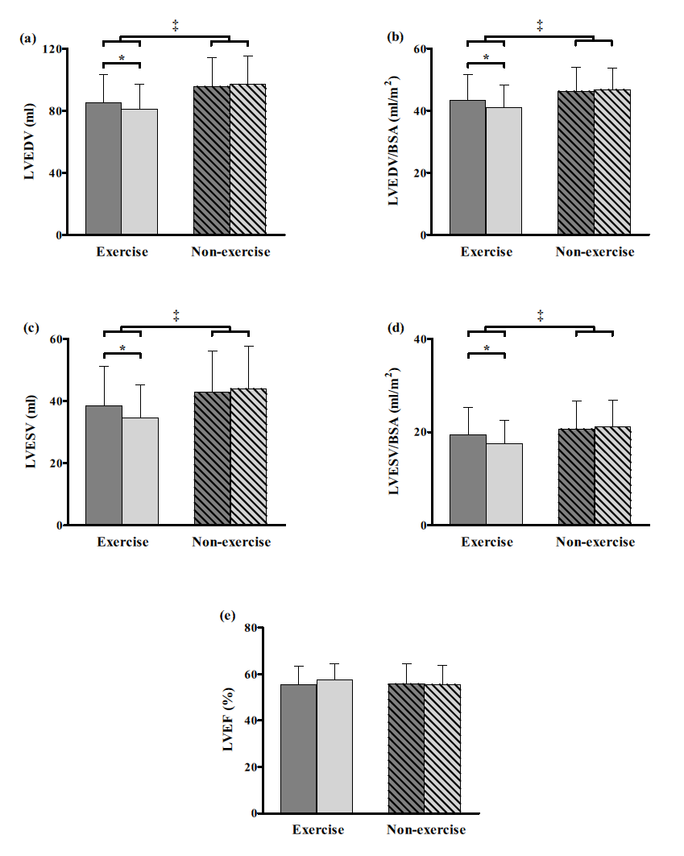
Figure 1.—Left ventricular (LV) volumetric parameters at baseline (dark grey bars) and at 10 weeks (light grey bars) in the exercise training group (solid bars) and non-exercise group (striped bars). A) LV end diastolic volume (mL); B) LV end diastolic volume/BSA (mL/cm²); C) LV end systolic volume (mL); d) LV end systolic volume/BSA (mL/cm²); E) LV ejection fraction (%). Data as mean±SD. ‡ P<0.05 group × time interaction effect (ANOVA), *P<0.001.

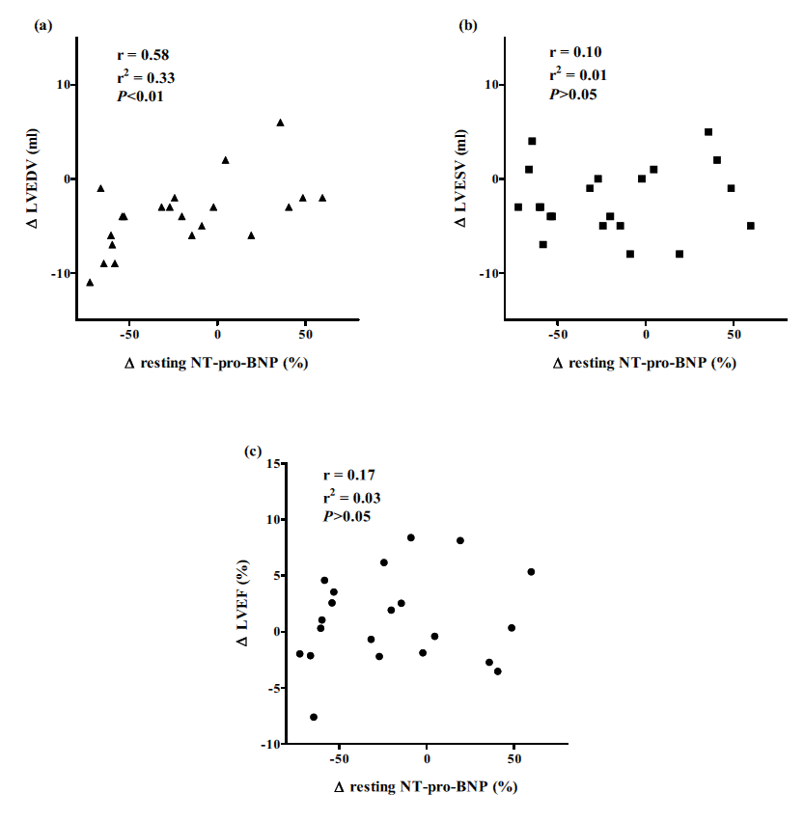
Figure 2.—Correlation between the relative change (∆) in NT-pro-BNP (%) and the absolute change (∆) in left ventricular (LV) (A) end diastolic volume (EDV) (mL), (B) end systolic volume (ESV) (ml) and (C) ejection fraction (EF) (%) in the exercise training group.

