**A DIGITAL PROCESS OPTIMIZATION, PROCESS DESIGN AND PROCESS INFORMATICS SYSTEM FOR HIGH ENERGY ABRASIVE MASS FINISHING**

Jamal, M1; Morgan, M N2 and D. Peavoy1

1 The manufacturing Technology Centre, Ansty, UK

2 GERI, Liverpool John Moores University, Liverpool, UK

E-mail: [1mikdam.jamal@the-mtc.org](mailto:1mikdam.jamal@the-mtc.org) ; [m.n.morgan@ljmu.ac.uk](mailto:m.n.morgan@ljmu.ac.uk)

**Abstract**

This research describes a new digital based system to improve the efficiency and to reduce costs of high energy abrasive mass finishing processes. The system is developed from a rigorous programme of theoretical analyses, technical experiments and industry validations. The system is able to predict the response of the process, in the context of component surface roughness and cycle time, due to employed input parameters: machining speeds, rotational velocities, immersion depth and abrasive media type. A graphical user interface (GUI) was designed using MATLAB and Python script to permit on-screen analyses and determination of system response under a wide range of parameters. The system converges to an optimised machining solution using optimisation methods and convergence theory. The output from the system associates optimised machining parameters with output criteria that may be a target surface roughness, a minimum cycle time or a production planning period. This facilitates use of the system as a cycle design tool, as production decision support or as a process cost model. The system is generic in design and with minor modification of input and output criteria, has potential application to many other processes and applications including for example, pharmaceutical, food processing, agriculture and automotive.

**Keywords:** Taguchi, ANOVA, Response Surface Methodology, Stream Finishing, Drag Finishing

**1 INTRODUCTION**

The optimisation of a machining process or of processes that have a wide range of variables is very challenging and is rarely achieved without extensive experimental and production testing and the knowledge contributions from process experts. It is also the case that optimised parameters are frequently overtaken by developments within the field. This results in inefficient production and a consequent higher cost per part. It is also deleterious in respect of environmental impact. There is no quick and easy method to achieve optimal machining and much research has been completed or is ongoing in this area. Importantly, there are very few methods, if any, able to inform the user that optimal conditions have in fact been achieved. It is generally the domain of the operator to advise the process planner or designer how parameters may be modified in an effort to improve productivity without increased risk to part quality. This situation, clearly unsatisfactory and not-sustainable, has been a key driver in the research of more advanced machining control system technologies / systems. Methods to deliver optimal machining are most commonly based on adaptive control (A/C) techniques. In such cases continual process monitoring is undertaken and machining parameters automatically modified when a target threshold is breached or approached. The most advanced A/C techniques may also be supported with intelligent systems that employ strategies to manage historical data in an efficient and intelligent manner. However, and similarly, strategies for optimisation and process control are prone to redundancy due to advances in the technology, by higher quality demands or by the more practical challenges met in attempting to introduce and implement an A/C system (operator reluctance, software engineering and others).

It was within this context that an ambitious programme of research was initiated to develop a process optimisation method for application in the fast emerging and increasingly important area of mass finishing process (MF) such as drag finishing and stream finishing. MF typically requires a large number of parameters to be set prior to cycle start.

Despite the widespread application of mass finishing processes, the fundamentals of this process have not yet been rigorously researched. The majority of publications on vibratory finishing come from an industrial source, the choice of values for the parameters are presently based on experience and expert knowledge and lack basic scientific standards.

There are no measurements available to inform the user of production parameters needed to achieve target criteria of surface roughness e.g. [1-3]. More articles have been published on empirical studies of applications of vibratory mass finishing process, which has led to some understanding about the influence of vibration amplitude, frequency, cycle time, and abrasive media on the metal removal rate and surface roughness [4-7]. However, most of them are not valid for generic vibratory finishing processes

The most significant generic findings are given by: [8, 9]; the authors state that the metal removal rate per unit time is constant and a function of velocity, bowl acceleration, workpiece material, and specific energy. A metal removal model combined with a model for the media movement for a centrifugal disk mass finishing process was developed by Cariapa et al [10]. Uhlmann et al [11] developed a model that combines machining process parameters and metal removal mechanisms validated with an empirical process model that can be used to predict surface roughness of material for given parameters. DEM simulation was also performed to investigate the contact between media and workpiece.

Up to now, no analysis of the drag and stream finishing process is available. A comprehensive process model is currently being developed by Barletta [12]. The experimental practice has allowed an increase in the knowledge of the modelling of fluidized bed assisted drag finishing. However, the comprehensive basic mechanism involved during MF process and a theoretical model concerning the surface roughness and metal removal are still missing. Barletta [13] established a comparative study of fluidized bed assisted drag finishing and centrifugal disc finishing. The results showed that the fluidized bed assisted drag finishing was more efficient than centrifugal disc finishing in both achievable surface roughness quality and reduced processing time.

To lessen such uncertainty in knowledge of efficiency, cost and in achievable quality, we have now developed a software tool that is able to predict cycle efficiency over a wide range of parameters and identify an optimal set of parameters one should employ to deliver any stated target criteria. This information can then readily be extrapolated to give production cost. Additionally, the system will also predict cost and efficiency when parameters are modified in any way and predict the consequence on achievable quality.

In this Paper, the core of the system reported is based on readily available and well-understood proprietary statistical and mathematical software packages. The tools used are ANOVA, The Taguchi experimental methodology and the Response surface methodology (RSM) coupled with a MATLAB - Graphical User Interface (GUI) code to develop a surface roughness prediction model of advanced mass finishing technology (drag and stream finishing processes) under various machining parameters conditions. This model can be used to estimate process parameters needed to achieve a desired roughness of a workpiece.

The usefulness of the system is not restricted to optimisation in the production context. It can also be used as design tool or as a production planning aid. As a design tool it can provide optimal parameter sets for materials new to the process or not in common use, and as a planning tool to plan production cycles to match related operations and to avoid misalignment of outputs with other processes, or to ensure maximum machine utilisation or indeed both. Further, it has potential to be of great benefit to machine tool ‘systems’ salespersons and production engineers in the field.

**2 PROCESS UNDER INVESTIGATION**

The latest development of mass finishing technologies of drag and stream finishing processes was investigated. The stream finishing machine is a completely new concept which features short processing times, easy automation and excellent reliability. It produces a good mirror finish even inside channels. In this process, the workpieces are held by special jig arrangements and then immersed in a high energy fast flowing and circulating grinding or polishing medium. The process times are tremendously short compared with traditional mass finishing process. For example in workpieces made of aluminium, the roughness of Ra 0.9 µm can be reduced to Ra 0.05 µm in minutes through a single step dry finishing process. The applications of stream finishing process are deburring, edge honing, the smoothing and polishing is 5-10 times faster than drag finishing process due to the generation of additional centrifugal forces**.**

In the drag finishing process workpieces are mounted on special holders. These are dragged in a circular motion at high speed through a container filled with grinding or polishing media. The circular motion creates high contact pressures between the workpieces and the media, producing good results in short time in the form of high-precision rounding of the edges or high finish in a quality that can otherwise only be obtained through hand polishing. The application of drag finishing process are deburring, edge honing, smoothing and polishing.

**3 EXPERIMENTAL DESIGN AND SETUP**

On-site experimental investigations were carried out at a partner company using drag and stream finishing OTEC machines as is shown in the experimental set-up Figure 1. Aerospace turbine blades were used in the experiments with average surface roughness values of 1.9 µm ($∓0.1µm)$. Liquid compound SC15 at a constant dosing rate of 3%, and plastic media KM10 were employed in the tests. All experiments were performed at a constant processing time of 20min. The machining parameters were selected as follows: The experimental tests that involve drag finishing were performed with variable spindle speed, $DSS$ within range $(10≤DSS≤80)$ rpm, the head speed, $DHS$ various within range $(10≤DHS≤60)$ rpm and the immersion depth $,ID$ various within range $(300≤DID≤380$) mm. In the case of stream finishing, the experimental tests were performed with high power head speed $SHS,$ which varies within the range $(40≤SHS≤1500)$ rpm, the bowl speed, *SBS* various within range $(20≤SBS≤60)$ rpm, and the immersion depth $,SID$ varies within range $(100≤SID≤300$) mm. Another important parameter that should be considered in the drag and stream finisher is the angled head of the workpiece. Due to the shape of the turbine blade, the angled head was selected to be zero in all tests using a special holding arrangement to ensure continuous flow of media on the workpiece surface during operation. The positions of workpieces in the stream finisher were selected to be the same for all experiments, 10 cm away from the bowl wall which provided the best media flow according to (OTEC 2013).

The surface roughness tests were carried out by tracing the surface using a Taylor Hobson surface instrument at several positions along the workpiece surface before and after finishing processes as is shown in Figure 2.

Three surface roughness measurements were performed on each workpiece material, the average of the group results are presented in this study. The process optimization system (POSY) of Taguchi, ANOVA, and Surface response methodologies were conducted to develop a mathematical model used to predict the surface roughness of an aerospace component. In general, POSY is based on planning, performing and evaluating results of matrix experiments to determine the performance levels of control parameters. Figure 3 illustrate a schema of the Process Optimization System.



Figure 1 Experimental set up a) Drag finishing process, b) Stream finishing process



Figure 2 Taylor Hobson surface roughness measurement of aerospace turbine blade



Figure 3 A schema of the Process Optimization System

**4 RESULTS AND DISCUSSIONS**

**4.1 Analysis of the signal-to-noise (S/N) ratio (Taguchi method)**

The S/N number represents the ratio between desirable and non-desirable values. The process parameter with the highest value causes the most significant effect on the optimization process. In this study, the Taguchi optimization process was selected for six degree of freedom, three factors and three levels. This methodology minimises experimental tests whilst delivering insightful qualitative results. The process parameters and their levels in drag and stream finishing processes were presented in Table 1, and Table 2, respectively.

The process variables and their levels were set up over a wide range of parameters in order to cover a comprehensive performance capability of the finishing processes. A set of experiments were conducted on drag and stream finishers using the L9 orthogonal array with nine experiments. Table 3, and Table 4 shows the DOE layout and results of drag and stream finishing processes, respectively. Due to different units within the process parameters, each factor need to be coded with three levels -1, 0, 1. The influence of interaction between variables is neglected in the Taguchi method. Regardless of the machining process characteristics, a greater S/N value is related to a better performance. Therefore, the optimal level of the machining parameters is responding to the greatest S/N value. Based on the S/N ratio analysis, the optimal drag finisher performance for better surface roughness was obtained at 80 rpm spindle speed (level 3), 10 rpm head speed (level 1) , and 380 mm immersion depth (level 3). While the optimal stream finisher performance was obtained at 60 rpm bowl speed (level 3), 1500 rpm head speed (level 3), and 300 mm immersion depth (level 3). Optimal finishing conditions for drag and stream finishing processes are shown in Table 5, and Table 6, respectively. Table 5 illustrates that the rank 1 indicates that spindle speed factor has the strongest effect on the finishing process followed by rank 2 the head speed, while rank 3, the immersion depth has the minimum effect on the process. Table 6 shows that the rank 1 indicates that the immersion depth factor has the strongest effect on the finishing process followed by rank 2 the head speed, whereas rank 3 the bowl speed has the minimum effect on the process.

Figure 4 shows the main effects plots for *S/N* ratio. The strongest influence of the factor on the finishing process is measured by differences values. The factor contributes with higher difference in the mean S/N ratio over the selected design control factor, the more significant impact. Optimal finishing conditions of design control factors of drag and stream finishing processes can be determined from the *S/N* response graphs in Figure 4 (a, and b) respectively. The lower the better S/N ratios was assigned to determine the influence of ($DSS$, $DHS,$ and $DID$) factors of drag finisher and also the effect of ($SHS$, $SBS,$ and $SID)$ factors of stream finisher on the surface roughness values of the turbine blades. As displayed, the spindle speed shows the higher slope of the S/N ratio, which identifies the significant impact on the finishing process. It is also noticed that the immersion depth has a remarkably significant effect on the stream finishing process.

However, the results demonstrated that the surface roughness decreases with the increasing drag spindle speed, and stream head speed. The S/N ratios for the other factors had less influenced between the three levels.

Table 1 Drag finishing process parameters and their levels

|  |  |  |  |
| --- | --- | --- | --- |
| Process parameter | Level 1 | Level 2 | Level 3 |
| Spindle speed (*DSS*) | 20 | 40 | 80 |
| Head speed ( $DHS)$ | 10 | 30 | 50 |
| Immersion depth ($DID$) | 300 | 340 | 380 |

Table 2 Stream finishing process parameters and their levels

|  |  |  |  |
| --- | --- | --- | --- |
| Process parameter | Level 1 | Level 2 | Level 3 |
| Bowl speed ($SBS$) | 20 | 40 | 60 |
| Head speed ( $SHS)$ | 500 | 1000 | 1500 |
| Immersion depth ($SID$) | 100 | 200 | 300 |

Table 3 DOE lay out and drag finishing results using Taguchi method

|  |  |  |  |  |  |
| --- | --- | --- | --- | --- | --- |
| No. | $$DSS$$ | $$DHS$$ | $$DID$$ | Ra | S/N |
| 1 | -1 | -1 | -1 | 1.69 | -4.558 |
| 2 | -1 | 0 | 0 | 1.12 | -0.984 |
| 3 | -1 | 1 | 1 | 0.6 | 4.437 |
| 4 | 0 | -1 | 0 | 1.75 | -4.861 |
| 5 | 0 | 0 | 1 | 1.22 | -1.727 |
| 6 | 0 | 1 | -1 | 0.65 | 3.742 |
| 7 | 1 | -1 | 1 | 1.71 | -4.660 |
| 8 | 1 | 0 | -1 | 1.48 | -3.405 |
| 9 | 1 | 1 | 0 | 0.84 | 1.514 |

Table 4 DOE lay out and stream finishing results using Taguchi method

|  |  |  |  |  |  |
| --- | --- | --- | --- | --- | --- |
| No. | $$DSS$$ | $$DHS$$ | $$DID$$ | Ra | S/N |
| 1 | -1 | -1 | -1 | 0.78 | 2.158 |
| 2 | -1 | 0 | 0 | 0.63 | 4.013 |
| 3 | -1 | 1 | 1 | 0.31 | 10.458 |
| 4 | 0 | -1 | 0 | 0.63 | 4.013 |
| 5 | 0 | 0 | 1 | 0.48 | 6.375 |
| 6 | 0 | 1 | -1 | 0.57 | 4.883 |
| 7 | 1 | -1 | 1 | 0.67 | 3.479 |
| 8 | 1 | 0 | -1 | 0.51 | 5.849 |
| 9 | 1 | 1 | 0 | 0.35 | 9.119 |

****Table 5 S/N Ratios for surface roughness using drag finisher

****Table 6 S/N Ratios for surface roughness using stream finisher



Figure 4 Effect of process parameters on surface roughness by a) Drag finisher, b) Stream finisher

**4.2 Development of Response Surface Model**

The statistical analysis using the Taguchi method presented in section (4.1) is an analysis only for the main factors that affect surface roughness without any consideration of correlation and interaction between control factors. Therefore, response surface methodology RSM was employed to predict the surface roughness of aerospace components in drag and stream finishing processes.

The essential data required for developing the RSM have been collected by design of experiments based on central composites design (CCD) arrangement. CCD is a second order polynomial design, which was introduced by Box and Wilson, and graphically can be represented as a cube consisting of factorial or fractional factorial design with axial and centre points. The CCD of the three-factor design includes 8- factorial points, 6- axial points, and 6- central points in the cube. In this study, the DOE system used for RSM consisted of 20 experiments of three factors with three levels each. Full replication was used to analyse and optimize the main effects and interaction of process parameters of drag and stream finishing techniques. The process factors and their levels in drag and stream finishing processes were presented in Table 1, and Table 2, respectively, the three level design of each coded factor given as -1, 0, 1. Table 7 and Table 9 shows the DOE layout and results of drag and stream finishing processes, respectively.

Based on three independent control factors and their levels, the statistical models were formalized into second order polynomial mathematical relationships (quadratic model) to explain the effect of parameters with interaction given by Equations (1), and (2) for drag and stream finishers, respectively. The models’ coefficients were obtained using a multiple regression analysis (MINITAB 17).

${ R}_{a}\left(DF\right)=0.85-3.83×{10}^{-2}DSS+7.4×{10}^{-3}DHS+1.09×{10}^{-2}DID+7.6×{10}^{-3}{\left(DSS\right)}^{2}-8×{10}^{-3}{\left(DHS\right)}^{2}-2.4×{10}^{-5}{\left(DID\right)}^{2}-9.7×{10}^{-5}\left(DSS\right)\left(DHS\right)+5×{10}^{-5}5\left(DSS\right)\left(DID\right)+1.4{×10}^{-5}\left(DHS\right)\left(DID\right)$ (1)

$R_{a}\left(SF\right)=0.726+1.03×{10}^{-3}SBS+4.65×{10}^{-4}SHS-1.14×{10}^{-3}SID-1.33×{10}^{-4}{\left(SBS\right)}^{2}+1.1×{10}^{-6}\left(SHS\right)\left(SBS\right)-1.2×{10}^{-6}\left(SHS\right)\left(SID\right)+3.11×{10}^{-6}\left(SBS\right)\left(SID\right)$ (2)

**4.3 Models: Accuracy and fitness analyses**

The analysis of variance (ANOVA) was applied to calculate the significance of the coefficients and suitability of models in determining the mathematical relationships between the response (surface roughness) and the machining parameters in the drag and stream finishing processes. Tables 8, and Table 10 show the ANOVA results for surface roughness obtained by the drag and stream finishing processes. In the case of the drag finishing process, the presented ANOVA result shows that the model F value was 86.94, which demonstrated it is significant. The significance was proved by the value of P $<$ 0.05 (i.e. $α=0.05, or 95\% confidence),$ this indicates that the model terms are significant. The significance of the first order parameters can be clearly observed DHS, DSS and DID in the quadratic model. The interactions between $(DSS \&DHS)$, $and \left(DSS\&DID\right)$ were also found to be significant. The insignificant terms of the second order parameters ${(DSS)}^{2}$, ${(DHS)}^{2}, and {(DID)}^{2}and$ interaction $\left(DHS\&DID\right)$ were eliminated (model reduction) to simplify and improve the surface roughness model.

The $R^{2}$ value of 98.43% is close to unity, which indicates a good agreement between the predicted model and actual experimental data. The adjusted $R^{2}$ value of 97.6% is close to the $R^{2}$ value, indicating the good fitness of the experimental data to the predicted quadratic model. The ANOVA shows that the adequate precession value was 23.35, which is greater than 4, and indicates the predicted model was significant. The lack to fit value of 0.094 represents an insignificant effect, which indicates the model fits with experimental data. However, the created model proposed a higher determination of $R^{2}$ value and adequate precision can be considered as significant in fitting and predicted responses, authorising usage of the model to predict the response values within the DOE space [14]. From previous analysis, removing the insignificant variables ${(DSS)}^{2}$, ${(DHS)}^{2},{(DID)}^{2}$, and $\left(DHS\&DID\right)$ gave the final mathematical model of the drag finishing process in terms of more significant factors given by Eq. (3).

$${ R}_{a}\left(DF\right)=0.85-3.83×{10}^{-2}DSS+7.4×{10}^{-3}DHS+1.09×{10}^{-2}DID-9.7×{10}^{-5}\left(DSS\right)\left(DHS\right)+5×{10}^{-5}5\left(DSS\right)\left(DID\right) (3)$$

The ANOVA stream finishing process is given in Table 10. The model F value of 17.43 suggests that the model is significant. The P value less than 0.05 implies the model terms are significant. In this case, SBS, SHS and SID, interaction between (SBS&SID), and interaction between (SHS&SID) are considered as significant model terms. These values represent sufficient variables from the model, and they can be used to predict the response values within the DOE space. The $R^{2}$ value of 94.63% is close to the adjusted $R^{2}$ of 92.12%. The lack to fit value of 0.071 represents an insignificant effect, which indicates the model fits with experimental data. The adequate precision value that measures the signal to noise ratio was 19.73. The determination of $R^{2}$ value and adequate precision measurement suggested the significance of the model in predicting and fitting the response, which allowed usage of the model to predict the surface roughness values within the DOE space. However, the final mathematical model of the stream finishing process in terms of significant factors after eliminating the insignificant factors is given by Eq. (4).

$$R_{a}\left(SF\right)=0.726+1.03×{10}^{-3}SBS+4.65×{10}^{-4}SHS-1.14×{10}^{-3}SID-1.2×{10}^{-6}\left(SHS\right)\left(SID\right)+3.11×{10}^{-6}\left(SBS\right)\left(SHS\right) (4)$$

**4.4 Models validation for statistical analysis**

The capability of models for statistical analyses has been investigated by the examination of residuals using normal probability plots and the plots of the residuals versus the predicted response. The residual is the measure of the differences between the experimental and predicted values of response. The statistical model is validated when the normal distribution keeps the mean value in zero. A Least square regression method was employed to determine the normality; the straight-line distribution indicates no abnormalities [15]. Figure 5 (a, and b) shows the normal probability plot of residual of surface roughness determined by drag and stream finishing processes. As displayed the residuals are distributed fairly close to a straight line suggesting that the errors are normally disseminated and the regression model fitted well with the experimental values, which indicates the models are effective.

On the other hand, the data point distributions in the plots of the residuals versus the predicted response should be of non-obvious pattern (less structure). Figure 6 (a, and b) shows the plot of residual against fitted surface roughness values of drag and stream finishing processes, respectively. As illustrated, they have no obvious pattern and rare structure. This suggests that the models proposed are adequate and there is no reason for independence or constant variance assumption [18].

Table 7 DOE lay out and results of drag finishing process using Response Surface method

|  |  |  |  |  |  |
| --- | --- | --- | --- | --- | --- |
| Exp. No. | $DHS$ $(rpm)$ | $DSS$ $(rpm)$ | $DID$ $(mm)$ | Ra (*μm*) | Residual |
| 1 | 1 | 1 | 1 | 1.69 | -0.006 |
| 2 | 2 | 1 | 1 | 1.99 | 0.049 |
| 3 | 1 | 3 | 1 | 0.66 | -0.013 |
| 4 | 3 | 3 | 1 | 0.84 | 0.067 |
| 5 | 1 | 1 | 3 | 1.26 | 0.037 |
| 6 | 3 | 1 | 3 | 1.71 | -0.003 |
| 7 | 1 | 3 | 3 | 0.6 | -0.030 |
| 8 | 3 | 3 | 3 | 0.72 | 0.016 |
| 9 | 1 | 2 | 2 | 1.12 | -0.059 |
| 10 | 3 | 2 | 2 | 1.48 | -0.039 |
| 11 | 2 | 1 | 2 | 1.75 | -0.077 |
| 12 | 2 | 3 | 2 | 0.65 | 0.040 |
| 13 | 2 | 2 | 1 | 1.31 | 0.037 |
| 14 | 2 | 2 | 3 | 1.22 | -0.032 |
| 15 | 2 | 2 | 2 | 1.31 | 0.017 |
| 16 | 2 | 2 | 2 | 1.3 | -0.023 |
| 17 | 2 | 2 | 2 | 1.34 | 0.033 |
| 18 | 2 | 2 | 2 | 1.36 | 0.042 |
| 19 | 2 | 2 | 2 | 1.32 | -0.073 |
| 20 | 2 | 2 | 2 | 1.39 | 0.019 |

Table 8 ANOVA for surface roughness obtained by drag finisher



Table 9 DOE lay out and results of stream finishing process using Response Surface method

|  |  |  |  |  |  |
| --- | --- | --- | --- | --- | --- |
| Exp. No. | $$DHS (rpm)$$ | $DSS$ $(rpm)$ | $DID$ $(mm)$ | Ra (*μm*) | Residual |
| 1 | 1 | 1 | 1 | 0.838 | 0.062 |
| 2 | 2 | 1 | 1 | 0.711 | 0.006 |
| 3 | 1 | 3 | 1 | 0.723 | -0.035 |
| 4 | 3 | 3 | 1 | 0.571 | 0.035 |
| 5 | 1 | 1 | 3 | 0.520 | -0.035 |
| 6 | 3 | 1 | 3 | 0.590 | 0.035 |
| 7 | 1 | 3 | 3 | 0.306 | 0.002 |
| 8 | 3 | 3 | 3 | 0.270 | -0.061 |
| 9 | 1 | 2 | 2 | 0.651 | 0.006 |
| 10 | 3 | 2 | 2 | 0.526 | -0.009 |
| 11 | 2 | 1 | 2 | 0.636 | -0.069 |
| 12 | 2 | 3 | 2 | 0.430 | 0.059 |
| 13 | 2 | 2 | 1 | 0.690 | 0.047 |
| 14 | 2 | 2 | 3 | 0.660 | 0.017 |
| 15 | 2 | 2 | 2 | 0.610 | -0.033 |
| 16 | 2 | 2 | 2 | 0.650 | 0.007 |
| 17 | 2 | 2 | 2 | 0.640 | -0.003 |
| 18 | 2 | 2 | 2 | 0.630 | -0.013 |
| 19 | 2 | 2 | 2 | 0.620 | -0.023 |
| 20 | 2 | 2 | 2 | 0.650 | 0.007 |

Table 10 ANOVA for surface roughness obtained by stream finisher



Figure 5 Normal probability of residuals plot for surface roughness determined by a) drag and b) stream finishing processes

Figure 6 Plot of residual against fitted surface roughness values determined for a) drag and b) stream finishing processes

**5 EFFECT OF FINISHING PARAMETERS ON RESPONSE**

The effect of drag and stream fishing parameters on the surface roughness was investigated using the mathematical models of Eq. (3) and Eq. (4) by means of response surface methodology. Figure 7 shows contours and 3-D surface roughness plots developed with various combinations of input drag finishing parameters a) DHS and DID, b) DSS and DID, and c) DSS and DHS. These response contours and surface plots can help in the prediction of the Ra at any region in the experimental domain. It is clearly noticed from the 3-D surface plot Figure 7 (a) that the surface roughness decreases with the decreasing head speed and increasing immersion depth. The counter plot illustrated that for a given value of spindle speed, better surface roughness of 0.9 to 1.0 µm can be achieved within range of input parameters, 10-15 rpm head speed and 300-380 mm immersion depth. Referring to Figure 7 (b) the 3-D surface plot shows that the surface roughness decreases with the increasing spindle speed and head speed has no significant effect. The counter plot analysis for a given immersion depth demonstrated that lower surface roughness of 0.8 to 1.0 µm was attained within a range of 65-80 rpm spindle speed and 10-50 rpm head speed. The analysis of the 3-D surface plot shown in Figure 7 (c) suggested that the surface roughness decreases with the increasing spindle speed but no significant effect has been observed in the immersion depth. However, for holding head speed value of 30 rpm, the contour plot illustrated that range of 0.8 -1.0 µm surface roughness was achieved through various input parameters within, 70-80 rpm spindle speed and 300-380 mm immersion depth.

Figure 8 shows the contour and 3-D surface roughness plots developed with various combinations of stream finishing parameters a) SHS and SID, b) SBS and SID, and c) SBS and SHS. The 3-D surface plot shown in Figure 8 (a) suggested that the surface roughness decreases with the increasing head speed and immersion depth. The counter plot displayed the range of input parameters for a given bowl speed, 1200-1500 rpm head speed and 220-300 immersion depth were anticipated for enhanced response of Ra $<$ 0.4µm. The 3-D surface plot shown in Figure 8 (b) illustrated that the surface roughness decreases with increasing bowl speed and immersion depth for a given head speed value of 1000. It is clearly shown that the surface roughness can be enhanced to minimum values of 0.5 to 0.6 µm using immersion depth of 250 to 300 mm and bowl speed has no significant effect. The analysis of the 3-D surface plot shown in Figure 8 (c) suggested that for a given immersion depth of 200 mm, surface roughness decreases with the increasing bowl speed and spindle speed. The counter plot analysis confirmed that a very small range of input parameters can satisfy the minimum surface roughness values of 0.45 to 0.55 µm. on the other hand, the Ra value significantly changes when the bowl speed decreases and becomes worst with head speed range of 500 to 1000 rpm.

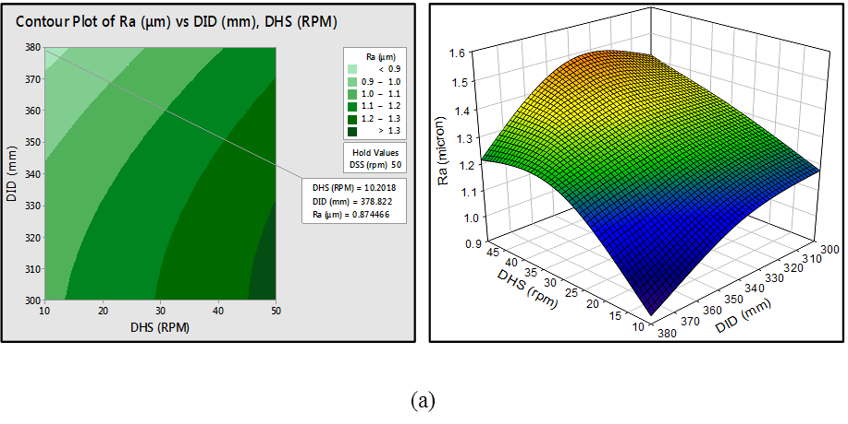

(a)

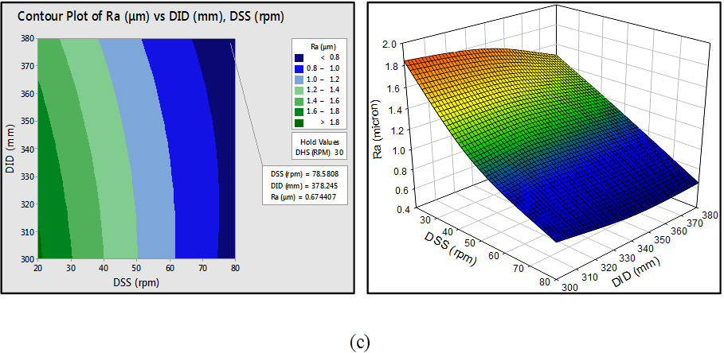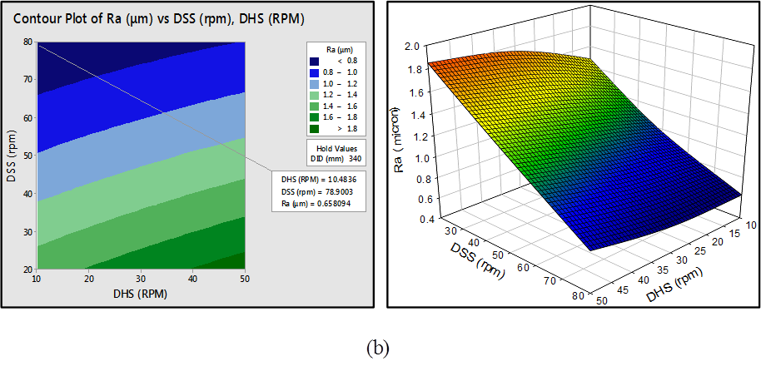

(c)

Figure 7 Contour and 3-D surface roughness plots developed with various combinations of drag finishing parameters a) DHS and DID, b) DSS and DID, and c) DSS and DHS.

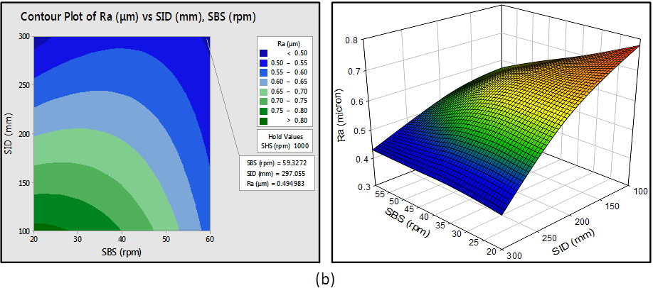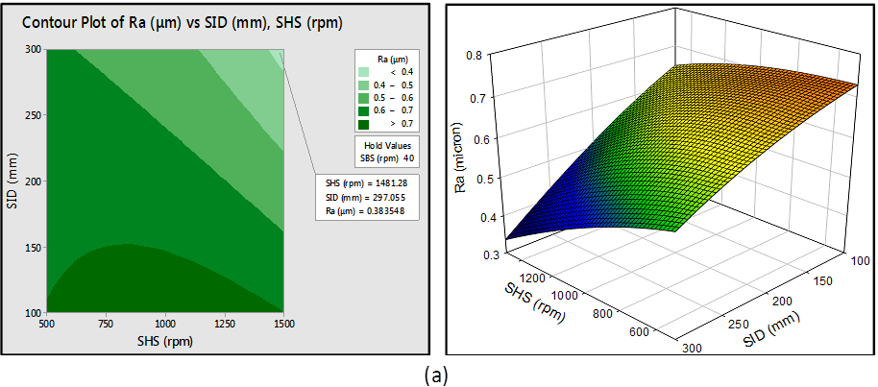

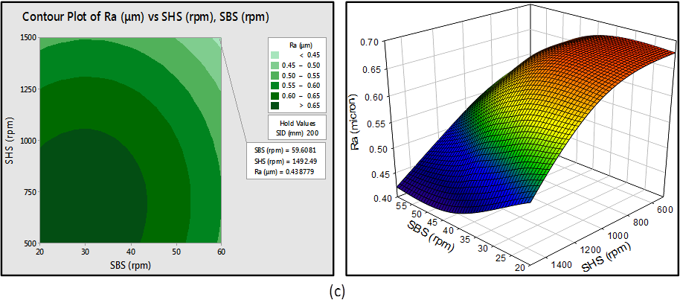

Figure 8 Contour and 3-D surface roughness plots developed with various combinations of stream finishing parameters a) SHS and SID, b) SBS and SID, and c) SBS and SHS

**6 INTERACTION BETWEEN FACTORS**

Figures 9 and Figure 10 show the interaction factor plots relative to the surface roughness using the drag and stream finishing processes, respectively. The interactions plot represents a plot of means for each level of a factor with the level of a second factor kept constant. The importance of the interaction plot is on the understanding of the relation between each factor of interaction (Minitab 17). This interaction plot is in balanced design when the uses of two types of factor are identical. Interaction is present when the response at a factor level depends on the levels of other factors. Parallel lines in an interactions plot indicate no interaction. The greater the deviation of the lines from the parallel condition, the higher the degree of interaction state. In this study, the quality control is surface roughness Ra, thus the smaller the better response was investigated throughout interaction factors analyses.

Figure 9 shows the drag finishing interaction plot between factors of DHS, DSS, and DID relative to surface roughness. The ANOVA demonstrated that interaction between (DHS & DSS), and (DSS & DID) were the most significant 2-way interaction factors. In the first case, surface roughness at minimum mean value of 0.62 µm, the head speed needs to be 10 rpm, and the spindle speed is 80 rpm. In the second case, surface roughness can be enhanced to minimum mean value of 0.66 µm throughout 80-rpm spindle speed and 380 mm immersion depth. However, the result of interaction in both cases agrees well with the Taguchi analysis in Table 5 and surface response methodology in Table 8, with regard to the significant factor with the highest impact on response. The interaction factors DHS & DID have no significant effect on the finishing process response.

Figure 10 shows the stream finishing interaction plot between factors of SBS, SHS, and SID relative to surface roughness. When these parameters were examined, the ANOVA suggested that the interaction between (SBS & SID) and (SHS & SID) were the most significant 2-way interaction factors. The first interaction result plot has been observed at the Ra value of 0.42 µm when the bowl speed is 60 rpm and the immersion depth is 300 mm. The second group was observed at the Ra value of 0.35 µm given by head speed of 1500 rpm, and immersion depth of 300 mm. The interaction factors agree well with the Taguchi and response surface methodology presented in Table 6, and Table 10, respectively.

However, the stream finishing interaction plot suggested that the (SHS&SID) was the most significant interaction factor on the finishing process. The remaining interaction factors SBS and SHS have no significant effect on the process response.



Figure 9 Drag finishing interaction plot for surface roughness



Figure 10 Stream finishing interaction plot for surface roughness

**7 RESPONSE SURFACE OPTIMIZATION**

The most important aims of experiments related to the mass finishing process is to achieve the desired surface roughness by the optimal finishing parameters. The response surface optimization is a perfect method for characterising the best process parameters of the mass finishing operation. In this study, the goal from process optimization is to minimise surface roughness within the design requirement. However, this response should be accurately controlled to avoid major problems such as over-finishing of the workpiece surface. The larger the better desirability was used for the calculated surface roughness. The desirability measure is how well a combination of factors can satisfy the response target. Desirability measurement has a range of zero to one. One represents the ideal predicted response. Zero indicates that the response is outside the acceptable limit.

Figure 11 shows response surface optimization results of drag finishing parameters. Optimum parameter levels were identified at larger desirability numbers as follows: DHS of 10 rpm, DSS of 80 rpm, DID of 380 mm. The optimized surface roughness parameter was 0.561µm with a desirability number of 1, which indicates that the set parameters achieved the favourable result of response.

Figure 12 show response surface optimization results of stream finishing parameters. Optimal setting parameter levels were identified as follows: SBS of 20 rpm, SHS of 1500 rpm, DID of 300 mm. The optimized surface roughness parameter was 0.3 µm with a desirability number of 0.93. The desirability result verified that the set variables achieved the desired response.



Figure 11 Drag finishing process optimization tool



Figure 12 Stream finishing process optimization tool

**8 CONFIRMATION TEST**

The plots of predicted values using the reduction model (Eq. 3, and Eq. 4) against the actual values of surface roughness were displayed in Figure 13 for the drag and stream finishing processes. The data points falls close to the diagonal line, which indicates a good agreement between predicted values and the actual data points. However, in order to validate the accuracy of the proposed model, a confirmation test was established. The test conditions for the confirmation trials were also selected within the range of levels defined by the DOE array. An aerospace turbine blade was employed in the confirmation tests with average surface roughness values of 1.9 µm ($∓0.1µm)$. Combinations of finishing parameters were chosen randomly for the experimental trials, and the responses obtained were compared with those calculated by the developed models. Table 11, and Table 12 show three confirmation trials were performed by the drag and stream finishing processes, respectively. The error percentage is within the allowable limits. Thus, the proposed models can be used to successfully predict the surface roughness values of any combination of drag and stream finishing parameters within the range of the experimentation performed.

Figure 13 Comparison of predicted with actual values of surface roughness using drag and stream finishing process

Table 11Confirmation tests of drag finishing process

|  |  |  |  |  |  |  |  |
| --- | --- | --- | --- | --- | --- | --- | --- |
| Exp.No. | DHS  (rpm) | DSS  (rpm) | DID  (mm) | Actual Ra (μm) | Predicted Ra (μm) | Residual | Error  (%) |
| 1  2  3 | 50  25  40 | 70  30  50 | 320  340  300 | 1.01  1.51  1.23 | 0.95  1.46  1.27 | 0.06  0.05  0.04 | 6.32  3.42  3.25 |

|  |  |  |  |  |  |  |  |
| --- | --- | --- | --- | --- | --- | --- | --- |
| Exp.No. | SBS  (rpm) | SHS  (rpm) | SID  (mm) | Actual Ra (μm) | Predicted Ra (μm) | Residual | Error  (%) |
| 1  2  3 | 30  50  40 | 650  900  1200 | 150  200  300 | 0.81  0.68  0.44 | 0.75  0.64  0.48 | 0.06  0.03  0.04 | 8  6.25  9.1 |

Table12 Confirmation tests of stream finishing process

**9 SENSITIVITY ANALYSIS**

Sensitivity analysis is one the most important assessments in the optimization process because it provides information about the increases or decreases tendencies of the optimization function with the design parameters. This method categorizes the significant parameters and ranks them by their order of importance [17]. The sensitivity analysis of a design optimization model can be stated by a mathematical model of a partial derivative of the response with respect to its variables. The sensitivity analyses were carried out to differentiate response surface optimization models developed by means of drag finishing parameters of interest Eq.(1) and stream finishing parameters Eq.(2). Sensitivity models given by Eq. (5), Eq. (6), and Eq. (7) represents the sensitivity of surface roughness determined by the drag finishing process with respect to head speed (DHS), spindle speed (DSS), and immersion depth (DID), respectively. Similarly, the sensitivity models given by Eq. (8), Eq. (9) and Eq. (10) represent the sensitivity of surface roughness determined by the stream finishing process by means of bowl speed (SBS), head speed (SHS), and immersion depth (SID), respectively.

$$\frac{∂R_{a}\left(DF\right)}{∂DSS}=-3.83×{10}^{-2}+15.2×{10}^{-3}\left(DSS\right)-9.7×{10}^{-5}\left(DHS\right)+5×{10}^{-5}5\left(DID\right) \left(5\right)$$

$$\frac{∂R_{a}\left(DF\right)}{∂DHS}=7.4×{10}^{-3}-16×{10}^{-3}(DHS)-9.7×{10}^{-5}\left(DSS\right)+1.4{×10}^{-5}\left(DID\right) (6)$$

$$\frac{∂R_{a}\left(DF\right)}{∂DID}=1.09×{10}^{-2}-4.8×{10}^{-5}\left(DID\right)+5×{10}^{-5}5\left(DSS\right)+1.4{×10}^{-5}\left(DHS\right) (7)$$

$$\frac{∂R_{a}\left(SF\right)}{∂SBS}=1.03×{10}^{-3}-2.7×{10}^{-4}\left(SBS\right)+1.1×{10}^{-6}\left(SHS\right)+3.1{×10}^{-6}\left(SID\right) \left(8\right)$$

$$\frac{∂R_{a}\left(SF\right)}{∂SHS}=4.65×{10}^{-4}-1.3×{10}^{-6}(SHS)+1.1×{10}^{-6}\left(SBS\right)-1.2×{10}^{-6}\left(SID\right) (9)$$

$$\frac{∂R_{a}\left(SF\right)}{∂SID}=-1.14×{10}^{-3}-1.2×{10}^{-6}\left(SHS\right)+3.11×{10}^{-6}\left(SBS\right) \left(10\right)$$

The sensitivity study was aimed to predict the tendency of surface roughness due to change in drag and stream finishing parameters. The calculated sensitivity of surface roughness with respect to DSS, DHS, and DID in Eqs (5), (6), and (7), was shown in Figure 14 (a, b, and c) respectively. The results of DSS sensitivity indicates that as the spindle speed increases, surface roughness decreases 14 (a), whereas the DHS sensitivity demonstrated that as the DHS increases, surface roughness increases Figure 14 (b). The immersion depth has no significant effect on the surface roughness sensitivity Figure 14 (c). These results reveal that the surface roughness is more sensitive to DSS and DHS than DID. Generally, the sensitivity values of DSS are higher than DHS and DID. Thus, the DSS affects surface roughness more strongly than DHS, and DID.

The sensitivity analysis of the stream finishing process determined by Eqs. (8), Eq. (9), and Eq. (10), was shown in Figure 15 (a, b, and c) respectively. It is clearly noticed that all parameters follow the same trend of surface roughness decreasing with the increases of SBS, SHS and SID. However, the rate of influence on the surface roughness changed with various parameters. Sensitivity values of head speed shows the most important effect on the surface roughness followed by immersion depth, the bowl speed has ranked the lowest influence on the response.

(a) (b)

(c)

Figure 14 Sensitivity analysis results of drag finishing parameters of a) spindle speed, b) head speed, and c) immersion depth

(a) (b)

(c)

Figure 15 Sensitivity analysis results of stream finishing parameters of a) head speed, b) bowl speed, and c) immersion depth.

**9 CONCLUSION**

In this study, the experimental investigation with statistical analysis to determine the effect of DSS, DHS and DID in the drag finishing process, and also the effect of SBS, SHS, and SID in the stream finishing process on the surface roughness values of aerospace components has been established using the principles of Taguchi, ANOVA, and Response surface methods. Taguchi analysis is responsible for investigating the rank and the level of factors that have a significant effect on the response. The best fit between the developed models and the experimental data were further evaluated through ANOVA, F-statistical and P-value tests to determine whether the factors are significantly related to the response. The interaction plots were also used to compare the effects across the control factors when changes in response between levels of one factor are not the same as the changes in response at the same levels of a second factor. The proposed methods predict surface roughness to within 95% confidence level. Sensitivity analysis has been investigated to determine the efficiency of processing parameters on the optimization models developed by statistical regression analysis. The following conclusions are established:

* Taguchi statistical analysis of the drag finishing process suggested that the optimal control factors which minimize the surface roughness were DSS (level 3), DHS (level 1), and DID (level 3). The DSS had the greatest effect and its contribution was 89%, followed by the DHS and its contribution was 7.2 % and the DID had a lower effect, its contribution was 3.8 % on quality characteristics. The stream finishing process proposed that the optimal control factors were SBS (level 3), SHS (level 3), and SID (level 3) which contribute to minimizing the surface roughness by 52.8 %, 40.3 %, and 6.9 %, respectively.
* The significant factors and the rank of variables were examined and there is a good agreement between the observations.
* 3D surface and counter plots are useful tools in determining the optimum parameters condition for specific values of surface roughness at any region in the experimental domain. The plots also illustrated that the Ra decreases with increasing DSS and DID, and Ra increases with increasing DHS. In the case of the stream finishing process, Ra decreases with increasing control factors (SHS, SBS, and SID).
* Confirmation experiments suggested that the predicted quadratic models were successful in predicting surface roughness in the drag and stream finishing process within 6 %, and 9 % error, respectively.
* The interaction investigation of the drag finishing process demonstrated that the (DHS & DSS), and (DSS & DID) had the most significant effect on response, while (SBS & SID) and (SHS & SID) had the most significant effect in the stream finishing process.
* The ANOVA results with the confirmation trials have proved that the quadratic mathematical models of the process variables were fit and predicted the recorded experimental value with a 95% confidence interval.
* The optimization tool was employed to determine the design surface roughness with high desirability at various process conditions. The results obtained from this tool were in good agreement with the verification trials.
* The sensitivity analyses of the drag finishing process showed that the DSS affects surface roughness more strongly than DHS, and DID. Sensitivity values of SHS show the most important effect on the surface roughness followed by SID; the SBS factor has the lowest effect on the surface roughness.
* RSM has the potential for more complicated sensitivity analysis and may be used for optimal parameter determination of various mathematical models.

Finally, this study demonstrated that the proposed methods can be successfully applied for optimizing surface roughness of the advanced mass finishing process at an industrial scale and that it is an economical way of obtaining the maximum amount of information in a short period of time and with the lowest number of experiments.

**Acknowledgements**

This research work was completed with the aid of government and industry support under the ‘Innovate UK [TSB]’ project: Ref. 101275. The authors express their thanks to the industrial partners: Vibraglaz (UK) Ltd, Potters-Ballotini Ltd, Finishing Techniques Ltd, the Manufacturing Technology Centre, Glass Technology Services Ltd and Rolls-Royce plc, for their valued cooperation.

**References**

[1] Hashimoto, F. and D. DeBra (1996). "Modelling and optimization of vibratory finishing process." CIRP Annals-Manufacturing Technology **45**(1): 303-306.

[2] Arvin, J. (2002). The effect of chemically accelerated vibratory finishing on gear metrology, AGMA.

[3] Davidson, D. A. (2008). "Vibratory finishing: Versatile, effective, and reliable." Metal Finishing **106**(5): 30-34.

[4] Matsunaga, M. (1967). "Theory and experiments on centrifugal barrel finishing." The International Journal of Production Research **5**(4): 275-287.

[5] Wang, S., R. Timsit and J. Spelt (2000). "Experimental investigation of vibratory finishing of aluminum." Wear **243**(1): 147-156.

[6] Takahashi, Y., M. Kataoka, M. Uekusa and Y. Terumichi (2005). "Behavior of three kinds of particles in rotary barrel with planetary rotation." Multibody System Dynamics **13**(2): 195-209.

[7] Sangid, M. D., J. A. Stori and P. M. Ferriera (2011). "Process characterization of vibrostrengthening and application to fatigue enhancement of aluminum aerospace components—part I. Experimental study of process parameters." The International Journal of Advanced Manufacturing Technology **53**(5-8): 545-560.

[8] Domblesky, J., V. Cariapa and R. Evans (2003). "Investigation of vibratory bowl finishing." International journal of production research 41(16): 3943-3953.

[9] Domblesky, J., R. Evans and V. Cariapa (2004). "Material removal model for vibratory finishing." International journal of production research 42(5): 1029-1041.

[10] Cariapa, V., H. Park, J. Kim, C. Cheng and A. Evaristo (2008). "Development of a metal removal model using spherical ceramic media in a centrifugal disk mass finishing machine." The International Journal of Advanced Manufacturing Technology **39**(1-2): 92-106.

[11] Uhlmann, E., A. Dethlefs and A. Eulitz (2014). "Investigation of material removal and surface topography formation in vibratory finishing." Procedia CIRP **14**: 25-30.

[12] Barletta, M., A. Gisario, S. Venettacci and G. Rubino (2014). "A comparative evaluation of fluidized bed assisted drag finishing and centrifugal disk dry finishing." Engineering Science and Technology, an International Journal **17**(2): 63-72.

[13] Barletta, M., G. Rubino and P. Valentini (2014). "Experimental investigation and modeling of fluidized bed assisted drag finishing according to the theory of localization of plastic deformation and energy absorption." The International Journal of Advanced Manufacturing Technology: 1-16.

[14] Gopalakannan, S. and T. Senthilvelan (2013). "Application of response surface method on machining of Al–SiC nano-composites." Measurement **46**(8): 2705-2715.

[15] Khan, M., L. Romoli, M. Fiaschi, G. Dini and F. Sarri (2012). "Multiresponse optimization of laser welding of stainless steels in a constrained fillet joint configuration using RSM." The International Journal of Advanced Manufacturing Technology **62**(5-8): 587-603.

[16] Phadke, M. S. (1995). Quality engineering using robust design, Prentice Hall PTR.

[17] Sarıgül, A. and A. Secgin (2004). "A study on the applications of the acoustic design sensitivity analysis of vibrating bodies." Applied acoustics **65**(11): 1037-1056.

[18] Suresh, P., P. V. Rao and S. Deshmukh (2002). "A genetic algorithmic approach for optimization of surface roughness prediction model." International Journal of Machine Tools and Manufacture **42**(6): 675-680.

[19] Taguchi, G. and S. Konishi "Taguchi methods, orthogonal arrays and linear graphs, tools for quality engineering, 1987." Dearborn, Mich: American Supplier Institute.