Supporting information:
Starch-Chitosan Polyplexes: A Versatile Carrier System for Anti-Infectives and Gene Delivery
Hanzey Yasar ^{1,2,†}, Duy-Khiet Ho ^{1,2,†}, Chiara De Rossi ¹, Jennifer Herrmann ¹, Sarah Gordon ¹, Brigitta Loretz ^{1,}* and Claus-Michael Lehr ^{1,2}
¹ Helmholtz Institute for Pharmaceutical Research Saarland (HIPS), Helmholtz Center for Infection Research (HZI), Saarland University, D-66123 Saarbrücken, Germany
² Department of Pharmacy, Saarland University, D-66123 Saarbrücken, Germany
† These authors contributed equally to this work.

Abbreviations
CP – core polyplexes, anCP – anionic core polyplexes, cationic CP (or catCP) – cationic core polyplexes, cCP – coated polyplexes
Table S1. Summary of starch-chitosan CP characteristics obtained by varying polymer types, polymer concentration, and C/N molar ratio. N > 3, n = 3, mean ± SD.
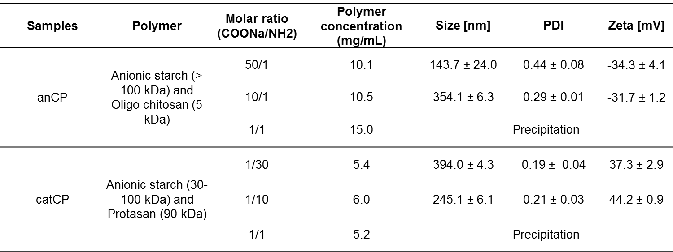
The anCP with C/N ratio 50/1 became precipitated after 3 days (data not shown) due to the low concentration of chitosan which might not be enough for the complexation and the resulted high polydispersity index under storage conditions (4 ºC). The catCP, in turn, could be formed with C/N ratio 1/30. However, the particles size had increasing tendency which is similar with that of catCP formed by C/N ratio 1/10 (data shown in Figure S1) and became precipitated after 5 days (data not shown). The observation would be explained by the adhesive nature of chitosan, and typical property of non-crosslinked polymeric polyplex system. Hence, the C/N ratio 10/1 and 1/10 were used to further experiment to produce anCP and catCP respectively.

Table S2. Summary of starch-chitosan CP characterization with optimal C/N ratio varied by change of polymer concentration. N > 3, n = 3, mean ± SD
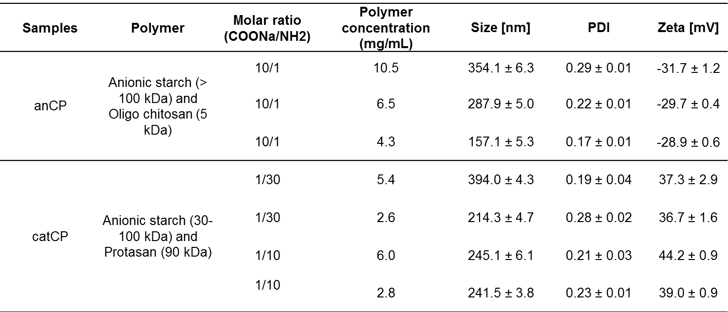

Table S3. Summary of anionic CP (anCP) and Protasan coated anCP (cCP) characteristics, in which anCP was produced with parameters, namely C/N ratio 10/1, and polymer concentration at 6.5 mg/mL. N > 3, n = 3, mean ± SD
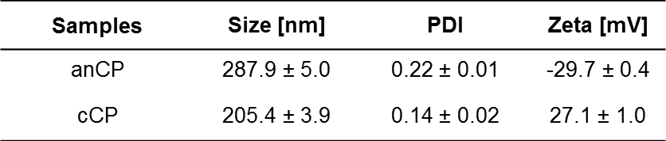

Figure S1. Physicochemical stability of starch-chitosan CP, in which anCP was produced with C/N ratio 10/1, and catCP was produced with C/N ratio 1/10, upon storage (4 ºC). The particles were diluted into MilliQ water at each time point for the measurement of size, PDI and ζ-potential. N = 3, n = 3, mean ± SD

Figure S2. Physicochemical stability of starch-chitosan anCP and cCP at different pH values ranging from 3.5 to 8.0, after 30 min and 1 h incubation. The initial pH- value of the samples was 5.5. N = 3, n = 3, mean ± SD

Table S4. Summary of tobramycin-loaded anCP characteristics achieved by variation of C/N ratio and polymer concentration. N > 3, n = 3, mean ± SD
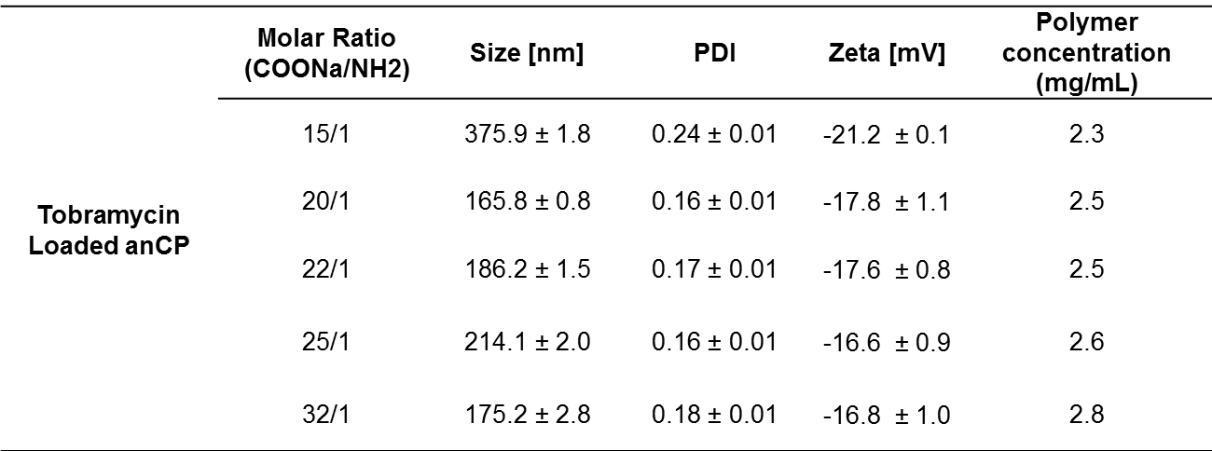
Table S5. Summary of colistin-loaded anCP characteristics resulting from variation of polymer concentration. N > 3, n = 3, mean ± SD
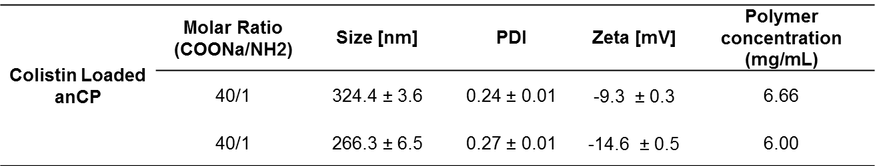
Table S6. Summary of drug loading quantification of tobramycin-loaded anCP. N > 3, n = 3, mean ± SD
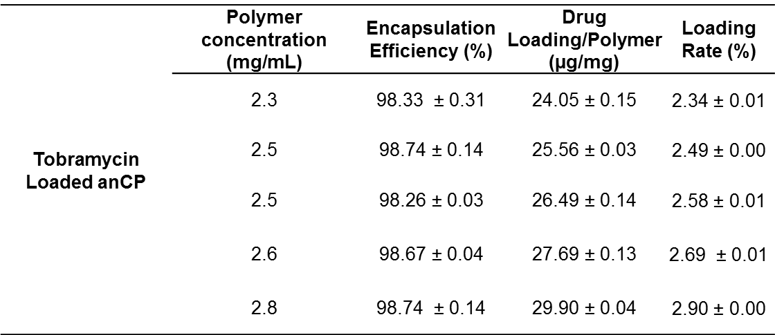
Table S7. Summary of drug loading quantification of colistin-loaded anCP. N > 3, n = 3, mean ± SD
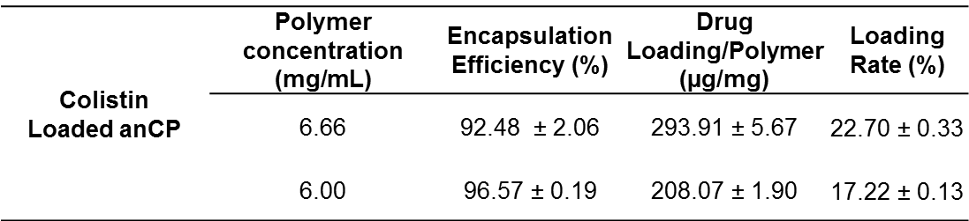

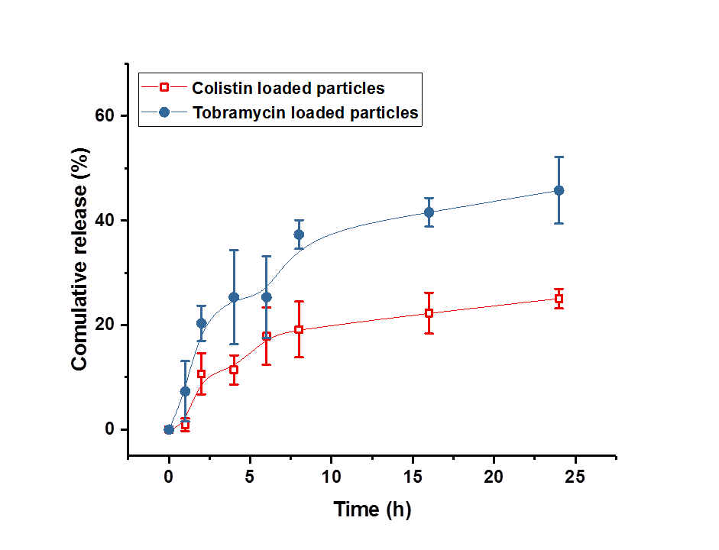
Figure S3. Cumulative release of tobramycin from tobramycin loaded anCP, and colistin from colistin loaded anCP performed in PBS at 37 °C. N = 3, n = 3, mean ± SD

