PHYSICAL ACTIVITY RECOGNITION AND MONITORING FOR HEALTHCARE IN INTERNET OF THINGS ENVIRONMENT

JUN QI

A thesis submitted in partial fulfilment of the requirements of Liverpool John Moores University for the degree of Doctor of Philosophy

October 2018

List of Contents

List of Contents 2
List of Figures 6
List of Tables 10
Acknowledgements 11
Abstract 12
List of Abbreviations 14
Chapter 1. Introduction 16
1.1 background 17
1.2 Objectives and Research Aim 20
1.3 Thesis Outline 22
1.4 Research contributions 23
1.5 List of publications 24
1.6 Summary 25
Chapter 2. Literature review 28
2.1 Introduction 28
2.2 Sensing layer 30
2.2.1 On-body sensors 30
2.2.2 On-object sensors 34
2.3 Network layer 35
2.3.1 Bluetooth 36
2.3.2 Zigbee 36
2.3.3 Near field communication (NFC) 36
2.3.4 Wireless local area networking (Wi-Fi) 37
2.3.5 Cellular 37
2.4 Processing layer 38
2.4.1 Data pre-processing 38
2.4.2 Feature extraction 40
2.4.3 Classification and clustering 44
2.4.4 Discussion 49
2.5 Application layer 50
2.5.1 Mobile fitness tracking 51
2.5.2 Ambient assisted living 52
2.5.3 Remote health monitoring 53
2.5.4 Diagnosis and rehabilitation 53
2.5.5 Emergency system 54
2.6 Summary 66
Chapter 3. Daily Physical activity recognition and monitoring using mobile phone 67
3.1 Introduction 67
3.2 Classification techniques 68
3.2.1 Decision tree classifier 68
3.2.2 Artificial neural network 71
3.2.3 Support vector machine 73
3.2.4 Random forest 75
3.2.5 K-nearest neighbours 76
3.2.6 Naïve Bayes classifier 77
3.3 Daily physical activity recognition using mobile phone 78
3.3.1 Data collection with mobile app 78
3.3.2 Feature extraction 80
3.3.3 Physical activity classification 80
3.4 Summary 87
Chapter 4. Gym physical activity recognition and measurement using wearable sensors 89
4.1 Introduction 89
4.2 Background of GPA recognition 92
4.3 Data collection 93
4.4 Data processing 98
4.4.1 Pre-processing 98
4.4.2 Feature extraction and selection 98
4.4.3 Data processing with standalone machine learning approaches 99
4.4.4 Proposed Framework 104
4.5 Experimental Evaluation 109
4.5.1 GPA preliminary classification 109
4.5.2 GPA fine-grained classification 110
4.5.3 GPA measurements 111
4.6 Summary 120
Chapter 5. Lifelogging PA data with irregular uncertainties 121
5.1 Introduction 121
5.2 Classification of data uncertainty in IoT healthcare systems 124
5.3 Deal with irregular uncertainties with Ellipse fitting model 125
5.3.1 Ellipse fitting model for removing irregular uncertainties 125
5.3.2 Performance Evaluation of Ellipse Fitting model 128
5.4 Discussion and summary 139
Chapter 6. Lifelogging physical activity monitoring with regular uncertainties 140
6.1 Introduction 140
6.2 Proposed lifelogging PA intensity decision making model 141
6.3 Density map visualization for RU determination 142
6.3.1 Feature extraction 143
6.3.2 Distance measure 144
6.4 Handling RU with DST decision making model 145
6.4.1 Dempster-Shafer theory of evidence (DST) 146
6.4.2 Mass function definition in density map 148
6.4.3 Evidence combination of density maps 149
6.4.4 Decision making rules 149
6.4.5 Case study 150
6.4.6 Lifelogging PA intensity pattern comparisons 157
6.4.7 Comparison of PA intensity pattern with mobile devices 158
6.4.8 Density maps dissimilarity evaluation from mobile phone 159
6.4.9 Density maps dissimilarity evaluation from wearable device 161
6.4.10 PA Intensity pattern comparisons with two devices 163
6.5 Discussion and summary 164
Chapter 7. Conclusion and future prospects 165
7.1. Conclusion 165
7.2 Limitations 167
7.3 Future prospects 167
7.3.1 Cost effective and non-obtrusive wearable sensing 168
7.3.2 Sensing interoperability 168
7.3.3 Effective data validation in healthcare 169
7.3.4 Free living environment 169
7.3.5 Life-logging PARM 170
7.3.6 High volume of data 170
7.3.7 Security and privacy 170
7.3.8 Low-cost device 171
7.3.9 Physical activity types 171
References 173

List of Figures

Figure 1- 1 Architecture of the research project 20
Figure 2- 1 Number of Journal and Conference articles related to IoT and PARM from 2000 to 2018 29
Figure 2- 2 Time window segmentation (a) fix-sized non-overlapping; (b) dynamic-sized non-overlapping; (c) fix-sized overlapping; (d) dynamic-sized overlapping 39
Figure 3- 1 Wireless sensor network in PARM 68
Figure 3- 2 Procedure of processing PARM 69
Figure 3- 3 Example of a general decision tree 69
Figure 3- 4 Binary decision tree for PAR 70
Figure 3- 5 Feedforward network 72
Figure 3- 6 Model of an artificial neuron 73
Figure 3- 7 Linear and non-linear SVM (a) liner SVM; (b) non-linear SVM 74
Figure 3- 8 A model of RF 75
Figure 3- 9 A model of kNN 77
Figure 3- 10 The android app for sensor data collection (a) Home page with all sensors; (b) real-time accelerometer data; (c) saving accelerometer data to the phone’s internal storage 79
Figure 3- 11 Raw sensor signals collected from mobile device 79
Figure 3- 12 Classification results using RF 82
Figure 3- 13 Classification error with number of grown trees in RF 83
Figure 3- 14 Confusion matrix of ANN in PAR 83
Figure 3- 15 ROC-based ANN 84
Figure 3- 16 Classification result of kNN 84
Figure 3- 17 Classification results of conventional classifiers 87
Figure 4- 1 Manual records (a manual recording with notebook and mobile app) 91
Figure 4- 2 A subject performs free weight activities with ECG attached 94
Figure 4- 3 Raw tri-axial accelerometer data of free weight activities on the wrist (a) Non-free-weight PA accelerometer signals of wrist; (b) Strength accelerometer signals of wrist; (c) Cardio accelerometer signals of waist; (d) Strength accelerometer signals of waist. 97
Figure 4- 4 Three sets of standing curl 99
Figure 4- 5 Classification results with learning algorithms (a) classification results with decision tree; (b) classification results with SVM; (c) classification results with ANN 101
Figure 4- 6 Results of different time window overlapping, filter and features using ANN (a) ANN with filter, 50% overlap, and all features; (b) ANN with filter, 80% overlap, and all features; (c) ANN with 50% overlap, time and frequency domain features and no filter; (d) ANN with 50% overlap, time features and no filter. 103
Figure 4- 7 Flow chart of GPARMF 104
Figure 4- 8 Proposed gym physical activity recognition approach 105
Figure 4- 9 HMM structure in GPARMF 108
Figure 4- 10 Distribution of features of distance of peaks (pink), mean (green) and variance (red) from tri-axial accelerometers of GPAs 109
Figure 4- 11 Distribution of free weight and non-free weight activities using OC-SVM 110
Figure 4- 12 Comparison of accuracy of four recognizers in non-free weight activities with only wrist accelerometer 111
Figure 4- 13 One set of a free weight activity repetition calculates (a) deadlift numbers; (b) squat numbers; (c) bench press numbers 113
Figure 4- 14 Semantic model of free weight exercise in Protégé 5.2 114
Figure 4- 15 Free weight intensity measurement using SWRL rules in Protégé 5.2 115
Figure 4- 16 Heartrate per minute using ECG (a) finding R-R intervals; (b) two sets of a free weight activity with low intensity (8-12RM) in blue line, medium intensity (6-8 RM) in red line, high intensity (4-6 RM) in green line and extremely high intensity (2-4 RM) in purple line. 120
Figure 5- 1 Concept of IoT personalized healthcare systems 125
Figure 5- 2 Distribution of PA with IU and RU 126
Figure 5- 3 Ellipse fitting distribution of daily steps and speed of four subjects, respectively (c=0.95) (a) subject no.1; (b) subject no. 2; (c) subject no.5; (d) subject no.12 131
Figure 5- 4 Ellipse fitting distribution of daily steps and speed of selected subjects (c=0.95) (a) group 1 (subjects no.1 & no.2 & no.3); (b) group 2 (subjects no.4& no.5 & no.6); (c) all subjects. 133
Figure 5- 5 Different central coordinate of ellipse fitting (green: geometric mean; red: arithmetic mean) 134
Figure 5- 6 1D fitting results (a) Smoothing Spine fitting; (b) Gaussian fitting 135
Figure 5- 7 The function of time period duration (a) Average of daily steps as the function of time period duration; (b) DAPS as the function of time period duration 138
Figure 6- 1 Flowchart of proposed approach 142
Figure 6- 2 An example of PA density map from the mobile device’s dataset 144
Figure 6- 3 An example of histogram distribution for the density map 144
Figure 6- 4 Euclidean distance measures dissimiliary of density map with RU for four subjects of five months dataset from the mobile device 145
Figure 6- 5 Lattice model of DST for personal lifelogging PA pattern decision 146
Figure 6- 6 Histogram distribution with the threshold setting 147
Figure 6- 7 Intervals of Belief (Bel) and Plausibility (Pls) of DPA and SPA 150
Figure 6- 8 Case study #1 Ellipse fitting model for IU removal of the subject’s Moves dataset (c= 0.98) 151
Figure 6- 9 Case study #1 (a) Density maps of four consecutive months’ datasets from Moves; (b) Euclidean distance measures dissimiliary of the density maps in (a) displaying RU; (c) histogram distribution of four month. 153
Figure 6- 10 Case study #2 (a) Ellipse fitting model for IU removal of the subject’s Moves dataset (c= 0.95); (b) density maps of two inconsecutive months’ datasets from Moves; (c) histogram distribution of the density maps in (b). 156
Figure 6- 11 The typical adult pattern of daily activities [percentage of a 24-h day] when categorised in terms of intensity level assessed using accelerometer counts. About 31% [7.5 h] is sleep, 39% [9.4 h] is spent in sedentary activities [sitting], 27% [6.5 h] in [202]. 158
Figure 6- 12 Lifelogging pattern determination with mobile datasets (a) Ellipse fitting model for IU removal of consecutive four months’ of the subject’s Moves dataset (c= 0.98) (b) Density maps of four consecutive months’ datasets (c) histogram and texture features dissimilarity for four consecutive months’ datasets 161
Figure 6- 13 Lifelogging pattern determination with wearable device datasets (a) Ellipse fitting model for IU removal of consecutive four months’ of the subject’s Moves dataset (c= 0.98) (b) Density maps of consecutive four months’ datasets (c) histogram and texture features dissimilarity for four consecutive months’ datasets 162
Figure 6- 14 Four subjects’ density map dissimilarities comparison of five months using mobile phone from histogram and texture features 163
Figure 6- 15 Four subjects’ density map dissimilarities comparison of five months using wearable device from histogram and texture features 163

List of Tables
Table 1- 1 IoT-based layers and descriptions for PARM 18
Table 1- 2 Physical activity categories and examples 21
Table 2- 1 Physical activity categories and examples 29
Table 2- 2 Sensor categories, examples and descriptions 33
Table 2- 3 Network protocols used in PARM 36
Table 2- 4 Comparison of popular wireless radio communication technologies in PARM 37
Table 2- 5 Feature extraction category and extracted features 40
Table 2- 6 Studies of PARM based on IoT structure 58
Table 4- 1 Typical GPA categories 94
Table 4- 2 Feature extraction category and extracted features for fine grained classifications 98
Table 4- 3 GPA concept, properties and instances 114
Table 4- 4 Classification results in GPARMF 117
Table 4- 5 Comparison of precision (P), recall (R) and F-measure (FM) of different classifiers in free weight training recognition 117
Table 5- 1 Pros and Cons of existing life-logging PA measure devices 123
Table 5- 2 Values of four individuals (m, n, $Ty$, $Ts$) 131
Table 5- 3 Values of the three groups (a, b, $Ty$, $Ts$) 132
Table 5- 4 Removing IU 136
Table 6- 1 PA intensity levels standard [200] 142
Table 6- 2 Dempster’s rule of combination 149
Table 6- 3 The subject’s known SPA durations and their ratio per month 153
Table 6- 4 Pixel numbers for density maps of four months 154
Table 6- 5 Evidence fusion for Jul. and Aug. 154

Acknowledgements
First of all, I would like to express my sincere gratitude to my supervisors, Dr. Po Yang, Dr. Martin Hanneghan, and Dr. Stephen Tang for their useful suggestions, comments and encouragement. I am deeply grateful for their help in the completion of this thesis. Particularly, I would like to thank Dr. Po Yang for not only providing me advice and guidance on research throughout the whole three years but also motiving me to achieve a variety of research approaches. I also wish to thank Dr. Martin Hanneghan and Dr. Stephen Tang for their constructive comments on our papers and this thesis.
Second, I sincerely appreciate my friends and my classmates for their assistance in sharing their comments and suggestions on addressing my research problems, as well as to all research students’ support and friendship. Also the gratefulness to other staff in the Department of Computer Science, the Research Graduate School of Faculty of Engineering and Technology, and the University Research Office.
Last but not least; my gratitude also extends to my parents. They have been my strongest backup when I was frustrated. It is with their support, caring and encouragement that I can finish my PhD journey today.

Abstract
Due to importantly beneficial effects on physical and mental health and strong association with many rehabilitation programs, Physical Activity Recognition and Monitoring (PARM) has been considered as a key paradigm for smart healthcare. The emergence of the Internet of Things (IoT) enabling technology is transferring PARM studies to open and connected uncontrolled environments by connecting heterogeneous cost-effective wearable devices and mobile apps. Little is currently known about whether traditional PARM technologies can tackle the new challenges of IoT environments and how to effectively harness and improve these technologies. Two new challenges exist in the current IoT technologies PARM field. 1) Traditional lifelogging PA measures require relatively high cost and can only be conducted in controlled or semi-controlled environment, though they enjoy remarkable precision of lifelogging PA monitoring outcomes. Recent advancements in commercial wearable devices and smartphones for recording one’s lifelogging PA enable a popularized and uncontrolled environment possible. However, due to diverse life patterns and heterogeneity of connected devices as well as the PA recognition accuracy, lifelogging PA data measured by wearable devices and mobile phone contains much uncertainty so that they are hardly ever adopted for healthcare studies. 2) Traditional PA recognition techniques focus on repeated aerobic exercises or stationary PA. As a crucial indicator in human health, it covers a range of bodily movement from aerobics to anaerobic that may all bring health benefits. However, existing PA recognition approaches are mostly designed for specific scenarios like hospital or smart homes and often lack extensibility for application in other areas, thereby limiting their usefulness.
In an effort to tackle the two issues of PARM by using IoT technologies in PARM, this thesis has two main contributions 1) in order to improve the feasibility of the PA tracking datasets from commercial wearable devices, we propose a lifelogging PA intensity pattern decision making approach for life long PA measures. The approach has significantly reduced the uncertainties and incompleteness of datasets from the third party devices. The results indicate that the proposed approach can improve the effectiveness of PA tracking devices or apps for various types of people who frequently use them as a healthcare indicator. 2) More physical activities are detected in addition to traditional PA using acceleration in the gym scenario. A two layer recognition framework is proposed that can classify aerobic, sedentary and free weight activities, count repetitions and sets for the free weight exercises, and in the meantime, measure quantities of repetitions and sets for free weight activities. The results indicate the proposed framework has better performance in recognizing and measuring GPAs than other approaches. The potential of this framework can be extended in supporting more types of PA recognition in complex applications.

List of Abbreviations

IoT Internet of Things
SH Smart Home
PA Physical Activity
AR Activity Recognition
PAR Physical Activity Recognition
PAM Physical Activity Monitoring
ACC Accelerometer
NN Neural Network
DT Decision Tree
MEMS Microelectromechanical
GPS Global Positioning System
OWL Web Ontology Language
ADL Activity of Daily Lives
AAL Ambient Assisted Living
DTC Decision Tree Classifier
NB Naïve Bayes
SVM Support Vector Machine
KNN k-Nearest Neighbours
DTW Dynamic Time Wrapping
GMM Gaussian Mixture Model
SWRL Semantic Web Rule Language
ANN Artificial Neural Network
RF Random Forest
OC-SVM One Class Support Vector Machine
SVDD Support Vector Domain Description
ECG Electrocardiogram
LVQ Learning Vector Quantization
HMM Hidden Markov Model
GPA Gym Physical Activity
GPARMF Gym Physical Activity Recognition and Monitoring Framework
PCA Principal Component Analysis
IU Irregular Uncertainties
RU Regular Uncertainties
DST Dempster–Shafer theory
DPA Dynamic Physical Activity
SPA Sedentary Physical Activity
DAPS Daily Activity in Physical Space

Chapter 1. Introduction

Regarding the survey conducted by the World Health Organization (WHO), physical inactivity has been identified as the fourth leading risk factor for global mortality causing an estimated 3.2 million deaths globally. Low levels of physical activity (PA) are detrimental to the health and functioning of older persons [1], and cause many chronic diseases [2], [3], such as diabetes, obesity, cancers, etc. Effective long-term observation of PA has significance in promoting diagnosis and treatment of these chronic diseases, and rendering assistance services such as falls detection for older people [4]–[8] and functional loss prevention in many rehabilitation programs [5], [9]–[12]. Also, the applications of recognizing and monitoring PA also promote a healthier lifestyle for the elderly people and potentially provide substantial reduction in healthcare costs. For example, patients with arthritis, obesity, or fatty liver usually need non-pharmic treatments such as exercise adjustment or social activities (e.g., walking, running, cycling or playing ball games), and thereby the activity record would better help caregivers adapting and managing therapy success. Likewise, patients with chronic disease such as skeleton joints diseases or heart disease are required to take physical tests (e.g., climbing stairs test, 6 minutes walking test) periodically to assess their symptoms, and subsequently to be recommended with non-pharmic or pharmic pathways by caregivers or clinical decision support systems. Apart from the normal activity, monitoring abnormal activities also play a key role in healthcare. Falls are the largest cause of emergency hospital admissions for older people, and delaying treatment and care would significantly influence long-term outcomes. Other abnormal activities such as going to the toilet too many times at night can predict some disease like bladder inflammation or diabetes.
Hence, due to the above importantly beneficial effects, numerous studies over the last few decades have focused on the research of delivering accurate and robust physical activity recognition and monitoring (PARM) solutions for clinical use. Recently, the ever increasing technological advances in Internet of Things techniques have enabled PARM as a key paradigm in many fields including smart health [13], smart rehabilitation [14], [15] and ambient assisted living (AAL) [16], [17].

Background
Traditionally, PARM studies most focus on the discovery of PA pattern or subjects, accurate recognition of PA itself and system robustness of monitoring PA in controlled environment, like clinics or labs. The achievement of these tasks is based on either designing standalone novel wearable sensors to achieve highly accurate recognition of human movements, or investigating advance machine learning algorithms for training features from observed wearable sensory data of human body positions into several specific activity types. Also, some researchers investigate how to attach wearable sensors into the most suitable positions for optimal accuracy or utilize body area network for energy-efficient PA monitoring. While these conventionally state-of-the-art PARM technologies enable achieving PARM for recognition of 10-20 activity types with accuracy ranging up to 100%, one major challenge limiting their usefulness and efficiency in practical cases nowadays is that the emergence of Internet of Things (IoT) enabling technology is transferring PARM studies from traditional hubs of healthcare to personalized, open and connective uncontrolled healthcare environments. (An uncontrolled environment refers to completely out of lab and natural settings, and a controlled environment is that data are collected and evaluated at the lab setting.) This trend leads to a number of key obstacles on adoption and utilization of existing PARM studies for delivering holistic, mobile, energy-efficient PARM solutions that provide accurate state detection and monitoring with moderate complex implementation in an IoT environment. For instance, how to estimate and measure uncertainties of PA with varied human life patterns; how to maintain recognition accuracy of PA with moderate use of low-cost wearable devices; etc. In this aspect, little is known about whether traditional PARM solutions can tackle these new obstacles, and how to harness and improve their utilization in the IoT environments.
In an effect to understand the advance of PARM studies in the uncontrolled environment, this project aims to infer the user’s PA with the lowest energy and the highest accuracy by using smart phones and wearable devices/sensors. It also attempts to address the uncertainties and, one step further, to improve the efficiency of low-cost wearable and mobile devices for one’s PA intensity pattern in a long range effort. Meanwhile, this research project is targeting on investigating PARM algorithms that suit wearable and mobile devices.
Table 1- 1 IoT-based layers and descriptions for PARM
Layers | Description
Sensing layer | The layer detects and collects signals from a variety of sensors on human body or in environment.
Network layer | The layer is responsible for transferring signal data from sensing layer to analysis layer over wired, wireless sensor or actuator networks.
Processing layer | The layer processes and analyses raw signals, and classifies/clusters into different PA types.
Application layer | The layer provides applications that interact with users.

The concept of the Internet of Things (IoT) encompasses a set of technologies that enable a wide range of devices and objects to connect, communicate and interact using networking technologies. Initially, Radio Frequency Identification (RFID) technology is considered as a fundamental solution to implement IoT based systems. In the last few years, advances in sensing technologies have promoted more cost-effective wearable devices connecting in an IoT environment. Hence, the concept of IoT based personalized healthcare systems is established and becoming increasing popular. These systems use a set of interconnected devices to create an IoT network devoted to healthcare assessment, including patients and automatically detecting situations. Four IoT-based layers are involved in PARM system structure, as shown in Figure 1-1 and Table 1-1. The general system collects personalized health information from different wearable sensing devices through a middleware that provides interoperability and security needed in the context of the IoT for healthcare. These wearable devices are capable of recording multiple type health data, including weight, sleep, heart rate, blood pressure and user-context information. Among this data, as a result of the technical and functional maturity of microelectromechanical (MEMS) accelerometer technology and global positioning system (GPS), PA is mostly well-observed. Utilizing these IoT assets to monitor and access some low level type of PA has become popular and approachable for normal users. Wired or wireless networks (e.g., Bluetooth, Wi-Fi or ZigBee) are normally adopted in the network layer. As the raw data usually contain redundant information that needs to be filtered, they are processed in the analysis layer sub-categorized into four phases from pre-processing up to activity type classification/clustering. Data pre-processing is to clean data and reduce dimensions, which are subsequently divided into equal or non-equal time windows for the specific recognition. Key signal features using time-domain, frequency-domain or other techniques are collected in the feature extraction phase in order to provide more useful and robust representation. The activity classification/clustering step eventually categorizes these features into different basic PA types. Combination with user context information (e.g., user’s location, object’s state) will infer high-level daily activities like eating, cooking or dressing listed in the table 1. The application layer provides a user interface to interact with users such as ordinary people, patients or caregivers to present PARM results and treatments.

Figure 1- 1 Architecture of the research project

Objectives and Research Aim
This research project is divided into two main parts as shown in Figure 1-1: PARM investigation and lifelogging PA pattern decision making. The raw sensor data is collected by wearable devices/sensors, in which the accelerometer is the main sensor for the purpose of reducing computational load. Three parts are coming in the PARM approach: time segmentation, feature extraction and machine learning algorithms. The results often contain many uncertainties such as erroneous PA recognition types, durations, which significantly impact the PA evaluation for the healthcare usage. Due to the limitation of the research system and numbers of subjects, customer wearable/mobile devices/apps (e.g., Fitbit [18], Moves [19]) are adopted for lifelogging PA evaluation in our work. To better take advantage of PA monitors for the healthcare applications and studies, we exploit evidential theory to handle the uncertainties of the decision making.
- Aims
The project is aiming to accurately recognize three categories of PA listed in Table 1-2 using raw sensor signals from Shimmer sensors and mobile device sensors. And then use parameters of third party devices (e.g., steps, distances, activity classification, etc.), investigating energy-efficient offline lifelogging PA uncertainties. Two parts of the research will only take advantage of a small number of low-cost and easy-to-use wearable devices and mobile devices, from low-level data acquisition up to high-level data integration using data-driven and knowledge-based approaches.
Table 1- 2 Physical activity categories and examples
Categories | Examples
Aerobic PA | Walking, running, ascending, cycling
Non-aerobic PA | Lifting, curling
Sedentary PA | Sitting, lying, standing

- Objectives
The project aims at investigating the accurate recognition of different types of physical activity. In order to research this, this project will provide a number of objectives defined as follows:
- Investigate and develop a PARM model using wearable sensors and mobile devices
- Identify PA types and subjects of PA.
- Investigate data processing approaches to recognise PA types.
- Construct machine learning model that is able to classify repetitive PA and time sequence changing PA.
- Analyse, evaluate and compare existing approaches to construct an offline PA model to achieve high recognition accuracy.
- Investigate and handle uncertainty of lifelogging PA data from third party mobile devices/apps.
- Identify uncertainty types.
- Handle uncertainties in wrapped data from third party devices for PARM model construction.
- Implement the model and evaluate in case study.

Thesis Outline
In order to achieve the research aim and objectives of the project, we have four coherent chapters containing main contributions to the project. These include daily PA recognition with mobile phone (Chapter 3), Aerobic PA and non-aerobic PA recognition and intensity measurement with Shimmer sensors (Chapter 4), handling irregular uncertainties of lifelogging PA data with third party devices/apps (Chapter 5), handling regular uncertainties of lifelogging PA data with third party devices/apps (Chapter 6). The outline of the thesis is as follows:
Chapter 2 provides a literature review and introduces the basic approaches for human physical activity recognition and monitoring from the IoT’s perspective, where it analyses the main techniques in wearable and ambient sensing, network protocols, data-based and knowledge-driven algorithms and gives some existing PARM applications.
Chapter 3 introduces PARM methodologies and applies 10 daily PA in some traditional machine learning approaches. The performance of each classifier is compared and concludes which is the best one.
Chapter 4 a hybrid hierarchical framework is proposed for gym PA recognition including 19 aerobic and non-aerobic activities. The results are compared with typical traditional standalone machine learning approaches, showing the proposed framework gives a better performance and is more extensible and scalable than traditional classifiers.
Chapter 5 presents an Ellipse fitting model to handle lifelogging PA data with irregular uncertainties from third party devices (i.e., mobile app or wrist band). With the 10 months data collection from a mobile personalized healthcare platform MHA [20], the proposed model is capable to cover more scattered data than other 1D fitting models with 95% to 99% confidence interval.
Chapter 6 gives a density map, DST to visualise and handle lifelogging data with regular uncertainties using the same datasets from MHA. The approach has significantly reduced the regular uncertainties and incompleteness of datasets from third party devices. Some case studies are carried out. The results indicate that the proposed approach can improve the effectiveness of PA tracking devices or apps for various types of people who frequently use them as a healthcare indicator.
Finally, chapter 7 presents the summary of the thesis and provides some potential further research trends. Conclusions are also drawn in chapter 7.

Research contributions
This thesis has three contributions:
- It is the first work to give a systematic review, critically examining PARM studies from a typical IoT layer-based perspective through summarising the state-of-the-art in traditional PARM methodologies as used in the healthcare domain, including sensory, feature extraction, recognition techniques and application environment.
- A novel two-layer sensor fusion based PA recognition framework GPARMF is proposed for effectively recognizing and classifying free weight and non-free weight GPA, where a NN model is for aerobic and sedentary PA recognition; a HMM is to provide a further classification in free weight PA. Intensities of free weight exercises are measured through counting repetitions and sets with normalized threshold. The results show that the proposed framework has better performance in recognizing and measuring GPAs than other standalone approaches.
- It identifies IU and RU of lifelogging data from third party devices in an IoT environment, projects the distribution of IU by defining a walking speed related score named DAPS and presents an Ellipse-fitting model-based validity improvement method for reducing IU of life-logging PA measures. Then it constructs a series of monthly based hour-day density map images for representing PA intensity patterns with RU in each month and explores DST fusion information from density map images for generating a decision making model of a final personal lifelogging PA intensity pattern. The results indicate that the proposed approach can improve the effectiveness of PA tracking devices or apps for various types of people who frequently use them as a healthcare indicator.

List of publications
During the PhD period, 8 papers have been published which include 5 journals with good impact factor and 3 conferences both in internet of things and bioengineering fields including IEEE Internet of Things Journal (IF: 5.76), Neurocomputing (IF: 3.3), Pervasive and Mobile Computing (IF: 2.95) and IEEE EMBC’18, etc. where the paper “Multiple density maps information fusion for effectively assessing intensity pattern of lifelogging physical activity." is ESI (Essential Science Indicators) highly cited paper ranked in the top 1% in computer science in 2017-2018.
Journals:
[1] Jun Qi, Po Yang, Atif Waraich. “Examining Sensor-based Physical Activity Recognition and Monitoring for Healthcare Using Internet of Things: A Systematic Review.” Journal of biomedical informatics. 2018.
[2] Jun Qi, Po Yang, Martin Hanneghan, Stephen Tang and Bo Zhou. “A Hierarchical Framework for Gym Physical Activity Recognition and Measurement Using Wearable Sensors.” IEEE Internet of Things Journal. Early Access.
[3] Jun Qi, Po Yang, Geyong Min, Oliver Amft, Feng Dong, and Lida Xu. "Advanced internet of things for personalised healthcare systems: A survey." Pervasive and Mobile Computing 41 (2017): 132-149.
[4] Jun Qi, Po Yang, Martin Hanneghan, Dina Fan, Zhikun Deng, and Feng Dong. "Ellipse fitting model for improving the effectiveness of life-logging physical activity measures in an Internet of Things environment." IET Networks 5, no. 5 (2016): 107-113.
[5] Jun Qi, Po Yang, Martin Hanneghan, and Stephen Tang. "Multiple density maps information fusion for effectively assessing intensity pattern of lifelogging physical activity." Neurocomputing 220 (2017): 199-209.
Conferences:
[1] Jun Qi, Po Yang, Martin Hanneghan, Atif Waraich and Stephen Tang “A Hybrid Hierarchical Framework for Free Weight Exercise Recognition and Intensity Measurement with Accelerometer and ECG Data Fusion.” IEEE engineering in medicine and biology society annual conference 2018 (EMBC’18). pp. 3800-3804. IEEE, 2018.
[2] Jun Qi, Po Yang, Martin Hanneghan, Kieran Latham, and Stephen Tang. "Uncertainty Investigation for Personalised Lifelogging Physical Activity Intensity Pattern Assessment with Mobile Devices." In Internet of Things (iThings) and IEEE Green Computing and Communications (GreenCom) and IEEE Cyber, Physical and Social Computing (CPSCom) and IEEE Smart Data (SmartData), 2017 IEEE International Conference on, pp. 871-876. IEEE, 2017.
[3] Jun Qi, Po Yang, Dina Fan, and Zhikun Deng. "A survey of physical activity monitoring and assessment using internet of things technology." In Computer and Information Technology; Ubiquitous Computing and Communications; Dependable, Autonomic and Secure Computing; Pervasive Intelligence and Computing (CIT/IUCC/DASC/PICOM), 2015 IEEE International Conference on, pp. 2353-2358. IEEE, 2015.

Summary
Actively performing physical activity brings importantly beneficial effects to humans’ mental and physical healthcare and has strong association with many rehabilitation programs, thus PARM has been considered as a key paradigm for smart healthcare with hundreds and thousands of related research papers. However, two main issues still exist in most of the work. Firstly, a majority of PA recognition and monitoring approaches lack extensibility and scalability. The workflow of these studies is very much identified by following steps from data collection, feature selections to algorithms training. But due to the diversity and complexity of daily activities, there has been some trade-off between recognition accuracy and types of activities. PA approaches designing for certain cases have limited extension and scalability in supporting more types of activities in other cases. It lacks some general framework that can potentially integrate existing PAR into an extendable and scalable framework with less effort in supporting more activities and different applications. Secondly, traditional methods for PARM focus on controlled environments with the aim of increasing types of identifiable activity subjects and improving recognition accuracy and system robustness by means of novel body-worn sensors or advance learning algorithms, accurate recognition of PA itself and system robustness of monitoring PA in controlled environments, like clinics or labs. The achievement of these tasks is based on either designing standalone novel wearable sensors to achieve highly accurate recognition of human movements, or investigating advance machine learning algorithms for training features from observed wearable sensory data of human body positions into several specific activity types. Also, some researchers investigate how to attach wearable sensors into the most suitable positions for optimal accuracy or utilize body area network for energy-efficient PA monitoring. While these conventionally state-of-the-art PARM technologies enable achieving PARM for recognition of 10-20 activity types with accuracy ranging up to 100%, one major challenge limiting their usefulness and efficiency in practical cases nowadays is that the emergence of technology is transferring PARM studies from traditional hubs of healthcare to personalised, open and connective uncontrolled healthcare environments. For instance, how to estimate and measure uncertainties of PA with varied human life patterns; how to maintain recognition accuracy of PA with moderate use of low-cost wearable devices; etc. In this aspect, little is known about whether traditional PARM solutions can tackle these new obstacles, and how to harness and improve their utilization in the uncontrolled environments.
In this thesis, we attempt to tackle the two issues above by designing a hybrid hierarchical framework aiming at re-constructing two main specific-sensor based PA methods into an effective hybrid solution for general weight exercise applications. We address the important beneficial effects of free weight exercises by establishing a hybrid hierarchical free weight recognition and measurement framework that identifies sets and repetition counts using acceleration and electrocardiogram (ECG) information. Differing from previous PA recognition work, the proposed framework may offer extensibility and scalability to integrate more PA types from simple PA (i.e., repetitive movements: walking or running) to complex PA (time-series-based changing PA: anaerobic exercises or playing ball games). With the comparison with other traditional physical activity recognition approaches, our novel two-layer sensor fusion based framework is proposed for effectively recognising and classifying free weight exercises, and one step further, the intensity of free weight is also measured through counting repetitions and sets with a normalized threshold. For the second research issue, we propose a method to take advantage of the datasets from third part devices/apps, which is to firstly remove some irregular uncertainties (IU) via an Ellipse fitting model, and then construct a series of monthly based hour-day density map images for representing PA intensity patterns with regular uncertainties (RU) in each month. Finally it explores the Dempster-Shafer theory of evidence fusing information from these density map images for generating a decision making model of a final personal lifelogging PA intensity pattern. The approach, based on our platform MHA [20], has been proved to significantly reduce the uncertainties and incompleteness of datasets from third party devices.

Chapter 2. Literature review

2.1 Introduction
In an effort to understand the advance of IoT technologies in PARM studies, this thesis aims to provide a systematic review of current research on PARM from an IoT layer-based perspective, as shown in Figure 2-1. We undertook an extensive literature review by examining relevant articles from major academic databases (IEEE Xplore, ACM, Springer digital library and Science-Direct). Key search terms include the key words ‘Internet of Things’, ‘Activity Recognition’, ‘Activity Monitor’ and ‘Physical Activities’ and a wide range of other technologies. In addition, we reviewed the research projects related to IoT, e-health, smart healthcare, etc, by searching from EU, TSB and EPSRC funded projects. As a result, we found a large number of journal articles and conference papers related to PARM studies and IoT enabled healthcare respectively, and a number of opportunities for future researchers. A main contribution of this section is that it is the first attempt to categorise classic PAMA technologies into an IoT architecture systematically; it reviews the current research of IoT, key enabling technologies, major PARM applications in healthcare, and identifies research trends and challenges.

Figure 2- 1 Number of Journal and Conference articles related to IoT and PARM from 2000 to 2018

Table 2- 1 Physical activity categories and examples
Category | Subcategories | Examples
Simple physical activities | Aerobic exercises | Walking, jogging, climbing, descending, running, swimming
Simple physical activities | Transportation | Driving, cycling, taking a bus
Simple physical activities | Sedentary postures | Sitting, lying, standing, tilting
Simple physical activities | Transitional activities | Sit-to-stand, stand-to-walk, walk-to-run, run-to-walk
Complex physical activities | ADL | Cooking, brushing teeth, cleaning, eating, dressing, having a party
Complex physical activities | Ball sports | Playing football, playing tennis
 | Weight training | Bench press, deadlifts, squats

2.2 Sensing layer
The sensing layer is the identification of objects and gathering information from sensors, tags, etc. In the early attempts, lifelogging PA monitoring was preliminarily surveilled by image capturing via external camera [21]–[23]. Since not everyone likes to be constantly monitored by others, such approach would deem invading one’s privacy and has gradually become a matter. Wearable devices nowadays have been widely utilized to continuously track one’s PA such as wearable camera, wristwatch and mobile phone [24]. The SenseCam wearable camera, a form of visual lifelog, which hung over one’s neck, has been explored as every day’s activity data recorder in [25]–[27] by the means of analysis of a series of captured photos wearers viewed. Compared with traditional indoor/outdoor cameras, personal privacy of wearable camera has been higher protected. Although, it is a general consensus that the device is appropriate for healthcare purpose, in most of cases, it is designed with costly price for patients or researchers in the controlled environment such as labs. Record and storage of a majority of lifelong pictures is also a big challenge for the SenseCam.
The prominent development of low-cost and small-in-size wearable sensors such as inertial sensors (e.g., accelerator, gyroscope or barometric pressure sensors) and physiological sensors (e.g., spirometer, skin temperature sensor or blood pressure cuff), as well as wearable devices (e.g., fitness band or mobile phone) has facilitated the process of measuring attributes related to individuals and their soundings in recent years. In addition to these, GPS localization, Bluetooth and so on are also extensively incorporated into the devices. As a major risk measure for chronic diseases, daily PARM with wearable sensors has been investigated by a number of researchers. Table 2-2 shows a variety of wearable sensor categories.

On-body sensors
1) Inertial sensors: an accelerometer is a small-scale MEMS device that is the current leader for PARM, widely used for monitoring dynamic activities. But when distinguishing static postures (e.g., lying, standing, sitting), it requires to be placed on a specific part of the body [28] and sets the threshold or value to discriminate them [29]. Apart from acceleratory PA, a gyroscope is generally exploited as an additional application for measuring rotational movements. Detecting such behaviours like falling [6] via measuring angular velocity of patients’movements such as bending knees, descending stairs [12], ascending stairs [12], [30]–[32] or turning [33]. Likewise, a Barometric pressure sensor, along with accelerometer is also useful in monitoring stairs behaviours [34] and fall detection [35] owing to their relationship between sensory readings and altitude. A magnetic field sensor can be placed close to the measurement location and thus achieves higher spatial resolution to detect a human’s direction. When recognizing “watching TV”, for instance, a magnetometer can tell that the person is facing the direction of the television whilst combining accelerometers and indoor localization information [36]. But it is not essential to use magnetic field sensors to detect activities measuring altitudes or angles such as fall [8], [9], [37].
2) Physiological sensors: physiological sensors are for monitoring patients in and out of hospital conditions. They are ordinarily used in combination to observe other types of medical health data. Among these sensors, are heart rate monitors such as Electrocardiogram (ECG) which has broadly contributed to PARM for healthy subjects [38], [39]–[42], as well as for patients [11] in their daily lives. It is believed that there is a distinct relationship between heart rate and PA. For example, when a subject starts performing intensive activities such as running or swimming, their heart rate would be accordingly increased. Nevertheless, it is difficult for such sensors to precisely determine activity transitions for a very short period since when a subject stops running, his/her heart rate would remain the same level for a while [43]. To overcome the issue, special feature extraction methods were applied in some studies. This will be presented in section 2-4.
3) Wearable/mobile devices: recently, many commercial wearable products and mobile applications have been released for the long term record and collection of personal lifelogging physical activity. The most famous mobile apps, such as Moves [31], which is based on smartphone 3D accelerometer data and GPS information allows tracking user movement activities including location, distance and speed. The wearable products are wristband devices that record steps count, distance, and calories burnt. These wearable devices communicate with mobile phone via Bluetooth employing relevant mobile applications. Also, smart watch and mobile phone, as new replacements of conventional wearable sensors, have been regarded as uncertain placement sensors around human body especially in the uncontrolled environment.
4) Discussion: gyroscope, barometric pressure sensor and magnetic field sensor, due to their integration insufficiencies, are normally required to be compensated with accelerometers, leading to inertial sensors attaching over an individual’s body [38], [44]–[49]. Despite that, many studies concluded multiple sensor fusion can achieve highly accurate PA recognition results [38], [45], [50], while such a method is also obtrusive, uncomfortable, impractical and expensive. Therefore, increasing studies have their focal point on applications with only one wearable sensor attached on a certain part of the body [51]–[58], such as hip [16], [17], back [54], wrist [53], [60], chest [51], [52], waist [61] or thigh [29]. Some works investigated the best performance placement with various algorithms and activities. For example, A. Purwar et al [62] found that putting it on the chest is better than on the wrist in fall detection. Others have no requirement of certain placement. A. M. Khan et al [63] allowed subjects to put an accelerometer in any pocket of the body and achieved 94% accuracy in ambulation and static postures.
Although inertial sensors have made great progress in the last decade, they are still limited for long-term activity monitoring in the free living environment, as even only a small single sensor attached on a certain part of the body is still uncomfortable for permanent monitoring. On the other side, the physiological dataset is rarely used in PARM in consequence of the time-delay and obscure signal features, and therefore hardly plays a vital role but acts simply as a supplement for inertial sensors in static and ambulatory activity detections, and almost none appeared as a single sensor for discrimination of PA. While wearable and mobile devices have proven their popularity among general users owning to their portability and cheapness. However, because of diversity of life pattern and environmental impacts, personal PA data from individual wearable device exhibits remarkable uncertainty in the natural environment such as battery, capacity issues and placed positions. The results are widely divergent when the mobile phone is put in the pants pocket as opposed to in handbags. Particularly, inertial sensors are sensitive to any changes in position and orientation. Despite some studies having tried training data from different orientations [64] or positions [65], the issue is not fully and largely resolved. Therefore, validating of these PA data in longitudinal healthcare cases is very challenging.
Table 2- 2 Sensor categories, examples and descriptions
Sensor category | Sensor subcategories | Sensor examples | Description
On-body sensors | Inertial sensors | Accelerometer | Measures linear acceleration of movement
 |  | Gyroscopes | Measures the angular rotational velocity
 |  | Pressure sensors | Measures object’s altitude
 |  | Magnetic field sensors | Measures location for higher spatial resolution
 | Location sensors | GPS | Tracks outdoor locations
 | Physiological sensors | Blood pressure cuff | Measures human systolic and diastolic blood pressure
 | Physiological sensors | Electrocardiogram (ECG) | Test and records the rhythm and electrical activity of the heart.
 |  | Spirometer | Measures respiration, flow rate and lung volume
 |  | Electrooculography (EOG) | Measures eye movement.
 |  | Skin temperature sensor | Measure subject temperature on surface of the skin
On-object sensors | Environment sensors | Thermometer | Measures indoor/outdoor temperature
 |  | Hygrometer | Measures indoor/outdoor humidity
 |  | Energy sensors | Measures object’s energy usage
 | Binary sensors | Window contact | Detects window open/close state
 |  | Door contact | Detects door open/close state
 |  | Light switch | Detects light on/off state
 |  | Remote control switch | Detects remote control on/off state
 | Location doctors | Infra-red | Detects human indoor localization
 |  | Zigbee | Detects human indoor localization
 |  | Active RFID | Detects human indoor localization
 | Tags | RFID tags | Detects objects individual interact with
 | Tags | NFC tags | Detects objects individual interact with

On-object sensors
An inhabitant’s interaction with objects needs to be involved for composite activity recognition like watching TV, preparing a meal or washing clothes. For that purpose, low-cost, easy-to-install on-object sensors (e.g., environment sensors, binary sensors or RFID) are able to provide such advantages in an unobtrusive and private way. Environmental sensors are used for measuring indoor environmental conditions such as humidity, temperature and energy [66], [67]. Binary sensors can sense an object’s state with digit 0 or 1, representing on/off, open/close [67]–[70]. Indoor localization sensors including Bluetooth, Radio-Frequency Identification (RFID) [71], [72] and outdoor localization such as GPS [73], [74] are used in localization information acquisition, which are effective embedded devices to some complex activity recognition without using a number of on-object sensors. For example, inhabitants are normally lying in the bedroom, if a system detects a person lying in the toilet, therefore he/she has possibly fainted. RFID is the wireless use of electromagnetic fields to transfer data, exploited as on-object sensors for the purposes of automatically identifying and tracking tags attached to objects [75], [76].
Discussion: in order to accurately capture complex PA in a context-aware environment, a majority of sensors are required to be installed on each object even on the cups and cans. The study in [67] presents hundreds of on-object sensors installed in the laboratory. As such, maintenance costs for such a number of sensors are fairly high. Furthermore, abundant sensors also suffer from uncertainties during the process of data acquisition including transmission error, low battery and asynchrony. For example, tap sensor, light sensor, toilet flush sensor and cabinet sensor hardly ever turn on at the same time in the toileting recognition [71].

2.3 Network layer
The networking layer for PARM is responsible for connecting all devices in the sensory layer together and allowing personalized health data to be collected, stored, transmitted, shared and aggregated under IoT infrastructures. Typically, the layer contains a wide field of concepts and techniques, such as communication and location technologies, topologies, architecture, security and privacy, etc.
The body area networks (BANs) is the ad hoc sensor network and tags attached on an individual’s body, constituting numerous inertial sensors, biological sensors, RFID tags, etc.
The IoT network covers a range of PARM use cases on the scale from a single constraint sensor to dozens of cross-platform real-time technologies. There are numerous communication protocols from legacy, contemporary to emerging that govern the sensors and servers to talk to each other. This section is mainly on the most important part of the network stack, the communication / transport layer.
Table 2- 3 Network protocols used in PARM
 | Traditional PARM | IoT Suit
Application Layer | HTTP/FTP etc. | CoAP
Transport Layer | TCP/UPD | UDP
Network Layer | IPv4/IPv6 | 6LoWPAN
Link Layer | IEEE 802.3 Ethernet / 802.11 Wireless | IEEE 802.15.4e

Bluetooth
Bluetooth is a wireless technology standard for exchanging data among devices within a short distance. It has been widely used in PARM studies. Chen et al. [77] have created a framework MoGATU which abstracts all devices in the environment as a collection of information managers, information providers, and information consumers with several communication interfaces for supporting ad-hoc IEEE 802.11 and Bluetooth like networks.

Zigbee
The ZigBee protocol uses the 802.15.4 standard and is capable of data rate of 250 kbps operating in the 2.4 GHz frequency range. Zigbee allows encryption with 128-bit AES and works with nodes up to 200 meters in range. Zigbee sensor networks applied in PARM can be referred in [7].

Near field communication (NFC)
Based on ISO/IEC 18092:2004 standard, using inductive coupled devices at frequency center of 13.56 MHz, allows short range to communicate with data rate up to 424 kbps. NFC has proven to simplify human machine interaction such as automatically storing and launching smartphone apps though tapping the tag on various objects [78], [79].

Wireless local area networking (Wi-Fi)
Wi-Fi is an IEEE 802.11 standard network. Wi-Fi is able to provide indoor localizations for PARM using received signal strength indicator (RSSI) [80] as well as wireless transmission of PA signals among sensors, mobile devices and servers [81],

Cellular
Mainly used by mobile phones and have GPRS/2G/3G/4G cellular currently in use. Mobile phones are used by research projects as monitoring devices, the multiple sensor nature of mobile phone and direct internet connection gives mobile phones a special position in PARM solutions. For examples refer to [82] and [83].

Table 2- 4 Comparison of popular wireless radio communication technologies in PARM
Standard | Zigbee/802.15.4 | Bluetooth | Wifi | NFC | Cellular (4G)
Frequency | 868/915 MHz, 2.4 GHz | 2.4 – 2.5 GHz | 2.4, 5 GHz | 13.56 MHz | 450 MHz - 2.6 GHz
Data Rate | 250 Kbps | 723 Kbps | 11 - 1730 Mbps | 424 Kbps | 1 Gbps
Range | 10 – 300m | 50m | 10 – 100m | 20m | 70km
Power | Very Low | Low | High | Low (active) | High
Battery Life | months to years | days to weeeks | hours | days to weeks | days

Processing layer
Processing layer stores and analyzes the signal information received from the network layer. Data pre-processing, feature extraction and classification/clustering are three main steps for PARM.

Data pre-processing
1) Time-series segmentation: Temporal segmentation methods are typically used for PARM. In order to match PA patterns, sensor data sets need to be segmented as a result in consecutively activated sensors either on a human’s body or in an environmental context. Such data sets are broken down with temporal series using time windows. Generally, time-series segmentation methods applied in PARM are categorised into two types, which are the sliding window method, and the sliding-window and bottom-up algorithm (SWAB) method [84]. Sliding window, with its outstanding online performance in time point clustering and sub-series clustering, is a simple, intuitive and thus most broadly used method for feature extractions and classifications [85]–[92]. As presented in Figure 2-2, the static sliding windows including fixed temporal length with overlapping [85], [86] and non-overlapping instances [93], [94] are extensively adopted in most of the studies. Inappropriate lengths of non-overlapping time window will split an activity instance with continuous sensor signals and thus cause wrong recognition outputs, while a high percentage (e.g., 50% [86], 70%, 90% [95]) of overlapping time window would lead to time and resource consuming. Dynamic sliding window, as non-fixed length segmentation, enables us to extract the features when the specific events are detected via sensors [88], [89], which tends to be more energy-efficient for the long-term activity monitoring. Heuristics, probability approaches [87] or user-specific thresholds [89], etc. are commonly exploited for dynamic length partition. SWAB segmentation method is able to produce better results but more complicated since it combines sliding window and bottom up approaches, allowing the algorithm to be used online while keeping a global view on the data. It has been successfully applied in the gesture identification with continuous signal stream from accelerometers, gyroscopes or ECG [96]–[100].

(a)
(b)
(c)
(d)
Figure 2- 2 Time window segmentation (a) fix-sized non-overlapping; (b) dynamic-sized non-overlapping; (c) fix-sized overlapping; (d) dynamic-sized overlapping

2) Discussion: the key challenge of temporal segmentation is, how to determine the suitable window length at the runtime. Various defined sizes in the literature are based on different signals’ attributes or applied environments. Short window size (e.g., 6.7s [86], 1s [57], 0.25s [85]) may improve the efficiency of classification algorithms but dissipate too much energy that current sensing devices may fail to afford. Long window size (e.g., 30s [101]), on the contrary, could conserve energy but tends to bring more redundant information, there also might be more than one activity existing, leading to inconspicuous features. However, the indispensable issue is that, almost all the existing works focus on the online time series segment of the high classification accuracy, but limit to battery and capacity which hardly support seconds/minutes-based PARM algorithms.
Table 2- 5 Feature extraction category and extracted features
Category | Extracted features
Time domain | Mean, standard deviation(SD), magnitude, covariance, variance, min, max, Range, correlation, integration, cross-correlation, root mean square (RMS), signal magnitude area (SMA), signal magnitude vector (SVM)
Frequency domain | Coefficients sum, DC component, dominant frequency, spectral energy, entropy, spectrum centroid
Biometrical domain | Magnitude of change, trend of vital signs, cepstral feature
Others | Linear Discriminant Analysis (LDA), Principal Component Analysis (PCA), Dynamic time warping (DTW)

Feature extraction
Feature extraction is a crucial procedure for PARM since any classification methods can be appropriately selected if the features are robust. Although different names with subtly different detailed implementation emerged in existing works, there are primarily four groups: time-domain, frequency domain, biometrical domain and other methods, as shown in Table 2-5.
1) Time domain features: are intuitive and observable mathematical and statistical metrics that present randomly continuous signal changes with time, hence are suitable for discriminating signals of inertial sensors. The traditionally well-known extracted features from sensor signals are mean [74], variance [102] , standard deviation (SD) [59], root mean square (RMS) [47], covariance [75] and energy [86]. The mean, a basic statistical metric that measures different kinds of sensor types, is able to smooth signals as a whole. SD is able to provide the stability of signals. Variance describes the distance to the expectation, which has been used to extract features from signals of static postures, walking and running [102]. RMS is a quadratic mean and is commonly known as wavelet classification that is available in analysing both static and dynamic activity features [105].
$SMA=\sum_{i=1}^{N}{\left(\left|x\left(i\right)\right|+\left|y\left(i\right)\right|+|z\left(i\right)|\right)}$ (2-1)
$SVM=\sqrt{x_{i}^{2}+y_{i}^{2}+z_{i}^{2}}$ (2-2)
2) Frequency domain features: they are mostly extracted by using Fourier Transform (FT) like Fast Fourier Transform (FFT) and Discrete Fourier Transform (DFT). DC component [86], spectral energy [57], entropy [31], [86], [84]are the popular features in frequency domain. The DC component is the average acceleration value of the input signal series during the time window. The energy is known as the sum of the squared discrete component magnitudes of the signal. The entropy provides the normalized information entropy of the FT components so that it is able to distinguish the different activities with the similar energy values [86]. These features are normally related to the repeatedly specific activities such as walking or running [57], [86] and gestures [107]. On the other hand, FT efficiently supplements frequency domain information but lost the time information where these frequency components occurred [108]. But wavelet transformation (WT), consisting of low-frequency components called approximation and high-frequency components called the detail, takes advantage of both facets in the time and frequency domains in which it can appropriately analyse low frequency physiological sensors signals like ECG [109], and deal with high frequency accelerometer signals. Walking [110], descending, ascending stairs [46], [86], static postures [111] all can be detected by using WT.
3) Biometrical features: Quantitive previous works stood in negative positions in the significance of physiological sensors in PARM since traditional time and frequency domains have their limitations in the bio-feature discriminations, especially in recognizing transitional activities as we discussed in section 3. A few works, however, disputed the conclusions and took advantages of biometrical features or self-defined threshold to overcome this issue. For example, Perriot et al. [40] proposed two new features called magnitude of change and trend of vital signs to extract effective information from ECG, skin temperature, respiration rate and heart rate sensor signal. The functions of proposed features are defined time series states and extent of changes of ECG signals [109]. In order to strengthen the PARM model and improve accuracy, Liu et al. [34] used a biometric called cepstral features in conjunction with time-domain features from the accelerometer. The cepstral features simplify the procedure of ECG signals of pre-processing and time segmentation. Formula (2-3) defines the cepstral feature extraction method, where $θ_{i}(t)$ represents cardiac activity mean (CAM) which denotes the normal heartbeat signal, $x_{i,j}(t)$ is an additive motion artefact noise (MAN) of $i$th activity, and $δ_{i,j}(t)$ is the ECG signal noise.
$r_{i,j}\left(t\right)=θ_{i}\left(t\right)+x_{i,j}\left(t\right)+δ_{i,j}(t)$ (2-3)
4) Others: Linear discriminant analysis (LDA) is a linear classifier that enables reduction of the data dimension through projecting a dataset onto a lower-dimensional space with good class separability [112]. Formula (4) defines the optimal discrimination projection matrix where $D_{opt}$ comes from the maximum value of the ratio of within-class scatter matrix $S_{B}$ and $S_{W}$, which can be used to discriminate transitional activities [56], static postures, running, walking, ascending and descending stairs [47]. Principal Component Analysis (PCA), similar to LDA, is another dimensionality reduction approach that allows various signal data to be identified in the principal directions through computing the eigenvector of variance and covariance [46]. Mantyjarvi et al. [46] investigated PCA, ICA and WT methods for different human ambulation activities, and concluded that classification results of PCA and ICA outperformed WT, and PCA achieved the highest recognition rate. Whereas, PCA has an undesirable restriction that categorizes all data into one cluster. To overcome this restriction, common principal component analysis (CPCA) has been proposed by Dolédec et al. [113] and adopted by Yang et al. [105] for determining a set of simple PA and complex PA. Dynamic time warping (DTW) is an algorithm that measures the similarity of two time sequence. It aims at aligning two sequences of feature vectors by warping the time axis iteratively until an optimal match between the two sequences is found [114]. The distance is denoted as formula (2-5) and (2-6), where $w_{k}$ represents the warp path of time series of $i$ and $j$; $D\left(i,j\right)$ is the shortest warp path. The DTW has been applied in recognizing daily activities for elderly and disabled people [114], hand gestures [115], ascending and descending stairs [116].
$D_{opt}={argmax\frac{D^{T}S_{B}D}{D_{T}S_{W}D}=\left[d_{1},d_{2},⋯,d_{t}\right]}^{T}$ (2-4)
$$w_{k}=\left(i,j\right), w_{k+1}=\left(i^{'},j^{'}\right) i≤i^{'}≤i+1, j≤j^{'}≤j+1$$
(2-5)
$D\left(i,j\right)=Dist\left(i,j\right)+min\left[D\left(i-1,j\right),D\left(i,j-1\right),D\left(i-1,j-1\right)\right]$ (2-6)
5) Discussion: Although general performance of the frequency domain features like FFT exceeds the time domain features [117], they require more algorithmic complexity and consumption limits to the long-term monitoring due to the battery and capacity issues [47]. This drawback also leads to the weakness of employment in transitional activities (e.g., lie-to-sit, stand-to-walk). In contrast, traditional time domain features outweigh spectral methods in this circumstance [61]. Other straightforward metrics that directly process acceleration signals are also levered in transitional PARM. For example, signal magnitude area (SMA) [56], [57], defined in formula (2-1) represents accelerometer signals from three axes $x\left(i\right), y\left(i\right),z\left(i\right)$ respectively. Likewise, signal magnitude vector (SVM) shown in formula (2-2) provides a measurement of the degree of activity intensity, where$x_{i}$, $y_{i}$ and $z_{i}$ are similar as formula (2-1). Apart from this, static postures, ambulation and falling also can be detected by using SMA [56] and SVM metrics [57]. Furthermore, SMA enables the possibility of changing positions and orientations for mobile devices [118]. Besides, using simple time domain features (e.g., mean, SD) is reported to achieve better outcomes than the frequency domain features in static postures [119]. But this situation is only restricted to multiple wearable sensors, when it comes to a single sensor, the frequency domain features play a greater role in such a more complicated scenario [103].

Classification and clustering
Classification and clustering are the two key techniques in machine learning, corresponding to supervised and unsupervised algorithms, respectively. Semi-supervised learning is a class of supervised learning but makes use of unlabelled data for training. Meanwhile, rule-based PARM approaches also appear frequently in some studies. Table 2-6 lists some typical works based on IoT structure.
1) Supervised learning methods
a) Artificial neural networks (ANNs) consist of a number of interconnected artificial neurons falling into three parts: input layer, hidden layer and output layer. The lines between the nodes indicate the flow of information from one node to the next. From PARM’s perspective, the input layer normally comes from vectors of feature extraction, sequentially duplicated and sent to all of the hidden nodes. One key issue for ANNs is how to decide the size of hidden layers for the classification. A main approach is to try various sizes and then to choose the model with the best cross-validated estimate of performance, i.e., 5-fold cross validation [53] or 12-fold cross validation [52]. Compared with a higher number of neurons, fewer neurons are preferable as long as they can achieve satisfactory results [53]. But generally the PARM performance tends to be more accurate with a higher number of hidden nodes [120]. The other issue is the noise of activity signals often influences convergence of the model, leading it to the partial minimal value. But choosing a big learning rate or integrating algorithms of global optimum, i.e., genetic algorithm, is capable of avoiding this issue. Besides, the indispensable drawbacks of ANNs are that continuously selecting notes every time is fairly time-consuming, and they require a majority of training data beforehand.
b) Hidden Markov models (HMMs) are the tools for representing probability distribution over sequence of observations [121]. It is utilized to represent and learn the sequential and temporal characteristics of activity sequences using the Baum-Welch algorithm where activities can be seen as the hidden states and the observable output is regarded as sensor data, and using the Viterbi algorithm in the recognizing stage to calculate the maximum likelihood with each input vector. With such characteristics, HMMs are suitable for sequence activities like eating [122]. Meanwhile, extensions of HMM such as hierarchical hidden Markov model (HHMM) [123] and switching hidden semi-Markov model (S-HSMM) [124], [125] are carried out for the purpose of increasing accuracy as well as measuring some more complex PA (e.g., working or cooking). Structure of the extensions is normally divided into two layers: the top layer is Markov chain of switching variables to detect simple physical activities or gestures, while parameters in the bottom layer combine the sub-activities from the top layer to infer more complex activities [123]–[125]. In addition to the requirement for prior knowledge of various facets of the model, nevertheless, the most overt limitation of HMMs is that they suffer from the sequence consistency of each activity, yet activities in real life would not be constantly in the same order because of a variety of uncertainties.
c) Decision trees (DT) are multistage decision making algorithms to classify data through a set of rules based on an object’s attributes [126]. The construction of DT is built by many leaf nodes and branches, which represent outcomes of binary decisions and classification rules, respectively. The rules can be set making use of domain knowledge and feature of signals [127]. The results with cross validation experiments in some studies compared different classifiers in Weka [128], a machine learning tool, showed that DT classifier has achieved the best performance in more than 20 activities including reading, using computer, eating [67], [86], walking, sitting, stretching, vacuuming [86], static postures, transportation [127], descending, running [47] etc. Although DT is an easy and high effective learning method compared to ANN or Bayesian models, a large tree with a number of branches, would be a complex and time-consuming affair.
d) Support vector machine (SVM) is a statistical algorithm for both linear and non-linear classification by building a model to assign new data into one category or the other [129]. For non-linear classification, it discriminates patterns and classes through constructing separating boundaries in a high-dimensional feature space with kernel functions. SVM is pable to address the issue of either multiple wearable sensors data fusion for precisely observing ambulation and complex activities [45], or process signals from only a single inertial sensor for detecting ambulation and static postures [103]. Extensions of SVM are also applicable in terms of different situations. For instance, Anguita et al. [130] exploited Hardware-Friendly SVM to address the hardware-limited devices problem. Naik et al. [131] presented twin SVM as suitable for handling EMG signals to classify hand gestures.
2) Unsupervised and Semi-supervised learning methods
Undoubtedly, supervised learning methods have their abilities to achieve high accuracy of PARA, but in practice, labelling every sample is expensive and requiring lots of human efforts. Also, some datasets provided by an unknown third party may exclude user annotations. In such situations, some works explored semi-supervised classification and unsupervised clustering for detection in PARM with only a few or without any annotations.
a) Unsupervised methods: a few PARM studies investigated typical unsupervised clustering methods like K-means cluster [59] and Gaussian mixture model (GMM) [59], [132]. For example, Maekawa et al. [133] proposed a probabilistic model employing GMM to calculate the similarity of physical characteristics between a new user and source users and hence find the closest activity pattern. On the other hand, Alshurafa et al. [59] pointed out that GMM is the better algorithm compared to K-means clustering in different levels of activity intensity which would benefit inter-subject variability. In addition to these, minority unsupervised learning methods have the aid of an Intermediary to analyse abundant data resources from the web rather than directly labelling raw signals collected by the researchers. For instance, the “bag-of-words” model [134] is a text processing technique, while Huỳnh et al. [135] employed in activity observation where a series of sensor data were converted into documentation for inference of different types of activity. As such, sensor-based activity data are regarded as a stream of natural language terms to match objects for mining models from the web [136], [137].
b) Semi-supervised methods: are to train a small amount of labelled data and a large amount of unlabelled data in order to improve practical feasibility or reduce cost. Co-training is a classic semi-supervised setting that takes advantage of two classifiers independently to train and update data from multi-view using unlabelled samples with a high degree of confidence [138]. Stikic et al. [139] made use of accelerometer and infra-red, compared different semi-supervised techniques, found that co-training and self-training methods are the most adaptive methods for activity models. En-Co-training is an improved version proposed by Guan et al. [140] which is more flexible for PA data classification, since compared to Co-training with two separately strong classifiers, En-Co-training trains data as a whole without requirement for confidence of the labelling of each classifier. The study showed with 40 wearable sensors on the individual’s legs, results of static postures and ambulation obtained better performance than supervised methods when 90% samples are unlabelled.
Apart from the well-known semi-supervised techniques, the combination of supervision or semi-supervision with full supervision algorithm is the other common approach for reducing labelled samples. For example, Huỳnh et al. [141] proposed a scheme of mixture of unsupervised multiple eigenspaces with fully supervised SVMs, revealing that recognition outcomes of static postures, stair activities, shaking hands and keyboard activities overweigh supervised naïve Bayes and unsupervised eigenspaces method with 6 sensors on different part of a human’s body. Similarly, Mathie et al. [142] presented the semi-supervised virtual evidence boosting (sVEB) algorithm associated with unlabelled conditional entropy for training supervised conditional random fields (CRFs) frame. In addition, multi-instance learning and SVM are integrated by Stikic et al. [143] to deal with different coarse-grained labels without researcher’s supervision. The approach has been verified with activities used by Bao et al. [86] and ultimately acquired high recognition rates.
3) Rule-based classification methods
Organizationally, knowledge model construction and rule-based inference are two main stages for carrying out rule-based methods. The structure of models is built by decision tree or ontology in a way that allows systems to automatically process reasoning, whilst the inference is made of a set of IF-THEN rules from training data or ontological instances. It more common on recognizing complex activities like ADLs in a context-aware environment.
The knowledge model is expressed in some knowledge representation language or data structure that enables a computer to execute the semantic rules. Knowledge-based approaches consist of syntax-based, logic-based and ontology-based approaches. The syntax-based approach makes use of grammar that express the structure based on language modelling. It follows a hierarchical structure containing two layers which are HMMs (Hidden Markov Models) and BNs (Bayes Networks) on the bottom and CFGs (Context Free Grammars) on the top. Logic-based method such as description logic (DL) describes entities and then makes logical rules for high-level reasoning. Among knowledge-based approaches, ontology is the most flexible and widely used approach in IoT PARM due to its reusability, computational completeness, decidability and practical reasoning algorithms. The model is implemented in [93], [144]–[146] for context-aware activity recognitions with the definitions of concepts, properties, and relationships among them, as well as the supports of instance-based reasoning.
W3C OWL is normally adopted for rule-based inference as it provides an expressive formalism for knowledge modelling and representation that supports computational completeness, decidability and practical reasoning algorithms. Each object in a context-aware environment can be regarded as a fact, and the relationships are represented between activities or objects for rule-based reasoning in the inference engine. A situation related to the environment is inferred through these relationships. Take “cooking” for example, the activity includes environmental information, i.e., location is kitchen, objects are knife and pan, time period is an hour, and occupant’s simple PA states, i.e., standing or sitting. The logical description is defined as:
$COOKING⊑∀HASACTOR.\left(PERSON1⊓PERSON2…\right)⊓∃HASLOCATION\left(KITCHEN\right)⊓∀HASTIMEPERIODE\left(1HOUR\right)⊓∀HASUTENSILS(PAN)⊓∀HASPOSTURE(STANDING)$ (2-8)
And rule can be defined as:
$Person\left(?p1…?p2\right), hasLocation\left(?kitchen\right),$ $hasTimePeriode\left(?1hour\right), hasUtensils\left(?pan\right),hasPosture\left(?standing\right)→hasKitchenActivity(?p1…?p2, ?cooking)$ (2-9)
Where on the left of arrow is called conditions, on the right is called conclusions. In formula (2-9), the classes are defined as “Person”, “Location”, “TimePeriod”, “Utensils”, “Posture” and “KitchenActivity”, the relationships between an individual and environment or him/her-self are defined as “hasLocation”, “hasTimePeriod”, “hasUtensils”, “hasPostures” and “hasKitchenActivity”. Whilst instances are defined inside brackets for the purpose of conducting this reasoning.

Discussion
Supervised learning methods have a mature and deep theoretical foundation, providing reliable and stable results for PARM, and thus have been explored by a majority of studies. While the greatest weakness is to require a large number of samples to be set in appropriate categories ahead of time, especially statistical models like HMM must be trained beyond sufficiently massive samples. Also, each sample in supervised learning needs to be precisely labelled, which is a tedious and time-consuming procedure (may take months depending on the size of samples). In comparison with diverse experiments and scenarios of supervised learning, PARM investigations in unsupervised and semi-supervised learning situations are relatively limited. Only a few studies are devoted to long-term PARM performance in naturalistic or semi-naturalistic environments by using multiple sensors [135], [143] or mobile phones [147]. Almost none study complex PA according to context-aware applications. This is because their intrinsic limitations which is a big theoretical gap still exist. Firstly, it is an ambiguity to know the correct classification boundaries when exactly separating features into different PA groups. Secondly, most studies assume that the numbers of clustering is known, and thus suffer from extending PA types, besides, setting unknown numbers often leads to unstable consequences, so it is difficult to control the complexity of the algorithm for trying different initial selections. Nonetheless, semi-supervised and unsupervised approaches are more eligible in real life with many uncertainties, and thereby to resolve the complexity and accuracy of the algorithms, or adding more complex PA types is a challenging topic that can be further investigated. On the other hand, rule-based inference has no requirement of any training samples. Using Knowledge representation is unambiguous, sharable and reusable. The significant drawback is that simple PA must be recognized in advance for the further rule-based reasoning, yet the methods are hardly carried out in incomplete conditions. Likewise, it is impossible to draw conclusions from rules in which there are missing data from the sensing layer. If the acquired sensor data are empty or inaccurate, the rules would fail to be executed or produce faulty results. But errors often occurred due to sensor asynchronies or network transmission in practice. Thus, it is believed that rule-based systems still need to be further investigated.

Application layer
PARM has been applied in many healthcare relevant fields from activity tracking products (e.g., mobile app and wearable fitness band) to medical interventions (e.g., monitoring daily living activities for elderly and measuring chronic diseases). Some existing PARM applications are introduced in this section from aspects of fitness tracking and monitoring, remote AAL, remote health monitoring, diagnosis and rehabilitation, emergency alert.

Wearable fitness tracking
PARM in fitness has been a relatively mature and widely commercialized technique that is designed for various groups of people from elderly citizens, patients with chronic diseases to healthy sedentary and physically active adults.
WISDM (Wireless Sensor Data Mining) [82] is a typical platform that detects PA based on Android phone sensors placed in one’s pocket. Data is from the accelerometer, some repetitive PA (e.g., walking, jogging, etc.) are investigated using supervised training algorithms like J48 [148], logical regression, multilayer perceptron and straw man. The result exhibits that ascending and descending stairs is the most difficult to recognize PA. Shoaib et al. [149] offers comprehensive possibilities in mobile phone PARM. The experiment tests PA performances (e.g., walking, running, etc.) in position-aware, position-unaware and pfiersonalised evaluation scenarios with accelerometer, gyroscope embedded in smart phone, respectively. The comparison of results using some typical classifiers from signals of upper arm, wrist, belt and right pocket through four groups of features extracted from time and frequency domain in the three scenarios, presents that each sensor takes the key duty in different activities, and the positions only have a little influence on classification results.
On the other side, weight training especially free weight activity recognition using wearable sensors, as a new physical activity tracking field, has limited research. Chang et al. [150] is the pioneer in the last decade to use tri-axial accelerometers to recognize weight training exercises. The study not only tracked repetition numbers but also compared HMM and naïve Bayes on nine exercises showing that recognition accuracy of HMM is over 90%, outperforming naïve Bayes. Later on, Pernek et al. [151] evaluated upper body exercise recognition accuracy with SVM using different numbers and placement of sensors, features, sliding window and classifiers and concluded that a two second window length with 50% overlap yields the highest exercise recognition. Hausberger et al. [152] assessed three single time-series approaches, namely dynamic time wrapping (DTW), HMM and SVM, applied on seven weight training exercises and concluded DTW provided the highest accuracy with over 99% recognition. DTW also shows satisfying results in the study [153] with only a mobile phone as the sole sensing device. The platform is able to classify free weight activities, set and repetition counts and provide feedback to the user.

Ambient assisted living
AAL is the use of ICT in a person’s daily living and working environment to enable them to stay active longer, remain socially connected and live independently into old age. It covers a range of research areas, particularly in ADL recognition within an individual’s context and situation. AAL uses numerous ambient sensors and one or several wearable sensors to understand an individual’s behaviours in the context-aware environment. For instance, E. M. Tapia et al. [154] installed 77 simple and low-cost environmental sensors in occupants’ real homes for ADL detections (i.e., cooking or eating). Naïve Bayesian network as a PA classifier is implemented for the ADL recognition. One noteworthy point in the work is that experience sampling method (ESM) is ultilised for labelling binary sensors data especially in the uncontrolled living environment, where self-reported diary entries in personal digital assistant (PDA) can be triggered when a user performs PA in successive time windows. However, the study also reports the user’s experiences towards ESM that in their daily life they are not very positive about responding to the computer all day long and the monitoring does impact their behaviours. S. Chernbumroong et al. [155] propose an ADL recognition method with feature combinations using small and low-cost wearable sensors on the wrist. The data are collected from the free living environment of elderly adults and point out that recognition accuracy can be improved by combining data from a temperature sensor or an altimeter sensor with accelerometer in the SVM model. On the other hand, dressing is not well detected with the model.

Remote health monitoring
Special interest in home-based remote PARM is often of significance to seniors or people with chronic diseases as well as caregivers and physicians. PA patterns can reflect physical states of the patients and thus recording such PA data will provide physicians and caregivers a useful way in accurate intervention and diagnosis. The work [57] presents an early online remote monitoring system for patients using a wireless 3D accelerometer through recognizing simple PA, static PA, ambulation and abnormal PA, etc. The data processing and classification procedures are carried out on a small waist-worn unit where the battery and capacity would be constrained. Moreover, the classification method is implemented through the threshold of a straightforward SMA calculation. Hence the online system is low consumption cost, fast and more useful in the free living environment. M. Hynes et al. [156] implement a smartphone-based long-term remote monitoring system for both patients and caregiver that is capable to display PA states (walking or resting), levels (high, medium, low and inactive) and durations. The PA intensity is calculated from average magnitude difference function (AMDF) and evaluated on the placement of jacket, belt and trousers. Resource consumptions are also considered in the work.

Diagnosis and rehabilitation
ICT technologies are used to facilitate patients with chronic diseases through PA measurements in the home or hospital environment. Compared with conventional questionnaires or manual exercise test (i.e., 6 minute walk test), subjective PA assessments by using smart monitoring and sensor technologies in diagnosis and rehabilitation systems will deliver particular information for physicians and carers and thus assist self-management wellbeing, reduce healthcare cost, and avoid undesirable consequences, in a personalised manner for different patients in accordance with a period of behaviour analysis.
M. Li et al. [41] combine ECG and accelerometer data to categorise PA for the purpose of health assessment, rehabilitation and intervention. The special feature extraction approach proposed is an integration of time domain and cepstral domain from two sensors’ signals respectively especially illustrating how to harness ECG in PARM. COPDTrainer [157] is a smartphone-based system of detection and monitoring rehabilitation training exercise (e.g., arm extension, elbow circle, etc.) for COPD patients. With a holster carrying the phone on the wrist and ankle, the system provides real-time feedback regarding the exercise performance and quality to users through comparison of “teaching model” and “training model”. Classification of exercises is determined by features, speed and range of motion. The work demonstrates that recognition of training exercises can be a possible way in using a single mobile phone. mHealthDroid (Mobile Health Android) [158] is an open source framework designed to facilitate the rapid and easy development of biomedical android application. The platform is able to collect data from connecting heterogeneous commercial devices for both ambulation and biomedical signals. The healthcare interventions such as alerts and guidelines are also available. The most important aspect is its extensibility, which supports diverse modes and ways to facilitate new system implementation for time and cost saving. For instance, mDurance [159], a mobile healthcare support system for assessment of trunk endurance, is implemented in terms of the core functionalities of mHealthDroid.

Emergency system
Monitoring abnormal activities is a major issue in healthcare for elders particularly for those who are living independently. Falls are the largest cause of emergency hospital admissions for older people, and delaying treatment and care would significantly influence long-term outcomes. Other abnormal activities such as going to the toilet too many times at night can predict some disease like bladder inflammation or diabetes. Therefore, immediate emergency systems are essential to monitor and detect such abnormal PA and thus avoid adverse consequences. T. V. Duong et al. [160] propose an effective scheme to detect ADL and abnormality through two layers of switching hidden semi-Markov model (S-HSMM) where an ADL is divided into a series of atomic PA combinations, whilst abnormality detection is determined by the likelihood of a parameter of the normal model and abnormal model. The study is a typical time sequence application addressing complex PA recognition and abnormality detection. Another fall monitoring and rescue system is presented in [7] that employs a smartphone built-in sensor in an elder’s pocket and then information of GPS is sent to the rescue centre via the 3G communication network in real-time once falling occurs. The mechanism of fall detector is through verifying a series of features in sequential states and classifying with SVM. Also the smartphone as the processing platform, well manages the consumption issues and recognition rate.

Uncontrolled Lifelogging PA tracking
Life logging, refers to the process of capturing one’s entire life using digital devices for health and wellness, i.e., medical intervention, physical activity recommendation. In the early attempts, Lifelogging PA monitoring was preliminarily surveilled by image capturing via external camera [21]–[23]. Since not everyone likes to be constantly monitored by others, such approach would deem invading one’s privacy and has gradually become a matter. Modern technology extends the definition of lifelogging into broader range. Wearable devices nowadays have been widely utilized to continuously track one’s PA such as wearable camera, wristwatch and mobile phone [24]. The SenseCam wearable camera, a form of visual lifelog, which hung over one’s neck, has been explored as every day’s activity data recorder in [25]–[27] by the means of analysis of a series of captured photos wearers viewed. Compared with traditional indoor/outdoor cameras, personal privacy of wearable camera has been higher protected. Although, it is a general consensus that the device is appropriate for healthcare purpose, in most of cases, it is designed with costly price for patients or researchers in the controlled environment such as labs. Record and storage of a majority of life long pictures is also a big challenge for the SenseCam.
In recent years, low-cost customer wearable PA trackers with embedded inertial sensors are generating increasing public attention. Popular products, such as Fitbit Flex[18], Nike+ Fuelband [161], Endomondo[162], etc. are wristband devices that record PA information (e.g., steps, distance, and calories burnt) and other physiological information (e.g., heartbeat rate). Some third party APIs of wearable devices have provided the functions to assess the intensity of PA regarding walking speed. For instance, Fitbit [18] classifies the intensity of daily activities into very active, moderately active, lightly active and sedentary. Mobile apps, such as Moves [19] is based on smartphone 3D accelerometer data and GPS information which allows tracking user’s movements including location, distance and speed. Moves records a series of walking segments containing duration, distance and speed.
Evidently, customer PA monitors have addressed some practical issues such as storage, battery life and cost, especially mobiles apps are cheap and even free. Nevertheless, PA recognition results offered by mobile devices are widely divergent as a result of different places being carried on by different users such as clothes’ pocket or handbags [163], [81]. Furthermore, the diverse life pattern of individual person may cause huge indeterminateness, as they are performing PA vary in manners owning to different age, gender, weight, etc. Hence, a specific PA tracking model that fits one group of user may not fit another one [164]. In addition to that, some applications often automatically switch off themselves for energy efficiency has contributed to missing data. In general, the uncertainties of lifelogging PA from customer devices here is divided into two types:
Irregular Uncertainty (IU): randomly and accidently occurs in lifelogging PA data. The causes of these uncertainties include device malfunctions or faults, breakdown of third party server, misuse of devices, sudden change of personal circumstance. The occurrence of IU will appreciably impact the efficiency and accuracy of assessing personal health.
Regular Uncertainty (RU): frequently and persistently occurs in lifelogging PA data. The causes resulting in these uncertainties are mainly from some regular influencing issues, like intrinsic sensors’ errors, differentiation of personal physical fitness and changes of environment. The occurrence of regular uncertainty in physical activity data is inevitable so that it is impossible to completely eliminate these uncertainties.

Table 2- 6 Studies of PARM based on IoT structure
 | Sensing layer |  | Network layer | Processing layer |  |  |  |  | Application layer
Works | Device/s | Placed position | Network | Segmentation  /Features | Classifier/  Cluster | Subjects | Detected activities | Accuracy | Application layer
[53] | 1 ACC | Waist | Not mention | Time-domain and frequency-domain features | SVM, ANN, DT | 20 young healthy people | Postures, transitions, walk, run, cycle, football | In lab: 82%-99%  Out of lab: 24%-83% | Compared PAR models in and out of the lab and proposed potential solutions
[51] | ACOR+ kinematic system (1 3D ACC, 1 microcontroller | day: belt; night: chest | Bluetooth | Not mention | DT | 15 (9 COPD patients, 6 healthy people | Postures, walk, read, exercises | 77%-94% | Simple device and real-time PARM applied on COPD (chronic obstructive pulmonary disease) patients home monitoring.
[50] | 1 3D ACC, 1 wearable camera | ACC on the belly;  Camera hung over neck | ZigBee, Wi-Fi, Bluetooth | FFT (mean, energy,  correlation) | SVM | Not mention | Run, go downstairs, go upstairs, take an elevator, walk forward, walk backward, stand, sit, turn | 90%-99% | Apply in the context-aware environment for lifelogging health monitoring.
[45] | 2 3D ACC, 1 ventilation sensor | Accelerometers : hip, wrist; ventilation sensor: abdomen | Not mention | Time-domain (mean value, SD, median, percentiles); frequency-domain (energy, entropy) | SVM | 50 healthy people | Postures, vacuum, cycle, play balls, work | 89.3% on average | Effectively and accurately assess PA energy expenditures using multi-sensor fusion technique.
[12] | 1 gyro on shoe | Feet, knee | Not mention | Not mention | Knowledge-based algorithm | 10 able  body people, 6 people with impaired gait | Walk on level ground, walk up and down a steep cobblestone road, walk on grass, ascend and descend, stand up and down, bend knees, rotate | >96% | A system of controlling the gait cycle of a neuroprosthesis for walking in real time.
[165] | 1 3D ACC, 1 3D gyro, 1 3D magnetic sensor. | Upper and lower limb | Bluetooth | Kalman-filtering | Kinematic modelling | 8 healthy male people (24–40 years old) | circular, rectangular motion,  reach, hand to mouth, flexion-extension, elevation | 95%-98% | A low-cost human motion capture system used in the domain of home-based stroke rehabilitation for measure of different motion circumstances
[61] | A 3D seismic ACC，3 gyros | Belt on waist | Not mention | Statistics for each axis |  | 15 older patients of a geriatric rehabilitation clinic  (median age 81 years) , 10 young healthy people (median age  37 years) | lying-to-sit-to-stand-to-walk (LSSW) test | 90%-100% | Detect falls at bedsides for elderly and patients in independent living environment with cost-effective method.
[166] | 1 watch with 1 ACC, 1 gyro, 1 iPhone 4 | Belt on waist, thigh, shank; | Not mention | self-defined features based on each interpeak  segmented period | Bayes | 49 people | Gestures, drinks, swallows, chews, bites | 79%-95% | Detect energy intake for the study of obesity by the means of continuously and automatically detecting the periods of eating throughout the day.
[86] | 5 biaxial ACCs | right hip, dominant wrist, non-dominant  upper arm, dominant ankle, and non-dominant thigh | Not mention | Time-domain (sum, energy, mean, ); FFT (DC component, entropy) | nearest neighbor algorithms; leave-one-subject-out training | 20 people (age from 17 to 48) | ambulation,  posture, stretch, laundry, brush teeth, ride lift eat, drink, bike, read, vacuum | 43%-97% | First work of wireless accelerometers measuring PA in an uncontrolled environment for the purpose of assessing PA accuracy.
[96] | Inertial sensors | Arm | Not mention | SWAB segment; Euclidean distance | HMM |  | object interaction  gestures, dietary intake gestures | 97.4%-98.4% | Facilitate PA recognition and context applications in real life.
[57] | 3D ACC unit | Wrist, arm | ZigBee | SMA, SVM | Calculate angle between the z-axis vector and the gravitational vector | 6 people | Transitions, fall, walk, static postures, circuit | 83.3%-95.6% | Assist remote supervision for healthcare monitoring in terms of promoting the longevity of battery life and thus enhancing the system’s usability in real life.
[167] | 9 ACCs | Chest, waist, right thigh, left ankle | Not mention | Multiple HMM regression segmentation | Multiple HMM regression (MHMMR) | 6 healthy subjects with age 25–30 years old, weight 55–70 kg. | Stairs down, stand, sit down sit, from sitting to sitting on the ground, sit on the ground, lie down, lie, from lying to sitting on the ground, stand up, walking, stairs up | 82.3%-98.5% | Automatic recognition of PA without human efforts in a healthcare monitoring environment.
[41] | 1 ECG,  1 ACC | Left hip | Bluetooth | Time domain and Cepstral features | SVM, GMM | 5 young healthy people (ages 13-20 2 M, 3 F) | Postures, play games, brisk walk, slow walk, run | 79.3%-97.3% | Healthcare assessment and rehabilitation intervention
[38] | 5 ACCs, 1 ECG necklace | Chest, ankle, thigh, wrist, right hip | Wireless network |  | Activity-specific energy expenditure methods | 15 young healthy people (11 M, 5 F) | Sedentary, lifestyle, sports, run | 70%-98% | Compared sensor numbers and positioning to accurately measure PA types and energy expenditures for healthcare and wellbeing purpose
[168] | Gyros, ACCs | Shoulder, elbow | Not mention | Not mention | Kalman filtering | 8 healthy people | Elbow and shoulder flexion/extension, forearm supination/pronation, shoulder abduction /adduction | 95%-99% | Diagnosis of neurological movement disorders, rehabilitation from injury, and enhancement of athletic performance.
[169] | A watch with 1 ACC and 1 gyro | Wrist | Not mention | Not mention | HMM | 23 subjects | Wave arms, watch check, drink, pick up phones from a table, shake hands, natural arm actions when walking | 97.1% on average | Help people to achieve performance goals and reduce bad habits through arm motion recognition.
[59] | 1 3D ACC, metabolic cart | Left hip | Not mention | Time-domain (mean, SD, variance) | K-means cluster, GMM | 12 young healthy people | Walk, run | 90.8%-94.3% | Measure PA intensity with intersubject variability.

Summary
Given the importance of physical activity recognition and monitoring (PARM) for healthcare support of a variety of chronic diseases, musculoskeletal rehabilitation, independent living of elderly, as well as fitness goals of active life styles, a majority of studies have been devoted to the crucial issues of PARM during the last two decades. The contribution of this work is from the perspective of the internet of things (IoT) that sequentially covers sensing layer, network layer, processing layer and application layer, distinctively and systematically summarizes existing primary PARM devices, methods, and environments. Wearable and portable sensors/devices, inertial signal data processing and classification/clustering approaches are described and compared in light of physical activity types, subjects, accuracy, flexibility and energy. Typical research and project applications regarding PARM are also introduced. In the end, research challenges and potential future trends are analyzed and highlighted associated with the IoT

Chapter 3. Daily Physical activity recognition and monitoring using mobile phone

Introduction
The four layer IoT-based PAR structure is shown in Figure 3-1 and Figure 3-2. The general system collects personalized activity information from different wearable sensing devices through a middleware that provides the interoperability and security needed. These wearable devices are capable of recording multiple types of health data, including weight, sleep, heart rate, blood pressure and user-context information. Among this data, as a result of the technical and functional maturity of micro-electromechanical (MEMS) accelerometer technology and GPS, PA is mostly well-observed. Utilizing these assets to monitor and access some low level types of PA has become popular and approachable for normal users. Wired or wireless networks (e.g., Bluetooth, Wi-Fi or ZigBee) are normally adopted in the network layer. As the raw data usually contains redundant information that needs to be filtered, they are processed in the processing layer which is sub-categorized into four phases from pre-processing up to activity type classification/clustering. Data pre-processing is to clean data and reduce dimensions, which are subsequently divided into equal or non-equal time windows for the specific recognition. Key signal features using time-domain, frequency-domain or other techniques are collected in the feature extraction phase in order to provide more useful and robust representation. The activity classification/clustering step eventually categorizes these features into different basic PA types. Combination with user context information (e.g., user’s location, object’s state) will infer high-level daily activities like eating, cooking or dressing. The application layer provides a user interface to interact with users such as ordinary people, patients or caregivers to present PARM results and treatments.

Classification techniques

3.2.1 Decision tree classifier
A DTC is a tree structure which can be a binary tree or a non-binary tree [170]. Each non-leaf node represents a test on a feature attribute, and each branch represents the output of the feature attribute in a range of values, whilst each leaf node stores a category. The decision-making process using decision trees is to start from the root node, then input the corresponding feature vectors, and select the output branches according to their values ​​until reaching the leaf nodes. And thus the category stored in the leaf nodes is used as the decision result. Figure 3-3 presents a decision-making process using decision tree classifier.

Figure 3- 1 Wireless sensor network in PARM
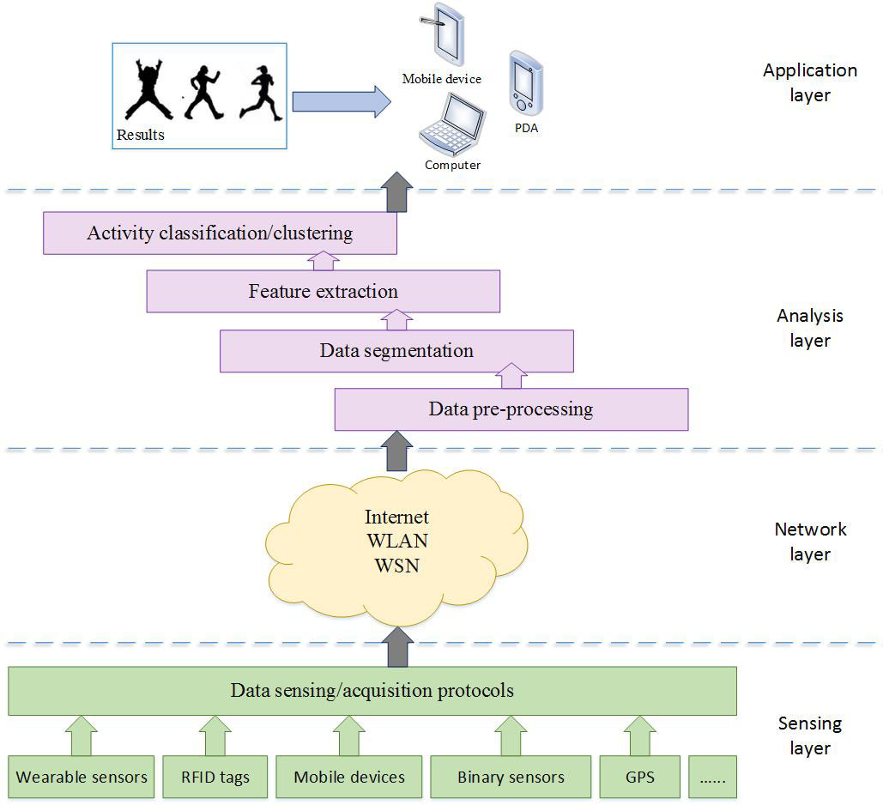
Figure 3- 2 Procedure of processing PARM
Figure 3- 3 Example of a general decision tree

DTC is widely used in the Data Mining field, and especially in the classification of the problem, it is a very effective method [53]. In addition to the easy-to-understand advantages of graphical analysis results, decision trees have the following advantages: 1) DTC can be represented graphically or by rules, and these rules are easy to interpret and understand and to use and are very effective. 2) It can handle continuous or categorical variables. Segmentation variables are selected with maximum information gain, and the model shows the relative importance of the variables. 3) In the face of large data sets, it also capable of being handled quite well, in addition, because the size of the tree is independent of the size of the database, the amount of calculation is small. When there are many variables into the model, the decision tree can still be constructed.

Figure 3- 4 Binary decision tree for PAR

There are three main steps in the construction of the decision tree: the first is to choose the appropriate algorithm to train the sample to construct the decision tree, the second is to properly prune the decision tree, and the third is to extract knowledge rules from the decision tree.
Let D be the division of training tuples with categories, then the entropy calculation method for D is
$E\left(D\right)=-\sum_{i=1}^{m}{p_{i}\log_{2}(p_{i})}$ (3-1)
Where $p_{i}$ represents the probability of occurrence of the i-th category in the entire training set, thus the expected information is

${EX}_{A}\left(D\right)=\sum_{j=1}^{v}{\frac{\left|D_{j}\right|}{\left|D\right|}info(D_{j})}$ (3-2)
Where $\frac{\left|D_{j}\right|}{\left|D\right|}$ represents the proportion of each D in the overall training set, and the information gain is the difference between the two:
$gain\left(A\right)=E\left(D\right)-{EX}_{A}(D)$ (3-3)
When the gain(A) reaches the maximum, the feature is the best partitioning feature. The best feature is selected as the current node and then continue to iterate.
Pseudocode
Algorithm 3-1
Input: an attribute-valued dataset PA
1: Tree = { }
2: if D is pure OR other stopping criteria met then
3: terminate
4: end if
5: for all PA features $f∈D$do
6: Compute information-theoretic criteria if split on f
7: end for
8: $f_{best}=$ Best features according to the above computed criteria
9: Tree = Create a decision node that test $f_{best}$ in the root
10: $D_{v}$ = Induced sub-datasets from PA based on $f_{best}$
11: for all $D_{v}$ do
12: ${Tree}_{v}$ = C4.5($D_{v}$)
13: Attach ${Tree}_{v}$ to the corresponding branch of Tree
14: end for
15: return Tree

3.2.2 Artificial neural network
ANN is a biologically inspired computer program designed to simulate the way in which the human brain processes information [171].
Apply feature vector F to layer of neurons.
Calculate
$V_{i}\left(n\right)=\sum_{i=1}^{p}{(W_{ji}F_{i}+Threshold)}$ (3-5)
Where $F_{i}$ is the activation of previous layer neuron I, $W_{ji}$ is the weight of going from node i to node j, p is the number of neurons in the previous layer
Calculate output activation
$Y_{j}\left(n\right)=\frac{1}{1+exp⁡(-V_{j}(n))}$ (3-6)
Update weights and thresholds using
$w_{j,k}=w_{j,k}+(-η)\frac{∂E(\vec{x})}{∂θ_{k}}$ (3-7)
$θ_{k}=θ_{k}(-η)\frac{∂E(\vec{x})}{∂θ_{k}}$ (3-8)
$η$ is a possibly time-dependent factor that should prevent overcorrection.
Using a sigmoid function, we get
$\frac{∂E(\vec{x})}{∂w_{jk}}=-y_{i}δ_{j}$ (3-9)
$δ_{i}=f^{'}({net}_{j})(t_{j}-y_{j})$ (3-10)
Logistics function ϕ has derivative $’\left(t\right)=(t)(1-t)$
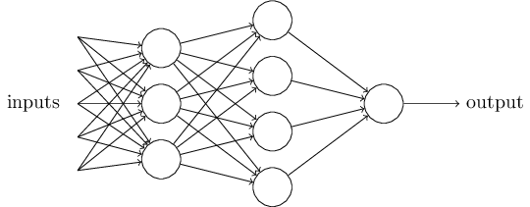
Figure 3- 5 Feedforward network

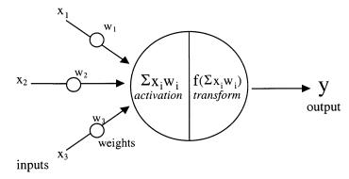
Figure 3- 6 Model of an artificial neuron

Algorithm 3-2
Initialise network weights $W_{ji}$
1: for j = n + 1 do
2: compute error from output $o_{i}$
3: compute weight $w_{i}$ for all weights from hidden to output layer
4: compute weight $w_{j}$ for all weights from input layer to hidden layer
5: update network weights
6: end for
7: return network

3.2.3 Support vector machine
SVM is a supervised machine learning algorithm which can be used for both regression and classification including linear and non-linear classifications [172]. The linear separation is shown in the Figure 3-7 (a) below, there is a two-dimensional plane. And two different types of data on the plane. They are represented by green and blue dots. Since these data are linearly separable, the two types of data can be separated by a straight line. This line is equivalent to a hyperplane. The y corresponding to the data points on the side of the hyperplane is -1, and the other side is 1. So how to find this hyperplane is the key issue of using SVM. Intuitively, the hyperplane is the straight line that best separates the two types of samples. The criterion for determining "best fit" is the largest distance between the straight line and the samples.

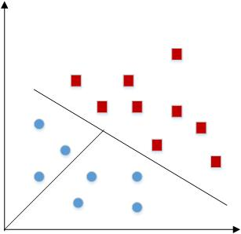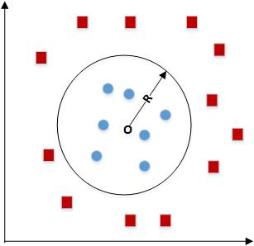
(a) (b)
Figure 3- 7 Linear and non-linear SVM (a) liner SVM; (b) non-linear SVM

The liner SVM is based on the class of hyperplanes
($w×x)+b=0, w∈R^{N}$, $b∈R$ (3-11)
In accordance to the decision functions
$f\left(x\right)=sign((w×x)+b)$ (3-12)
And the functional margins
$\hat{γ}=y\left(w^{T}x+b\right)=yf(x)$ (3-13)
For non-linear classifier, the classification function is
$f\left(x\right)={(\sum_{i=1}^{n}{a_{i}y_{i}x_{i}})}^{T}x+b=\sum_{i=1}^{n}{a_{i}y_{i}〈x_{i},x〉+b}$ (3-14)

SVM has achieved significant performance in PARM. It was originally designed for binary classifications with a hyperplane determined by a maximum margin to the support vectors. For multiple classification problems, it often builds multiple binary SVM classifiers and then combines them to achieve the final results. We use SVM multi-class Error-correcting output codes (ECOC) model in Matlab classification learner toolbox to train PA datasets. ECOC is a solid framework to process multiclass classification issues in terms of the combination of binary classifiers. The principle of using ECOC is to avoid the direct multiclass problem by breaking the multiclass task into several binary classification tasks and then combining the results from these indirect classifiers.

3.2.4 Random forest
RF is a classifier that uses the combination of DTCs to train and predict samples [173]. The classifier was first proposed by Leo Breiman and Adele Cutler, which is combined with the idea of "Bootstrap aggregating" and “random subspace method" to build a set of decision trees. There is no correlation between each decision tree in the random forest. The classification principle is that each DTC in the RF makes a separate decision when new samples are input. The decision will made by the most chosen DTCs. RF can both handle quantities with discrete values, such as the ID3 algorithm, as well as quantities with continuous values, such as the C4.5 algorithm [148]. Each decision tree in the forest is learned from a random subset of training examples and a random subset of features. In the training stage, the outputs from each DTC are averaged to determine the overall output. Specifically, each tree is traversed until reaching a leaf node. A probability score is assigned according to the ratio of training examples of each activity type that belong to the leaf node. These probability scores are averaged over each tree in the forest to obtain an overall probability score. Finally, the physical activity class with highest probability is predicted for that example.
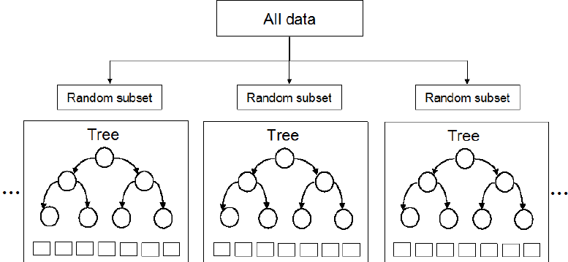
Figure 3- 8 A model of RF

Algorithm 3-3
1: for i=1 to n do
2: draw n points $D_{l}$ with replacement from D
3: build full decision tree on $D_{l}$
4: if split is with features $f_{1…k}$ then
5: pick uniformly at feature $f_{new}$
6: end if
7: prune tree to minimise error
6: end for
7: Average all T trees

K-nearest neighbours
KNN classification is a theoretically mature method and one of the simplest and most intuitive machine learning algorithms. ​​KNN, as proposed by Fix and Hodges, refers an unknown sample to be assigned to the most heavily represented among its k nearest neighbours [174]. The approach determines the class to which the sample is to be classified based on the category of the nearest one or several samples in the classification decision. Although the KNN method also depends on the limit theorem in principle, in the category decision, it is only related to a small number of adjacent samples. Also, the samples are also assigned to weight functions (i.e., distance-weighted KNN rule) for the neighbours of different distances on the samples.
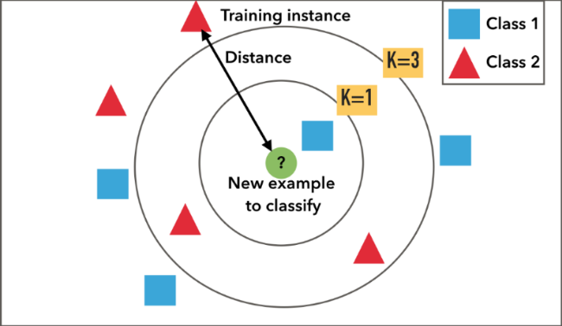
Figure 3- 9 A model of kNN
In most case, KNN classifier is commonly based on the Euclidean distance between test samples with training samples. Let $x_{i}$ be an input PA data with f features $(x_{i1},x_{i2}.⋯x_{if})$, thus the Euclidean distance between sample $x_{i}$ and $x_{m}(m∈R)$ is defined as
$d\left(x_{i},x_{m}\right)=\sqrt{{(x_{i1}-x_{m1})}^{2}+{(x_{i2}-x_{m2})}^{2}+⋯+{(x_{if}-x_{mf})}^{2}}$ (3-15)
Although the KNN classifier has a range of applications including PARM, one of its biggest drawbacks is its high computation complexity, as in order to find the k neighbours of each x from the training sample, all distances between x and all samples need to be calculated, leading to it having low effectiveness on big data’s applications. But as our datasets are only with 10 subjects, the approach is capable of being applied to the case.
Algorithm 3-4
1: Classify ($X,Y,x$)
2: for i=1 to m do
3: Compute distance d($X_{i},x$)
4: end for
5: Compute set I containing indices for the k smallest distances d($X_{i},x$).
6: return majority label for $Y_{i} where i∈I$

Naïve Bayes classifier
Naïve Bayes (NB) is based on Bayes’ theorem with the independence assumptions between predictors. It is a simple technique for constructing classifiers: models that assign class labels to problem instances, represented as vectors of feature values, where the class labels are drawn from some finite set.
$P\left(x_{i}\right)=\sum_{i=1}^{n}{P(x_{i}|c)P(c)}$ (3-16)
Where $x=<x_{1},x_{2}⋯x_{i}>$ is the PA features, and $P(c|x_{i})$ is the prior probability, $P(h_{1})$ is the probability associated with hypothesis$c$. For n different hypotheses, we have
$P\left(c | x_{i}\right)=\frac{P(x_{i}|c)P(c)}{P(x_{i})}$ (3-17)
Algorithm 3-5
1: for each PA class $c_{i}$
2: compute $P(C_{i})$
3: for each feature $x_{j}$
4: compute $P(x_{j}|c_{i})$
5: end for
6: end for

Daily physical activity recognition using mobile phone

Data collection with mobile app
We use a mobile phone for the stage of first data collection. An android app has been developed for data collection, 10 participants record these data. The functionality of the app is to call the phone’s internal sensors including accelerometer, gyroscope, magnetic field sensor, etc., in which the accelerometer is the key parameter to detect PA recognition, and thus the raw sensor data is recorded in Excel format stored on the phone. Android API only provides 4 types of sampling rate (5Hz, 16Hz, 50Hz and 100Hz), among which data are collected for four difference sampling frequencies and compared in the next section. The example of collected data is shown in Figure 3-10, 10 PA types which include 7 dynamic PAs (walking, jogging, running, cycling, rowing, fast walking, descending stairs) and 3 sedentary PAs (standing, lying and sitting). Here ascending is not included as its similar feature as descending. Some fluctuation in the sedentary PA’s signals may come from phone being moved showing sensor noises in natural environment.
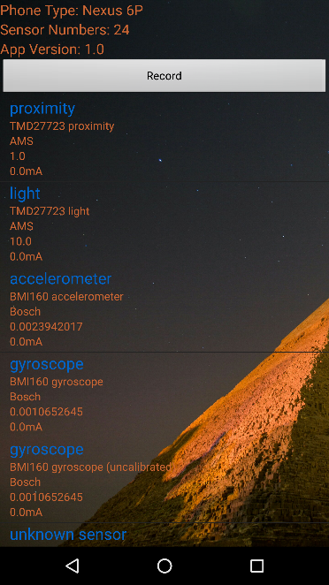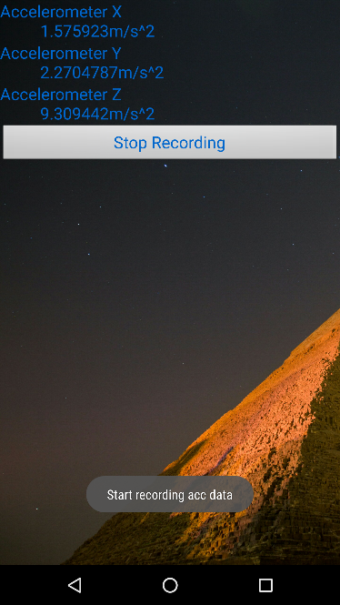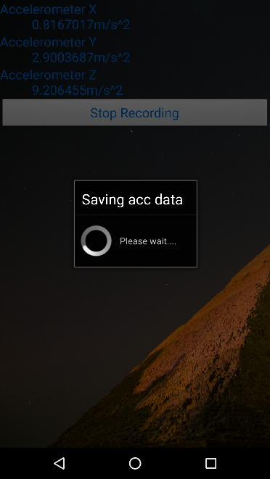
- (b) (c)
Figure 3- 10 The android app for sensor data collection (a) Home page with all sensors; (b) real-time accelerometer data; (c) saving accelerometer data to the phone’s internal storage
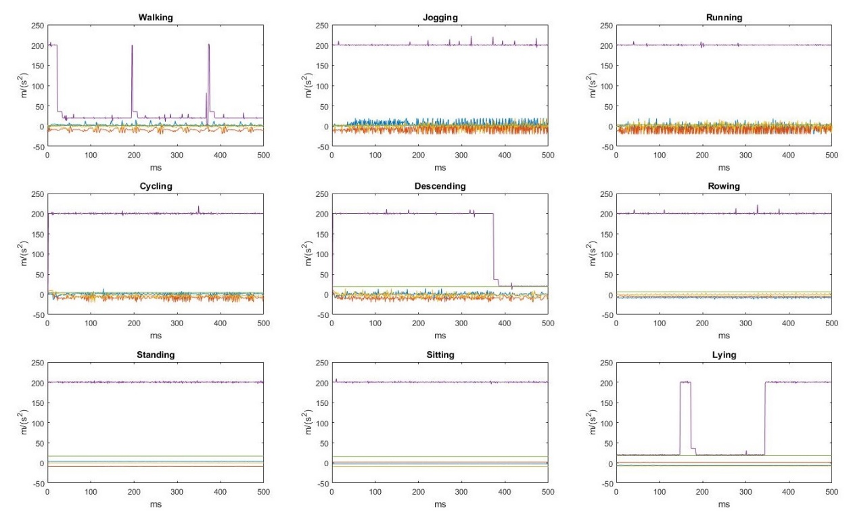
Figure 3- 11 Raw sensor signals collected from mobile device

Feature extraction
The features are extracted with 50% overlapping sliding windows with 1 second partition for 100Hz, 2 seconds for 50Hz, 6.25 seconds for 16Hz and 20 seconds for 5Hz, respectively, thus 100 samples are in every frame. Six time domain features (mean, max, min, standard deviation, variance and correlation coefficients) and 1 frequency domain feature (energy) are selected for each axis and three axes in total with 26 feature vectors. An Elliptic High pass filter is applied before the process of feature extraction.
The features’ formulas are shown as below.
$\overline{y}=\frac{1}{n}\sum_{i=1}^{n}{y_{i}}$c (3-18)

SD and Variance
$σ_{y}=\sqrt{\frac{1}{n-1}}\sum_{i=1}^{n}{{(y_{i}-\overline{y})}^{2}}$ (3-19)
$σ_{y}^{2}=\frac{1}{n-1}\sum_{i-1}^{n}{{(y_{i}-\overline{y})}^{2}}$ (3-20)

$ρ_{x,y}=\frac{cov(x,y)}{σ_{x}σ_{y}}$ (3-21)
Where cov is the covariance, $σ_{x}$ is the standard deviation of x, $σ_{y}$ is the standard deviation of y.
$Energy\left(y\right)=\frac{\sum_{i=1}^{n}{F_{i}^{2}}}{n}$ (3-22)
Domain transform measures such as the energy, where $F_{i}$ is the i-th component of the Fourier Transform of y.

Physical activity classification
With the extracted feature vectors, supervised machine learning approaches are primarily implemented and compared in our work as it has a more mature and deep theoretical foundation compared with unsupervised and semi-supervised approaches. Ten PA types are defined as: walking, jogging, running, cycling, rowing, fast walking, descending, standing, lying and sitting, where idle refers user does not take the phone. On the other hand, transitional activities (e.g., stand to sit, sit to lay) are not considered in our work. Figure 3-17 lists 6 classification results using WEKA [128]. With the comparisons of four different sampling frequencies, we found that the classification results are not much difference above 16Hz. Thus from the energy efficiency perspective for PA, 5Hz is sampling rate but recording the data 1Hz or 2Hz for lifelogging PA monitoring.
Five conventional machine learning classifiers: DTC, RF, SVM, ANN, kNN and naïve Bayes are evaluated in the datasets (results are shown in Figure 3-12 to Figure 3-17). We use 10-cross evaluations with statistical tests to compare classifiers’ performance. The classification results for each model are represented as a confusion matrix $M_{n×n}$ for n PA types. Matrix $M_{ij}$ is the number of instances from class i that were actually classified as class j. The following values can be obtained from the confusion matrix classifications:
• True Positives (TP): The number of positive instances that were classified as positive.
• True Negatives (TN): The number of negative instances that were classified as negative.
• False Positives (FP): The number of negative instances that were classified as positive.
• False Negatives (FN): The number of positive instances that were classified as negative.
The accuracy is the most standard metric to summarize the overall classification performance for all classes and it is defined as follows:
$Accurarcy=\frac{TP+TN}{TP+TN+FP+FN}$ (3-23)

$Precision=\frac{TP}{TP+FP}$ (3-24)

$Recall=\frac{TP}{TP+FN}$ (3-25)

$F-measure=2×\frac{Precision×Recall}{Precision+Recall}$ (3-26)

In addition, we use the receiver operating characteristic (ROC) curve, which is a graphical plot that illustrates the diagnostic ability of a binary classifier system as its discrimination threshold is varied. ROC is able to select the best diagnostic limit, which means the closer the ROC curve is to the upper left corner, the higher the accuracy of the evaluation. The point that is closest to the ROC curve in the upper left corner is the best threshold for the least error, with the lowest total number of false positives and false negatives.
The results are shown in Figure 3-17. As we can see, all the classifiers are able to achieve high accuracy with the four discriminative activities with average accuracy 94.86% for decision tree, 97.64% for random forest, 96.81% for SVM, 98.1% for ANN, 91.1% for kNN and 95.98% for naïve Bayes, where ANN presents the best performance. However, as we can see from the experiment’s results, descending is the most difficult PA to recognize due to its similarity of signals and features with walking.
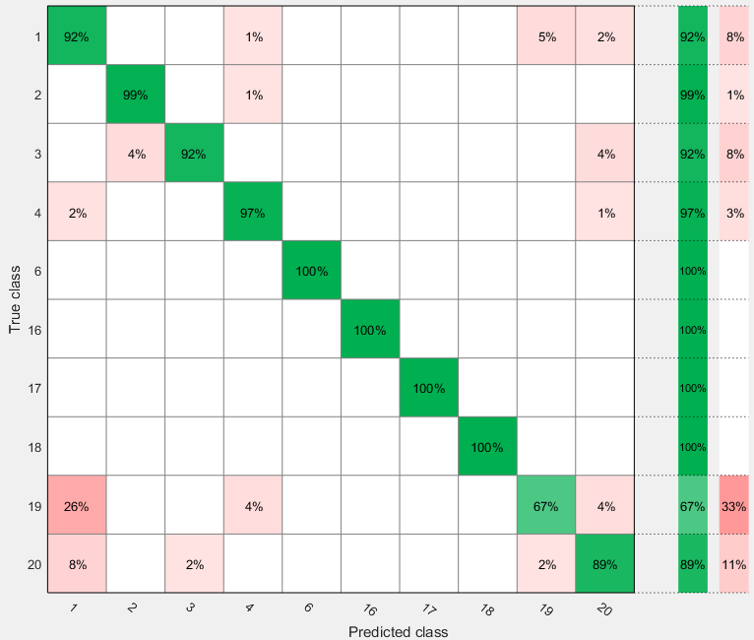
Figure 3- 12 Classification results using RF
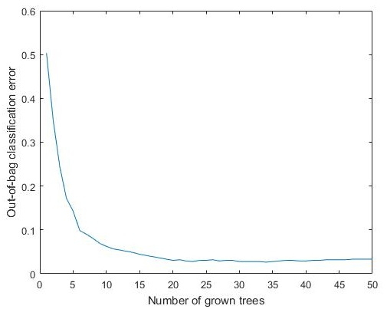
Figure 3- 13 Classification error with number of grown trees in RF

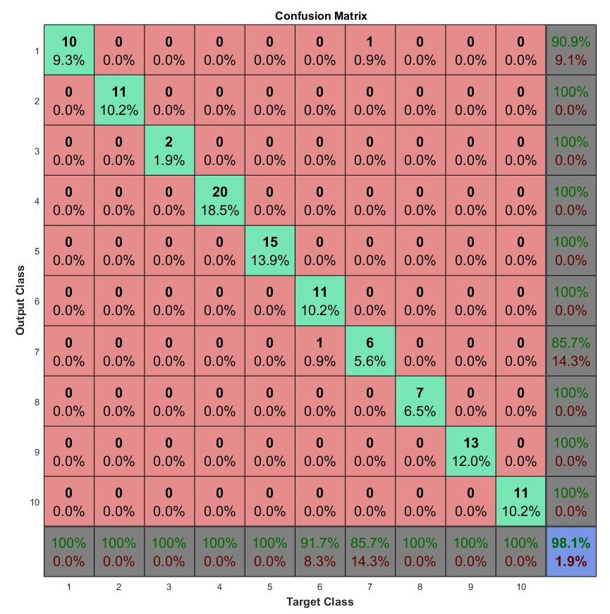
Figure 3- 14 Confusion matrix of ANN in PAR
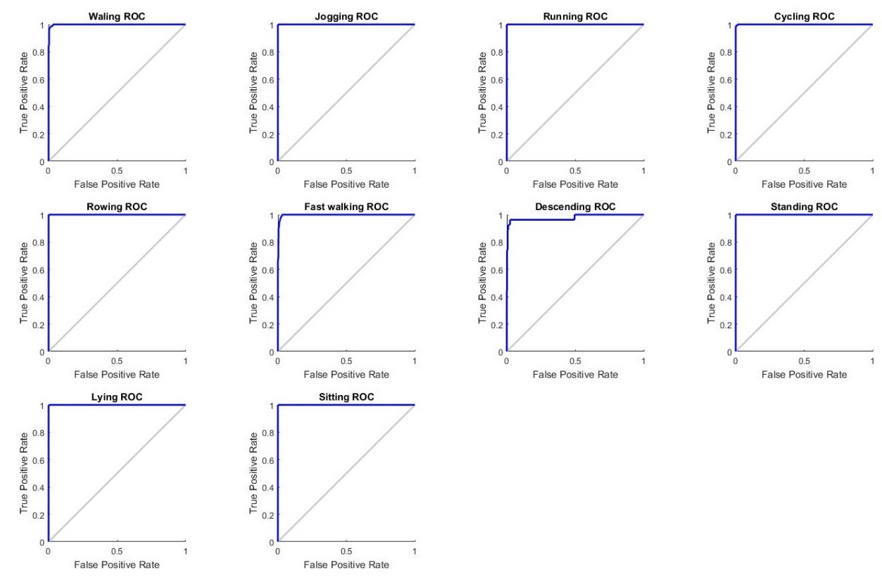
Figure 3- 15 ROC-based ANN
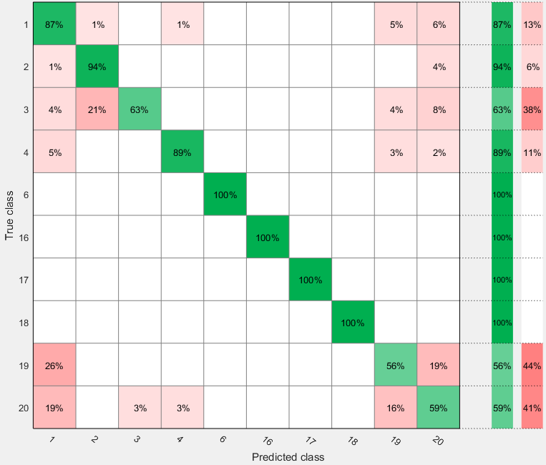
Figure 3- 16 Classification result of kNN

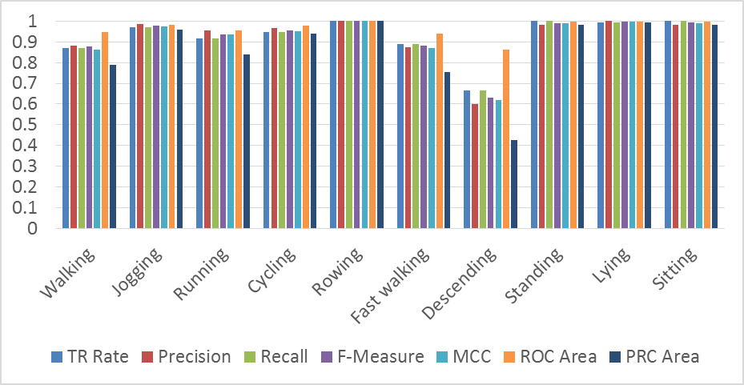
- Classification results of DTC

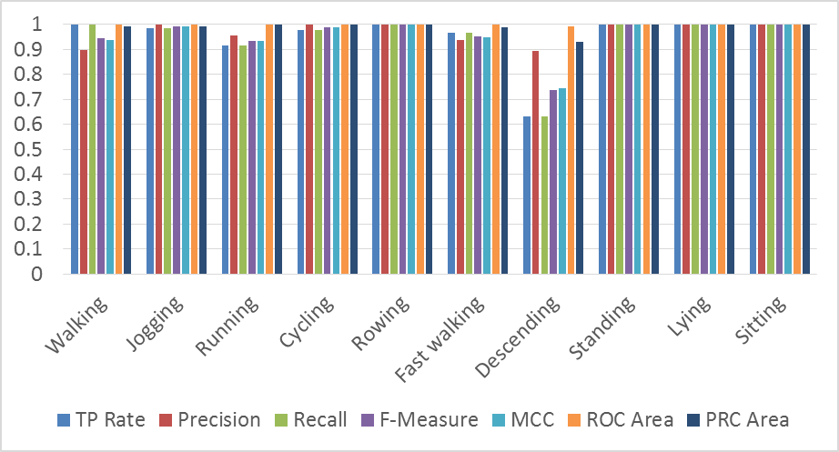
- Classification results of random forest
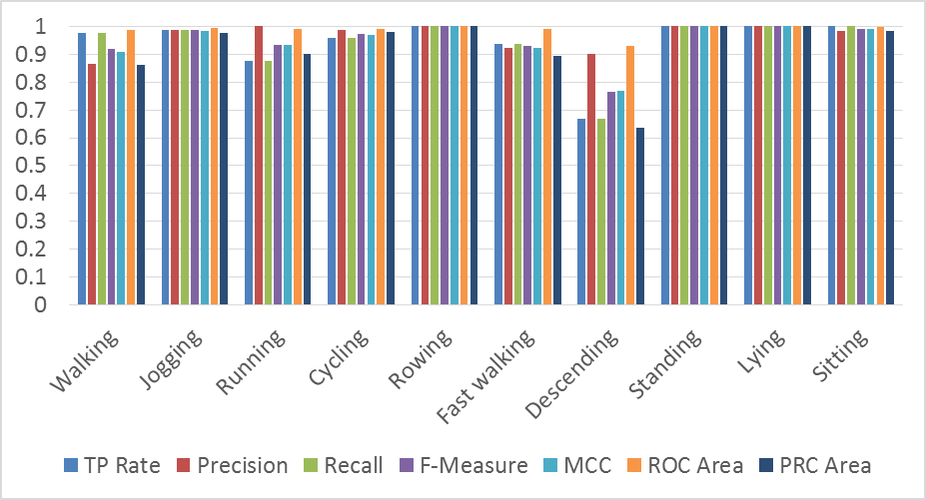
- Classification results of SVM

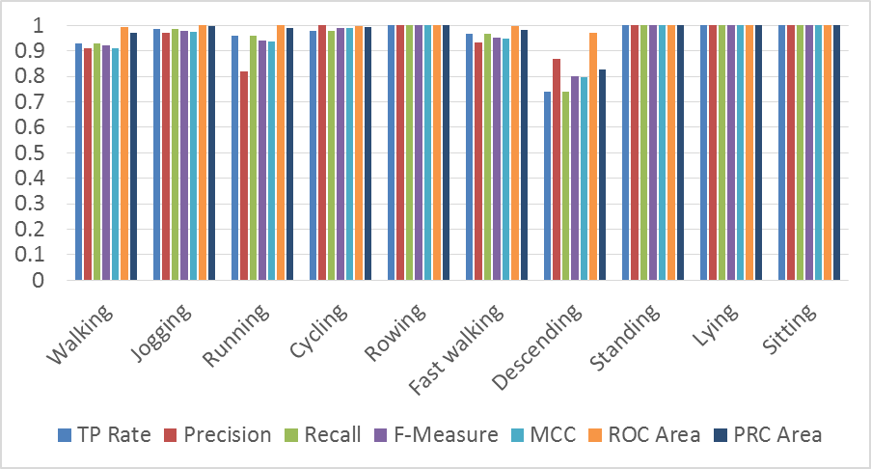
- Classification results of ANN

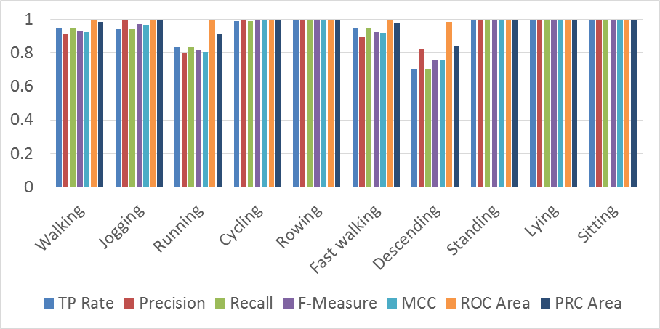
- Classification results of kNN

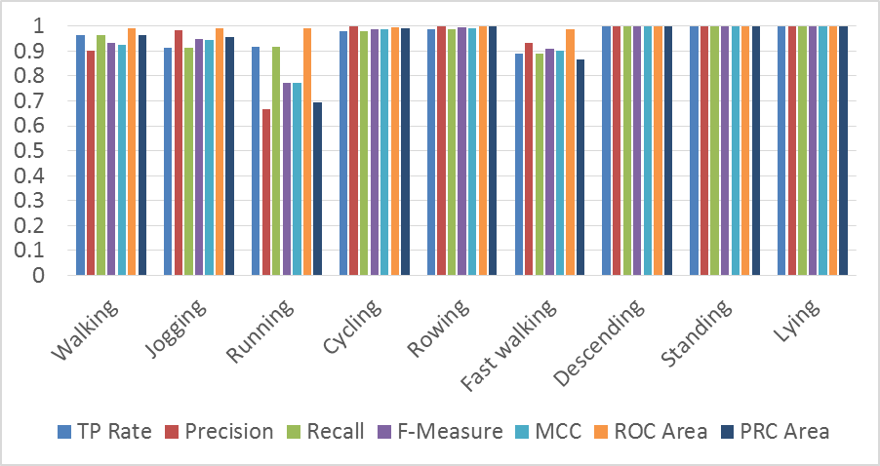
- Classification results of naïve Bayes
Figure 3- 17 Classification results of conventional classifiers

3.4 Summary
This chapter presents and implements machine learning approaches applied in daily PA recognition. We first described the methodology of daily PA classifications from the IoT’s perspective which is sensing, network, analysis and application layers. And then introduced mechanisms of some typical and effective machine learning approaches including DTC, ANN, SVM, RF, kNN and naïve Bayes. The implementations are carried out based on a self-developed data collection app that calls android phone’s internal sensor package. The accelerometer is exploited as the key sensing source. 10 PA types (walking, jogging, running, cycling, rowing, fast walking, descending stairs, standing, lying and sitting) are performed by 10 subjects with a mobile phone placed in the left pocket of trousers. Feature extractions in terms of time domain and frequency domain are processed next. In the end, 6 classifiers introduced earlier are implemented on the collected data. The results show that only a single accelerometer is able to sufficiently and effectively detect human daily PA and ANN achieved the best performance though each classifier has relatively high accuracy, precision and recall. However, descending presents lower accuracy due to its similarity of signals and features with walking. This experiment only shows the sensor placement in pants’ pocket, on the other hand, different positions may lead to different recognition results because that motion sensors are sensitive to body positions and thus still being a challenge at the moment. Generalising a classifier from all positions or sub-classifier for each position and choose a specific classifier in terms of each occasion are the current solutions to position-independent problem.

Chapter 4. Gym physical activity recognition and measurement using wearable sensors

4.1 Introduction
Traditional physical activity recognition techniques have more focal points on the exercises of repetitive movement such as walking, running and cycling, etc. or static actions such as standing, sitting and lying[29], [56]–[58]. In clinical and rehabilitation fields, work has been carried out on methods for transitional activity detections such as stand-to-sit, sit-to-lie, etc. [175][81][105]. Also, in recent years, customer physical activity tracking devices/apps have been released in the fitness market [176]–[179]. Unfortunately, tracking and detecting weight training is mostly excluded in the existing studies/products. The American Heart Association (AHA) [180], the American College of Sport Medicine (ACSM) [181] and the American Association for Cardiovascular and Pulmonary Rehabilitation (AACVPR) [182] have declared that weight training has been considered an important modality for human healthcare and developed guidelines for various groups from elderly people, patients with chronic diseases to healthy sedentary and physically active adults [183]. Furthermore, a survey has shown [184] that an increasing number of people have become gym members in recent years with fitness membership hitting nine million in UK alone last year (approximately 14% of the population). The significance of aerobic exercises and weight training are generally approved both in medical communities and public societies. Moreover, automatically tracking and recording each workout provides systematic support to increase the repetitions progressively which is especially essential for frequent weight trainees, as manually recording is not only time consuming and tedious but would affect one’s exercising schedule. During the last decade, nevertheless, sensing and monitoring weight training has only contributed a limited amount of research [185]–[187]. The reason is that first compared with routine physical activities especially like walking and sitting, weight training is less frequently performed by each person each single day. Second, there is a massive variety of training activities as well as various measures of performance which is a tedious task to select and collate. More importantly, the separation of sets of free weight activity from non-free weight activity is an important issue since the duration of the activity of each set is short and the states of activity are continuously changing, while a whole exercise commonly consists of three to five sets with non-free weight activities in between. In other words, such activity is composed of several atomic activities such as sitting, lying, lifting, standing, thus making it more difficult to identify. These composite activities cause traditional standalone machine learning methods to fail to identify patterns efficiently and accurately.
Sets and reps provide organization and structure to an individual’s workout. Recording and tracking them for each workout provides a systematic format to increase the repetitions progressively. However, manual recording is not only time consuming but would affect one’s exercising schedule. Although some workout trackers have been successively released in recent years such as “Google fit” and “Gym watch”, most fitness people still choose to manually record with a notebook or mobile apps due to the limitation of the device’s / app’s precision.
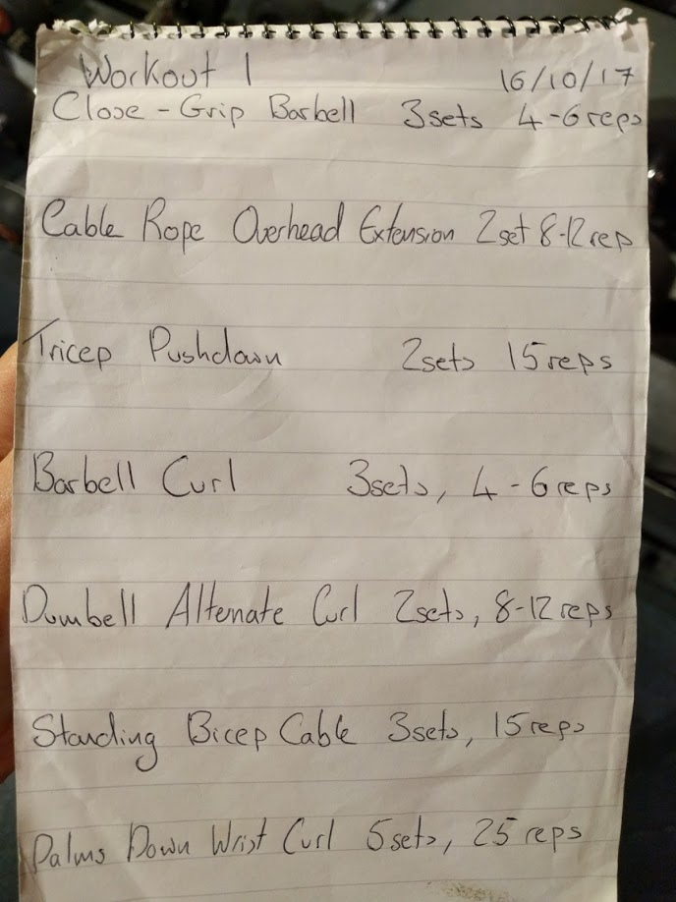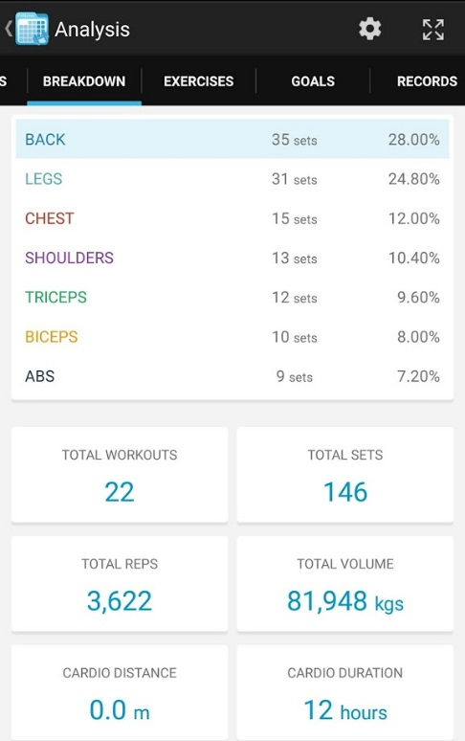
Figure 4- 1 Manual records (a manual recording with notebook and mobile app)

This chapter establishes a gym physical activity recognition and measurement framework (GPARMF) that involves more GPA category recognitions and implements sets and repetitions counts for each weight training activity using two wearable accelerometers. Due to the training machine limitations, we only consider free weights with barbells and dumbbells, as it is regarded as the most effective strength training way for healthcare and muscle mass[188]. The framework is composed of two layers. In the first layer, a one-class support vector machine (OC-SVM) classifier is applied to separate free weight (i.e., bench press, deadlifts or squats) and non-free weight activities (i.e., walking, running or sitting). In the second layer, a hidden Markov model (HMM) is utilized to provide a fine grained classification in free weight activities, using a neural network (NN) for classifying non-free weight. In contrast to existing studies that either simply recognize aerobic exercises and static postures [29], [56]–[58] or merely focus on weight training activities [185]–[187], this work covers all three categories of physical activities. Additionally, by achieving high recognition accuracy, almost all studies classify weight training activity with only one set of signals data in a controlled environment while in practice, people typically perform different activities between sets within a whole weight training programme. Thus, our training data samples are collected from 10 healthy subjects by each exercise rather than each set in which the former contains much more uncertain activity combinations that haven’t been resolved to date.
To summarize, this chapter has the following contributions:
- A novel two-layer sensor fusion based physical activity recognition framework GPARMF, is proposed for effectively recognizing and classifying free weight and non-free weight gym physical activities in an uncontrolled environment. This framework is capable of accurately separating and recognizing free weight and non-free weight gym physical activities.
- During GPARMF, a one-class SVM (OC-SVM) is designed to coarsely classify free weight and non-free weight activities. Also, a neural network (NN) model is utilized for aerobic and sedentary activities recognition; a hidden Markov model (HMM) is to provide a further classification in free weight activities.
- A thorough experimental evaluation on a practical gym environment with heterogeneous devices is carried out. We measure GPA through counting repetitions and sets with normalized threshold for free weight exercises. The results show that the proposed framework has better performance in recognizing and measuring GPAs than other standalone approaches.
The chapter is organized as follows: 4.2 presents the background on free weight activity recognition. Section 4.3 describes our gym physical activity recognition framework and data processing algorithms. Section 4.4 presents the traditional machine learning approaches to handle our datasets. Section 4.5 gives details of the implementation of the framework, and conclusions are presented in Section 4.6.

Background of GPA recognition
The studies in chapter 2.5.1 show outstanding experimental results in diverse approaches and functionalities, including some extraordinary recognition results and thorough user demands [152][153]. However, they are all conducted in a controlled environment, which means each activity is predefined with only one pattern. Additionally, most work uses repetitions of signal datasets that cut out from the whole free weight activity or only count repetition numbers. Yet there are more diverse performances within one activity especially among sets in free weight exercises. Thus segmenting free weight from non-free weight within uncontrolled environments is a problem that has not been explored to date. To cope with this problem, we built a two-layer framework to recognize and measure GPAs. In the first layer, we attempt OC-SVM [189] which adapts a traditional binary SVM to a one class situation to set apart non-free weight and free weight activities. The algorithm has been widely applied in anomaly detections [190] and unbalanced labelling data [191]. We adopt this due to the unbalanced training samples of the two classes in realistic scenarios.
DTW is a template-based dynamic programming matching technique for efficiently matching two time-series signals. However, when it comes to different patterns of activity with transient free weight activity within all sets and other activities that may take a longer time and contain more uncertainties, it needs a large number of templates for a variety of patterns and also fails to match undefined templates. Hence, in the second layer of our framework, another time-series approach, HMM, is presented to resolve the free weight activity recognition issue. HMM is a probabilistic sequence model that describes a process of mapping a sequence of observations to a sequence of hidden states. It has been successfully applied in speech recognition [192], gesture recognition [96] and activity recognition [122], etc. We chose HMM because it is a spatio-temporal model that is capable of handling undefined patterns which is suited to a variety of free weight performances. HMM requires high computational expense and a large number of training samples, thus to balance the feasibility and efficiency, neural networks (NN) have been designed to recognize non-free weight activities in this layer. Whilst the NN is not able to detect free weight from all GPAs, it gives the best performance in classifying traditional physical activity types [52][41]. Subsequently, GPA measurement approaches with wearable sensors of accelerometers are also offered in GPARMF through counting the numbers of sets and repetitions for free weight exercises.

Data collection
The goal of our data collection is to implement gym physical activity recognition and intensity measures of free weight activities based on realistic data in natural training conditions. A total of 10 healthy subjects (7 males, 3 females; age: 30 ± 5; BMI: 25 ± 5.5 kg/ m^2; body fat: 20.5±5.4) took part in the data collection process. Four of the subjects are professional trainees that have continuously trained for 2 to 5 years.

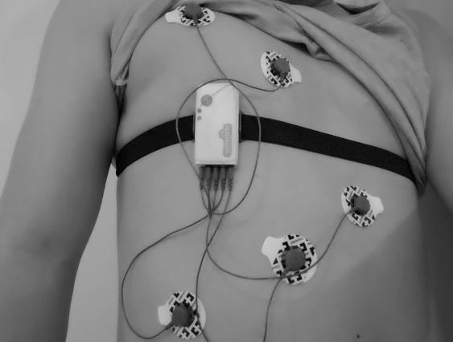
Figure 4- 2 A subject performs free weight activities with ECG attached
Table 4- 1 Typical GPA categories
Activity class | Activity name | Activity category | Muscle groups | Posture
A1 | Bench press | Free weight | Chest | Lying
A2 | Squats | Free weight | Legs | Standing
A3 | Lunges | Free weight | Legs | Standing
A4 | Bend-over rows | Free weight | Back | Standing
A5 | Deadlifts | Free weight | Back | Standing
A6 | Good morning | Free weight | Back | Standing
A7 | Shrugs | Free weight | Shoulders | Standing
A8 | Front raises | Free weight | Shoulders | Standing
A9 | Overhead extensions | Free weight | Triceps | Lying
A10 | Curls | Free weight | Biceps | Standing
A11 | Walking | Aerobic | None | Standing
A12 | Jogging | Aerobic | None | Standing
A13 | Running | Aerobic | None | Standing
A14 | Cycling | Aerobic | None | Sitting
A15 | Ascending | Aerobic | None | Standing
A16 | Rowing | Aerobic | None | Sitting
A17 | Sitting | Sedentary | None | Sitting
A18 | Standing | Sedentary | None | Standing
A19 | Lying | Sedentary | None | Lying

Others are untrained people engaging in sedentary desk jobs. The subjects were asked to place two Shimmer3 wireless wearable sensors [193] on wrist and chest respectively, shown in Figure 4-2. As reported in the study [56], the chest is closer to the centre of the body mass and thus is an ideal measurement position especially for sedentary activities, whilst the heartbeat also can be obtained. Arm movements play an important role in most physical activities, thus we select a sensor put on the wrist to increase recognizer accuracy. The sensor sampling rates are 50Hz which is higher than basic requirements (20Hz is sufficient to infer ambulation activities [164]). Yet considering the short duration of each set of free weight exercise and heart rate, we decided to use 50Hz for data collection. The sensors were connected and the signals were stored on an Android mobile phone (Nexus 6P) via Bluetooth.
Furthermore, rather than controlled lab settings, the datasets are collected in the user’s real training environment (i.e., gym), so each free weight set is in terms of an RM (repetition maximum) principle which is the most weight a subject can lift for a defined number of exercise movements, so that it truly reflects the heartrate change and duration of the free weight exercises. Each subject first performed six types of aerobics (walking, jogging, running, cycling, ascending, and rowing) and three types of static postures (sitting, standing, and lying) for 5 minutes each and repeated three times. And then they did ten types of typical and important free weight movements selected for the human main muscle groups: chest, legs, back, shoulders, triceps and biceps, as presented in Table 4-1. Each free weight activity was performed as the intensity of light (8-12 RM), medium (6-8 RM), high (4-6 RM) and extremely high (2-4 RM)[194], and repeated three times, so 12 sets in total per subject.
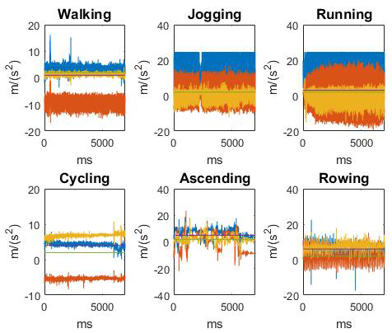
(a)
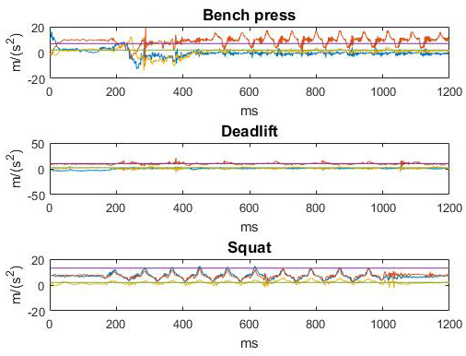
(b)
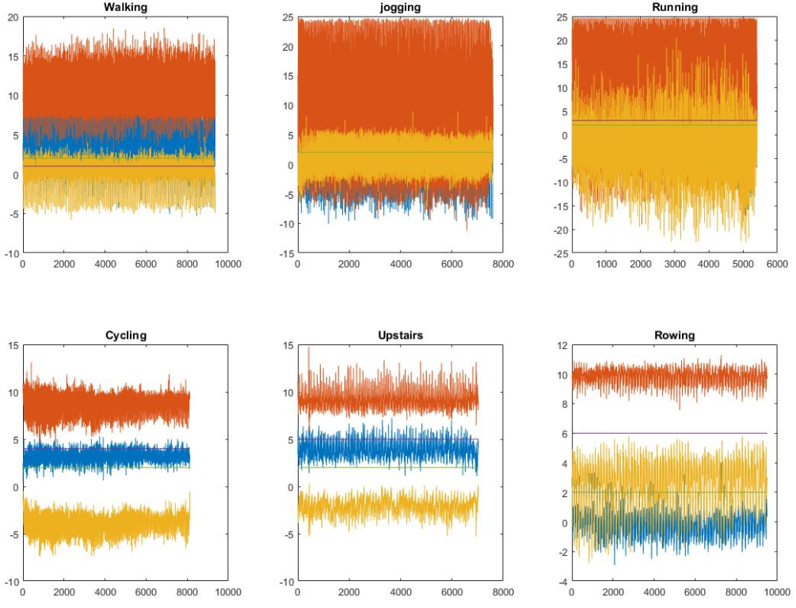
(c)
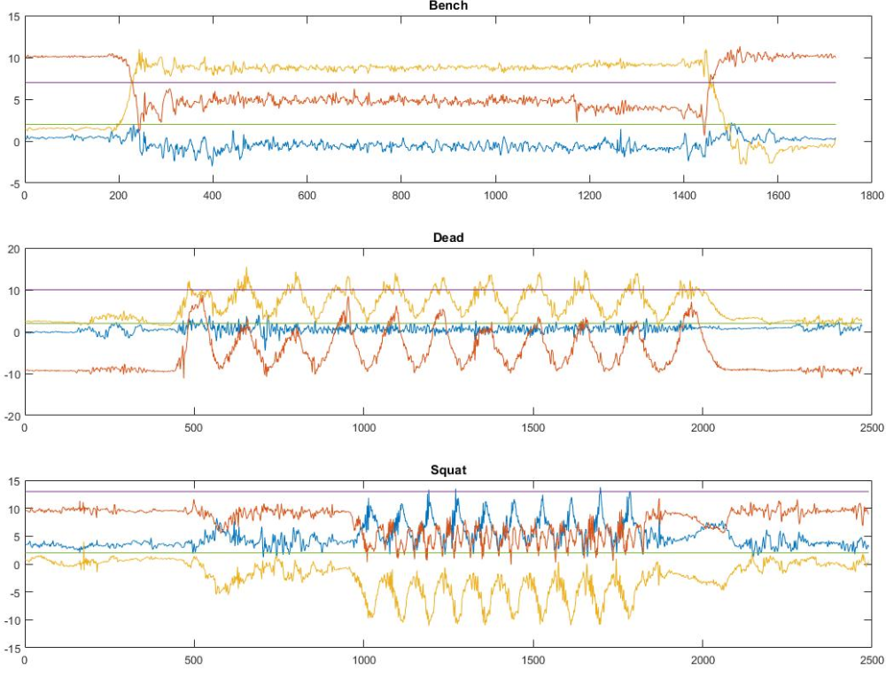
(d)
Figure 4- 3 Raw tri-axial accelerometer data of free weight activities on the wrist (a) Non-free-weight PA accelerometer signals of wrist; (b) Strength accelerometer signals of wrist; (c) Cardio accelerometer signals of waist; (d) Strength accelerometer signals of waist.

Data processing

Pre-processing
In the pre-processing stage, we first apply a straightforward metric called signal magnitude vector (SMV) that directly processes acceleration signals from three axes$x\left(i\right), y\left(i\right),z\left(i\right)$ respectively, shown in Eq. (1), which provides a measurement of the degree of activity intensity. We then smooth the metrics through Savitzky Golay filters [195]. Figure 4-3 (a) shows three-axis raw signals of six types of aerobic exercise. Figure 4-3 (b) shows raw signals of deadlifts, squats and bench press. Figure 4-4 shows a whole period of standing curl activity after SVM and smoothing processing.
$SMV=\sqrt{x_{i}^{2}+y_{i}^{2}+z_{i}^{2}}$ (4-1)

Feature extraction and selection
Feature extraction is a crucial procedure for GPA recognition since any classification method can be appropriately selected if the features are robust. Time domain and frequency domain features are extracted from each accelerometer axis, and R waves are extracted from the ECG for heartrate calculation. The extracted features are presented in Table 4-2.

Table 4- 2 Feature extraction category and extracted features for fine grained classifications
Category | Extracted features
Time domain | Mean, standard deviation (SD), covariance, variance, min, max, correlation, root mean square (RMS), signal magnitude vector (SMV)
Frequency domain | FFT energy, entropy, interval of peaks, height of peaks
Biometrical domain | R wave

The ECG is exploited to measure one’s heart rate for sets tracking. As free weight activities are normally performed within a very short time, an individual’s heartbeat would dramatically fluctuate during this period. When one set finished, he/she may have a break and prepare for the next set. During the break time, one would perform different activities, such as walking, standing, sitting, etc. Detecting and distinguishing short time activities within such a large random activity with motion sensors is a difficult task. However, there is an inevitable relation between intensity and heartbeat, and an individual’s heart rate undergoes regular changes when performing the activities. During, and a short time after the activity, heartbeat will be dramatically increased, and tends to be stable during the break regardless of types of movement. As such, we adopt ECG for sets calculation. The ECG signals are firstly detrended and filtered, then we find R wave peaks which are used to calculate heartbeat every minute in terms of Eq. (2)
$Heartbeat\left(i\right)=\frac{sampling rate×60}{R_wave (i+1) - R_wave (i)}$ (4-2)

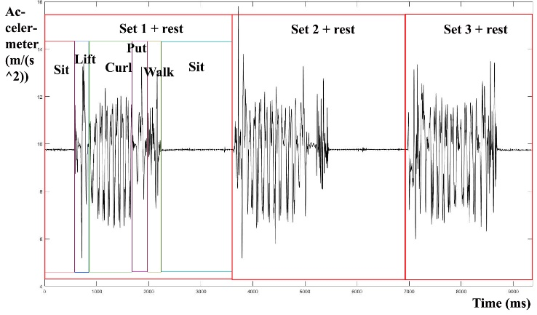
Figure 4- 4 Three sets of standing curl

Data processing with standalone machine learning approaches
After the procedure of feature extraction, some typical machine learning approaches in Weka are applied to classify the activities. The results of decision tree, artificial neural networks (ANN), and support vector machine (SVM) are shown in Figure 4-5 and Figure 4-6. The experiments are carried out with filters, time and frequency domain features, 50% overlapping fixed window size, and 10 fold cross validation.
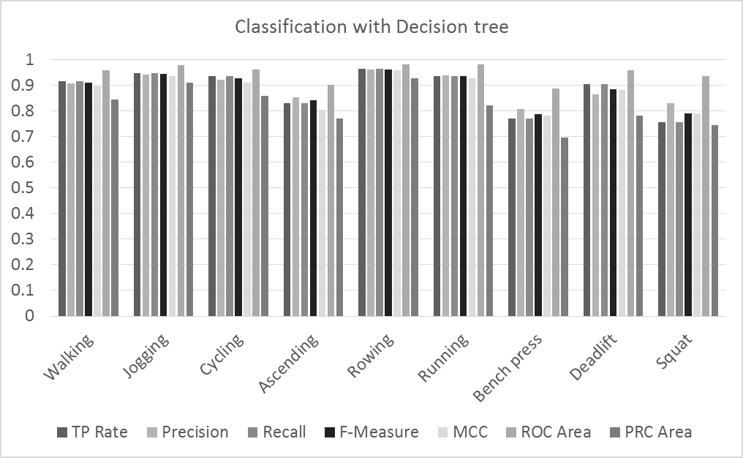
(a)
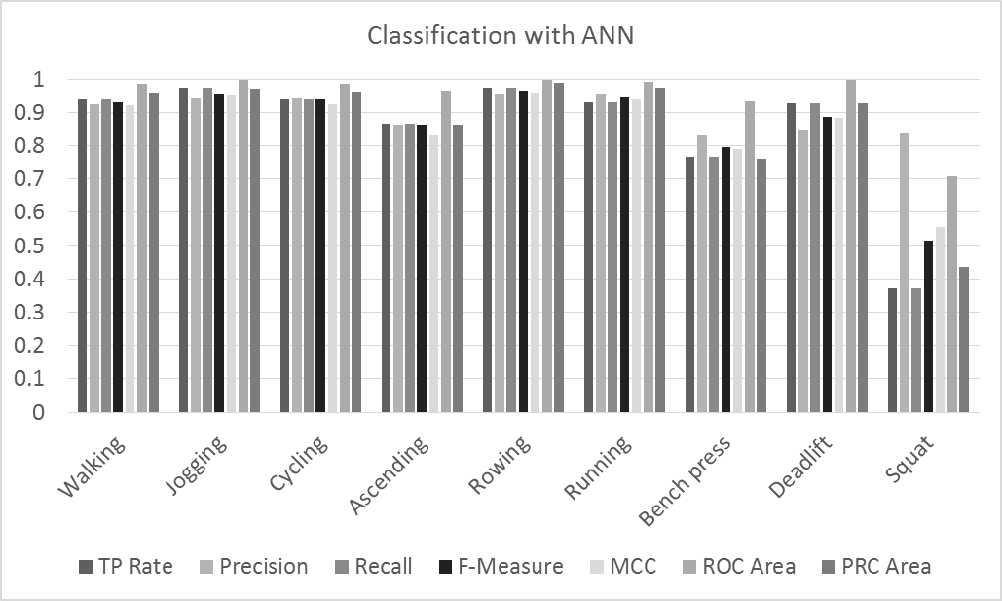
(b)
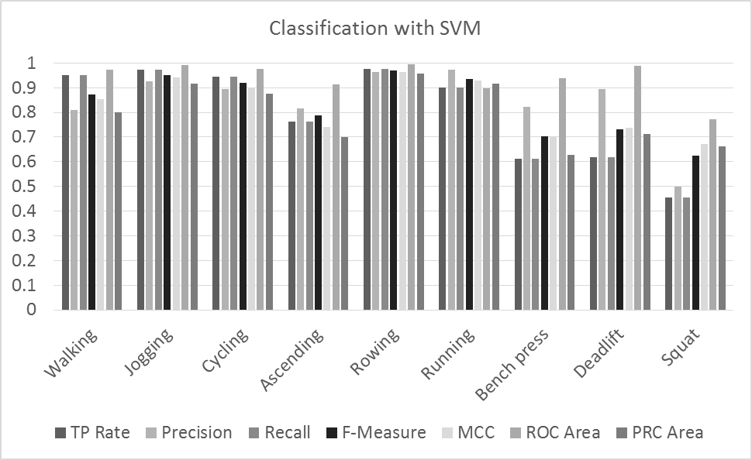
(c)
Figure 4- 5 Classification results with learning algorithms (a) classification results with decision tree; (b) classification results with SVM; (c) classification results with ANN

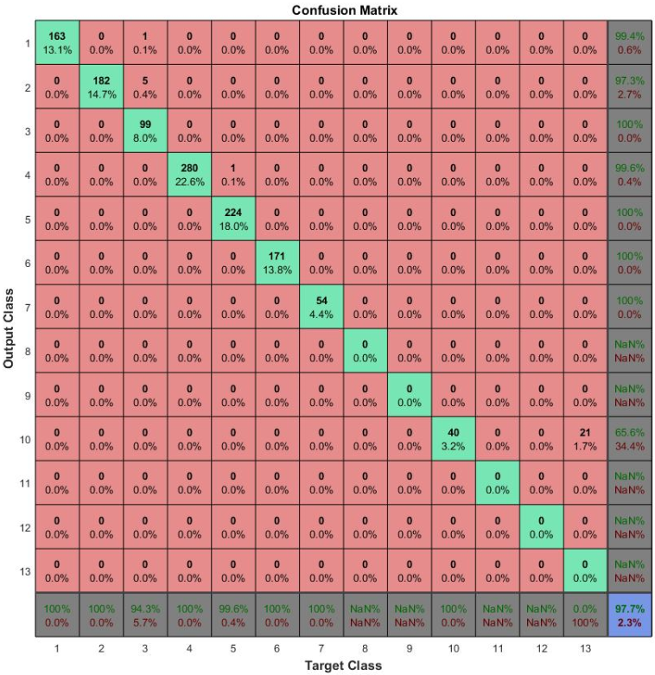
(a)
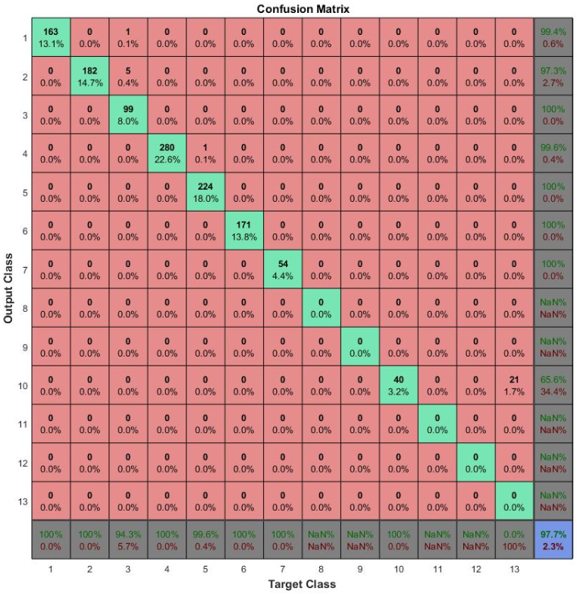
(b)

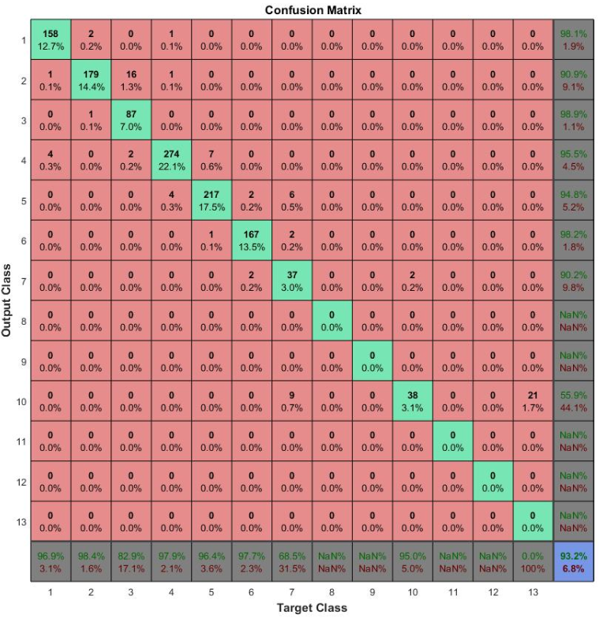
(c)
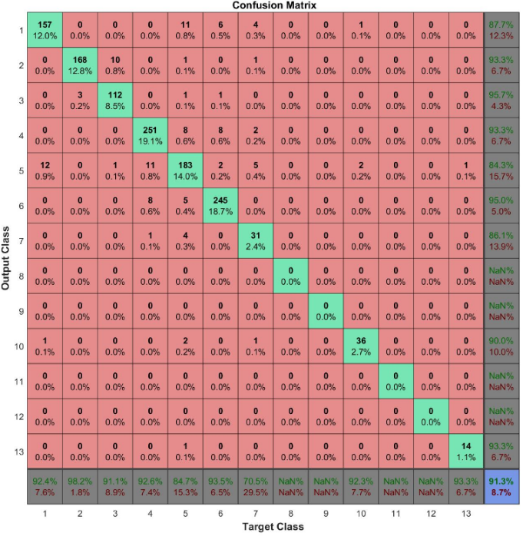
(d)
Figure 4- 6 Results of different time window overlapping, filter and features using ANN (a) ANN with filter, 50% overlap, and all features; (b) ANN with filter, 80% overlap, and all features; (c) ANN with 50% overlap, time and frequency domain features and no filter; (d) ANN with 50% overlap, time features and no filter.

From the experimental results, we can find that: 1) Increasing overlap size doesn’t help much, 50% is sufficient. Large overlapping would cause slower running speed. 2) High pass filter is a very important part, leading to accuracy dramatically increasing from 93% up to 97% in total. 3) Using both frequency and time domain features is more effective than time domains only. Accuracy rises from 91.3% up to 93.2% in total. 4) Cardio activities (walking, jogging, running, cycling, going upstairs and rowing) are quite easily classified with traditional classifiers (most are over 90%, going upstairs is lower and mixed up with walking). However, strength training/free weight activities are relatively low (very few over 90%, even 50% to 60% in some cases above). Although some free weight activities do not have bad performances such as in ANN and random forest, the accuracy is not convincing in this case due to the imbalanced samples. As their samples are much less than cardio activities (around 0.3: 0.7), thus the results would be higher than they should be. To solve the problem, in the next section, we would separate cardio and free weight classes, and propose a hybrid hierarchical framework to handle this issue.

Proposed Framework
As we can see, traditional standalone approaches can precisely classify daily PA, while the GPARMF consists of two recognition steps: preliminary classification and fine-grained classification, as shown in Figure 4-8. Acceleration data are firstly collected from the sensing layer before features are extracted and selected through time and frequency domains. OC-SVM is exploited to roughly distinguish free weight and non-free weight activities. In the second classification step, HMM is used to classify free weight exercises and NN is used to classify aerobic activity and static postures to obtain the concrete activity results. The repetitions and sets are also measured in the framework through given thresholds and heartbeat fluctuations. The whole procedure is presented in Figure 4-7.
Figure 4- 7 Flow chart of GPARMF

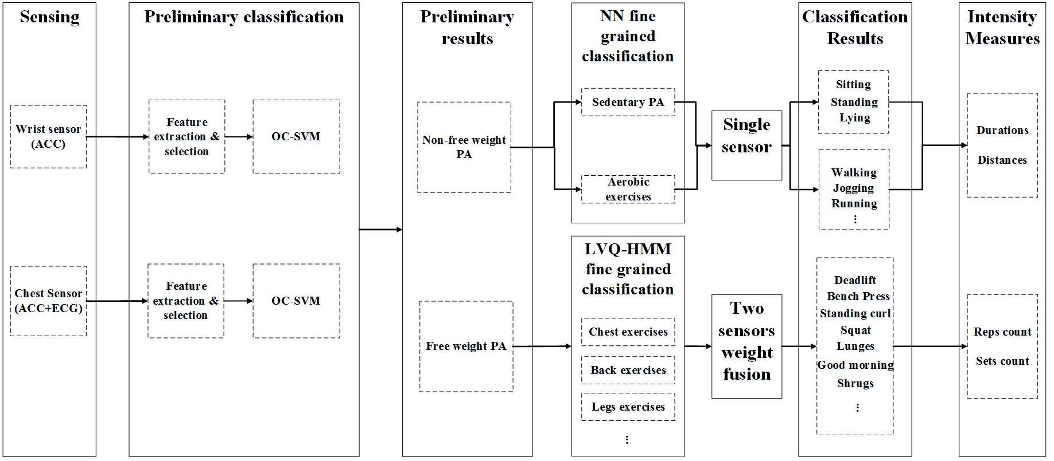
Figure 4- 8 Proposed gym physical activity recognition approach

Preliminary classification with OC-SVM model
As free weight exercises are instant and intensive compared with other physical activities such as walking and sitting, the first step in the framework is to distinguish free weights from non-free weight activities. This is a typical issue of binary classification if the non-free weight activities are denoted as positive samples, and the free weights are negative samples. However, there are only small portions of free weight activity volumes within our GPA dataset owing to the fact that our data collections are from real training scenarios, in which rest periods between sets vary from 30 seconds to five minutes depending on training levels. Normally, it takes 2.5 to three minutes to recover from a set of intense exercise [196]. On the contrary, the weight training period of a set is around one minute or less. Also when mixed with other activities free weight samples are difficult to capture for binary classification. Therefore, OC-SVM is designed in the first level of GPARMF. We use support vector domain description (SVDD) such as that proposed by Tax et al. [189] to separate non-free weight and free weight activities. Instead of a conventional OC-SVM that finds a hyperplane to separate target samples from the origin using maximum separation, our algorithm maps all target samples which are non-free weight activity features into high dimensional feature space through a radial basis function (RBF) kernel function and computes the surface of a minimal hypersphere with all positive samples. The outliers are the regions with densities lower than the given threshold, and are then classified as free weight activities.
Let $A_{nw}=\{a_{nw1}, a_{nw2}⋯a_{nwm}, m∈R\}$ as non-free weight positive samples, and x as the centre of hypersphere, R as the radius, so the optimal form that involves positive samples is:
$min⁡(R^{2}+\frac{1}{vl}\sum_{i=1}^{l}{ξ_{i})}$ (4-3)
Subject to:
$\left\|ϕ\left(a_{nwi}\right)-x\right\|≤R^{2}+ξ_{i}$ ($ξ_{i}≥0;i∈m$) (4-4)
Where $a_{nwm}$ is the $i^{th}$ non-free weight training pattern, m is the total number of training patterns, and ${ξ=[ξ_{1},⋯,ξ}_{i}]$ is the vector of the slack variables, which is to optimize the function margin to be convergent.
In the GPARMF, we assume that frequency of arm swings is slower in performing free weight than non-free weight activities. And arm movements are presented the way of up and down in most of free weights, while they are back and forth in aerobics and static or irregular movements in sedentary situations. Hence to differentiate the two classes, the interval of signal peaks, mean and variance are adopted to set the threshold, and we have the following rules:
$if f_{i}\left(x\right)>y, then x∈\{free weight\};$
$iff_{i}\left(x\right)<y, then x∈\{non-free weight\}$ (4-5)
Where $f_{i}\left(x\right)$ is the SVM decision function and y is the threshold defined by Eq. (6)
$y=d_{i}+m_{i}+v_{i}$ (4-6)
Where $d_{i}$, $m_{i}$ and $v_{i}$ are the distance between peaks, mean and variance computed from all decision function values in terms of Gaussian distribution.

Free weight classification with HMM
A free weight activity is composed of different postures and activities in order. For example, when an individual performs the activity bench press, he/she would first lie on the bench, and then lift and hold the barbell, next press, and repeat pressing, after that, put back the barbell and keep lying or sitting up. (Described as a series of activities: lie->hold barbell->press->... (Repeat pressing)-> put back barbell->sit to rest->…). To build the recognizer, there are two stages: 1) the training stage, and 2) the recognizing stage.
- Training stage
In this stage, representing the combination of postures and activities with a series of sequences means it is essential to use an HMM approach. As an HMM is a collection of finite states connected by transitions, let $λ=\left(A,B,π\right)$ be a free weight activity recognition model, as it is shown in Figure 4-10, where A is the matrix of activity state transitional possibilities, denoted as $A=\left\{A_{i,j}\right\}$, where $A_{i,j}$ is the activity state transition from state i to state j. B is the matrix of emission possibilities, denoted as $B=\{B_{i,j}\}$. And $π$ is the vector of the initial probabilities state n. Observation sequence O$=\left\{O_{1}, O_{2}⋯,O_{t}\right\}$is the input observation state from accelerometer’s signals at time t. And hidden state is denoted as $I=(i_{1},i_{2},⋯i_{t})$, the set of time is $T=(t_{1},t_{2},⋯t_{m})$.
Training an HMM is the procedure of maximizing the probability of the observation sequence $P(O|λ)$, where
$P\left(O | λ\right)=\sum_{I}{P(O|I,λ)P(I|λ)}$ (4-7)

And then Baum-Welch algorithm is employed for building a free weight activity HMM. Let $\left(O,I\right)=(o_{1},o_{2},⋯,o_{t},i_{1},i_{2},⋯i_{t})$ be all states, $\hat{λ}=(\hat{A},\hat{B},\hat{π})$ be the re-estimation from $λ=\left(A,B,π\right)$, so to obtain the maximum log-likelihood, we have
$argmax\sum_{i∈I}{logP\left(O,I;λ\right)P\left(I | O;\hat{λ}\right)}=argmax\sum_{iϵI}{\log{P\left(O,I;λ\right)}P\left(I,O;\hat{λ}\right)=argmax\hat{L}(λ,\hat{λ})}$ (4-8)
Where
$P\left(N,O;λ\right)=\prod_{i=1}{(π_{i_{1}}B_{i_{1}}(O_{1})\prod_{t=2}^{T}{{A_{i_{t-1}i_{t}}(O_{t})B}_{i_{t}}(O_{t})})}$ (4-9)
And Eq. (4-8) and Eq. (4-9) give

$L\left(λ,\hat{λ}\right)=\sum_{i∈I}{logπ_{i_{1}}P\left(I,O;\hat{λ}\right)}+\sum_{iϵI}{\sum_{t=2}^{T}{logA_{i_{t-1}i_{t}}}P\left(I,O;\hat{λ}\right)+\sum_{iϵI}{\sum_{t=2}^{T}{logB_{i_{t-1}i_{t}}}P\left(I,O;\hat{λ}\right)}}$ (4-10)

After applying Lagrange multipliers, the three factors in the model are:
$π_{j}=\sum_{i=1}^{I}{P(i_{1}=i|O;\hat{λ})}$ (4-11)
$A_{j}=\frac{\sum_{t=2}^{T}{P(i_{t-1}=j|\hat{λ})}}{\sum_{t=2}^{T}{P(i_{t-1}=j|\hat{λ})}}$ (4-12)
$B_{j}=\frac{\sum_{t=1}^{T}{P(i_{t}=j|\hat{λ})I(i_{t}=j)}}{\sum_{t=1}^{T}{P(i_{t}=j|\hat{λ})}}$ (4-13)
Since an HMM training only receives discrete variables, the features need to be quantified into observation symbols. To improve the reliability and accuracy of the training, all samples in our dataset are labelled, hence a learning vector quantization (LVQ) neural network [197] is adopted for the continuous observation densities. An HMM model of free weight activity consists of a range of atomic activities which are labelled as subclass for LVQ training, and then the extracted features are input as training vectors for assigning to individual classes.
Due to the complexity of free weight exercises, in order to improve its performance, we use both wrist and chest accelerometers to assess them. The results are derived from two sensor fusion, each of which is given a weight, and the final fusion will be a summation of the sensor’s Gaussian distributions based on each atomic activity, and one sensor dominates in both. For example, in the activity bench press, the chest sensor in the first atomic activity (lying) is assigned a larger weight (say 0.9), and in the second atomic activity (holding barbell), wrist sensor is initialized a larger weight than chest sensor, as it is an arm movement. Likewise, in the next movement (pressing), the wrist sensor is also a larger weight. As such, the combination from two sensors with discriminant weight during the HMM training procedure can provide more accurate outcome than a single one. The training procedure is presented in Figure 4-9.
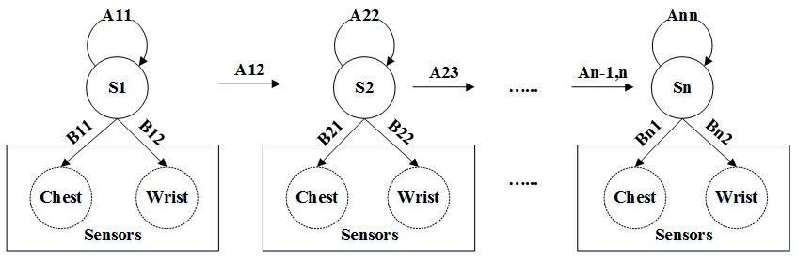
Figure 4- 9 HMM structure in GPARMF
- Recognizing stage
In the recognizing phase, the free weight activities are embedded in a range of input streams. Finding the start and end points is the key issue. The Viterbi algorithm is used in this phrase to find the most likely observation sequence at time t defined as Eq. (4-14)
$δ_{t}\left(i\right)=maxP(i_{t}=i,i_{t-1},⋯i_{1},o_{t},⋯o_{1}|λ)$ (4-14)
As such, we can find the most optimal possibility and classify it in the corresponding activity class.

Experimental Evaluation

GPA preliminary classification
We first evaluate OC-SVM performance in GPARMF. The threshold is set from three features which are peaks of distance, variance and mean whose distribution is presented in Figure 4-10. The classification result is shown in Figure 4-11, where the blue part is non-free weight activity features and red dots falling outside the circle are free weight activity features. The classification accuracy is up to 85% in this layer.
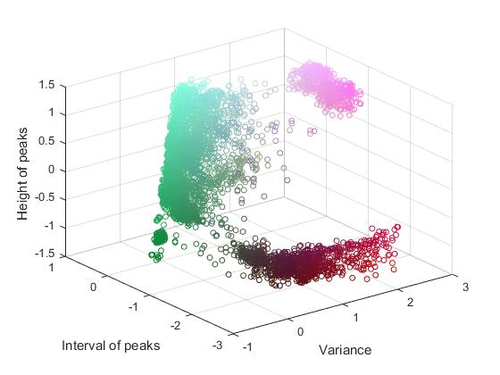
Figure 4- 10 Distribution of features of distance of peaks (pink), mean (green) and variance (red) from tri-axial accelerometers of GPAs
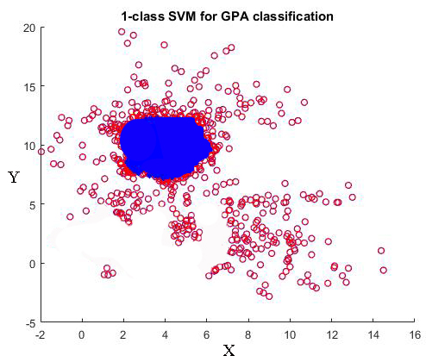
Figure 4- 11 Distribution of free weight and non-free weight activities using OC-SVM

GPA fine-grained classification
After separating free weight and non-free weight classes, we first evaluate nine non-free weight activities (6 aerobics and 3 static states) with an NN. In order to match the activity patterns, data sets are segmented as results in consecutively activated sensors on the subject’s body. Such data sets are broken down with temporal series using a time window. In the GPARMF, the sliding windows are segmented into a fixed temporal length of one second with 50% overlapping.
Due to the large number of features, dimensionality is very high with redundant information that may cause high computational complexity for the next classification procedure. Thus, we select some features using a typical dimension reduction approach principal component analysis (PCA) which reduces data dimensionality by projecting a dataset onto a lower dimensional space but keeping the most information within the datasets. In our implementation, the dimension is reduced from to $1×88$ to $1×36$ for each window size after using PCA.
Three layers (input, hidden and output layer) feedforward NNs are explored for the aerobic and sedentary activities classification. To build three layers NN models, we only make use of feature vectors from the accelerometer data of the wrist as input layers, 18 neurons assigned within the hidden layer and 9 neurons in output layer in terms of aerobic and sedentary activities. The accuracy of the NN model is evaluated by 10-fold cross-validation. The classification results are compared with decision tree (DT), k-nearest neighbours (KNN) and hidden Markov model (HMM) and show that the neural network gives the best performance as shown in Figure 4-12 and Table 4-4 (A1-A9). The precision in NN in A1 to A9 are 95.2% on average.

Figure 4- 12 Comparison of accuracy of four recognizers in non-free weight activities with only wrist accelerometer

GPA measurements

Free weight repetition calculation
A rep (or repetition) is a single movement of any exercise. We tracking the number of reps by finding peaks of the accelerometer signal in each activity set. To do so, we need to 1) smooth the raw accelerometer data; 2) standardise the axis value; 3) define the threshold in each set’s signal including minimum height of the peak and distance between two peaks. We use vertical and horizontal thresholds to define the peaks. With the majority of sets’ data we collected, the peaks are at least 20% higher than start point vertically, and distance between two peaks is 1,000 millisecond minimum. Results are shown in Figure 4-13, where (a) is deadlift peaks and (b) is squat peaks marked in green dots.

Free weight intensity and set calculation
Four intensity levels (low, medium, high, extremely high) are measured with Shimmer ECG electrons when the subject is performing a deadlift. To calculate heartrate per minute, finding out the R-R interval is essential. The threshold is set through the minimum distance of two peaks and minimum height of smoothed and detrended signals. Figure 4-12 (a) presents the R-R intervals in red dots. And Figure 4-13 (b) shows the heartrate changing states when doing free weight exercises. As we can see, in low and medium intensity, the activity is performed longer and the subject’s heartrate increases slowly. The heartrate is up to 128 beat/min in low intensity at 10s point, while it is 148 beat/min at 10s. However, in the activities of high and extremely high intensity, the heartrate increase dramatically and reach to highest point at 7s and 5s respectively in the first set. With the heartrate changing status during the activity, as such, it is also clear that the subject has done two sets in this case shown in the Figure 4-16 (a). And the procedure of processing ECG dataset is shown in Figure 4-16 (b).

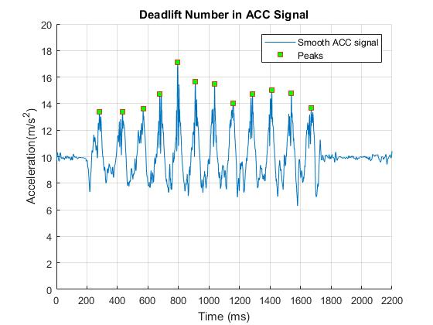
(a)
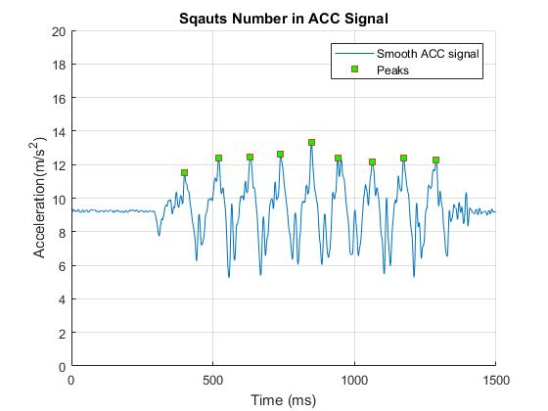
(b)
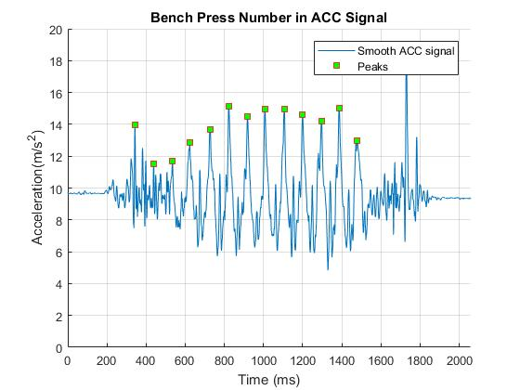
(c)
Figure 4- 13 One set of a free weight activity repetition calculates (a) deadlift numbers; (b) squat numbers; (c) bench press numbers
After recognising the exercise, we attempt to assess its intensity, and thus RM-based rules are defined in terms of Semantic Web Rule Language (SWRL) in the framework. First, the ontologically hierarchical model is constructed including concepts/classes as shown in Figure 4-14. The relationships between classes are represented as properties. In the ontological model, for example, the class of free weight exercise has five muscle group subclasses, e.g. Abs_Exercise and Back_Exercise,and each of them has 7 data properties like reps, sets and intensity listed in Table 4-3. The intensity measurement protocols are the data properties of free weight exercise class targeting on the ranges of reps of each exercise set. The ranges are sub-categorised into four levels (light, medium, high and extremely high). Each intensity rule will be automatically triggered when the reps fall in to predefined ranges.

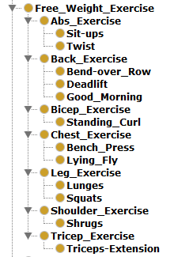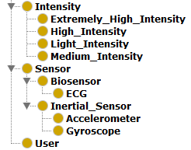
Figure 4- 14 Semantic model of free weight exercise in Protégé 5.2
Table 4- 3 GPA concept, properties and instances
Concept | Properties | Instances
User | hasName  hasBodyFat  hasHealthState  doesExercise  doesExerciseReps  doesExerciseSets  useEquipment  wearSensor | John  20%  Healthy  Deadlift  12  4  Barbell  Accelerometer
Free weight exercise | hasExerciseName  hasExerciseReps  hasExerciseSets  hasLightIntensity  hasMediumIntensity  hasHighIntensity  hasExtremelyHighIntensity | Deadlift  10  3  12  8  6  2
Equipment | hasEquipmentType | Barbell;  Dumbbell
Sensor | hasSensorType | Accelerometer; ECG

Four intensity levels (low, medium, high, extremely high) are measured with Shimmer ECG electrons when the subject is performing an exercise. The decision making intensity is implemented in protégé 5.2 with semantic modelling and SWRL rules. Figure 4-15 presents the implementation of four rules in light of the intensity levels.
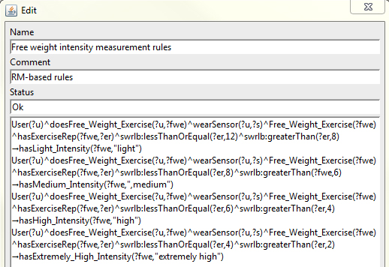
Figure 4- 15 Free weight intensity measurement using SWRL rules in Protégé 5.2

The classification results are shown in Table 4-4 and Table 4-5. Table 4-4 presents all PA recognition precision, recall and F-measure, from 76.5% up to 99.1%, by exploring NN in non-free weight exercises, whilst LVQ and HMM in free weight exercises. The free weight results also compared with DWT, NN, GMM and HMM, show that LVQ and HMM give a better performance from 76.5% to 93%.

Table 4- 4 Classification results in GPARMF
Class | A1 | A2 | A3 | A4 | A5 | A6 | A7 | A8 | A9 | A10 | A11 | A12 | A13 | A14 | A15 | A16 | A17 | A18 | A19
Precision | 97.0 | 94.2 | 99.1 | 96.9 | 88.6 | 96.6 | 98.2 | 96.7 | 95.3 | 89.6 | 90.2 | 89.6 | 90.4 | 82.6 | 82.4 | 88.4 | 82.6 | 92.4 | 91.4
Recall | 95.2 | 98.6 | 91.7 | 95.1 | 94.2 | 98.6 | 97.0 | 95.2 | 91.2 | 80.5 | 88.5 | 82.4 | 88.2 | 81.2 | 78.8 | 82.5 | 82.8 | 90.5 | 93.0
F-Measure | 96.1 | 96.3 | 95.3 | 96.0 | 91.3 | 97.6 | 96.5 | 92.2 | 92.6 | 88.6 | 92.2 | 88.6 | 91.2 | 89.8 | 80.5 | 88.6 | 76.5 | 88.8 | 86.2

Table 4- 5 Comparison of precision (P), recall (R) and F-measure (FM) of different classifiers in free weight training recognition
Classifier | A10 | A11 | A12 | A13 | A14 | A15 | A16 | A17 | A18 | A19
DTW | P: 66.3  R: 70.5  FM: 72.4 | P: 70.6  R: 71.5  FM: 80.4 | P: 80.6  R: 80.5  FM: 78.6 | P: 80.5  R: 82.2  FM: 85.3 | P: 70.5  R: 77.3  FM: 78.5 | P: 74.3  R: 79.5  FM: 76.4 | P: 81.2  R: 80.1  FM: 85.7 | P: 75.4  R: 81.5  FM: 79.0 | P: 85.4  R: 81.2  FM: 82.5 | P: 81.3  R: 76.5  FM: 85.0
NN | P: 81.3  R: 85.5  FM: 80.2 | P: 85.3  R: 88.5  FM: 90.3 | P: 81.4  R: 75.5  FM: 78.3 | P: 85.9  R: 88.8  FM: 86.7 | P: 75.4  R: 77.5  FM: 80.6 | P: 69.8  R: 71.2  FM: 77.4 | P: 75.6  R: 78.9  FM: 80.5 | P: 71.3  R: 74.0  FM: 70.8 | P: 80.2  R: 81.5  FM: 74.9 | P: 82.4  R: 85.5  FM: 86.7
GMM + HMM | P: 72.5  R: 75.2  FM: 75.8 | P: 75.4  R: 79.4  FM: 75.6 | P: 83.5  R: 82.4  FM: 88.9 | P: 91.5  R: 90.6  FM: 89.8 | P: 80.6  R: 80.5  FM: 85.6 | P: 79.4  R: 80.8  FM: 82.2 | P: 85.4  R: 82.3  FM: 80.6 | P: 78.3  R: 79.4  FM: 80.5 | P: 88.7  R: 90.8  FM: 92.0 | P: 89.8  R: 91.2  FM: 85.6
LVQ + HMM | P: 89.6  R: 80.5  FM: 88.6 | P: 90.2  R: 88.5  FM: 92.2 | P: 89.6  R: 82.4  FM: 88.6 | P: 90.4  R: 88.2  FM: 91.2 | P: 82.6  R: 81.2  FM: 79.8 | P: 82.4  R: 88.8  FM: 80.5 | P: 88.4  R: 82.5  FM: 88.6 | P: 82.6  R: 82.8  FM: 76.5 | P: 92.4  R: 90.5  FM: 88.8 | P: 91.4  R: 93.0  FM: 86.2

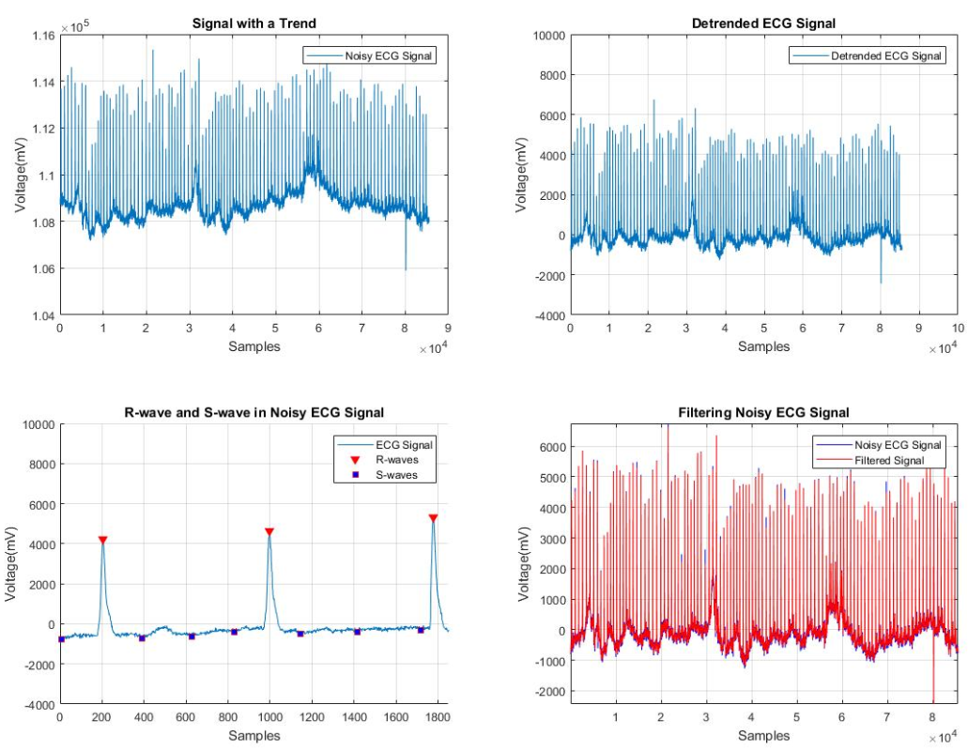
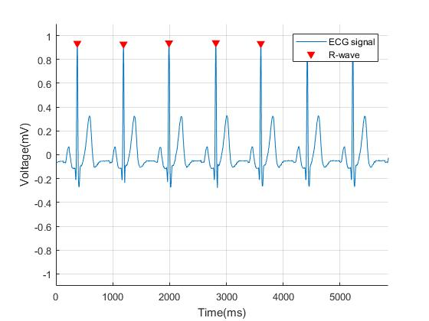
(a)
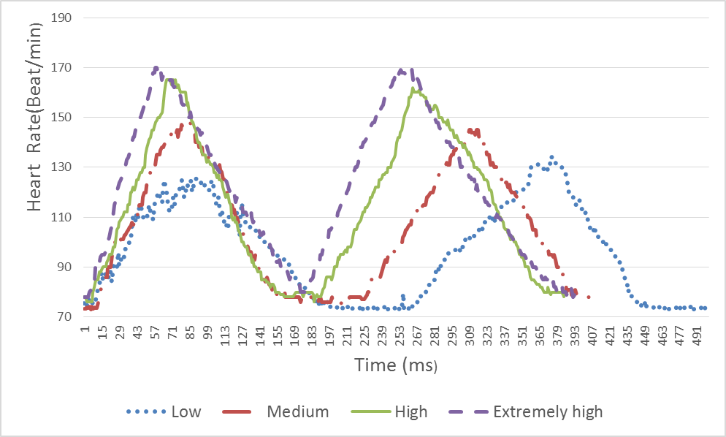
(b)
Figure 4- 16 Heartrate per minute using ECG (a) finding R-R intervals; (b) two sets of a free weight activity with low intensity (8-12RM) in blue line, medium intensity (6-8 RM) in red line, high intensity (4-6 RM) in green line and extremely high intensity (2-4 RM) in purple line.

Summary
Regular PA is essential for human health. There are a number of studies that contribute to the field of physical activity recognition and monitoring. However, there are still a large range of activity types that have not been explored. In this chapter, with accelerometers and ECG, we build a gym physical activity recognition and measurement framework (GPARMF) that is capable of classifying 19 gym physical activities including free weights, aerobic and sedentary activities. The framework is divided into two layers based on the non-free weight boundary. An OC-SVM is applied in the first layer to separate free weight and non-free weight activities in light of a given threshold, and in the second layer, NN and HMM are adopted to classify non-free weight and free weight activities respectively. In addition, LVQ is used to quantize feature vectors for continuous input to the HMM, which gives the better performance than a GMM and other classifiers. Furthermore, GPARMF, based on the RM principle, evaluates the intensity of free weight exercises with changing heartrate within a user’s natural environment. It is also capable of calculating repetitions and sets for each free weight exercise.

Chapter 5. Lifelogging PA data with irregular uncertainties

Introduction
As a key indicator in a number of conditions such as obesity, diabetes and other chronic diseases, effective measurement and monitoring of physical activity is critical in order to design programs for preventing/treating metabolic syndrome and chronic diseases (e.g. obesity, diabetes or arthritis). Measuring physical activity and the associated estimates of instantaneous and cumulative energy expenditure (EE) in the long term enable clinical decision making and provides important feedback to caregivers in order to assess a patient’s symptoms and thus achieve a healthy lifestyle. While the IoT has prompted renewed interest in healthcare areas where a number of PA sensors and monitors have been developed for capturing lifelogging physical activity information and providing continuous, real-time feedback to users.
However, due to inherent commercial drivers, nearly all of the popular wearable devices and mobile phones in the market focus more on personal fitness and exhibit a lack of compatibility and extensibility. In addition, as a result of the heterogeneity of connected devices and rapid change of diverse life patterns in an IoT environment, lifelogging physical activity information captured by mobile devices usually contains much uncertainty. Effective and efficient validation of big volume, highly dynamic and multi-dimensional personal lifelogging physical activity data becomes an extremely challenging task. Traditional methods use either dedicated wearable sensors [29], [36], [38], [52] or advanced machine learning algorithms [10]–[163] to accurately monitor lifelong PA and assess activity patterns and intensity level. Most of these methods, however, process and analyse human behaviours through raw sensor data of a single sensor or a combination of GPS and accelerometer. In contrast, in IoT-based personalized healthcare systems, PA data is generated on a daily basis from globally heterogeneous third party devices. As such, physical activity validation is harder to handle by virtue of scattered and heterogeneous data sets. Almost no literature to date reports successful validation of heterogeneous physical activity from different resources in an IoT healthcare environment.
Recently, many commercial wearable products and mobile applications have been released that support long-term recording and collection of personal health information, particularly on PA. Popular mobile apps, such as Moves [19], are based on smartphone 3D accelerometer data and GPS information which allows tracking user movement activities including location, distance and speed. The wearable products, such as Fitbit Flex [18], Nike+ Fuelband [161], Withings [200] and Endomondo [162], are all wristband devices that record steps count, distance, and calories burnt. A brief comparison of above products is listed in Table 5-1 and explained in detail below:
- Endomondo is a popular GPS based mobile application for tracking route, distance, duration, split times and calorie consumption. It offers a full history with previous workouts, statistics and a localized route map for each workout.
- Moves is also based on the use of GPS to record the user’s path, speed, distance and elevation while they walk, run, and cycle (or do any activities) outside.
- Google Fit can automatically detect walking, running and cycling. It also works with Android wear, and supports third-party devices and apps. Visual graphs are available to observe the user’s physical activity changes.
- Cyclemeter can accurately assess cyclists’ activities and record bike related data, e.g. bike speed, bike cadence and power. It also tracks the user’s steps while walking and running. There is no valid API that can be accessed by third-parties.
- Fitbit Flex records steps taken, distance travelled, and calories expended. These devices communicate with a host computer using Bluetooth that in turn sends data directly to a user’s account on the Fitbit website.
- Nike+ Fuelband is worn on the wrist and records calories, steps, distance, and Nike’s own unit of activity term “Nike Fuel”. The device connects via USB to a host machine which synchronises the data to a user’s account on the Nike+ website.
- Jawbone Up calculates steps, distance and calories. Currently the Jawbone up can only be used with a mobile device, drivers for laptop and PCs are not provided.
- Misfit is a low cost and light wearable band. It records basic steps, sleep and calories that can be synchronised to a mobile app on the user’s phone.
These wearable devices communicate with a mobile phone via Bluetooth running the relevant mobile application. While the above products have proven their popularity among general users, their usage is limited in the fitness field. This is due to a diversity of life patterns and environmental impact since personal physical activity data from an individual wearable device exhibits remarkable uncertainty. The validity of physical activity data in lifelong healthcare cases is very challenging. Also, with the rapid growth in the mobile healthcare market, numerous similar wearable products have been developed, which significantly increases the heterogeneity and diversity of devices connected in IoT-based personalized healthcare systems.
Table 5- 1 Pros and Cons of existing life-logging PA measure devices
 | Product | Data | Pros | Cons
Mobile Apps | Endomondo | Route, distance, speed | Community sharing, Android and iOS | Short battery longevity, does not work indoor
Mobile Apps | Moves | Route, distance, speed | View data live, application program interface (API) support | Short battery longevity, does not work indoor, step counter not precise. Android only.
 | Google Fit | Duration, distance, steps, calorie | Connected to the android wear, manually choose different types of activity in the list | Heat beat value not correct
 | Cyclemeter | Duration, distance, calorie | Accurately records bike related data as well as steps | No supported API
Device | Fitbit Flex | Steps, calories, food | Low cost, Android and iOS, long battery life  Reasonable cost, Android and iOS  Reasonable cost, Android and iOS | Limited application program interface (API)
Device | Nike+ | Steps, calories, food |  | Variations on accuracy
Device | Jawbone Up | Steps, distance, calorie |  | No application program interface (API)
 | Misfit | Steps, calories, distance, sleep | Low cost, Android and iOS | Variations on accuracy

Classification of data uncertainty in IoT healthcare systems
In an IoT-enabled healthcare system, lifelogging healthcare data is ultra-diverse, dynamic and multi-dimensional. Regarding physical activities, accuracy of lifelogging data is widely impacted by a variety of issues, including devices, ages, gender, activity subjects, etc. Thus, uncertainties of lifelogging PA data are distributed differently, and occur persistently according to these issues. Also, considering the dimension of time, the increment of lifelogging physical activity data over a given timeline results in an expansion of the entire data, further leading to more complex uncertainties. In this section, we attempt to classify data uncertainty in IoT healthcare systems by three important factors: person, time and devices, as shown in Figure 5-1. In terms of the concept of IoT, personal health data is accumulated and measured as a cube in three dimensions (3D): Persons, Devices and TimeLine. The increment in any dimension results in an expansion of the health data grid. The products like Fitbit Flex [18] or Moves [201] occur on a 2D plane (Persons × TimeLine), which refer to scenarios in which a single device is used by an increasing population over time. Similarly, physical activity recognition with sensor fusion [45], [46], [102] appears on a 2D plane (Devices × TimeLine) for classifying an individual person’s activities with historical health data.

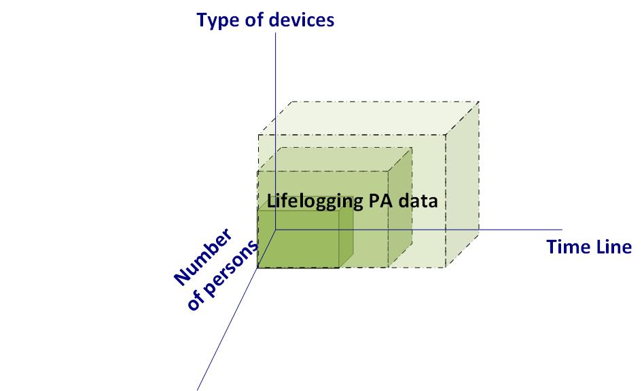
Figure 5- 1 Concept of IoT personalized healthcare systems

Deal with irregular uncertainties with Ellipse fitting model

Ellipse fitting model for removing irregular uncertainties
After classifying the above two types of uncertainties, it is important to clearly understand the distribution of IU and RU. Typically in an IoT environment, the level of physical activity is assessed and represented by the number of steps walking per day, named as Daily Steps $S_{d}$, or the distance walking per day, named as Daily Walking Distance: $D_{dw}$. Current wearable devices or smartphones also enable measuring walking speed related information, like Daily Walking Speed $V_{daw}$. Therefore, our inspiration for managing the above two types of uncertainties is to build a 2D distribution of physical activity regarding two benchmarks: Daily Walking Steps (Steps) and Daily Walking Speed (Speed). In terms of the characteristic of two uncertainties, the distribution of daily physical activities with normal life pattern and wearable devices can be conducted to follow a condition that: a centroid point P marks by an average ${DWS}_{s}$ and an average DWS. Although there are some points which might fall into the normal range (e.g., 4,000 steps/ hour), here only estimation of the best fit of samples for individuals is taken into account, and thus the distance from the centre to the perimeter along the x and y axis are distributed a certain range close to the mean. Accordingly, the daily physical activities with regular uncertainties will be regularly all around point P; the daily physical activities with IU will be some distance away from point P. As shown in Figure 5-2, the x axis represents walking speed and the y axis represents daily walking steps. The light points represent daily physical activities with regular uncertainties; and the dark point represents daily physical activities with IU. Regarding this assumed distribution of physical activity, we are able to use an ellipse shape to separate RU and IU. In Figure 5-2, the dark dots that fall outside of the ellipse represent the IU. The light dots are the regular physical activity data with RU covered by the ellipse modelling algorithm.
Figure 5- 2 Distribution of PA with IU and RU
Figure 5-2 presents the physical activity samples distribution. In order to enclose points $P:\{P_{1},P_{2},…,P_{n}\}$ in the 2D plane, we use an ellipse $ε$ to cover all the points with RU: $P_{n}$. The ellipse with central point (i, j) and semi-axes m and n can be defined in equation (1):
$\frac{{(x-i)}^{2}}{m^{2}}+\frac{{(x-j)}^{2}}{n^{2}}=1$ (5-1)
Where:
i: Average daily walking speed
j: Average daily walking steps
m: Error range of average daily walking speed
n: Error range of average daily walking steps
Additionally, the benchmark of DWS can be extended to represent a person’s physical fitness from completed physical activity data sources. Here a walking speed related score is defined to represent a person’s physical fitness, named Daily Activity in Physical Space (DAPS). This score is inspired from earlier work [179] that proposed a Movement and Activity in Physical Space score as a functional outcome measurement for encompassing both physical activity and environmental interaction. Currently, most third party APIs of wearable devices or mobile apps provide functions to assess the intensity of physical activity regarding walking speed. For instance, Fitbit [18] classifies the intensity of daily activities into Very Active, Moderately Active, Lightly Active and Sedentary; Moves [201] records a series of walking segments containing duration, distance and speed. Here, we classify the intensity of daily physical activity into N levels in terms of the ranges of walking speeds $(V_{1},V_{2},…,V_{n})$. The DAPS formula is created by summing these different level walking speeds:
(5-2)
Using the data of DAPS and Daily Steps, we can calculate $V_{daw}$, and plot $S_{d}$ and $V_{daw}$ in 2D diagram as in Figure 5-3. A noticeable issue here is that we only consider the lower limits of walking steps and the upper limits of walking speeds as threshold parameters. On some days users might walk distinctly more steps than normal, while other days might be more sedentary. The threshold parameters are represented in equation (3):
$T_{y}=i+m$;
$T_{s}=j-n$ (5-3)
Thus, the strategy for removing irregular uncertainty will follow the steps below:
- To configure the information related to the IoT environment and collect certain types of raw physical activity (PA) data.
- To calculate the parameters $S_{d}$, $D_{dw}$, $V_{daw}$ with raw data.
- To plot the data of $S_{d}$, $D_{dw}$, $V_{daw}$ and calculate the value of $T_{s}$ and $T_{y}$ with an ellipse filtering equation to cover data with a confidence interval of 95%-99%. The confidence defines that 95%-99% of all samples can be drawn from the underlying Gaussian distribution. The value of confidence depends on the different sample distribution. For instance, when the data is scattered and disordered, the value can be set to be 99% so that it covers a wider range. In contrast, when the data is insensitively aggregative, the value can be set to be 95% to enclose the best fit.
- To use $T_{s}$ and $T_{y}$for removal of irregular uncertainty physical activity data.
- To iterate the above process in another time period with updated raw data.
The following rules are also applied:
- Following the ellipse filtering equation, we can get the value of $T_{s}$ and $T_{y}$ .
- For daily physical activity data, if daily walking steps is lower than $T_{s}$, or average daily walking speed is lower than $T_{y}$, we will abandon this data.

Performance Evaluation of Ellipse Fitting model
In order to evaluate the performance of our proposed ellipse fitting model, we use the life-logging PA data collected from a research platform MHA [20]. This platform is an IoT enabled personal healthcare experiment platform connecting Moves, Fitbit Flex and Withings. This platform enables a user to transfer their physical activity data from these third party providers into the MHA server, and then to be able to visualize and analyse this information to gain a better understanding. The evaluation of irregular uncertainty distribution is based on the MHA platform. We initially collected daily physical activity (Steps, Distance and Calories) of seven users over one year using three types of wearable device (Withings, Fitbit Flex and Moves). All these users (one female and six male) are researchers in a university, and their ages are in the range of 30-50 years old. The methodology for evaluating the performance of our ellipse fitting model includes four steps: A) Evaluation of the overall physical activity distribution; B) Evaluation of an individual PA distribution; C) Evaluation of the group PA distribution; and D) Effect of the changed confidence interval.

Evaluation of the overall PA distribution
Firstly, we calculate $V_{daw}$ , and plot $S_{d}$ and $V_{daw}$ in a 2D diagram with the overall set of “Moves” and “Withings” data from randomly selected individuals.
The features of this physical activity data are:
- All seven people use Moves. Two of them additionally use “Withings”, and another three people use Flex.
- Data are frequently lost in Withings and Flex because users easily forget they are wearing them.
- Some data in Flex shows lower steps, which is because users take off their wearable devices sometime during the day, or the devices run out of battery power.
- Moves data are more complete than Flex or Withings, but with relatively high errors.

Based on these PA data, the ellipse fitting method is used to cover the distribution of all data. Some facts are concluded:
- Daily steps of an individual recorded by Moves are about 4,000 – 7,000,
- Flex or Withings give daily steps about 6,000 – 13,000.
- Moves gave a lower measurement of daily steps than Flex or Withings with the same conditions.
- Healthy people should have daily steps in the range 1,000– 20,000.
- Flex and Withings sometimes show daily steps below 1,000.
- Following equation (3), we can get $T_{s}$ = 68, and $T_{y}$ = 0.56 for Moves, and $T_{s}$ = 1329, and $T_{y}$ = 1.67 for Flex.
For dealing with overall PA uncertainty, the proposed ellipse-fitting model allows us to obtain two parameters $T_{s}$ and $T_{y}$ to effectively filter IU.

Evaluation of an individual PA distribution
While our ellipse-fitting model works with overall physical activity data, it is also necessary to know its performance on an individual activity distribution. We randomly selected four individual persons’ PA data to see if their distributions still work with the proposed ellipse-fitting model. Figure 5-3 shows four individuals’ daily steps and speed acquired from the mobile personalized healthcare platform MHA [20] connecting the mobile app “Moves”. The confidence value of ellipse fitting is 0.95 for each individual, which means that 95% of samples fall inside the defined region based on a Gaussian distribution. The features of this PA data are:
- Four persons have a different PA distribution pattern.
- Two persons’ PA data have a dense distribution, which reflects that their life patterns and mobile devices are relatively stable.
- Two persons’ PA data have a sparse distribution, which indicates that their life patterns are irregular; or their mobile devices have some larger intrinsic errors.
- Subject A’s regular daily steps are significantly less than subject B and D.
- Subject C and D have fairly sparse physical activities during the test period. On the contrary, their speed is relatively similar, ranging from 0.5 up to 2.2 m/s.
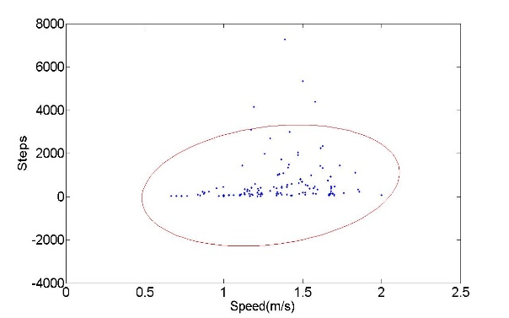
(a)
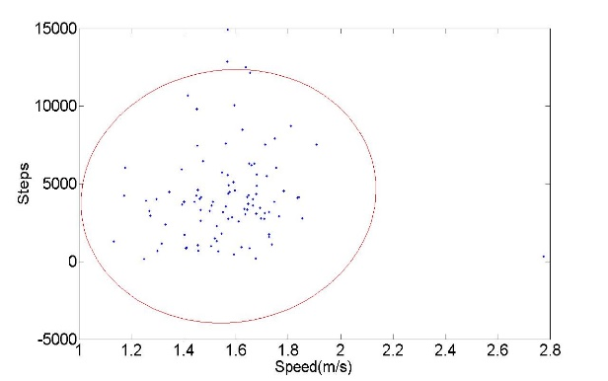
(b) 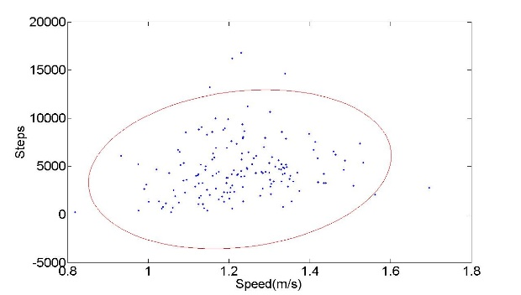
(c)
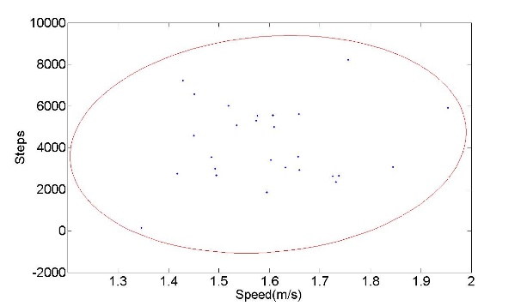
(d)
Figure 5- 3 Ellipse fitting distribution of daily steps and speed of four subjects, respectively (c=0.95) (a) subject no.1; (b) subject no. 2; (c) subject no.5; (d) subject no.12
Table 5- 2 Values of four individuals (m, n, $T_{y}$, $T_{s}$)
 | m | n | $$T_{y}$$ | $$T_{s}$$
P1 | 2451.2 | 0.6979 | 2967.4 | 0.5997
P2 | 7135.2 | 0.4924 | 11333 | 1.0796
P3 | 7225.9 | 0.3233 | 11921 | 0.9034
P4 | 8476.8 | 0.4639 | 13676 | 1.0265

Table 5-2 shows m, n, $T_{y}$, $T_{s}$ values of four individuals in terms of equation (5-1) and (5-3). The results of the first subject (P1) are relatively different from others. Most of the individuals, however, have closed parameters from their activity patterns. In other words, diverse physical characteristics (i.e. height, weight, age, etc.) do not lead to a significant difference in physical behaviour measurement.
In summary, different subjects have different physical activity distribution patterns. The ellipse-fitting model is still able to work with these data, but the shape and axes angle of ellipse are different for each person. The key parameters of the ellipse will be varied in terms of an individual’s circumstance. Further, the parameters $T_{s}$ and $T_{y}$ for filtering IU will be also varied in terms of individuals.

Evaluation of the Group PA distribution
We further consider evaluating the performance of our ellipse fitting model on certain groups of personal PA distribution. We randomly selected three groups of personal physical activity data:
- Group_1 (Subject 1, 2, 3)
- Group_2 (Subject 4, 5, 6)
- Group_3 (All subjects)
Figure 5-3 (a), (b) and (c) respectively shows the physical activity distribution for the above three groups. The confidence value of ellipse fitting is also 0.95 for each group, which means that 95% of samples fall inside the defined region based on a Gaussian distribution. The features of this data are:
- The three groups have a similar physical activity distribution pattern.
- The physical activity data on walking speed of each group is within a very close interval (0.5~2.5).
- The physical activity data on daily steps of each group differs within intervals, which are (0~500), (0~1000) and (0~2000).
- The physical activity data on daily steps of each group is similar within intervals, which is in the range of (0~20000).

Table 5- 3 Values of the three groups (a, b, $T_{y}$, $T_{s}$)
 | a | b | $$T_{y}$$ | $$T_{s}$$
G1 | 7547.4 | 0.6295 | 10551 | 0.7068
G2 | 7083.7 | 0.5378 | 11635 | 0.9416
All | 7602.4 | 0.6246 | 10900 | 0.7309

Figure 5-4 shows that different groups of subjects have different physical activity distribution patterns. Our ellipse fitting model is still able to work with this data, but the shape and axes angle of ellipse are different by groups. Further, the parameters $T_{s}$ and $T_{y}$ for filtering IU will be also varied in terms of groups. However, the ellipse fitting model encloses different groups with different data distributions.
From Table 5-3, we can see that data in group 2 (G2) are quite scattered and most of them are distributed in the range of (2,500-10,000), compared with the range (0-8,000) in group 1 (G1), leading to a bigger average value of daily steps (a), which is the k value defined in equation (5-1). And thus, although its a and b value are smaller than group 2’s, $T_{y}$ and $T_{s}$ are outnumbered. This also implies that some subjects in group 2 keep irregular uncertainties that are far more than in normal situations. Nevertheless, there is no great influence on the overall measurement with only a few irregular samples, which strongly demonstrated that our ellipse fitting model is adaptive for different occasions.
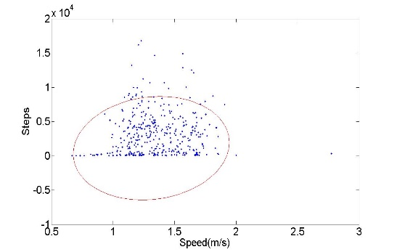
(a)
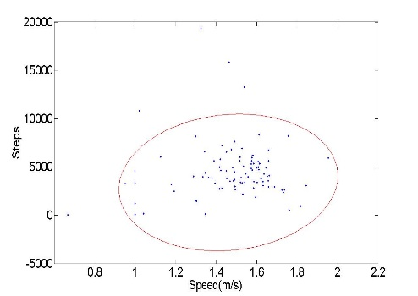
(b)
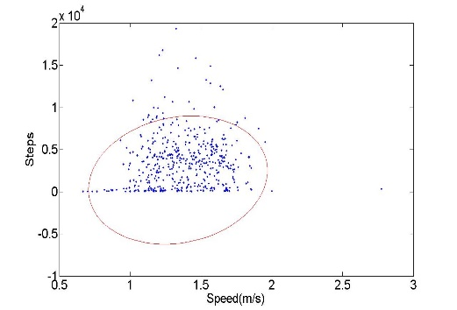
(c)
Figure 5- 4 Ellipse fitting distribution of daily steps and speed of selected subjects (c=0.95) (a) group 1 (subjects no.1 & no.2 & no.3); (b) group 2 (subjects no.4& no.5 & no.6); (c) all subjects.

Impact of Central Point
Another key parameter for the proposed ellipse fitting model needs to be considered: the central point of ellipse (i, j). Regarding the definition in equation 1, the central point represents the value of average daily walking steps and the value of average daily walking speed. But a number of ways are available to calculate the average mean in literature. Here, we choose two typical methods to measure the mean of distribution: geometric mean and arithmetic mean.
A comparison of the geometric mean and arithmetic mean set for the central points of the data distribution is presented in Figure 5-5. The red ellipse is modelling with arithmetic mean: the range of steps is 0-10,000, and the speed is between 0.7m/s-1.9m/s on average. The green ellipse is modelling with geometric mean: the range of steps is 0-8,000, and the speed is 0.4m/s-1.8m/s. It appears that the green ellipse covers fewer samples than the red ellipse but the gap between them is not large. This means that both samples are distributed in balance and regular on average daily walking speed. But, daily walking steps differs by individual, leading to an apparent gap between geometric mean and arithmetic mean. Although there is only a slight difference between the two central points, the arithmetic mean covers more samples than the geometric one, and thus achieved a better result.
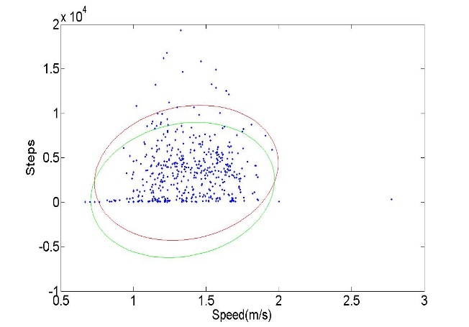
Figure 5- 5 Different central coordinate of ellipse fitting (green: geometric mean; red: arithmetic mean)

Comparison with other fitting methods
Two curve fitting methods (Smoothing Spine fitting and Gaussian fitting) are carried out in order to compare with our ellipse fitting model, shown as equations (3) and (4).
$y=p\sum_{i}{w_{i}{(y_{i}-s(x_{i}))}^{2}+(1-p)\int{{(\frac{d^{2}s}{{dx}^{2}})}^{2}dx}}$; (5-4)
$y=\sum_{i=1}^{n}{a_{i}e^{\left[-{(\frac{x-b_{i}}{c_{i}})}^{2}\right]}}$; (5-5)

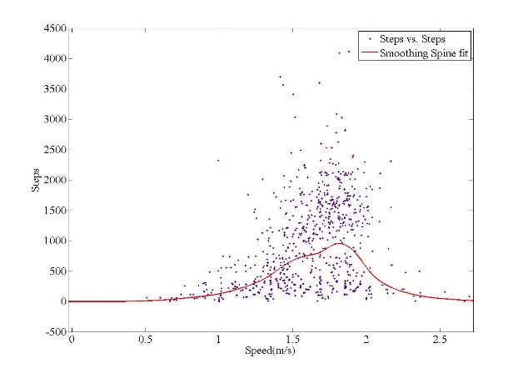
(a)
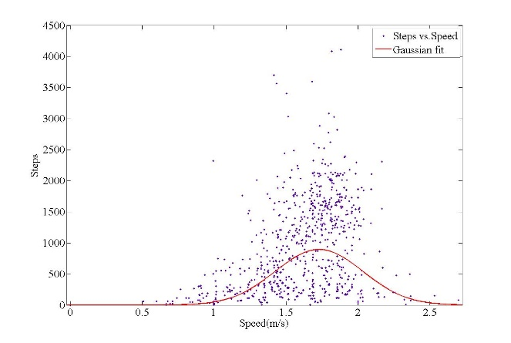
(b)
Figure 5- 6 1D fitting results (a) Smoothing Spine fitting; (b) Gaussian fitting
In formula (5-4), p defined in the range 0 to 1, from a least-square straight-line fitting to cubic spline interpolant. Formula (5-4) is based on the Gaussian distribution presenting the numbers of Gaussian peaks. In Figure 5-6 (a), the smoothing parameter p = 0.95 is selected to produce a relatively smooth curve. Nevertheless, as the raw samples are abundant but aggregated, we can see an amount of data in a normal step and speed range are above and outside of the curve. In comparison with our ellipse model presented earlier, the 1D fitting functions shown in Figure 5-6 hardly fit in our data samples. Therefore, the ellipse fitting model performs better among the three fitting method applying in this situation.

Evaluation among devices
In this section, we discuss the performance evaluation of our proposed method in a case study on the MHA platform [20]. The criteria for verifying our validation model will concentrate on the efficiency and adaptability of the method.
Table 5- 4 Removing IU
 | Moves | Fitbit Flex | Withings
$T_{s}$ Daily Steps | 4303 | 6872 | 5267
$T_{y}$ DAPS Speed (m/s) | 2.0 | 4.0 | NA
Total number of people | 14 | 5 | 3
Percentage of people with IU | 43% | 100% | 100%
Number of IU occurrence | 40 | 17 | 8
IU confirmed by user | 40 | 15 | 5
Average number of IU occurrence per person (User Feedback) | 6.6 | 5.4 | 2.7
Accuracy of identifying IU (95%) | 100% | 88.2% | 62.5%
Accuracy of identifying IU (98%) | 100% | 100% | 100%

The dataset from the MHA platform includes year-long daily physical activity information of 14 subjects acquired with three devices: Moves was used by 14 users for nine months; Flex was used by five users for 12 months; Withings was used by three users for three months. These people are healthy in the age range of 30-50 years. The evaluation methodology for verifying the efficiency of the proposed model involved interviews with the participants, collection of feedback reflecting on users’ experiences on their physical activity uncertainties through different devices. The feedback is used as a standard benchmark to compare the correctness of the model.
In order to validate the accuracy of identifying IU, we follow equation (5-2) and (5-3) with a confidence interval of 95% to filter data from three different devices. We use the values (130, 1784, 884) of threshold parameter $T_{s}$ respectively in Moves, Flex and Withings, for filtering incorrect daily steps data. The results are shown in Table 5-4.
Moves has much lower threshold parameters of Daily Steps and DAPS speed than Flex and Withings which are 130 and 0.5 m/s respectively (Table 5-4). This is because Moves has larger device uncertainties than Withings and Flex as we observed in section 4. Thus the GPS and smartphone internal sensors-based App is not as accurate as an accelerometer-only based wrist wearable device. In terms of percentage of people having IU, Moves is much lower than Withings and Flex. It is because most of the uncertainties from Moves have been classified into regular uncertainties, so its irregular uncertainties became less than for other two devices. However, for average IU occurrence per subject, Moves has higher performance than other two devices (Table 5-4). The accuracy of identifying IU appears that on the condition with a confidence interval of 95%, the related value of threshold parameter $T_{s}$ can successfully filter IU in Moves. So Moves has the best IU identification accuracy up to 100%, which means that the incorrect daily steps detected by equation (3) in Moves have been all approved by users. Flex and Withings have accuracy up to 88.2% and 62.5% respectively, which implies that some correct daily steps are eliminated by our method. The increase of confidence interval will have an effect on filtering accuracy of IU. If we increase the confidence interval up to 98%, and recalculate threshold parameters, the accuracy of identifying IU of three devices would increase to 100%. However, a noticeable issue here is that if we increase the confidence interval, some IU might be ignored and put into the procedure of dealing with RU. Similarly, in Moves, a high accuracy of identifying IU does not mean all the IU have been removed but more likely that some of the IUs are considered as regular uncertainties.
For validating the adaptivity of the proposed ellipse fitting model, we consider the whole group of 14 subjects as one group due to the similar professions and backgrounds. We estimate the change of daily steps $T_{s}$ and DAPS with different periods (from one to 12 months) with a confidence interval of 95%. The results are shown in Figure 5-7.

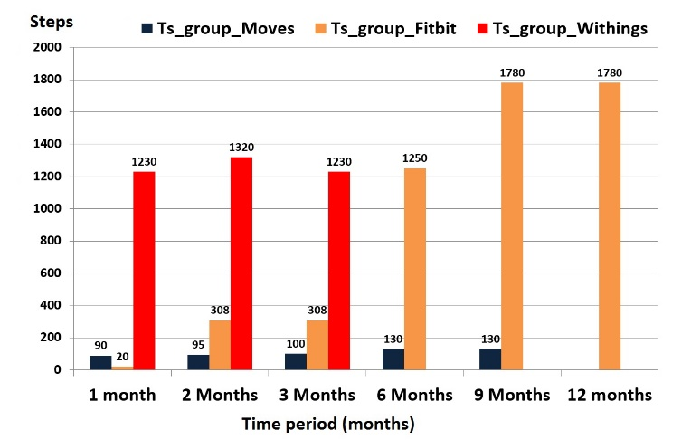
(a)
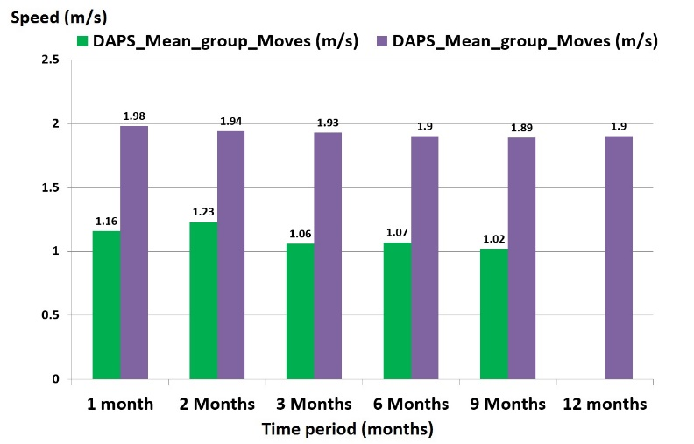
(b)
Figure 5- 7 The function of time period duration (a) Average of daily steps as the function of time period duration; (b) DAPS as the function of time period duration
Figure 5-7 (a) shows the parameter Daily Steps as the function of time period duration. The value of this parameter is lower for shorter time periods than for longer time periods. The value of this parameter also varies with different devices. For Moves and Withings, the value of this parameter over different periods is growing slightly, but for Fitbit Flex, this parameter dramatically increases after six months. This effect may be influenced by the setting of the confidence interval.
Figure 5-7 (b) shows little variation of DAPS parameter in the proposed method when the time period duration is changed. There are some minor fluctuations of DAPS on both Moves and Fitbit Flex but in the long term, the value of DAPS is quite stable, which indicates that personal physical fitness does not have significant differences within this group of 14 people.

Discussion and summary
There are several obvious concerns of the method proposed in this section. First, the scalability of our proposed ellipse-fitting model-based validity improvement method for dealing with increased volume and types of health data has not been considered in this section. In a practical IoT-enabled healthcare environment, personal health information will be a life-long collection. The practical efficiency on multi-type health data in a long-term collection needs further evaluation. Second, the evaluation of data validation efficiency and regular uncertainty indicator for our proposed method is subject to a small number of users’ feedback due to the long duration of data collection and huge cost of human effort (i.e., data standardization). The standardized criteria of judging correctness and efficiency of the ellipse-fitting model-based validity improvement method on removing and estimating uncertainties requires more user feedback. Also, for different targeted groups, the adaptability of the proposed method needs to be verified by more users. While this work has the above further improvements to make in this study, we believe that the benefit of this method outweighs its current limitations. The proposed ellipse-fitting model-based validity improvement method has provided a new approach to validate physical activity data in an IoT environment and has been verified by a rich set of personal health data in real experiments, including other medical data, such as ECG and blood pressure for example. The research outcome is extremely valuable and beneficial for effective and efficient management, analysis, visualization and exploration of large-scale health data in order to bring useful knowledge and intelligence for more solid clinical decision-making and policy formulation.

Chapter 6. Lifelogging physical activity monitoring with regular uncertainties

Introduction
After removing IU, in this section, we attempt to address the issue of dealing with regular uncertainties. First, hour-day density map images are constructed to represent the RU pattern in each month. Then two approaches are proposed to deal with RU: super-resolution and Dempster-Shafer theory. The models are applied to these density map images fusion for determining a robust lifelogging PA intensity pattern. Unlike the five categories based on MET, only two basic standards of intensity (active and sedentary) are considered for long term observation. This work may help bring attention to the opportunities available for using datasets from commercial wearable devices and mobile phones for the purpose of healthcare studies and will stimulate additional work in this area.
The Ellipse fitting algorithm is represented in the last section as a circular form via projection to an image plane, which is often used to remove scattered or noisy data samples through setting points to the best fit or geometric fit. In comparison with a curve fitting function such as Gaussian fitting or smoothing fitting, the ellipse fitting method is more suitable for the aggregative samples that belong to elliptical conic and excluding non-elliptical data. Furthermore, the method has low computation cost and is easy to implement.
Density map is a visualization technique to use different colours for presenting different levels of motion sensor density. In the work [202], an activity density map based visualization method is proposed for analyzing passive infrared motion sensor data for eldercare monitoring. Due to the similarity of motion sensor data and lifelogging PA data, density map is also used in our work to generate uncertainty patterns of lifelogging PA measures.
The DST was proposed for the first time by Dempster in 1968 and improved by his student Shafer in 1971. The most important facet of this theory is the capability to deal with uncertainties from incomplete pieces of evidence in a way that multiple criteria facilitate an information fusion procedure, and then make a better decision by reducing this uncertainty and imprecision. The application of evidence theory has been widely regarded in various areas to effectively improve the overall performance by fused sources. For example, multi-sensor fusion based on DST has been applied to engine fault diagnosis [203] and activity recognition [204]. Similarly, multiple image fusion has been used for image restoration in [205], [206]. The applicability of this theory is relatively useful to our work and is used to create the dataset with RU from low-cost wearable and mobile devices.

Proposed lifelogging PA intensity decision making model
In this section, we propose a lifelogging PA intensity pattern decision making approach to assess the feasibility of the mobile device. The procedure is presented in Figure 6-1. Since lifelogging PA measures by mobile devices that contain a number of uncertainties including IU and RU as mentioned earlier, the Ellipse fitting model will firstly be used to preprocess the data and remove these IU through the projection of distribution of IU by defining a walking speed related score named as Daily Activity in Physical Space (DAPS) as chapter 5 introduced. Secondly, a sequence of hour-day PA grey-levelled density maps will be manually constructed on monthly basis. The features then can be extracted from the map for measures of the RU. If the result shows one’s unstable states monthly, the histogram distribution of the map will be acquired, with capability of the pixel classification for grey levels corresponding to the images. In the end, the D-S theory based lattice model will be utilized to reduce the RU and thus produce a lifelogging PA intensity pattern.
Figure 6- 1 Flowchart of proposed approach

Density map visualization for RU determination
We use a density map proposed in [207] to construct longitudinal PA monitoring data distribution. An example of a density map derived from the mobile device is presented in Figure 6-2. Here we select (METs) and PA duration as the validation standard for the each PA intensity. In other words, the intensity of the activity is based on the amount MET × duration. Some typical intensity levels emerged for all the PA types of the mobile devices are presented in the table 6-1, and intensity is shown in formula (6-1).

Table 6- 1 PA intensity levels standard [208]
PA intensity | MET
Writing, desk work, typing | 1.8
Slowing walking (2.7km/h) | 2.3
Normal walking (4km/h) | 2.9
Light cycling (15km/h) | 5.9
Normal cycling (20km/h) | 7.1
Jogging | 7.0-8.0
Running | 8.0-9.0

$Intensity=\frac{ActivityDuration/hr×MET/hr}{maxActivityDuration/hr×MET/hr}×pixel$ (6-1)
Where $ActivityDuration/hr×MET/hr$ refers to intensity of the PA in each hour; $ActivityDuration/hr×MET/hr$ refers to maximum intensity value of the month. In the density map, the vertical axis indicates 24 hours a day. While the horizontal axis indicates days of each month from 1st to 30th or 31st. Image pixel ranges from 0 to 255, which means the image is in the grey level. PA intensity ranges from light colour to dark colour, where dark colour denotes very high intensity and vice versa. The white part in the map represents sedentary and uncertain patterns.

Feature extraction
A grey-levelled histogram is able to explicitly reveal accociated grey levels of the image, and to cover abundant statistical distribution information that can well reflect the percentage and frequency of appearance for pixels in an image. Figure 6-3 is a typical example of the histogram distribution of PA density map recorded by a mobile device. We selected six features extracted from it: mean, variance, skewness, kurtosis, energy and entropy. The formulae are shown as the following:
$Mean(x_{1}⋯x_{N})=\frac{1}{N}\sum_{j=1}^{N}{x_{j}}$ (6-2)
$Var(x_{1}⋯x_{N})=\frac{1}{N-1}\sum_{j=1}^{N}{{(x_{j}-\overline{x})}^{2}}$ (6-3)
$Skew(x_{1}⋯x_{N})=\frac{1}{N}\sum_{j=1}^{N}{{\left[\frac{x_{j}-\overline{x}}{σ}\right]}^{3}}$ (6-4)
$Kurt\left(x_{1}⋯x_{N}\right)=\left\{\frac{1}{N}\sum_{j=1}^{N}{{\left[\frac{x_{j}-\overline{x}}{σ}\right]}^{4}}\right\}-3$ (6-5)
$Eng=\sum_{j=1}^{N}{{(\frac{x_{j}}{N})}^{2}}$ (6-6)
$Ent=\sum_{j=1}^{N}{\frac{x_{j}}{N}\log_{2}{\frac{x_{i}}{N}}}$ (6-7)
The mean, variance and skewness present the degree of average, discreted and asymmetrical distribution in a greyscale histogram, respectively. Kurtosis measures the realtive peakness or flatness of the distirbution to a normal distribution. Energy and entropy represent the average degree of grey distribution.
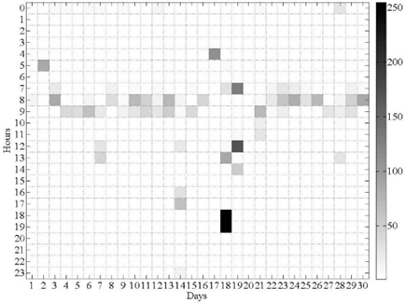
Figure 6- 2 An example of PA density map from the mobile device’s dataset
Figure 6- 3 An example of histogram distribution for the density map

Distance measure
In order to assess the subject’s PA intensity state, Euclidean distance is adopted to measure the dissimilarity among density maps, as formula (6-8).
${distance}_{i,j}=\sqrt{\sum_{i=2,j=1}^{k}{{(x_{i,j}-x_{i-1,j})}^{2}}}$ (6-8)
Where x represents the vectors of extracted features. $x=[x_{1}…x_{k}]$. The smaller the distance, the similar the two map images, and vice versa.
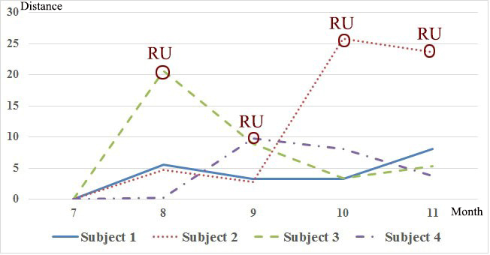
Figure 6- 4 Euclidean distance measures dissimilarity of density map with RU for four subjects of five months dataset from the mobile device
The validation dataset features four randomly selected healthy individuals using the mobile devices for 5 months. The subjects investigated are staff and reseach students at a university. They are working 6 to 8 hours in front of a computer every work day, whilst intensity and time for workout are relatively stable each month, thus distance of density maps should be highly similar with small fluctuations. However, as we can see in Figure 6-4, only the first subject present a normal PA pattern shown as the solid blue line, while others suffer from large distance changes, which demonstrates that there are major RU of PA types and durations recorded by the mobile devices.

Handling RU with DST decision making model
Due to the uncertainties and incompleteness of the existing dataset, the intensity and quantities emergent on the density map are considerably unstable. Using DST therefore, different prior knowledge from different density maps will arrive at a degree of belief that takes into consideration all the available evidence as well as to reduce the RU. Moreover, based on the concept of DST, we construct a three layer hierarchical lattice model to conduct a decision making process for the subject’s long-term PA intensity pattern.
In Figure 6-5, the three layers within the model are a visualization layer, data fusion layer and decision making layer. In the visualization layer, PA density, duration and category of each subject’s wearable/mobile device’s datasets are produced as density maps. DPA and SPA sets are also extracted as individual evidence presented as dash line round node. The data fusion layer comprises of combinations of the information presented as a dash line oval node in Figure 6-5. The decision making layer provides the final outcomes of the subject’s lifelogging PA intensity decision from prior knowledge revealed on density map and mass values from combination rules.

Dempster-Shafer theory of evidence (DST)
DST allows for direct representation and reasoning of uncertainties in a way that fuses accumulative evidence and changing prior knowledge in the presence of new evidence, where the input can be an imprecise or incomplete set or an interval, while the output is also a set or an interval.
DST assumes that there are all possible elements denoted as$Θ$. A basic probability assignment (BPA) is represented by mass function$2^{Θ}⊆[0,1]$, where$m\left(∅\right)=0,\sum_{A⊂U}{m\left(A\right)=1}.$ Set mass functions $m_{1},m_{2}$ are the BPA in $Θ$.
Figure 6- 5 Lattice model of DST for personal lifelogging PA pattern decision
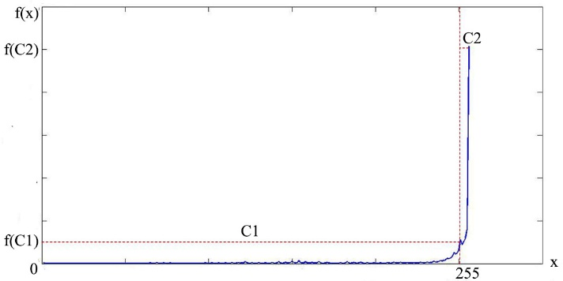
Figure 6- 6 Histogram distribution with the threshold setting
Upper and lower bounds of an interval are defined as belief function and plausibility function, expressed as Bel() and Pls(), denotes as:

$Bel\left(A\right)=\sum_{B⊂A}{m(B)}$ (6-9)
$Pls\left(A\right)=\sum_{B∩A≠0}{m(B)}$ (6-10)

Where $A∈2^{Θ}$ and $B∈2^{Θ}$, $0≤Bel\left(A\right)≤Pls\left(A\right)≤1$.
The plausibility is defined as the degree of objection or no objection towards A, which denotes as:

$Pls\left(A\right)=1-Bel(A)$ (6-11)

Therefore, the degree of belief is in the interval $[Bel\left(A\right),Pls(A)]$, in terms of the total interval [0,1].
Dempster’s combination rule [45] is a way to aggregate information from uncertain context whether data is a single source or multiple sources. The formula of fusion independent sources is defined as:

$m\left(C\right)=\left\{\begin{aligned}\frac{\sum_{A∩B=C}{m_{1}(A)m_{2}(B)}}{1-K} \\ 0 , C=∅\end{aligned}\right., ∀C⊆Θ, C≠∅$ (6-12)

Where $m(C)$ determines the final mass of $m_{1}(A)$and $m_{2}\left(B\right),$and $K=\sum_{A∩B=∅}{m_{1}\left(A\right)m_{2}\left(B\right).}$ $1-K$ is a normalization factor which is constant for all subsets whilst has no impact on the behaviour of the operator.$K=1$ represents $m_{1}$and $m_{2}$ is completely contradictory, so combination cannot be executed. When $K=0$, it refers to that two evidences are completely compatible. When $0<K<1$, it represents that two evidences are partly compatible.
Furthermore, multiple mass functions also can be combined to obtain the final result in terms of the orthogonal sum defined in Dempster’s combination rule, shown as formula (6-13).

$m_{1}⊕m_{2}⊕…⊕m_{n}=(((m_{1}⊕m_{2})⊕…)⊕m_{n})$ (6-13)

Mass function definition in density map
A crucial issue in DST inference is to define a mass function for each evidence set based on the sourced information, which are the density maps from the visualization layer in our work. From the grey levelled histogram distribution of the image, as shown in Figure 6-6, two classifications can be clearly determined based on the threshold $f(C_{1})$ presented as the red vertical dash lines in terms of the grey levels: in the interval [0,254] are grey pixel numbers representing the PA data acquired from wearable/mobile device (e.g., steps, distance and duration), whilst the value of sedentary and unknown PA are presented as the white pixel equal to 255. As there is a majority of blank uncertain information on the map, in order to better express its uncertainties, we assume that the duration of two stationary PAs (working and sleeping) of an individual is prior knowable. Thus the categories can be finally defined as three types:
- DPA: dynamic physical activity, e.g. walking, jogging or running, shown as grey and black part on the density map and denoted as a set $\left\{DPA\right\}$.
- SPA: sedentary physical activity, e.g. sitting, standing or lying, shown as white part on the density map and denoted as a set $\left\{SPA\right\}$.
- Ambiguity: not sure DPA or SPA, shown as white part on the density map and denoted as a set $\left\{DPA, SPA\right\}$.

According to Figure 6-6, therefore, the initial mass function based on the pixel numbers is defined as:
$m_{DPA}^{i}=\frac{f(C_{1}^{i})}{f(x^{i})}$ (6-14)
$m_{SPA}^{i}=\frac{f\left(C_{2}^{i}\right)-f\left(C_{1}^{i}\right)}{f\left(x^{i}\right)}×\frac{Duration\left(sleep+work\right)}{TotalDuration}$ (6-15)
$m_{DPA,SPA}^{i}=1-m_{DPA}^{i}-m_{SPA}^{i}$ (6-16)
Where i is the density map numbers. $f(C_{1})$ and $f(C_{2})$ are the grey levelled pixel numbers of $\{DPA$} and $\left\{SPA\right\}$ on the density map, respectively.

Evidence combination of density maps
In the evidence fusion layer, the combination m of two maps of information is acquired from Dempster’s rule of combination presented in Table 6-2 according to the formula (6-12). Some information may support the same conclusion, while others may conflict with each other. As such, different evidence will be computed in a way to obtain the final mass function m. The intervals of belief and plausibility of sets $\left\{DPA\right\}$ and $\{SPA\}$will also be ultimately achieved in the decision making layer based on the formula (6-13). Meanwhile, fusion of multiple density maps is possible to reduce the RU of an individual’s PA records.

Decision making rules
Once all the available density maps have been fused, the decision belief intervals can be consequently achieved by provided evidence, which are denoted as:

$EI\left(DPA\right)=\left[Bel\left(DPA\right), 1-Bel\left(SPA\right)\right]$;
$EI\left(SPA\right)=\left[Bel\left(SPA\right), 1-Bel\left(DPA\right)\right]$ (6-17)

Generally speaking, the more evidence fusion, the smaller value of RU. As shown in Figure 6-7, the lifelogging PA intensity pattern decision making strategy is based on whether the value of RU is eliminated. With consideration of the two conditions, the lifelogging PA style takes advantage of following rules:

- When $RU=0$
$\left\{\begin{aligned}If Bel\left(DPA\right)>Bel\left(SPA\right), \\ then one^{'}s lifelogging PA Intensity pattern is active; \\ If Bel\left(DPA\right)<Bel\left(SPA\right), \\ then one^{'}s lifelogging PA Intensity pattern is sedentary.\end{aligned}\right.$ (6-18)
- When $RU≠0$
$\left\{\begin{aligned}If EI(DPA)>EI(SPA), \\ then one^{'}s lifelogging PA Intensity pattern is active; \\ If EI(DPA)<EI(SPA), \\ then one^{'}s lifelogging PA Intensity pattern is sedentary.\end{aligned}\right.$ (6-19)

Table 6- 2 Dempster’s rule of combination
$$m_{2}$$
$$m_{1}$$
$$m_{2}$$  $$m_{1}$$ | $$\left\{DPA\right\}$$ | {$SPA$} | $$\left\{DPA, SPA\right\}$$
$$\left\{DPA\right\}$$ | $$\left\{DPA\right\}$$ | $$∅$$ | $$\left\{DPA\right\}$$
{$SPA$} | $$∅$$ | {$SPA$} | {$SPA$}
$$\left\{DPA, SPA\right\}$$ | $$\left\{DPA\right\}$$ | {$SPA$} | $$\left\{DPA, SPA\right\}$$

Figure 6- 7 Intervals of Belief (Bel) and Plausibility (Pls) of DPA and SPA

Shafer's framework allows for belief about such propositions to be represented as intervals, bounded by two values, belief (or support) and plausibility: Bel ≤ Pls. Bel measures the strength of the evidence ranging from 0 (indicating no evidence) to 1 (denoting certainty). Pls is 1 minus the sum of the masses of all sets whose intersection with the hypothesis is empty, which is an upper bound on the possibility that the hypothesis could be true.
When RU has been removed ($R=0$), the precise belief value would be derived, so the decision is taken through the comparison between $Bel(DPA)$ and $Bel(SPA)$. When RU has been reduced but still exists ($R≠0$), the result is determined by the comparison of values of interval. The higher confidence is assigned to the hypothesis with maximum belief value in the interval. For instance, if the belief interval of the set $\{DPA\}$ is [0.3, 0.6], and the belief interval of the set $\{SPA\}$ is [0.5, 0.9], the decision will be assigned to the set {$SPA$} with the maximum value for both lower limit and higher limit.

6.4.5 Case study
In order to better illustrate how the proposed approach using wearable or mobile devices is applied in the assessment of lifelogging PA intensity patterns, two case studies based on the two hypothesises defined earlier are introduced next. In the first case study, we use multiple density maps fusion to illustrate the long term PA intensity decision making procedure under the condition of removal of RU, represented with a certain value Bel. In the second example, two months density maps with confliting envidence are fused to state the other hypothesis that the RU still exsits, represented as intervals EI. Both subjects used the mobile app Moves [19] and its datasets are collected from the mobile personalized healthcare platform MHA [20].

Case study #1

Handling IU
The subject is a research student at the university, female, aged 29. The proposed Ellipse fitting model operates on the individual’s PA distribution for pre-processing. Figure 6-8 shows the subject’s daily steps and speed. The confidence value of Ellipse fitting is 0.98 for the individual, which means that 98% of samples fall inside the defined region based on a Gaussian distribution.

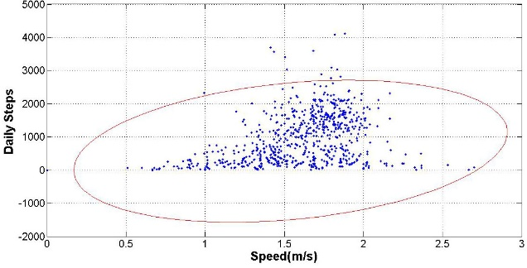
Figure 6- 8 Case study #1 Ellipse fitting model for IU removal of the subject’s Moves dataset (c= 0.98)
In Figure 6-8, 98% of data falling within the oval are below 3,000 steps per hour. The speed or walking intensity is between 0.5 to 2.7m/s for this individual.

RU confirmation
Figure 6-9 (a) shows the individual’s density map of PA distribution of Moves data record from July to Oct., 2015. Although the features of mean, variance, energy and entropy from images are quite close, the Euclidean distance measures significant dissimilarity among Sept. and Oct, as shown in Figure 6-9 (b). This is due to the features of large kurtosis difference. Density maps of Sept. and Oct. display more intensive distribution of the grey part, which means they have higher kurtosis, tends to have distinct peaks near the mean. This also implies that the mobile phone recorded more DPA data in most hour cells during this period than Jul. and Aug. Nevertheless, the subject’s healthcare condition and activity frequency were stable within this period. Furthermore, DPA datasets are relatively complete each month, since they are emergent almost every day on the images. Hence we can infer that the subject constantly kept her phone and the app on when performing DPA, the RU may come from the app’s internal error such as inaccurate activity recognition, the app’s mechanism (e.g., automatically off for energy saving) or data transmission failure, etc.

Lifelogging PA intensity pattern inference
To analyse the individual’s life-long PA intensity pattern, the DST is utilized in this situation. The steps are shown as below.
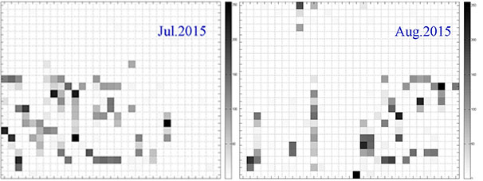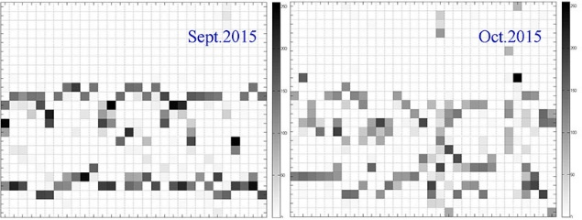
(a)
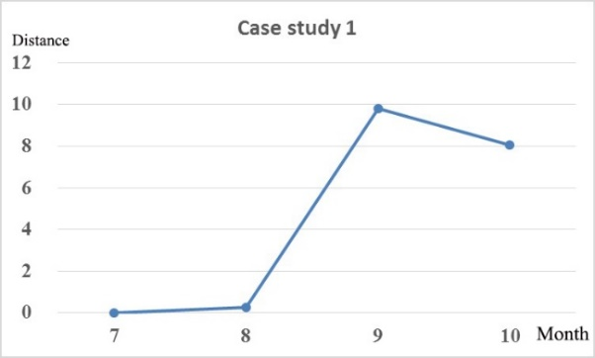
(b)
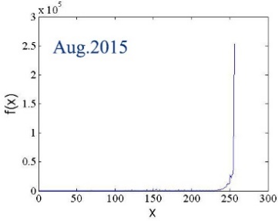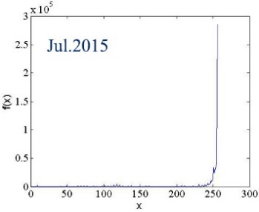
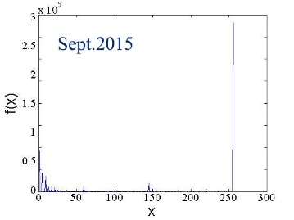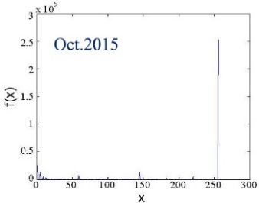
(c)
Figure 6- 9 Case study #1 (a) Density maps of four consecutive months’ datasets from Moves; (b) Euclidean distance measures dissimilarity of the density maps in (a) displaying RU; (c) histogram distribution of four month.

- Define the initial mass functions
A histogram regarding grey and white parts which are distinctly determined into two classes for the consecutive four months, as presented in Figure 6-9 (c). During this period, the subject performed routine activities. As determined by our face-to-face survey, she usually sat in front of the computer for 7 hours working every workday and sleeping 8 hours per day, and thus the information is regarded as the known SPA duration.
The ratio presented in Table 6-3 denotes the percentage of duration of SPA against the whole duration of the month (720 or 744 hours). Thus, the initial mass functions assigned for each density map based on knowable sedentary duration (Table 6-3) and the pixel number proportion (Table 6-4) are as below.
Table 6- 3 The subject’s known SPA durations and their ratio per month
SPA types | Duration (hours)
SPA types | Jul. | Aug. | Sept. | Oct.
Work | 161 | 147 | 140 | 154
Sleep | 248 | 248 | 240 | 248
Ratio | 0.55 | 0.53 | 0.53 | 0.54

Table 6- 4 Pixel numbers for density maps of four months
Classes | Pixel numbers
Classes | Jul. | Aug. | Sept. | Oct.
$$C_{DPA}$$ | 401955 | 678916 | 1127961 | 1077651
$$C_{SPA}$$ | 879293 | 734699 | 403211 | 440297
$$C_{DPA}∪C_{SPA}$$ | 2060670 | 2065140 | 1888737 | 1893015

Table 6- 5 Evidence fusion for Jul. and Aug.
 | $$m_{Jul}(DPA)$$ | $$m_{Jul}(SPA)$$ | $$m_{Jul}(DPA,SPA)$$
$$m_{Aug}(DPA)$$ | 0.07 | $$∅$$ | 0.12
$$m_{Aug}(SPA)$$ | $$∅$$ | 0.15 | 0.13
$$m_{Aug}(DPA,SPA)$$ | 0.07 | 0.13 | 0.12

$m_{Jul}\left(DPA\right)=$0.22 $m_{Jul}\left(SPA\right)=0.43$ $m_{Jul}\left(DPA,SPA\right)=0.35$;
$m_{Aug}\left(DPA\right)=$0.33 $m_{Aug}\left(SPA\right)=0.36$ $m_{Aug}\left(DPA,SPA\right)=0.31$;
$m_{Sept}\left(DPA\right)=$0.6 $m_{Sept}\left(SPA\right)=0.21$ $m_{Sept}\left(DPA,SPA\right)=0.19$;
$m_{Oct}\left(DPA\right)=$0.57 $m_{Oct}\left(SPA\right)=0.23$ $m_{Oct}\left(DPA,SPA\right)=0.2$;

- Using Dempster’s rule to combine them
According to the DST rule defined as the Table 6-2, we can obtain the following new mass functions one by one based on the formula (6-11) and (6-12). Therefore, we can obtain a new mass assignment for Jul. and Aug. shown in Table 6-5:
$m_{Jul,Aug}\left(DPA\right)=0.07+0.12+0.07$ = 0.28;
$m_{Jul,Aug}\left(SPA\right)=0.15+0.13+0.13$= 0.41;
$m_{Jul,Aug}(DPA,SPA)$ = 0.12;
As such, the new mass will be then combined with initial mass function from Sept. as:
$m_{Jul-Sept}\left(DPA\right)=m_{Jul,Aug}(DPA)⊕m_{Sept}(DPA)=0.29$;
$m_{Jul-Sept}\left(SPA\right)=m_{Jul,Aug}(SPA)⊕m_{Sept}(SPA)=0.18$;
$m_{Jul-Sept}\left(DPA,SPA\right)=m_{Jul,Aug}(DPA,SPA)⊕m_{Sept}(DPA,SPA)=0.02$;
Finally, we can obtain another mass functions combining with the evidence of Oct. as:
$m_{Jul-Oct}\left(DPA\right)=m_{Jul-Sept}(DPA)⊕m_{Oct}(DPA)=0.24$;
$m_{Jul-Oct}\left(SPA\right)=m_{Jul-Sept}(SPA)⊕m_{Oct}(SPA)=0.08$;
$m_{Jul-Oct}\left(DPA,SPA\right)=m_{Jul-Sept}(DPA,SPA)⊕m_{Oct}(DPA,SPA)=0$.
- Determine lifelogging PA intensity pattern
With the fusion of four density maps as a consequence of the above, the RU is almost removed. The final mass functions are next normalized based on the formula (6-11) and thus achieve the belief and plausibility value for DPA and SPA as:
${Bel}_{Jul-Oct}\left(DPA\right)={Pls}_{Jul-Oct}\left(DPA\right)=0.29$;
${Bel}_{Jul-Oct}\left(SPA\right){=Pls}_{Jul-Oct}\left(SPA\right)=0.1$;
Therefore, it can be inferred that the individual’s PA intensity pattern for the consecutive four months is active with the higher degree of confidence according to the rule defined in formula (6-18).

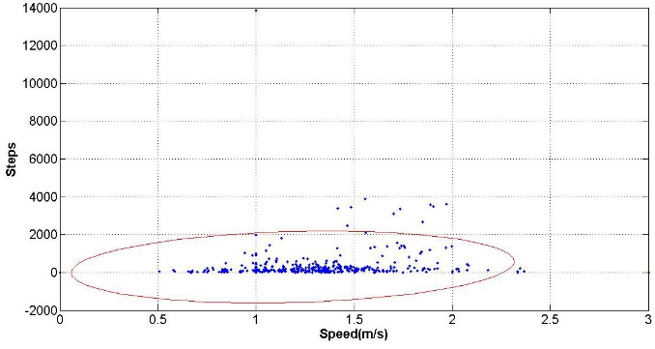
(a)
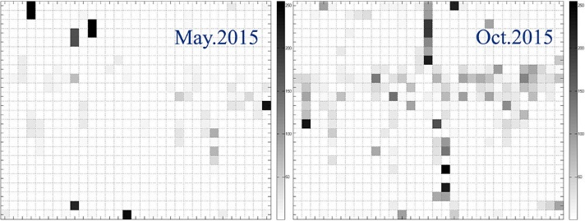
(b)
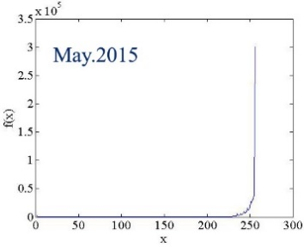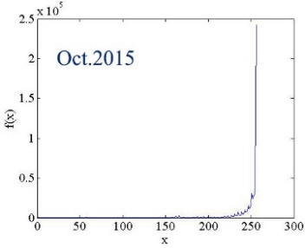
(c)
Figure 6- 10 Case study #2 (a) Ellipse fitting model for IU removal of the subject’s Moves dataset (c= 0.95); (b) density maps of two inconsecutive months’ datasets from Moves; (c) histogram distribution of the density maps in (b).

Case study #2
The second subject is a healthy person, male, aged 35. Similarly, he worked in a sedentary fashion in front of computer 7 hours per workday, and sleeping duration was 7 hours per day on average. The Moves datasets are collected for two inconsecutive months of May and October, 2015. The Ellipse fitting model is firstly conducted to remove IU. The confidence degree in this case is set to 0.95, somewhat smaller than in case 1, as most of the samples are scattered intensively between 0 and 1,000 steps. A few samples are still in the normal range such as 2,000 to 4,000 steps per hour (Figure 6-10 (a)), but here only estimation of the best fit of samples for this individual is taken into account.
As presented in the density maps in Figure 6-10 (b), a smaller amount of data has been collected in May. The subject either tends to be more sedentary or rarely records DPA data with a mobile phone so that the conclusion of active is impaired by the evidence in May. On the other hand, more information can be acquired from Oct., which may support this decision result.
Table 6-6 lifelogging PA pattern comparisons of four subjects
 | Subject1 | Subject2 | Subject3 | Subject4
$$Bel(DPA)$$ | 0.32 | 0.2 | 0.25 | 0.22
$$Bel(SPA)$$ | 0.21 | 0.26 | 0.08 | 0.05
Bel comparison | Bel(DPA)  >Bel(SPA) | Bel(DPA)  <Bel(SPA) | Bel(DPA)  >Bel(SPA) | Bel(DPA)  >Bel(SPA)
Intensity pattern of lifelogging PA | Active | Sedentary | Active | Active

Likewise, two classes are also defined associated with histogram distribution of the density maps in Figure 6-10 (c). With respect to pixel numbers in two classes as well as the duration of known sedentary PA (working and sleeping), the mass functions are assigned as:
$m_{May}\left(DPA\right)=0.15$; $m_{May}\left(SPA\right)=0.42$; $m_{May}\left(DPA,SPA\right)=0.43$;
$m_{Oct}\left(DPA\right)=0.4$; $m_{Oct}\left(SPA\right)=0.3$; $m_{Oct}\left(DPA,SPA\right)=0.3$.
Applying to the evidence fusion rule, we can obtain that,
$Bel\left(DPA\right)=0.28$; $Bel\left(SPA\right)=0.38$.
Thus, the intervals for $\{DPA\}$ and $\{SPA\}$ are [0.28, 0.62] and [0.38, 0.72], respectively. According to the decision making rules in formula (6-18), it can be concluded that the subject’s PA intensity pattern of is sedentary.

Lifelogging PA intensity pattern comparisons
The belief values of the four subjects’ PA styles we investigated for five months are presented in the Table 6-6. The subject 1, 3 and 4 are more active in DPA, as they were often walking around within most of each hour’s cells during the day. Apart from walking, for example, subject 3 often spent two hours a day playing sports and running. Subject 1 also performed jogging at least one hour a day. On the contrary, the subject 2 either tended to be more sedentary or rarely use a mobile tracker to log his DPA so that the conclusion is impaired by all the evidence.

Comparison of PA intensity pattern with mobile devices
PA intensity based on the energy expenditure is categorised into four types: sedentary (e.g., sitting and lying), light (e.g., standing, desk job, etc.), moderate (e.g., walking, cycling, etc.), vigorous (jogging, swimming etc.) and high (e.g., fast running, weightlifting, etc.). Traditionally, PA is mostly observed based on accelerometer technology as well as easily and openly accessible Global Position System (GPS). Numerous research works and commercial products have attempted to accurately monitor PA and assess activity patterns and intensity level, by using either dedicated wearable sensors [39], [40] or conducted in controlled or semi-controlled environments. Figure 6-9 accurately presents the typical daily adult PA intensity pattern. This result comes from accelerometer monitoring from a few studies under such conditions [210].
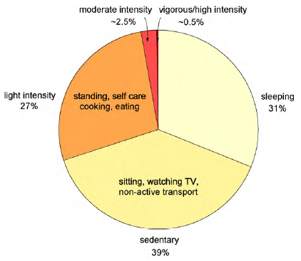
Figure 6- 11 The typical adult pattern of daily activities [percentage of a 24-h day] when categorised in terms of intensity level assessed using accelerometer counts. About 31% [7.5 h] is sleep, 39% [9.4 h] is spent in sedentary activities [sitting], 27% [6.5 h] in [210].
Recently, many commercial wearable products and mobile applications have been released that support long term recording and collection of personal health information, particularly on physical activity. Popular mobile apps, such as Moves, are based on smartphone 3D accelerometer data and GPS information which allows tracking user movement activities including location, distance and speed. The wearable products, such as Fitbit Flex, Nike+ Fuelband, JawboneUp, are all wristband devices that record steps count, distance, and calories burnt. However, lifelogging physical activity measured with mobile devices has significant differences from traditional PA measures on four aspects: low accuracy, data encapsulated, long term observation and uncontrolled environments. Thus, these four aspects lead to a variety of uncertainties for lifelogging PA measures.
In this case study, we create four months density maps from the subject using Moves app on amobile phone and Google Fit app on a Samsung Gear S2, respectively, with the datasets from July to October 2015. To measure the uncertainties of each month’s PA intensity pattern, histogram and texture features are extracted from both devices. The subject used the mobile app Moves and Google Fit datasets are collected from the mobile personalised healthcare platform MHA [20].

Density maps dissimilarity evaluation from mobile phone
The subject in the case study is a female, 30 years old, working as a researcher at the university 7 hours (desk job), and working out 1.5 hours per working day. Four months PA intensity are represented as the density maps shown as Figure 6-12 (a) and Figure 6-13 (a) from the mobile phone and wearable device respectively. Whilst Figure 6-12 (b), (c) and Figure 6-13 (b), (c) show the histogram features and texture features extracted from the maps, representing the PA intensity pattern dissimilarities among the four month using both devices. However, the subject’s lifestyles are relatively stable, while as we can see from the dissimilarity measures, the trend line displays large distance changes, which proves that much uncertainty exists using the commercial products.
Compared with the mobile phone PA tracker, the wearable device presents relatively more stable and lower limit of fluctuations. As we can see in the Figure 6-12 (b) and Figure 6-12 (b), the fluctuation limit is 2.8 with wearable device, while mobile phone is up to 10, and thus the uncertainty distance between each month is bigger than with the wearable device. The key reason is the placement on the human body - that the subject is able to take the band on the wrist all the time. Also, due to the battery and capacity saving mode, PA apps on mobile phones switch themselves off occasionally. The mobile device/sensor placement on the human body has therefore attracted increasing attention in the human physical activity research field in recent years [211].
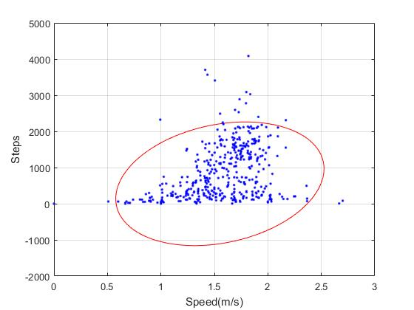
(a)
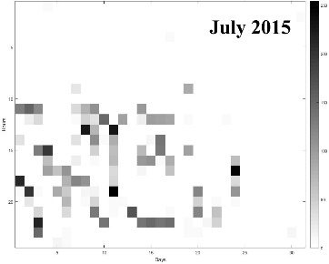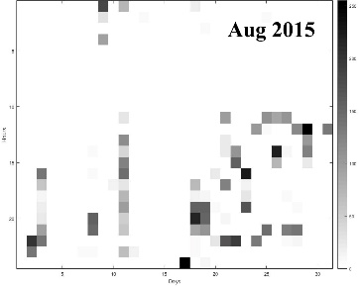
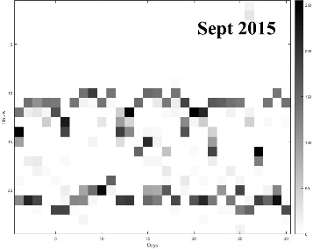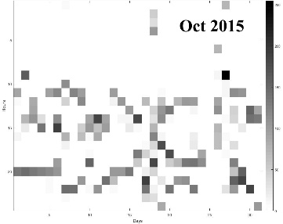
(b)
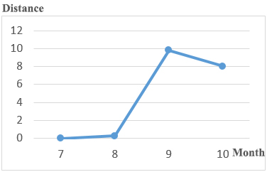
(c)
Figure 6- 12 Lifelogging pattern determination with Moves’ datasets (a) Ellipse fitting model for IU removal of consecutive four months’ of the subject’s Moves’ dataset (c= 0.98) (b) Density maps of four consecutive months’ datasets (c) histogram and texture features dissimilarity for four consecutive months Moves’ datasets

Density maps dissimilarity evaluation from wearable device
We also collected the Google Fit datasets from a wearable device from the same subject. As we can see from the Figure 6-13 (a), average walking/jogging speed is higher than with the mobile phone, and so are the daily steps. Figure 6-13 (b) shows more intensive data cells compared with the phone’s datasets, which denotes that the wearable device has relatively stable PA intensity records. The result is also shown in the Figure 6-13 (c) that distances between each monthly density map are lower than the datasets from the phone.
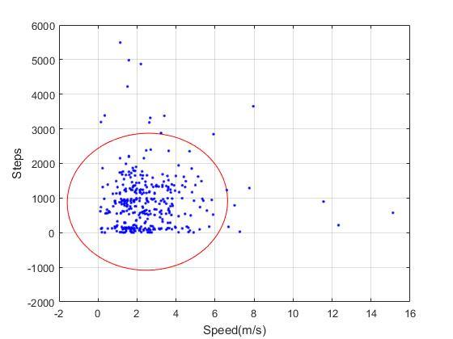
(a)
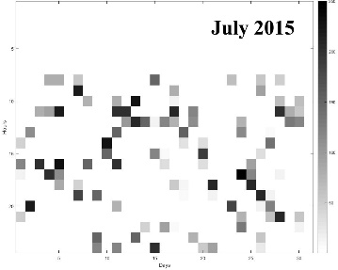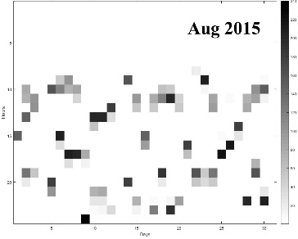
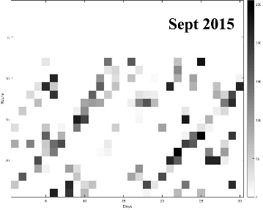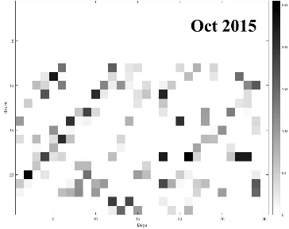
(b)
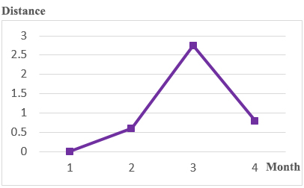
(c)
Figure 6- 13 Lifelogging pattern determination with Samsung wearable watch’s datasets (a) Ellipse fitting model for IU removal of consecutive four months’ of the subject’s dataset (c= 0.98) (b) Density maps of consecutive four months Samsung wearable watch’s datasets (c) histogram and texture features dissimilarity for four consecutive months Samsung wearable watch’s datasets

PA Intensity pattern comparisons with two devices
The data from the mobile phone and wearable device usage of four subjects’ PA intensity for consecutive five months are presented in the Figure 6-14 and Figure 6-15. The subjects are staff and research students at the university, spending 6 to 8 hours sitting in front of a computer, so the lifestyles are relatively sedentary. Subject 1 has fewer fluctuations with mobile phone, while others show more uncertainties with both histogram and texture features. On the other hand, the distance of wearable device is 90% lower than mobile phone, which presents as more stable with fewer uncertainties in lifelogging PA monitoring.
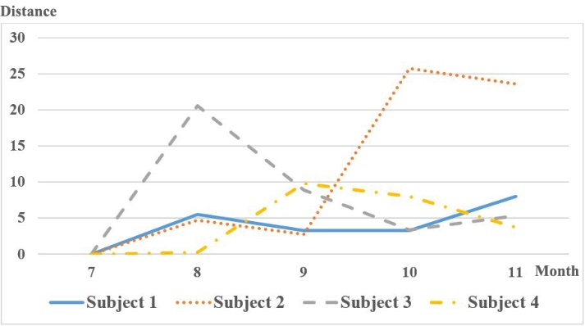
Figure 6- 14 Four subjects’ density map dissimilarities comparison of five months using mobile app Moves from histogram and texture features
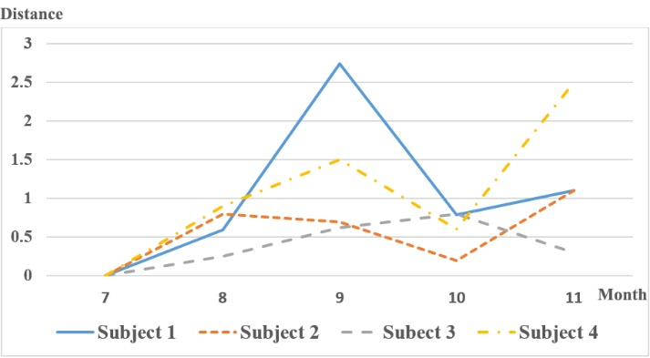
Figure 6- 15 Four subjects’ density map dissimilarities comparison of five months using Samsung wearable watch from histogram and texture features

Discussion and summary
Measuring lifelogging PA intensity pattern using datasets of third party devices is a challenging task due to a variety of uncertainties so that it is barely used in healthcare studies. In this chapter, we analysed lifelogging PA intensity from wrapped data of mobile apps and wearable watches. An ellipse-fitting model is firstly employed to remove irregular uncertainties (IU) from processed PA data based on the best fit of the samples for the individual. It then builds day-hour grey-levelled density maps for each month to represent the intensity for each hour cell. Finally, in order to reduce regular uncertainties (RU), DST evidence lattice model was applied to lifelogging PA decision determination in light of information fusion from multiple density images, respectively. The decision conclusion is categorized into two types which are active and sedentary. The results, based on the analysis of Moves [29] data sets from the mobile personalized healthcare platform MHA [1], have demonstrated that the proposed approach has a strong ability to achieve lifelogging lifestyles of intensity for different individuals who successively take the mobile tracker as an evaluation criterion for healthcare. One step further, the PA intensity comparison among subjects, uncertainty difference between mobile apps and wrist band are evaluated and analysed.
In this chapter, we limit discussion of PA to only use “steps”. The reason for this is firstly the step is the most significant lifelogging PA variable. Generally, from the perspective of longitudinal duration, individuals spend more time walking, jogging and running than other activities such as swimming or cycling. Secondly, some non-step activities are rarely automatically detected owing to the limitations of existing hardware devices (swimming and yoga are particularly problematic for example). We believe the proposed approach has extensibility with the technological progress of activity recognition techniques and device capability. Specifically, the “step” can be substituted as PA intensity in each hour cell (e.g., arithmetic product of PA types with their metabolic equivalent and PA duration). Furthermore, this chapter typically evaluated healthy subjects. Nonetheless, this principle can be applied for detection of PA changes for elderly people and patients with chronic disease using such low-cost devices or free apps. Since the section only assessed a few months’ data sets from limited devices, in the next stage, we will be collecting larger amounts of data over a longer period of time from more subjects for evaluation. More wearable commercial devices (e.g., Fitbit [26], Withings [14]) will be also taken into consideration as a part of resource for the information fusion.

Chapter 7. Conclusion and future prospects
This thesis focuses on physical activity recognition and monitoring (PARM) and lifelogging activity pattern analysis. This chapter summarizes the main contributions of this thesis and discusses several potential directions for future research.

7.1. Conclusion
Given the importance of PARM for healthcare support of a variety of chronic diseases, musculoskeletal rehabilitation, independent living of the elderly, as well as fitness goals for active lifestyles, a number of studies have been devoted to the crucial issues of PARM during the last two decades. The main contribution of this thesis is divided into two parts which are recognizing a variety of human physical activities from daily activities (e.g., walking, jogging or sitting) for healthy people to active people with regular sport exercises (e.g., free weight lifting) in terms of IoT techniques.
Firstly, we gave a systematic literature review from the IoT’s perspective in chapter 2 which sequentially covers the sensing layer, network layer, processing layer and application layer, distinctively and systematically summarizing existing primary PARM devices, methods, and environments. Wearable and portable sensors/devices, inertial signal data processing and classification/clustering approaches are described and compared in the light of physical activity types, subjects, accuracy, flexibility and energy. Typical research and project applications regarding PARM are also introduced.
Then we collected sensor signals of 10 healthcare subjects performing daily PA in the natural environment and gym PA in the gym environment with mobile phone and Shimmer wearable sensor. We analyzed different frequency, time window, features, and some typical machine learning algorithms in chapter 3 and then proposed a hierarchically hybrid framework of gym PA recognition and intensity measurements that may include more types of activities rather than conventional ones and thus are more scalable and extensible. The proposed framework is capable of classifying 19 gym physical activities including free weights, aerobic and sedentary activities. The framework is divided into two layers based on the non-free weight boundary. A one-class support vector machine (OC-SVM) is applied in the first layer to separate free weight and non-free weight activities in light of a given threshold, and in the second layer, a neural network (NN) and hidden Markov model (HMM) is adopted to classify non-free weight and free weight activities respectively. In addition, learning vector quantization (LVQ) is used to quantize feature vectors for continuous input to the HMM, which gives the better performance than a conventional Gaussian mixture model (GMM) and other classifiers. Furthermore, GPARMF, based on the repetition maximum (RM) principle, evaluates intensity of free weight exercises with changing heartrate within a user’s natural environment. It is also capable of calculating repetitions and sets for each free weight exercise.
In chapter 5 and chapter 6, lifelogging physical activity patterns of different subjects are analyzed using third party devices/apps such as mobile PA tracking apps or wrist bands that contain a mass of uncertainties. We first categorized the uncertainty types with irregular uncertainty (IU) and regular uncertainty (RU), and then proposed Ellipse fitting model to remove the IU in chapter 4 and Dempster–Shafer theory (DST) to handle RU. A DST evidence lattice model was applied to lifelogging PA decision determination in light of information fusion from multiple density images. The decision conclusion is categorized into two types which are active and sedentary, presented in chapter 6.

7.2 Limitations
Proposed PARM approaches and applications have met the research aims and objectives of this PhD project, but there still exist several issues which may need to be improved and investigated in the future work.
First, we limit discussion of PA to only use ‘steps’ and MET in lifelogging activity pattern analysis. The reason for this is firstly the step is the most significant lifelogging PA variable. Generally, from the perspective of longitudinal duration, individuals spend more time walking, jogging and running than other activities such as swimming or cycling. Secondly, some non-step activities are rarely automatically detected owing to the limitations of existing hardware devices (swimming and yoga are particularly problematic for example). We believe the proposed approach has extensibility with the technological progress of activity recognition techniques and device capability. Furthermore, this thesis typically evaluated healthy subjects. Nonetheless, this principle can be applied for detection of PA changes for elderly people and patients with chronic disease using such low-cost devices or free apps. Since the section only assessed a few months’ data sets from limited devices, larger amounts of data over a longer period of time from more subjects are needed for evaluation. Also, more subjects’ data needs to be collected to further improve the accuracy of the PA recognition framework and including further types of activities such as playing ballgames or eating, etc. in the future work.

7.3 Future prospects
While empowering the utility of IoT enabled technologies in PARM has huge potential benefits for the healthcare industry, it is still broadly agreed that the IoT technologies are in their infancy and face many challenges in successfully applying them into PARM due to the need of life-logging data, uncontrolled environment, high volume of data set, security and privacy, etc. Future efforts are required to address these challenges and examine the availability of existing PARM technologies to ensure a good fit in the IoT environment.

Cost effective and non-obtrusive wearable sensing
While existing sensing technologies have made great progress in the last decade, it is still limited with regards to long-term healthcare monitoring in the free living environment, as even only a small single sensor attached on a certain part of the body is still uncomfortable for permanent monitoring. While wearable devices have proven their popularity among general users, the majority of usage is limited to the fitness fields. The products simply provide processed measurements (e.g., steps, distance or calories) so that are not able to used for further data processing. Raw sensor data can be directly acquired from mobile phones, but because of diversity of life pattern and environmental impacts, personal data from individual wearable devices exhibits remarkable uncertainty in the natural environment such as battery, capacity issues and placed positions. The results are widely divergent when the mobile phone is put in the pants pocket as opposed to in the handbag. Particularly, inertial sensors are sensitive to any changes in position and orientation. Thus, so far, existing wearable sensing technologies are limited in terms of their size, fast response, continuous monitoring capability, wireless data transmission, and non-obstructive user experience. Moreover, there is usually a trade-off between high quality and low cost of developing sensing technologies. The ideal candidate for future sensing technologies for the IoT enabled PHS should be a tiny sensor inserted into personal daily use items, including but not limited to clothing, watches, glasses, shoes, belts, and so on. Moreover, for chronic disease monitoring, non-obstructive sensing devices are key to the success of IoT enabled PHS, and will potentially bring a lot of convenience to patients.

Sensing interoperability
Multiple sensors with different features often coexist in a single biometric system. While sensor interoperability refers to the ability of the system to merge and adapt data from different types of sensor and device. In IoT-based PARM, such interoperability is especially distributed in the network layer and processing layer. Firstly, the battery life and bandwidth overhead for low power sensor nodes is still a challenge. Second, due to different types of sensors having diverse characteristics such as frequency, many approaches and biomedical platforms have been proposed for sensing interoperability. However, almost every biomedical sensor has its interoperability issues, few systems so far are able to handle raw sensor data and feature extractions in pre-processing level in real time, and thus are expected to provide more practical and feasible approaches.

Effective data validation in healthcare
In an IoT environment, as we mentioned before, personal health data from individual wearable device exhibits remarkable uncertainty in the natural environment. How to validate these data in longitudinal healthcare cases is very challenging. In the exponential growth of the mobile healthcare market, numerous similar wearable products have been developed, which will significantly increase the heterogeneity and diversity of devices connected in IoT based personalized healthcare systems. Effectively validating these health data from heterogeneous devices in IoT enabled personalized healthcare environment is difficult, and needs more advanced intelligent algorithms.

Free living environment
As reported in some work the accuracy of PA recognizers drops dramatically from lab settings to the free living environment where a number of uncontrolled elements exist, such as short battery life or poor capacity of devices and time-consuming of running machine learning algorithms. Another key issue is the inter-subject variability, which means different people perform the same behaviours differently. One reason is due to various physical characteristics like age or weight. More importantly, uncertainties normally occur from PA types especially in complex PA (i.e., ADL or playing ballgames). As a standalone mathematical model hardly effectively recognize the changing time-sequence-based atomic simple PA due to inflexible patterns and templates, thus optimizing the existing algorithms/frameworks/platforms may improve the stability in the free living environment.

Life-logging PARM
One key feature of IoT environment is that the collection of life-logging data becomes possible. It means that daily PAs are monitored and accessed continuously and constantly in a life-long term. But existing works that are carried out in controlled environment have more points of focus on milliseconds-/seconds-based raw sensory signal processing. As such, online PARM faces a big challenge due to limited memory and power resource in affordable wearable devices, especially in the PARM for the elderly or people with chronic diseases.

High volume of data
The heterogeneous devices connected in IoT environments and life-logging collection of physical activity data will be driving major expansion in the big data of PA. These data contain not only a sheer volume of long-term PA information, but also complex, diverse and rich context of other health information. The uncertainty of these data will be much higher than physical activity data training by classic machine learning methods of PARM techniques. Effectively and efficiently improving validity of these PA data and exploring useful knowledge becomes a difficult task. Therefore, research work on how to explore these big PA data under IoT environments for bringing intelligence for more solid clinical decision-making and policy formulation will be significant.

Security and privacy
The architecture of IoT environment is supposed to be a very complicated heterogeneous network. PARM may be a specific application or service in the entire IoT healthcare system. But, the data of PARM will be stored and managed in the server of IoT systems. The typical issues of security and privacy in IoT networking architecture will be naturally inherited by PARM using IoT technologies. Compared to existing commercial wearable devices for PARM with data protection schemes on their standalone servers like Fitbit, etc. protecting privacy and security in the IoT environments is more serious and difficult since the number of potential attack vectors on IoT entities is obviously much larger. So more research work on how to protect security and privacy needs to be carried out in PARM using IoT technologies.

Low-cost device
Most previous works implemented their PARM algorithms/frameworks with relatively precise and stable but expensive devices/sensors for high recognition accuracy. But low-cost mobile devices have obtained much attention both in research and industrial fields in recent years. Due to its low-cost and portability, tracking everyone’s daily PA becomes possible. One of the inevitable issues is resource consumption (i.e., memory and battery), especially in online PARM systems where the user may acquire immediate feedback. Most studies showed the accuracy under offline settings where the data is processed remotely and feedback is provided after. To the best of our knowledge, on the other hand, there are some mobile online systems, but few have reported their computational demands. Thus there might be a trade-off between recognition accuracy and processing settings.

Physical activity types
PARM has been studied over decades, yet there are still a range of PA types that have not been studied or have only been explored by a few studies. For example, weight training exercises are essential PAs that may bring considerable healthcare benefits for various groups of people. However, works on such PARM are very few and immature. Also, some other fitness PA (i.e. playing basketball or playing tennis) are rarely involved. And surely compared with repetitive movements (i.e., walking, running) or sedentary actions (i.e., standing, sitting), the activities are relatively complex and thus require more effective techniques to implement. Moreover, in the AAL field, there are increasingly active researches on concurrent and interleaved activity recognition which are still in their infancy and face many challenges. For instance, a person may be cutting food while boiling water in an ADL cooking. Furthermore, multi-user and multi-activity recognition and monitoring also are of difficulty at the moment. While along with the development of sensing technologies, recognizing more complex PA types tends to be a promising opportunity. HMM and conditional random fields (CRF) [122] and knowledge-driven approaches [212] could be useful references for addressing such issues.

References

[1] C. J. Caspersen, K. E. Powell, and G. M. Christenson, “Physical activity, exercise, and physical fitness: definitions and distinctions for health-related research.,” Public Health Rep., vol. 100, no. 2, pp. 126–131, 1985.
[2] M. A. Minor, J. E. Hewett, R. R. Webel, S. K. Anderson, and D. R. Kay, “Efficacy of physical conditioning exercise in patients with rheumatoid arthritis and osteoarthritis,” Arthritis Rheum., vol. 32, no. 11, pp. 1396–1405, 1989.
[3] G. H. Guyatt, M. J. Sullivan, P. J. Thompson, E. L. Fallen, S. O. Pugsley, D. W. Taylor, and L. B. Berman, “The 6-minute walk: a new measure of exercise capacity in patients with chronic heart failure.,” Can. Med. Assoc. J., vol. 132, no. 8, pp. 919–23, 1985.
[4] P. Pierleoni, A. Belli, L. Palma, M. Pellegrini, L. Pernini, and S. Valenti, “A High Reliability Wearable Device for Elderly Fall Detection,” IEEE Sens. J., vol. 15, no. 8, pp. 4544–4553, 2015.
[5] J. K. Lee, S. Robinovitch, and E. Park, “Inertial Sensing-Based Pre-Impact Detection of Falls Involving Near-Fall Scenarios.,” IEEE Trans. Neural Syst. Rehabil. Eng., vol. 4320, no. c, pp. 1–27, 2014.
[6] M. Luštrek and B. Kaluža, “Fall Detection and Activity Recognition with Machine Learning,” Informatica, vol. 33, no. 2, pp. 205–212, 2009.
[7] L.-J. Kau and C.-S. Chen, “A smart phone-based pocket fall accident detection, positioning, and rescue system.,” IEEE J. Biomed. Heal. informatics, vol. 19, no. 1, pp. 44–56, 2015.
[8] G. Wu and S. Xue, “Portable preimpact fall detector with inertial sensors,” IEEE Trans. Neural Syst. Rehabil. Eng., vol. 16, no. 2, pp. 178–183, 2008.
[9] H. J. Luinge and P. H. Veltink, “Inclination measurement of human movement using a 3-D accelerometer with autocalibration.,” IEEE Trans. Neural Syst. Rehabil. Eng., vol. 12, no. 1, pp. 112–121, 2004.
[10] M. Sekine, T. Tamura, M. Akay, T. Fujimoto, T. Togawa, and Y. Fukui, “Discrimination of walking patterns using wavelet-based fractal analysis.,” IEEE Trans. Neural Syst. Rehabil. Eng., vol. 10, no. 3, pp. 188–96, 2002.
[11] J. P. Giuffrida, A. Lerner, R. Steiner, and J. Daly, “Upper-extremity stroke therapy task discrimination using motion sensors and electromyography,” IEEE Trans. Neural Syst. Rehabil. Eng., vol. 16, no. 1, pp. 82–90, 2008.
[12] I. P. I. Pappas, M. R. Popovic, T. Keller, V. Dietz, and M. Morari, “A reliable gait phase detection system,” IEEE Trans. Neural Syst. Rehabil. Eng., vol. 9, no. 2, pp. 113–125, 2001.
[13] L. Catarinucci, D. De Donno, L. Mainetti, L. Palano, L. Patrono, M. Stefanizzi, and L. Tarricone, “An IoT-Aware Architecture for Smart Healthcare Systems,” IEEE Internet Things J., vol. 4662, no. c, pp. 1–1, 2015.
[14] Y. J. Fan, Y. H. Yin, L. Da Xu, Y. Zeng, and F. Wu, “IoT-based smart rehabilitation system,” IEEE Trans. Ind. Informatics, vol. 10, no. 2, pp. 1568–1577, 2014.
[15] M. C. Domingo, “An overview of the Internet of Things for people with disabilities,” J. Netw. Comput. Appl., vol. 35, no. 2, pp. 584–596, 2012.
[16] A. Dohr, R. Modre-Opsrian, M. Drobics, D. Hayn, and G. Schreier, “The Internet of Things for Ambient Assisted Living,” 2010 Seventh Int. Conf. Inf. Technol. New Gener., pp. 804–809, 2010.
[17] A. J. Jara, M. a. Zamora, and A. F. G. Skarmeta, “An Internet of things-based personal device for diabetes therapy management in ambient assisted living (AAL),” Pers. Ubiquitous Comput., vol. 15, no. 4, pp. 431–440, 2011.
[18] “Fitbit Flex.” [Online]. Available: http://www.fitbit.com/uk. [Accessed: 10-Apr-2015].
[19] “Moves.” [Online]. Available: https://www.moves-app.com/. [Accessed: 14-Apr-2015].
[20] “MHA.” [Online]. Available: http://www.myhealthavatar.eu/. [Accessed: 10-Oct-2014].
[21] D. A. Epstein, F. Cordeiro, E. Bales, J. Fogarty, and S. A. Munson, “Taming Data Complexity in Lifelogs : Exploring Visual Cuts of Personal Informatics Data,” pp. 667–676, 2014.
[22] A. Jalal, Z. Uddin, and T. Kim, “Depth Video-based Human Activity Recognition System Using Translation and Scaling Invariant Features for Life Logging at Smart Home,” pp. 863–871, 2012.
[23] Q. LIU, W. ZHANG, H. LI, and K. N. NGAN, “Hybrid human detection and recognition in surveillance,” Neurocomputing, vol. 194, pp. 10–23, 2016.
[24] Z. Deng, P. Yang, Y. Zhao, X. Zhao, and F. Dong, “Life-Logging Data Aggregation Solution for Interdisciplinary Healthcare Research and Collaboration,” 2015 IEEE Int. Conf. Comput. Inf. Technol. Ubiquitous Comput. Commun. Dependable, Auton. Secur. Comput. Pervasive Intell. Comput., pp. 2315–2320, 2015.
[25] C. Gurrin, Z. Qiu, M. Hughes, and N. Caprani, “The Smartphone As a Platform for Wearable Cameras in Health Research,” AMEPRE, vol. 44, no. 3, pp. 308–313, 2013.
[26] A. R. Doherty, N. Caprani, C. Ó. Conaire, V. Kalnikaite, C. Gurrin, A. F. Smeaton, and N. E. O. Connor, “Computers in Human Behavior Passively recognising human activities through lifelogging,” Comput. Human Behav., vol. 27, no. 5, pp. 1948–1958, 2011.
[27] P. Wang and A. F. Smeaton, “Using visual lifelogs to automatically characterize everyday activities,” Inf. Sci. (Ny)., vol. 230, pp. 147–161, 2013.
[28] P. H. Veltink, H. J. Bussmann, W. de Vries, W. J. Martens, and R. C. Van Lummel, “Detection of static and dynamic activities using uniaxial\naccelerometers,” IEEE Trans. Rehabil. Eng., vol. 4, no. 4, pp. 375–385, 1996.
[29] G. M. Lyons, K. M. Culhane, D. Hilton, P. a. Grace, and D. Lyons, “A description of an accelerometer-based mobility monitoring technique,” Med. Eng. Phys., vol. 27, no. 6, pp. 497–504, 2005.
[30] P. a. Costigan, K. J. Deluzio, and U. P. Wyss, “Knee and hip kinetics during normal stair climbing,” Gait Posture, vol. 16, no. 1, pp. 31–37, 2002.
[31] B. Coley, B. Najafi, A. Paraschiv-Ionescu, and K. Aminian, “Stair climbing detection during daily physical activity using a miniature gyroscope,” Gait Posture, vol. 22, no. 4, pp. 287–294, 2005.
[32] H. Dejnabadi, B. M. Jolles, and K. Aminian, “A new approach to accurate measurement of uniaxial joint angles based on a combination of accelerometers and gyroscopes,” IEEE Trans. Biomed. Eng., vol. 52, no. 8, pp. 1478–1484, 2005.
[33] A. Salarian, H. Russmann, C. Wider, P. R. Burkhard, F. J. G. Vingerhoets, and K. Aminian, “Quantification of tremor and bradykinesia in Parkinson’s disease using a novel ambulatory monitoring system,” IEEE Trans. Biomed. Eng., vol. 54, no. 2, pp. 313–322, 2007.
[34] a Moncada-Torres, K. Leuenberger, R. Gonzenbach, a Luft, and R. Gassert, “Activity classification based on inertial and barometric pressure sensors at different anatomical locations,” Physiol. Meas., vol. 35, no. 7, pp. 1245–1263, 2014.
[35] F. Bianchi, S. J. Redmond, M. R. Narayanan, S. Cerutti, and N. H. Lovell, “Barometric pressure and triaxial accelerometry-based falls event detection,” IEEE Trans. Neural Syst. Rehabil. Eng., vol. 18, no. 6, pp. 619–627, 2010.
[36] S. a. Lowe and G. ÓLaighin, “Monitoring human health behaviour in one’s living environment: A technological review,” Med. Eng. Phys., vol. 36, no. 2, pp. 147–168, 2014.
[37] J. K. Lee, E. J. Park, and S. N. Robinovitch, “Estimation of attitude and external acceleration using inertial sensor measurement during various dynamic conditions,” IEEE Trans. Instrum. Meas., vol. 61, no. 8, pp. 2262–2273, 2012.
[38] M. Altini, J. Penders, R. Vullers, and O. Amft, “Estimating Energy Expenditure Using Body-Worn Accelerometers: a Comparison of Methods, Sensors Number and Positioning.,” IEEE J. Biomed. Heal. informatics, vol. 2194, no. c, pp. 1–8, 2014.
[39] Ó. D. Lara, A. J. Prez, M. a. Labrador, and J. D. Posada, “Centinela: A human activity recognition system based on acceleration and vital sign data,” Pervasive Mob. Comput., vol. 8, no. 5, pp. 717–729, 2012.
[40] H.-L. Chan, S.-C. Fang, Y.-L. Ko, M.-A. Lin, H.-H. Huang, and C.-H. Lin, “Heart rate variability characterization in daily physical activities using wavelet analysis and multilayer fuzzy activity clustering.,” IEEE Trans. Biomed. Eng., vol. 53, no. 1, pp. 133–139, 2006.
[41] M. Li, V. Rozgić, G. Thatte, S. Lee, A. Emken, M. Annavaram, U. Mitra, D. Spruijt-Metz, and S. Narayanan, “Multimodal physical activity recognition by fusing temporal and cepstral information,” IEEE Trans. Neural Syst. Rehabil. Eng., vol. 18, no. 4, pp. 369–380, 2010.
[42] G. Thatte, M. Li, S. Lee, A. Emken, S. Narayanan, U. Mitra, D. Spruijt-Metz, and M. Annavaram, “Knowme,” ACM Trans. Embed. Comput. Syst., vol. 11, no. S2, pp. 1–24, 2012.
[43] E. M. Tapia, S. S. Intille, W. Haskell, K. Larson, J. Wright, A. King, and R. Friedman, “Real-Time Recognition of Physical Activities and Their Intensities Using Wireless Accelerometers and a Heart Rate Monitor,” 2007 11th IEEE Int. Symp. Wearable Comput., pp. 1–4, 2007.
[44] T. Choudhury, J. Hightower, A. Lamarca, L. Legrand, A. Rahimi, A. Rea, B. Hemingway, K. Koscher, J. a Landay, J. Lester, and D. Wyatt, “An embedded Activity Recognition system,” IEEE Pervasive Comput., vol. 7, no. 2, pp. 32–41, 2008.
[45] S. Liu, R. X. Gao, D. John, J. W. Staudenmayer, and P. S. Freedson, “Multisensor data fusion for physical activity assessment,” IEEE Trans. Biomed. Eng., vol. 59, no. 3, pp. 687–696, 2012.
[46] J. Mantyjarvi, J. Himberg, and T. Seppanen, “Recognizing human motion with multiple acceleration sensors,” 2001 IEEE Int. Conf. Syst. Man Cybern. e-Systems e-Man Cybern. Cybersp., vol. 2, pp. 2–7, 2001.
[47] U. Maurer, a. Smailagic, D. P. Siewiorek, and M. Deisher, “Activity recognition and monitoring using multiple sensors on different body positions,” Int. Work. Wearable Implant. Body Sens. Networks, pp. 4–7, 2006.
[48] D. Minnen, T. Starner, J. a Ward, P. Lukowicz, and G. Troster, “Recognizing and Discovering Human Actions From On-Body Sensor Data,” IEEE Int. Conf. Multimed. Expo ICME, pp. 1545–1548, 2005.
[49] J. a. Ward, P. Lukowicz, G. Tröster, and T. E. Starner, “Activity recognition of assembly tasks using body-worn microphones and accelerometers,” IEEE Trans. Pattern Anal. Mach. Intell., vol. 28, no. 10, pp. 1553–1566, 2006.
[50] Y. Nam, S. Rho, and C. Lee, “Physical activity recognition using multiple sensors embedded in a wearable device,” ACM Trans. Embed. Comput. Syst., vol. 12, no. 2, pp. 1–14, 2013.
[51] B. Perriot, J. Argod, J. L. Pepin, and N. Noury, “Characterization of Physical Activity in COPD Patients: Validation of a Robust Algorithm for Actigraphic Measurements in Living Situations,” IEEE J. Biomed. Heal. Informatics, vol. 18, no. 4, pp. 1225–1231, 2014.
[52] M. Ermes, J. Pärkkä, J. Mäntyjärvi, and I. Korhonen, “Detection of daily activities and sports with wearable sensors in controlled and uncontrolled conditions,” IEEE Trans. Inf. Technol. Biomed., vol. 12, no. 1, pp. 20–26, 2008.
[53] I. C. Gyllensten and A. G. Bonomi, “Identifying types of physical activity with a single accelerometer: Evaluating laboratory-trained algorithms in daily life,” IEEE Trans. Biomed. Eng., vol. 58, no. 9, pp. 2656–2663, 2011.
[54] D. Naranjo-Hernández, L. M. Roa, J. Reina-Tosina, and M. Á. Estudillo-Valderrama, “SoM: A smart sensor for human activity monitoring and assisted healthy ageing,” IEEE Trans. Biomed. Eng., vol. 59, no. 12 PART2, pp. 3177–3184, 2012.
[55] G. Spina, P. Casale, P. S. Albert, J. Alison, J. Garcia-aymerich, R. W. Costello, D. Leuppi, R. Mesquita, S. J. Singh, F. W. J. M. Smeenk, R. Tal-singer, E. F. M. Wouters, M. A. Spruit, and A. C. Den Brinker, “Identifying Physical Activity Profiles in COPD Patients Using Topic Models,” vol. 19, no. 5, pp. 1567–1576, 2015.
[56] A. M. Khan, Y. K. Lee, S. Y. Lee, and T. S. Kim, “A triaxial accelerometer-based physical-activity recognition via augmented-signal features and a hierarchical recognizer,” IEEE Trans. Inf. Technol. Biomed., vol. 14, no. 5, pp. 1166–1172, 2010.
[57] D. M. Karantonis, M. R. Narayanan, M. Mathie, N. H. Lovell, and B. G. Celler, “Implementation of a real-time human movement classifier using a triaxial accelerometer for ambulatory monitoring.,” IEEE Trans. Inf. Technol. Biomed., vol. 10, no. 1, pp. 156–167, 2006.
[58] a. Godfrey, a. K. Bourke, G. M. Ólaighin, P. van de Ven, and J. Nelson, “Activity classification using a single chest mounted tri-axial accelerometer,” Med. Eng. Phys., vol. 33, no. 9, pp. 1127–1135, 2011.
[59] N. Alshurafa, W. Xu, J. Liu, M.-C. Huang, B. Mortazavi, C. Roberts, and M. Sarrafzadeh, “Designing a Robust Activity Recognition Framework for Health and Exergaming using Wearable Sensors.,” IEEE J. Biomed. Heal. informatics, vol. 18, no. c, pp. 1–11, 2013.
[60] J. Merilahti, P. Viramo, and I. Korhonen, “Wearable monitoring of physical functioning and disability changes, circadian rhythms and sleep patterns in nursing home residents,” IEEE J. Biomed. Heal. Informatics, vol. 2194, no. c, pp. 1–1, 2015.
[61] F. Bagala, J. Klenk, A. Cappello, L. Chiari, C. Becker, and U. Lindemann, “Quantitative description of the lie-to-sit-to-stand-to-walk transfer by a single body-fixed sensor,” IEEE Trans. Neural Syst. Rehabil. Eng., vol. 21, no. 4, pp. 624–633, 2013.
[62] a. Purwar, D. D. J. D. Do Jeong, and W. Y. C. W. Y. Chung, “Activity monitoring from real-time triaxial accelerometer data using sensor network,” 2007 Int. Conf. Control. Autom. Syst., pp. 2402–2406, 2007.
[63] A. M. Khan, Y. K. Lee, S. Lee, and T. S. Kim, “Accelerometer’s position independent physical activity recognition system for long-term activity monitoring in the elderly,” Med. Biol. Eng. Comput., vol. 48, no. 12, pp. 1271–1279, 2010.
[64] A. Khan, M. Siddiqi, and S.-W. Lee, “Exploratory Data Analysis of Acceleration Signals to Select Light-weight and Accurate Features for Real-time Activity Recognition on Smartphones,” Sensors, vol. 13, no. 10, pp. 13099–13122, 2013.
[65] H. Martín, A. M. Bernardos, J. Iglesias, and J. R. Casar, “Activity logging using lightweight classification techniques in mobile devices,” Pers. Ubiquitous Comput., vol. 17, no. 4, pp. 675–695, 2013.
[66] A. Environment and M. C. Mozer, “that Adapts to its Inhabitants,” pp. 0–4, 1998.
[67] B. Logan, J. Healey, M. Philipose, E. M. Tapia, and S. Intille, “A Long-Term Evaluation of Sensing Modalities for Activity Recognition,” UbiComp 2007 Ubiquitous Comput., vol. 4717, pp. 483–500, 2007.
[68] D. Ding, R. a. Cooper, P. F. Pasquina, and L. Fici-Pasquina, “Sensor technology for smart homes,” Maturitas, vol. 69, no. 2, pp. 131–136, 2011.
[69] K. Wongpatikaseree, M. Ikeda, M. Buranarach, T. Supnithi, A. O. Lim, and Y. Tan, “Activity Recognition Using Context-Aware Infrastructure Ontology in Smart Home Domain,” 2012 Seventh Int. Conf. Knowledge, Inf. Creat. Support Syst., pp. 50–57, 2012.
[70] V. Guralnik and K. Z. Haigh, “Learning Models of Human Behaviour with Sequential Patterns,” pp. 24–30, 2002.
[71] H. Liu, H. Darabi, P. Banerjee, and J. Liu, “Survey of Wireless Indoor Positioning Techniques and Systems,” IEEE Trans. Syst. Man, Cybern. Part C Appl. Rev., vol. 37, no. 6, pp. 1067–1080, 2007.
[72] M. a. Stelios, A. D. Nick, M. T. Effie, K. M. Dimitris, and S. C. a. Thomopoulos, “An indoor localization platform for ambient assisted living using UWB,” Proc. 6th Int. Conf. Adv. Mob. Comput. Multimed. - MoMM ’08, p. 178, 2008.
[73] L. Liao, D. J. Patterson, D. Fox, and H. Kautz, “Learning and inferring transportation routines,” Artif. Intell., vol. 171, no. 5–6, pp. 311–331, 2007.
[74] M. Han, J. Bang, C. Nugent, S. McClean, and S. Lee, “A Lightweight Hierarchical Activity Recognition Framework Using Smartphone Sensors,” Sensors, vol. 14, pp. 16181–16195, 2014.
[75] M. Philipose, K. P. Fishkin, M. Perkowitz, D. J. Patterson, D. Fox, H. Kautz, and D. Hähnel, “Inferring activities from interactions with objects,” IEEE Pervasive Comput., vol. 3, pp. 50–57, 2004.
[76] J. Wu, a Osuntogun, T. Choudhury, M. Philipose, and J. M. Rehg, “A Scalable Approach to Activity Recognition based on Object Use,” Comput. Vision, 2007. ICCV 2007. IEEE 11th Int. Conf., pp. 1–8, 2007.
[77] H. Chen, F. Perich, T. Finin, and A. Joshi, “SOUPA : Standard Ontology for Ubiquitous and Pervasive Applications ∗.”
[78] J. Rafferty, C. N.-I. Member, L. C.-I. Member, J. Qi, R. Dutton, A. Zirk, L. T. Boye, M. Kohn, and R. Hellman, “NFC based provisioning of instructional videos to assist with instrumental activities of daily living,” pp. 4131–4134, 2014.
[79] M. Kranz, A. Möller, N. Hammerla, S. Diewald, T. Plötz, P. Olivier, and L. Roalter, “The mobile fitness coach : Towards individualized skill assessment using personalized mobile devices,” Pervasive Mob. Comput., vol. 9, no. 2, pp. 203–215, 2013.
[80] C. Lu and L. Fu, “Robust location-aware activity recognition using wireless sensor network in an attentive home,” IEEE Trans. Autom. Sci. Eng., pp. 598–609, 2009.
[81] J.-L. Reyes-Ortiz, L. Oneto, A. Samà, X. Parra, and D. Anguita, “Transition-Aware Human Activity Recognition Using Smartphones,” Neurocomputing, vol. 171, pp. 754–767, 2015.
[82] J. R. Kwapisz, G. M. Weiss, and S. a. Moore, “Activity recognition using cell phone accelerometers,” ACM SIGKDD Explor. Newsl., vol. 12, p. 74, 2011.
[83] H. E. Jian and H. U. Chen, “T ELECOMMUNICATIONS FOR R EMOTE M EDICINE A Portable Fall Detection and Alerting System Based on k-NN Algorithm and Remote Medicine,” no. April, pp. 23–31, 2015.
[84] E. Keogh, S. Chu, D. Hart, and M. Pazzani, “Segmenting Time Series: A Survey and Novel Approach,” Data Min. Time Ser. Databases, pp. 1–21, 2003.
[85] J. Lester and T. Choudhury, “A hybrid discriminative/generative approach for modeling human activities,” Proc. 19th Int. Jt. Conf. Artif. Intell., pp. 766–772, 2005.
[86] L. Bao and S. S. Intille, “Activity Recognition from User-Annotated Acceleration Data,” Pervasive Comput., pp. 1–17, 2004.
[87] D. Krishnan, Narayanan; Cook, “Activity Recognition on Streaming Sensor Data,” vol. 13, no. 9, pp. 1133–1145, 2012.
[88] G. Okeyo, L. Chen, H. Wang, and R. Sterritt, “Dynamic sensor data segmentation for real-time knowledge-driven activity recognition,” Pervasive Mob. Comput., vol. 10, pp. 155–172, 2014.
[89] S. Kozina, M. Lustrek, and M. Gams, “Dynamic signal segmentation for activity recognition,” Proc. Int. Jt. …, pp. 1–12, 2011.
[90] Z. Yan, V. Subbaraju, D. Chakraborty, A. Misra, and K. Aberer, “Energy-Efficient Continuous Activity Recognition on Mobile Phones: An Activity-Adaptive Approach,” 2012 16th Int. Symp. Wearable Comput., pp. 17–24, 2012.
[91] C. Lombriser, N. B. Bharatula, D. Roggen, and G. Tröster, “On-body activity recognition in a dynamic sensor network,” Proc. ICST 2nd Int. Conf. Body area networks, pp. 1–6, 2007.
[92] D. Roggen, K. Förster, A. Calatroni, and G. Tröster, “The adARC pattern analysis architecture for adaptive human activity recognition systems,” J. Ambient Intell. Humaniz. Comput., vol. 4, no. 2, pp. 169–186, 2013.
[93] L. Chen, C. D. Nugent, and H. Wang, “A knowledge-driven approach to activity recognition in smart homes,” IEEE Trans. Knowl. Data Eng., vol. 24, no. 6, pp. 961–974, 2012.
[94] T. van Kasteren, A. Noulas, G. Englebienne, and B. Kröse, “Accurate Activity Recognition in a Home Setting,” pp. 1–9, 2008.
[95] I. E. Achumba, S. Bersch, R. Khusainov, D. Azzi, and U. Kamalu, “Activity Classification,” pp. 427–430, 2012.
[96] H. Junker, O. Amft, P. Lukowicz, and G. Tröster, “Gesture spotting with body-worn inertial sensors to detect user activities,” Pattern Recognit., vol. 41, no. 6, pp. 2010–2024, 2008.
[97] N. C. Krishnan, P. Lade, and S. Panchanathan, “Activity gesture spotting using a threshold model based on adaptive boosting,” 2010 IEEE Int. Conf. Multimed. Expo, ICME 2010, pp. 155–160, 2010.
[98] K. Van Laerhoven, E. Berlin, and B. Schiele, “Enabling efficient time series analysis for wearable activity data,” 8th Int. Conf. Mach. Learn. Appl. ICMLA 2009, pp. 392–397, 2009.
[99] D. Bannach, P. Lukowicz, and O. Amft, “Rapid Prototyping of Activity Recognition Applications,” Pervasive Comput. IEEE, vol. 7, no. 2, pp. 22–31, 2008.
[100] K. Van Laerhoven and E. Berlin, “When else did this happen? Efficient subsequence representation for matching in wearable activity data,” Proc. - Int. Symp. Wearable Comput. ISWC, pp. 101–104, 2009.
[101] K. Oh, H.-S. Park, and S.-B. Cho, “A Mobile Context Sharing System Using Activity and Emotion Recognition with Bayesian Networks,” 2010 7th Int. Conf. Ubiquitous Intell. Comput. 7th Int. Conf. Auton. Trust. Comput., no. Im, pp. 244–249, 2010.
[102] N. Kern, B. Schiele, and a Schmidt, “Multi-sensor activity context detection for wearable computing,” Ambient Intell., p. pp 220-232, 2003.
[103] Z. He and L. Jin, “Activity recognition from acceleration data based on discrete consine transform and SVM,” Syst. Man Cybern. 2009. SMC 2009. IEEE Int. Conf., no. October, pp. 5041–5044, 2009.
[104] N. Ravi, N. Dandekar, P. Mysore, and M. M. L. Littman, “Activity Recognition from Accelerometer Data,” Proc. Natl. …, pp. 1541–1546, 2005.
[105] J.-Y. Yang, J.-S. Wang, and Y.-P. Chen, “Using acceleration measurements for activity recognition: An effective learning algorithm for constructing neural classifiers,” Pattern Recognit. Lett., vol. 29, no. 16, pp. 2213–2220, 2008.
[106] Y.-J. Hong, I.-J. Kim, S. C. Ahn, and H.-G. Kim, “Mobile health monitoring system based on activity recognition using accelerometer,” Simul. Model. Pract. Theory, vol. 18, no. 4, pp. 446–455, 2010.
[107] J. Wu, G. Pan, D. Zhang, and G. Qi, “Gesture recognition with a 3-d accelerometer,” Proc. 6th Int. Conf. Ubiquitous Intell. Comput., pp. 25–38, 2009.
[108] O. Rioul and M. Vetterli, “Wavelets and signal processing,” IEEE Signal Processing Magazine, vol. 8, no. 4. pp. 14–38, 1991.
[109] E. Hankin, “Ambulatory cardiac monitoring.,” Conn. Med., vol. 41, no. 6, pp. 341–345, 1977.
[110] M. Sekine, T. Tamura, T. Togawa, and Y. Fukui, “Classification of waist-acceleration signals in a continuous walking record,” Med. Eng. Phys., vol. 22, no. 4, pp. 285–291, 2000.
[111] B. Najafi, K. Aminian, A. Paraschiv-Ionescu, F. Loew, C. J. Büla, and P. Robert, “Ambulatory system for human motion analysis using a kinematic sensor: Monitoring of daily physical activity in the elderly,” IEEE Trans. Biomed. Eng., vol. 50, no. 6, pp. 711–723, 2003.
[112] S. Mika, G. Ratsch, J. Weston, B. Schölkopf, and K.-R. Muller, “Fisher discriminant analysis with kernels,” Ieee, pp. 41–48, 1999.
[113] S. Dolédec and D. Chessel, “Between- and Within-Groups Principal Components Analyses,” Work. Pap., pp. 1–28.
[114] S. Paiyarom, P. Tungamchit, R. Keinprasit, and P. Kayasith, “Activity monitoring system using Dynamic Time Warping for the elderly and disabled people,” 2009 2nd Int. Conf. Comput. Control Commun., pp. 1–4, 2009.
[115] M. H. K. M. H. Ko, G. West, S. Venkatesh, and M. Kumar, “Online Context Recognition in Multisensor Systems using Dynamic Time Warping,” 2005 Int. Conf. Intell. Sensors, Sens. Networks Inf. Process., vol. 00, pp. 283–288, 2005.
[116] R. Musculo, S. Conforto, M. Schmid, P. Caselli, and T. D’Alessio, “Classification of motor activities through derivative dynamic time warping applied on accelerometer data,” Annu. Int. Conf. IEEE Eng. Med. Biol. - Proc., pp. 4930–4933, 2007.
[117] Z. He and L. Jin, “Activity recognition from acceleration data using AR model representation and SVM,” 2008 Int. Conf. Mach. Learn. Cybern., no. July, pp. 12–15, 2008.
[118] S. Reddy, M. Mun, J. Burke, D. Estrin, M. Hansen, and M. Srivastava, “Using mobile phones to determine transportation modes,” ACM Trans. Sens. Networks, vol. 6, no. 2, pp. 1–27, 2010.
[119] J. Fahrenberg, F. Foerster, M. Smeja, and W. Müller, “Assessment of posture and motion by multichannel piezoresistive accelerometer recordings.,” Psychophysiology, vol. 34, no. 5. pp. 607–12, 1997.
[120] J. Staudenmayer, D. Pober, S. Crouter, D. Bassett, and P. Freedson, “An artificial neural network to estimate physical activity energy expenditure and identify physical activity type from an accelerometer,” no. 17, pp. 1300–1307, 2009.
[121] a McCallum, D. Freitag, and F. Pereira, “Maximum Entropy Markov Models for Information Extraction and Segmentation.,” Icml, pp. 1–26, 2000.
[122] E. Kim, S. Helal, and D. Cook, “Human Activity Recognition and Pattern Discovery,” Pervasive Comput. IEEE, vol. 9, no. 1, pp. 48–53, 2010.
[123] Y. Lee, “Activity Recognition Using Hierarchical Hidden Markov Models on a Smartphone with 3D Accelerometer,” Hybrid Artif. Intell. Syst., pp. 460–467, 2011.
[124] T. L. M. Van Kasteren, G. Englebienne, and B. J. A. Kröse, “Activity recognition using semi-Markov models on real world smart home datasets,” Environments, vol. 2, pp. 311–325, 2010.
[125] P. Natarajan and R. Nevatia, “Coupled hidden semi Markov Models for activity recognition,” Proc. IEEE Work. Motion Video Comput., p. 10, 2007.
[126] R. S. Safavian and D. Landgrebe, “A survey of decision tree classifier methodology,” IEEE Trans. is Syst. man, Cybern., vol. 21, no. 3, pp. 660–674, 1991.
[127] J. Pärkkä, M. Ermes, P. Korpipää, J. Mäntyjärvi, J. Peltola, and I. Korhonen, “Activity classification using realistic data from wearable sensors.,” IEEE Trans. Inf. Technol. Biomed., vol. 10, no. 1, pp. 119–128, 2006.
[128] M. Hall, E. Frank, G. Holmes, B. Pfahringer, P. Reutemann, and I. H. Witten, “The WEKA data mining software,” ACM SIGKDD Explor., vol. 11, no. 1, pp. 10–18, 2009.
[129] J. Vandewalle, “Least Squares Support Vector Machine Classifiers,” Neural Process. Lett., vol. 9, no. 3, pp. 293–300, 1999.
[130] D. Anguita, A. Ghio, L. Oneto, X. Parra, and J. L. Reyes-Ortiz, “Human activity recognition on smartphones using a multiclass hardware-friendly support vector machine,” Lect. Notes Comput. Sci. (including Subser. Lect. Notes Artif. Intell. Lect. Notes Bioinformatics), vol. 7657 LNCS, pp. 216–223, 2012.
[131] G. R. Naik, D. K. Kumar, and Jayadeva, “Twin SVM for gesture classification using the surface electromyogram,” IEEE Trans. Inf. Technol. Biomed., vol. 14, no. 2, pp. 301–308, 2010.
[132] A. Bulling, J. a. Ward, and H. Gellersen, “Multimodal recognition of reading activity in transit using body-worn sensors,” vol. 9, no. 1, pp. 1–21, 2012.
[133] T. Maekawa and S. Watanabe, “Unsupervised activity recognition with user’s physical characteristics data,” Proc. - Int. Symp. Wearable Comput. ISWC, pp. 89–96, 2011.
[134] Y. Zhang, R. Jin, and Z. H. Zhou, “Understanding bag-of-words model: A statistical framework,” Int. J. Mach. Learn. Cybern., vol. 1, no. 1–4, pp. 43–52, 2010.
[135] T. Huỳnh, M. Fritz, and B. Schiele, “Discovery of activity patterns using topic models,” Proc. 10th Int. Conf. Ubiquitous Comput. (UbiComp ’08), pp. 10–19, 2008.
[136] P. Palmes, H. K. Pung, T. Gu, W. Xue, and S. Chen, “Object relevance weight pattern mining for activity recognition and segmentation,” Pervasive Mob. Comput., vol. 6, no. 1, pp. 43–57, 2010.
[137] D. Wyatt, M. Philipose, and T. Choudhury, “Unsupervised activity recognition using automatically mined common sense,” Sensors, vol. 20, no. 1, pp. 21–27, 2005.
[138] T. Mitchell and A. Blum, “Combining labeled and unlabeled data with co-training,” Proc. Elev. Annu. Conf. Comput. Learn. theory, pp. 92–100, 1998.
[139] M. Stikic, K. Van Laerhoven, and B. Schiele, “Exploring semi-supervised and active learning for activity recognition,” 2008 12th IEEE Int. Symp. Wearable Comput., pp. 81–88, 2008.
[140] D. Guan, W. Yuan, Y.-K. Lee, A. Gavrilov, and S. Lee, “Activity Recognition Based on Semi-supervised Learning,” 13th IEEE Int. Conf. Embed. Real-Time Comput. Syst. Appl. (RTCSA 2007), no. 1, pp. 469–475, 2007.
[141] T. Huỳnh and B. Schiele, “Towards less supervision in activity recognition from wearable sensors,” Proc. - Int. Symp. Wearable Comput. ISWC, pp. 3–10, 2007.
[142] M. Mahdaviani and T. Choudhury, “Fast and scalable training of semisupervised crfs with application to activity recognition,” Adv. Neural Inf. …, pp. 1–8, 2007.
[143] M. Stikic and B. Schiele, “Activity recognition from sparsely labeled data using multi-instance learning,” Lect. Notes Comput. Sci. (including Subser. Lect. Notes Artif. Intell. Lect. Notes Bioinformatics), vol. 5561 LNCS, pp. 156–173, 2009.
[144] S. Knox, L. Coyle, and S. Dobson, “Using Ontologies in Case-Based Activity Recognition.,” FLAIRS Conf., pp. 1–6, 2010.
[145] G. Meditskos, S. Dasiopoulou, and I. Kompatsiaris, “MetaQ: A knowledge-driven framework for context-aware activity recognition combining SPARQL and OWL 2 activity patterns,” Pervasive Mob. Comput., 2015.
[146] S. McKeever, J. Ye, L. Coyle, and C. Bleakley, “Activity recognition using temporal evidence theory,” J. Ambient Intell. Smart Environ., vol. 2, no. 3, pp. 253–269, 2010.
[147] Y. Kwon, K. Kang, and C. Bae, “Unsupervised learning for human activity recognition using smartphone sensors,” Expert Syst. Appl., vol. 41, no. 14, pp. 6067–6074, 2014.
[148] Bhargava and Sharma, “Decision Tree Analysis on J48 Algorithm for Data Mining,” Int. J. Adv. Res. Decis. Tree Anal. J48 Algorithm Data Min., vol. 3, no. 6, pp. 1114–1119, 2013.
[149] M. Shoaib, S. Bosch, O. Durmaz Incel, H. Scholten, and P. J. M. Havinga, Fusion of smartphone motion sensors for physical activity recognition, vol. 14, no. 6. 2014.
[150] K. Chang, M. Y. Chen, and J. Canny, “Tracking Free-Weight Exercises,” no. September 2007, 2015.
[151] I. Pernek, G. Kurillo, G. Stiglic, and R. Bajcsy, “Recognizing the intensity of strength training exercises with wearable sensors,” J. Biomed. Inform., vol. 58, pp. 145–155, 2015.
[152] P. Hausberger, A. Fernbach, and W. Kastner, “IMU-based Smart Fitness Devices for Weight Training,” pp. 5182–5189, 2016.
[153] I. Pernek, K. Anna, and P. Kokol, “Exercise repetition detection for resistance training based on smartphones,” pp. 771–782, 2013.
[154] E. M. Tapia, S. S. Intille, and K. Larson, “Activity Recognition in the Home Using Simple and Ubiquitous Sensors,” Pervasive Comput., vol. 3001, pp. 158–175, 2004.
[155] S. Chernbumroong, S. Cang, A. Atkins, and H. Yu, “Elderly activities recognition and classification for applications in assisted living,” Expert Syst. Appl., vol. 40, no. 5, pp. 1662–1674, 2013.
[156] M. Hynes, H. Wang, E. McCarrick, and L. Kilmartin, “Accurate monitoring of human physical activity levels for medical diagnosis and monitoring using off-the-shelf cellular handsets,” Pers. Ubiquitous Comput., vol. 15, no. 7, pp. 667–678, 2011.
[157] G. Spina, G. Huang, A. Vaes, M. Spruit, and O. Amft, “COPDTrainer : A Smartphone-based Motion Rehabilitation Training System with Real-Time Acoustic Feedback,” pp. 597–606, 2013.
[158] M. D. Oresti Banos, Rafael Garcia, Juan A. Holgado-Terriza and and C. V. Hector Pomares, Ignacio Rojas, Alejandro Saez, “mHealthDroid: A Novel Framework for Agile Development of Mobile Health Applications,” in Ambient Assisted Living and Daily Activities, Springer International Publishing, pp. 91–98.
[159] O. Banos, J. A. Moral-Munoz, I. Diaz-Reyes, M. Arroyo-Morales, M. Damas, E. Herrera-Viedma, C. S. Hong, S. Lee, H. Pomares, I. Rojas, and C. Villalonga, “MDurance: A novel mobile health system to support trunk endurance assessment,” Sensors (Switzerland), vol. 15, no. 6, pp. 13159–13183, 2015.
[160] T. V. Duong, H. H. Bui, D. Q. Phung, and S. Venkatesh, “Activity recognition and abnormality detection with the switching hidden semi-Markov model,” Proc. Comput. Soc. Conf. Comput. Vis. Pattern Recognit., vol. I, pp. 838–845, 2005.
[161] “Nike+ Fuelband.” [Online]. Available: http://www.nike.com/gb/en_gb/c/nikeplus-fuelband. [Accessed: 10-Apr-2015].
[162] “Endomondo.” [Online]. Available: https://www.endomondo.com/. [Accessed: 10-Apr-2015].
[163] J. Qi, P. Yang, D. Fan, and Z. Deng, “A Survey of Physical Activity Monitoring and Assessment using Internet of Things Technology,” 2015.
[164] O. D. Lara and M. a. Labrador, “A Survey on Human Activity Recognition using Wearable Sensors,” IEEE Commun. Surv. Tutorials, vol. 15, no. 3, pp. 1192–1209, 2013.
[165] H. Zhou, H. Hu, and S. Member, “Reducing Drifts in the Inertial Measurements of Wrist and Elbow Positions,” IEEE Trans. Instrum. Meas., vol. 59, no. 3, pp. 575–585, 2010.
[166] Y. Dong, J. Scisco, M. Wilson, E. Muth, and A. Hoover, “Detecting periods of eating during free-living by tracking wrist motion,” IEEE J. Biomed. Heal. Informatics, vol. 18, no. 4, pp. 1253–1260, 2014.
[167] D. Trabelsi, S. Mohammed, F. Chamroukhi, L. Oukhellou, and Y. Amirat, “An Unsupervised Approach for Automatic Activity Recognition Based on Hidden Markov Model Regression,” IEEE Trans. Autom. Sci. Eng., vol. 10, no. 3, pp. 829–835, 2013.
[168] M. El-Gohary and J. McNames, “Shoulder and elbow joint angle tracking with inertial sensors.,” IEEE Trans. Biomed. Eng., vol. 59, no. 9, pp. 2635–41, 2012.
[169] W. Shi, Z. Gao, S. Shah, X. Zhao, and T. Feng, “Continuous fine-grained arm action recognition using motion spectrum mixture models,” Electron. Lett., vol. 50, no. 22, pp. 1633–1635, 2014.
[170] S. R. Safavian and D. Landgrebe, “A Survey of Decsion Tree Clasifier Methodology,” IEEE Trans. Syst. Man. Cybern., vol. 21, no. 3, pp. 660–674, 1990.
[171] G. P. Zhang, “Neural networks for classification: a survey,” IEEE Trans. Syst. Man Cybern. Part C (Applications Rev., vol. 30, no. 4, pp. 451–462, 2000.
[172] A. Mannini and A. M. Sabatini, “Machine learning methods for classifying human physical activity from on-body accelerometers,” Sensors, vol. 10, no. 2, pp. 1154–1175, 2010.
[173] A. Statnikov, L. Wang, and C. F. Aliferis, “A comprehensive comparison of random forests and support vector machines for microarray-based cancer classification,” vol. 10, pp. 1–10, 2008.
[174] K. Kunze and P. Lukowicz, “Dealing with sensor displacement in motion-based onbody activity recognition systems,” Proc. 10th Int. Conf. Ubiquitous Comput. - UbiComp ’08, p. 20, 2008.
[175] L. Gao, A. K. Bourke, and J. Nelson, “Evaluation of accelerometer based multi-sensor versus single-sensor activity recognition systems,” Med. Eng. Phys., vol. 36, no. 6, pp. 779–785, 2014.
[176] J. Qi, P. Yang, M. Hanneghan, and S. Tang, “Neurocomputing Multiple density maps information fusion for effectively assessing intensity pattern of lifelogging physical activity,” Neurocomputing, vol. 220, pp. 199–209, 2017.
[177] E. G. Spanakis, “MyHealthAvatar : personalized and empowerment health services through Internet of Things technologies MyHealthAvatar : personalized and empowerment health services through Internet of Things technologies,” no. August, 2015.
[178] J. Qi, P. Yang, M. Hanneghan, D. Fan, Z. Deng, and F. Dong, “Ellipse fitting model for improving the effectiveness of life-logging physical activity measures in an Internet of Things environment,” pp. 107–113, 2016.
[179] P. Yang, M. Hanneghan, J. Qi, Z. Deng, F. Dong, and D. Fan, “Improving the Validity of Lifelogging Physical Activity Measures in an Internet of Things Environment,” 2015 IEEE Int. Conf. Comput. Inf. Technol. Ubiquitous Comput. Commun. Dependable, Auton. Secur. Comput. Pervasive Intell. Comput., pp. 2309–2314, 2015.
[180] “American heart association.” [Online]. Available: http://www.heart.org. [Accessed: 02-Oct-2017].
[181] “American college of sport medicine.” [Online]. Available: http://www.acsm.org. [Accessed: 02-Oct-2017].
[182] “American association for cardiovascular and pulmonary rehabilitation.” [Online]. Available: https://www.aacvpr.org. [Accessed: 02-Oct-2017].
[183] “prescription1a.pdf.” .
[184] “PRESS RELEASE: 2016 STATE OF THE UK FITNESS INDUSTRY REPORT.” [Online]. Available: http://www.leisuredb.com/blog/2016/5/11/press-release-2016-state-of-the-uk-fitness-industry-report. [Accessed: 10-Feb-2017].
[185] R. E. E. Weight, “A Platform for Free-weight Exercise Monitoring with Passive Tags,” vol. 1233, no. AUGUST 2016, 2017.
[186] M. Andreas, L. Roalter, S. Diewald, J. Scherr, M. Kranz, N. Hammerla, P. Olivier, and T. Pl, “GymSkill : A Personal Trainer for Physical Exercises,” no. March, pp. 213–220, 2012.
[187] S. Gleadhill, J. Bruce, and D. James, “The development and validation of using inertial sensors to monitor postural change in resistance exercise $,” J. Biomech., vol. 49, no. 7, pp. 1259–1263, 2016.
[188] S. Schwanbeck, P. Chilibeck, and G. Binsted, “A comparison of free weight squat to Smith machine squat using electromyography,” J. Strength Cond. Res., vol. 23, no. 9, pp. 2588–2591, 2009.
[189] D. M. J. Tax and R. P. W. Duin, “Support vector domain description,” Pattern Recognit. Lett., vol. 20, no. 11–13, pp. 1191–1199, 1999.
[190] R. Perdisci, O. Gu, and W. Lee, “Using an ensemble of one-class SVM classifiers to harden payload-based anomaly detection systems,” Proc. - IEEE Int. Conf. Data Mining, ICDM, pp. 488–498, 2006.
[191] “a4d79b90863571db6a0d0c81de2a35c7f67f.pdf.” .
[192] L. R. Rabiner, “A tutorial on hidden Markov models and selected applications in speech recognition,” Proc. IEEE, vol. 77, no. 2, pp. 257–286, 1989.
[193] “Shimmer sensing.” [Online]. Available: http://www.shimmersensing.com. [Accessed: 10-Feb-2017].
[194] J. R. Hoffman, “Periodized Training for the Strength/Power Athlete,” NSCA’s Perform. Train. J., vol. i, no. 9, pp. 8–12, 2002.
[195] A. Savitzky and M. J. E. Golay, “Smoothing and Differentiation of Data by Simplified Least Squares Procedures,” Anal. Chem., vol. 36, no. 8, pp. 1627–1639, 1964.
[196] W. K. Steven Fleck, Designing Resistance Training Programs, 4th ed. 2014.
[197] T. Kohonen, “Learning Vector Quantization,” Self-Organizing Maps, pp. 175–189, 1995.
[198] a. Dalton and G. OLaighin, “A Comparison of Supervised Learning Techniques on the task of Physical Activity Recognition,” IEEE Trans. Inf. Technol. Biomed., vol. 17, no. 1, pp. 1–1, 2012.
[199] W. Tang and E. S. Sazonov, “Highly accurate recognition of human postures and activities through classification with rejection,” IEEE J. Biomed. Heal. Informatics, vol. 18, no. 1, pp. 309–315, 2014.
[200] “Withings.” [Online]. Available: http://www.withings.com/uk/. [Accessed: 10-Apr-2015].
[201] “Moves.” [Online]. Available: https://www.moves-app.com/. [Accessed: 14-Oct-2014].
[202] S. Wang, M. Skubic, and Y. Zhu, “Activity density map visualization and dissimilarity comparison for eldercare monitoring,” IEEE Transactions on Information Technology in Biomedicine, vol. 16, no. 4. pp. 607–614, 2012.
[203] O. Basir and X. Yuan, “Engine fault diagnosis based on multi-sensor information fusion using Dempster – Shafer evidence theory q,” vol. 8, pp. 379–386, 2007.
[204] J. Liao, Y. Bi, and C. Nugent, “Using the Dempster-Shafer theory of evidence with a revised lattice structure for activity recognition.,” IEEE Trans. Inf. Technol. Biomed., vol. 15, no. 1, pp. 74–82, 2011.
[205] G. Simone, “Image fusion techniques for remote sensing applications,” vol. 3, pp. 3–15, 2002.
[206] A. Bendjebbour, Y. Delignon, L. Fouque, V. Samson, and W. Pieczynski, “Multisensor Image Segmentation Using Dempster – Shafer Fusion in Markov Fields Context,” vol. 39, no. 8, pp. 1789–1798, 2001.
[207] S. Wang, M. Skubic, and Y. Zhu, “Activity Density Map Visualization and Dissimilarity Comparison for Eldercare Monitoring,” vol. 16, no. 4, pp. 607–614, 2012.
[208] G. Blumchent, “Metabolic Equivalents ( METS ) in Exercise Testing , Exercise Prescription , and Evaluation of Functional Capacity,” vol. 565, pp. 555–565, 1990.
[209] I. Bloch, “ation Combination Operators for Data Comparative Review with Classi,” vol. 26, no. 1, pp. 52–67, 1996.
[210] K. Norton, L. Norton, and D. Sadgrove, “Position statement on physical activity and exercise intensity terminology ଝ,” vol. 13, pp. 496–502, 2010.
[211] M. Shoaib, S. Bosch, O. Durmaz Incel, H. Scholten, and P. J. M. Havinga, “A Survey of Online Activity Recognition Using Mobile Phones,” Sensors, vol. 15, pp. 2059–2085, 2015.
[212] J. Ye, G. Stevenson, and S. Dobson, “KCAR: A knowledge-driven approach for concurrent activity recognition,” Pervasive Mob. Comput., vol. 19, pp. 47–70, 2014.

