September 2025

Bridging Suicide Crisis Support Pathways: A Mixed-Methods Evaluation of the Martin Gallier Project in Partnership with Cheshire and Wirral Partnership NHS Foundation Trust
Authors: Pooja Saini, Ashline George, Em Avery, Laura Sambrook, Deryn Basnett and Jessica Gallier-Booth
Contents
Table of Contents
Executive Summary 5
1. Introduction and Background 7
1.1 Background Information 7
2. Methodology 10
2.1 Secondary anonymised quantitative data collected by the service. 10
2.2 Qualitative interview data from people attending the crisis service, carers of people attending the crisis service, those referring into the crisis service and those who work at and deliver the service 12
3. Analysis and Results 13
3.1 Demographic Analysis 13
3.1.1 Age Distribution 13
3.1.2 Gender Distribution 17
3.1.3 Referral Distribution 19
3.2 Mental Health Diagnosis & Active Engagement 21
3.2.1 Mental Health Diagnosis 21
3.3 Progress and Outcomes Analysis 22
3.3.1 Initial Analysis – Recovery Star Outcome Scores by Stage 22
3.3.2 Recovery Star Outcome Scores: Detailed Domain Analysis by Stage 23
3.3.3 Longitudinal Insights: Recovery Star Scores for Individuals with Final Stage Data 26
3.3.4 Longitudinal Insights: Recovery Star Scores by the NHS or Non-NHS Referral 28
3.4 Recovery Star Outcomes: Paired t-Test Analysis of Client Progress 29
Crisis to Final Stage 30
Crisis to Post-Crisis Stage 30
Crisis to Interim Stage 30
3.5 Missing-Data Analysis 31
4. Qualitative Semi-Structured Interviews 32
4.1 Rapid Access, Continuity & Immediate Support 32
4.2 Person-Centred & Tailored Support 33
4.3 Lived Experience & Relatable Staff 34
4.4 Bridging the Gap 36
4.5 Follow-Up & Communication 37
4.6 Bespoke & Group-Based Interventions 38
4.7 Carer Support & Empowerment 39
4.8 Emotional Validation & Trauma-Informed Care 40
How Clients First Heard About The Martin Gallier Project 41
Likelihood of Recommending the Service 41
Discussion 42
Future Recommendations 42
Conclusion 43
References 44

Acknowledgements

This report was produced by members of the Research Team from the School of Psychology, Liverpool John Moores University, in collaboration with The Martin Gallier Project (MGP) and front-line service providers. The aim of this evaluation was to explore The Martin Gallier Project ’s unique, non-clinical model continues to provide safe, effective, and accessible support for individuals in suicidal crisis, particularly those referred via the Cheshire and Wirral Partnership NHS Foundation Trust (CWP).
We would like to extend our sincere thanks to The Martin Gallier Project for commissioning and funding this evaluation. The views and content expressed in this report are those of the Evaluation Research Team and do not necessarily reflect those of the MGP.
We are also grateful to all the MGP staff, CWP clinicians, Emergency Department professionals, Primary Care providers, community referrers, and those with lived experience including clients, carers, and staff who generously shared their insights through participation in interviews and surveys.

The Martin Gallier Project Evaluation Team
- Dr Pooja Saini (PI), Reader in Suicide and Self-Harm Prevention, School of Psychology, Liverpool John Moores University
- Ashline George, Data Scientist and Research Associate, Liverpool John Moores University
- Em Avery, Executive Administrator, The Martin Gallier Project
- Laura Sambrook, Research Associate, School of Psychology, Liverpool John Moores University
- Deryn Basnett, Chief Operating Officer, The Martin Gallier Project
- Jessica Gallier-Booth, Founder & CEO, The Martin Gallier Project

Bridging Suicide Crisis Support Pathways: A Mixed-Methods Evaluation of The Martin Gallier Project in Partnership with Cheshire and Wirral Partnership NHS Foundation Trust

Executive Summary
Introduction
This evaluation assesses the impact and effectiveness of The Martin Gallier Project (MGP) in supporting individuals experiencing suicidal crisis, with a particular focus on those referred via the Cheshire and Wirral Partnership (CWP) NHS Foundation Trust. MGP offers a unique, non-clinical, community-based intervention model that provides rapid, high-street access to suicide intervention specialists without eligibility restrictions or waiting lists.
The evaluation draws on a mixed-methods approach, combining quantitative data from 9801 clients between February 23, 2019 (when the service began operating) and August 5, 2025, and qualitative insights from 50 semi-structured interviews with clients, carers, staff, and referrers.
Findings
- Qualitative interviews reinforce the quantitative findings by providing deeper insight into client experiences, confirming the value of rapid, accessible crisis support and ongoing postvention services.
- Recovery Star scores show strong progress across wellbeing domains, with non-NHS referrals starting higher and NHS referrals slightly ahead at the Interim stage. By the Final stage, outcomes are nearly identical, indicating both referral sources effectively support recovery from suicidal crisis, though differences in client profiles warrant further study.
- MGP is highly accessible, with many self-referrals reflecting its low-barrier ethos. Strong links with NHS services and community partners extend support across clinical and non-clinical settings, while a diverse referral network and improved data recording enhance service reach and monitoring.
- Demographic analysis shows that MGP predominantly serves adults aged 18 to 54, with younger and older age groups representing smaller proportions, reflecting patterns of suicidal crisis risk concentrated in early to mid-adulthood.
- Males make up the largest referral group, closely followed by females, with engagement also observed across a range of gender identities, indicating broad accessibility and inclusivity.
- The high proportion of referrals without a recorded diagnosis, coupled with the majority coming via non-CWP pathways, underscores MGP’s open-door, person-centred approach and challenges the misconception that suicidal crisis is limited to those with a formal mental health diagnosis.
Statistical analysis using paired t-tests showed consistent, significant improvements across all ten Recovery Star domains from Crisis through to Final stage, indicating that engagement with The Martin Gallier Project not only leads to meaningful progress in mental health, social functioning, and overall wellbeing, and contributes to keeping clients safe from suicide by strengthening coping skills, support networks, and overall resilience.
The evaluation of The Martin Gallier Project demonstrates that MGP delivers a highly effective, community-based response to suicidal crisis. Its unique model prioritising rapid access, personalised support, and continuity of care bridges critical service gaps between primary and secondary care and addresses long-standing issues within traditional mental health pathways.
Quantitative analysis of 2,361 clients shows significant improvements in mental health outcomes across all Recovery Star domains from the point of crisis through to recovery, highlighting that progress in areas such as emotional wellbeing, coping skills, and social functioning contributes to reducing suicide risk and enhancing client safety.
Qualitative insights from clients, carers, staff, and referrers further highlight the strength of MGP’s trauma-informed, non-clinical approach, with key themes including:
- Rapid access and continuity of care as essential in crisis moments
- Person-centred and tailored suicide crisis support, adaptable to individual readiness
- Lived experience integration, which fosters empathy, trust, and destigmatisation of suicide
- Holistic support, extending into group-based recovery and carer empowerment
All interviewed clients said they would recommend the service and many already had reflecting high satisfaction and impact.
Recommendations
- Leverage Evidence for Advocacy & Sustainability: Use this robust evaluation to secure funding, policy recognition, and support for model replication or scaling.
- Improve Data Quality & Monitoring: Standardise intake and follow-up processes, including digital tools and qualitative feedback loops.
Conclusion
The Martin Gallier Project represents an innovative, life-saving model for suicide prevention that complements NHS services and fills vital systemic gaps. This evaluation strongly supports its continuation, expansion, and sustained investment, highlighting its model as a replicable best practice framework for suicide interventions, with proven impact and suitability for wider adoption at regional and national levels.

1. Introduction and Background

Background Information
Suicide is a significant global public health issue, with more than 720,000 deaths each year, making it the third leading cause of death among individuals aged 15 to 29 (World Health Organisation [WHO], 2025). The majority of these suicides around 73% occur in low- and middle-income countries, where access to mental health care and support is often limited. The causes of suicide are complex and multifactorial, influenced by social, cultural, psychological, biological, and environmental factors across the lifespan. Effective suicide prevention requires a comprehensive, evidence-based, and multisectoral approach.
In the UK, suicide continues to pose a serious public health concern, with 6,069 deaths recorded in England and Wales in 2023 the highest number since 1999 equating to an age-standardised mortality rate of 11.4 per 100,000 (Office for National Statistics [ONS], 2024). Males remain disproportionately affected, comprising three-quarters of these deaths, with the highest rate observed in those aged 45 to 49 years. Concerningly, 80% of those who die by suicide while in contact with mental health services are assessed as ‘low’ or ‘no’ risk at their last contact, exposing the limitations of traditional risk prediction tools (NHS England, 2025). In response, NHS England has adopted a person-centred, relational approach that prioritises therapeutic engagement, collaborative safety planning, and a flexible understanding of psychosocial risk. This shift aligns with national recommendations, including the UK Government’s Suicide Prevention Strategy for England (2023 to 2028), which calls for targeted, compassionate, and evidence-informed interventions to address the growing and geographically challenge of suicide (Department of Health and Social Care, 2023).
LivingWorks is a global leader in suicide prevention training, offering evidence-based programs designed to equip individuals and organisations with the skills to intervene and support those at risk of suicide. Since its inception in 1983, LivingWorks has trained over a million people worldwide, including professionals in various sectors such as education, healthcare, military, and faith communities. LivingWorks' programs are utilised by various sectors, including workplaces, educational institutions, military and veteran services, first responders, and faith communities. The organisation's commitment to evidence-based training is reflected in its accreditation and widespread adoption across diverse populations. In 2023, over 200,000 people completed LivingWorks suicide prevention skills training worldwide, resulting in safer and stronger communities. LivingWorks trainers deliver ASIST and safeTALK. (LivingWorks, 2023). LivingWorks' programs are endorsed by the Suicide Prevention Resource Centre and Suicide Prevention Australia as Best Practices. They are also recognised by professional associations and educational bodies worldwide, including the Australian Counselling Association, the Australian Psychological Society, and the CPD Certification Service in the UK (LivingWorks, 2024).
The CWP NHS Foundation Trust is responsible for delivering mental health services across Cheshire and Wirral. In recent years, CWP has formed a pioneering partnership with The Martin Gallier Project, marking the first such collaboration of its kind in the UK to enhance suicide prevention through community-based, rapid-response support. This partnership allows individuals who access emergency departments or contact the CWP 24/7 Crisis Line to be referred directly by specialist mental health practitioners to MGP’s crisis intervention team within 24 hours (Birkenhead News, 2025).
The Martin Gallier Project (MGP) distinguishes itself from traditional services by providing immediate access to suicide intervention specialists in a non-clinical, high-street setting, free from eligibility criteria or waiting lists. Their intervention model offers a steady support from prevention to crisis intervention and longer-term postvention through structured group supports, counselling, and skills-based recovery workshops.
Pathway to Support and Recovery: The Martin Gallier Project, Client Journey
The client journey through The Martin Gallier Project (MGP) begins with referral, where contact is made within 24 hours, an initial safety plan is created, and suicide plans are disabled. During the initial appointment, support needs are assessed through phone or face-to-face meetings, safety plans are reviewed, and external referrals are made, if necessary, with client agreement on safety duration.
Each life-saving suicide intervention delivered by MGP is delivered using The Pathway for Assisting Life designed by LivingWorks.
The Pathway for Assisting Life (PAL) is the central intervention framework used within the Applied Suicide Intervention Skills Training (ASIST) model. It is a structured, evidence-based and researched backed process designed to guide caregivers through a compassionate and effective intervention with individuals considering suicide.
The PAL model consists of three phases: Connecting with Suicide, Understanding Choices, and Assisting Life. These phases provide a framework for building rapport, exploring the individual's suicidal ideation and collaboratively developing a safety plan with the individual.
Suicide intervention workers (SIW) are attuned to hearing the emotional depth in a person’s story, listening carefully for the reasons behind their pain in order to discover the reasons they may still want to live. These emotionally charged moments often become points of connection, when a person experiencing suicidal thoughts begins to reconnect with life.
In the Pathway for Assisting Life framework, these moments are known as Turning Points. Turning Points serve as opportunities to introduce a vital third option: staying safe from suicide for now.
“If it’s between life and death, let’s talk about a third option.”
This approach reframes the conversation around suicide, offering individuals a pathway to safety and support without judgment or delay.
Once a mutual agreement that safety for now is the focus, the SIW will then work collaboratively with the individual to create a safety plan which includes disabling suicide plans, identifying external resources to address any life-stressors, exploring coping strategies and gaining a commitment of safety for a time period that feels achievable to the individual.
In the Suicide Intervention Worker (SIW) phase, clients receive an average of 7.34 interventions focused on safety planning and managing life stressors. The SIW uses specialised tools to help clients develop coping strategies and maintain safety from suicide.
Once the client is confirmed safe from suicide for an indefinite or extended period, progress is reviewed with a further Recovery Star assessment to identify ongoing support needs.
Finally, clients are offered access to postvention services aimed at reducing social isolation and promoting wellbeing. If a client experiences a suicidal crisis again, they are promptly referred back to the Suicide Intervention Worker for support.
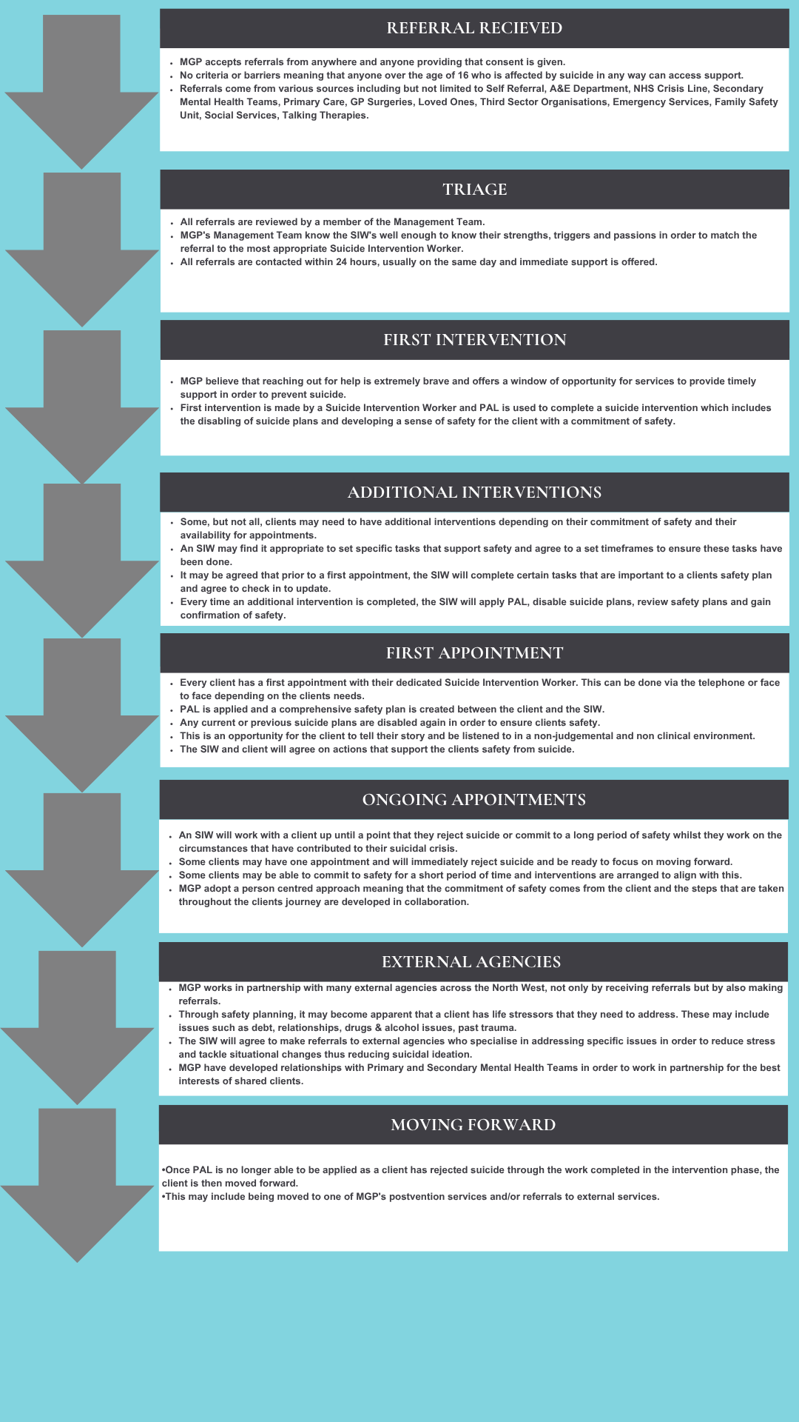

This evaluation aims to assess the outcomes and effectiveness of The Martin Gallier Project (MGP) in supporting individuals experiencing suicidal crisis, with a particular focus on those referred through the Cheshire and Wirral Partnership (CWP) NHS Foundation Trust. The evaluation also intent to provide robust, evidence-based insights into the impact of this innovative, non-clinical intervention model, and how it compares across various referral pathways.
1.2 Evaluation Scope and Purpose
The primary aims of this evaluation are:
- To produce a comprehensive report for the Cheshire and Wirral Partnership NHS Foundation Trust, assessing the outcomes and effectiveness of the Project’s support for NHS-referred individuals.

- To conduct a comparison study to see if there are notable differences in outcomes between NHS referred individuals and those who come to the service through self-referral or non-NHS referrals.

- To establish The Martin Gallier Project’s model as a replicable best practice framework for suicide interventions, demonstrating its proven impact and suitability for wider adoption at regional and national levels.

2. Methodology
This evaluation draws on both quantitative and qualitative data sources to produce a comprehensive assessment of The Martin Gallier Project's (MGP) service impact and client outcomes. Participants in this study are adults who are currently accessing or have previously accessed support from The Martin Gallier Project, a suicide intervention and prevention charity. Participants may have either been referred to the service by NHS mental health providers, such as through A&E, or come through self-referral or non-NHS referrals.
We will be using two forms of data:

2.1 Secondary anonymised quantitative data collected by the service.
We will be conducting a service evaluation of the secondary anonymised quantitative data collected by the service.
The study will access anonymised, pre-existing data collected by The Martin Gallier Project as part of routine service delivery. This data will include demographic information, service usage, and anonymised data on referral, wellbeing outcomes, and follow-up actions. Since the data was initially collected as part of The Martin Gallier Project’s operational records, all data will be fully anonymised before being provided to the research team to ensure confidentiality and compliance with ethical guidelines. The Martin Gallier Project will formally approve and facilitate access to this data, ensuring that privacy and confidentiality protocols are strictly followed.
Overview and Structure
Quantitative data were supplied by The Martin Gallier Project , based on routinely collected client records and structured outcome monitoring tools. The dataset covers the period since the opening of the MGP on 3rd February 2019 to 5th August 2025. This data was used to analyse trends in referral pathways, service engagement, and individual progress across key wellbeing domains.

- Records: The dataset includes client-level data from 9801 individuals who accessed MGP support services between 3rd February 2019 (when the service was established) and 5th August 2025. Over this 6 year and 6-month period, a total of 36,399 interventions were delivered.
- Outcome Score Source: Dataset of 2,550 were drawn from internal client records and the Recovery Star Outcome Tool, which MGP uses to track client progress and recovery trajectories.
Key Variables in the Dataset Include
- Referrer: Identifies the origin of each referral (e.g., CWP NHS Trust, self-referral, voluntary sector and others).
- CWP Referral (Yes/No): Indicates whether the referral was made directly via the CWP NHS partner.
- Mental Health Diagnosis (Yes/No): Flags whether the individual had a recorded mental health diagnosis.
- Age Range: Categorised age bands (16–24, 25–44, 45–64, 65+) to enable life-stage analyses.
- Gender: Self-reported gender of clients.
- Progress Score: A composite metric from the Recovery Star Tool measuring outcomes across domains such as mental health, social networks, and daily living skills.
Data Cleaning and Transformation
- Anonymisation: All records were anonymised by MGP prior to receipt and analysis.
- Data Cleaning: The datasets reviewed for duplicate entries, outliers, and inconsistencies.
- Missing or Repeated Data : Incomplete or duplication of records were assessed, with missing values managed via imputation or case-wise exclusion depending on the variable type.
- Categorisation: Referral sources grouped into three primary categories for analysis:
  - NHS Referral
  - Self-Referral
  - Other or Community Referral
- Score Standardisation: Progress scores checked and, where necessary, normalised to ensure comparability across time periods and demographic groups.

2.2 Qualitative interview data from people attending the crisis service, carers of people attending the crisis service, those referring into the crisis service and those who work at and deliver the service
The qualitative data will be gathered through semi-structured interviews. Each interview will last between 30 to 45 minutes and will take place either online via Microsoft Teams or in person at The Martin Gallier Project venue in a private room to ensure confidentiality and comfort.
(i) people attending the crisis service:
The interviews will explore participants' experiences with the service, including initial perceptions, support received, and perceived outcomes. Each interview will take approximately 30-45 minutes and will be audio-recorded for later analysis. Prior to participating, each individual will be asked to sign a consent form outlining their involvement, data confidentiality, and the voluntary nature of participation. Consent can also be audio-recorded prior to interviews taking place if needed.
(ii) carers of people attending the crisis service:
The interviews will explore carers' experiences of the crisis service, including their perspectives on the support provided to the person they care for, their involvement in the service, and the impact the service has had on them and their loved one. Each interview will take approximately 30-45 minutes and will be audio-recorded for later analysis. Before participating, carers will be asked to sign a consent form detailing their involvement, data confidentiality, and the voluntary nature of participation. If required, consent can also be audio-recorded prior to the interview.
(iii) those referring into the crisis service:
The interviews will investigate the experiences of those who refer individuals to the crisis service, covering their understanding of the service, their reasons for referral, and their perceptions of the service’s impact on clients. Each interview will last approximately 30-45 minutes and will be audio-recorded for analysis purposes. Prior to participating, referrers will be required to sign a consent form explaining their involvement, data confidentiality, and the voluntary nature of participation. If necessary, consent can also be recorded audibly before the interview begins.
(iv) those who work at and deliver the service:
The interviews will delve into the experiences of staff members who work at and deliver the crisis service, including their views on service effectiveness, the challenges they face, and areas for potential improvement. Each interview will take approximately 30-45 minutes and will be audio-recorded for thorough analysis. Staff will be asked to sign a consent form prior to participating, outlining details on their involvement, data confidentiality, and the voluntary nature of their participation. Audio-recorded consent can be arranged before the interview, if needed.
As a community-focused study, recruitment materials and research methods will be developed collaboratively with advisory groups that include former clients and stakeholders from The Martin Gallier Project . This participatory approach ensures that the study aligns with the needs and preferences of those most affected by suicide intervention efforts. The advisory groups will help shape the interview questions and recruitment approach to make sure they are accessible and respectful of participants' experiences. This community-led aspect is expected to enhance the study’s relevance and effectiveness in evaluating the impact of The Martin Gallier Project ’s support services.
Qualitative Data
Complementing the quantitative analysis, 50 semi-structured interviews were conducted with a range of stakeholders to capture qualitative insights. Participants included:
- 20 clients
- 10 carers
- 10 staff members
- 10 practitioners or referrers
These interviews offer narrative depth and contextual understanding of the lived experiences of individuals accessing or delivering MGP services. They serve to triangulate findings and highlight perspectives not evident through quantitative metrics alone.

3. Analysis and Results

3.1 Demographic Analysis

3.1.1 Age Distribution
This section presents the age distribution of individuals who accessed The Martin Gallier Project (MGP), also grouped by whether they were referred through the Cheshire and Wirral Partnership (CWP) or not.
The full distribution by age range is provided below:
Age Range | Number of clients
25 To 34 | 2337
35 To 44 | 2116
45 To 54 | 1830
18 To 24 | 1579
55 To 64 | 1135
65+ | 334
Under 18 | 237
Not on referral | 133
Unknown | 97
Under 16 (referral re-signposted) | 3
The dataset includes 9,801 clients, with referrals divided between those coming via the Cheshire and Wirral Partnership (CWP) also referred to as NHS subcontract arrangement (“Yes”) and other referrers outside this subcontract (“No”). This analysis examines age distribution differences between CWP and non-CWP referrals.
- The largest proportion of clients falls within the 25 to 34 age group (2,337 individuals), representing the core demographic accessing the service.
- Following closely are the 35 to 44 (2,116) and 45 to 54 (1,830) age groups, collectively constituting a significant portion of the client base.

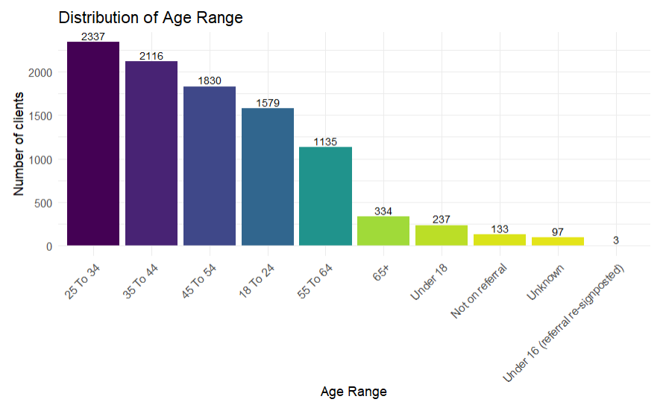
- The 18 to 24 age group (1,579) also represents a substantial segment, highlighting strong engagement with younger adults.
- Clients aged 55 to 64 account for 1,135 individuals, with those aged 65 and above representing 334, indicating reduced engagement in older age brackets.
- Younger clients under 18 make up 237 individuals, reflecting some accessibility to adolescents.
- Missing or unknown age data remains relatively low, with 133 marked as “Not on referral” and 97 as “Unknown.”
These findings illustrate that MGP predominantly serves adults aged 18 to 54, with younger and older age groups representing smaller proportions. The age distribution aligns with typical patterns of suicidal crisis risk concentrated in early to mid-adulthood.
Referral source analysis further explains age-related differences between clients referred through the Cheshire and Wirral Partnership (CWP) NHS subcontract and those referred by other sources.

Age Range | NHS Subcontract (Yes) | NHS Subcontract (No)
18 To 24 | 708 | 871
25 To 34 | 713 | 1624
35 To 44 | 588 | 1528
45 To 54 | 450 | 1380
55 To 64 | 248 | 887
65+ | 95 | 239
Not on referral | 26 | 107
Under 16 (referral re-signposted) | 0 | 3
Under 18 | 88 | 149
Unknown | 13 | 84

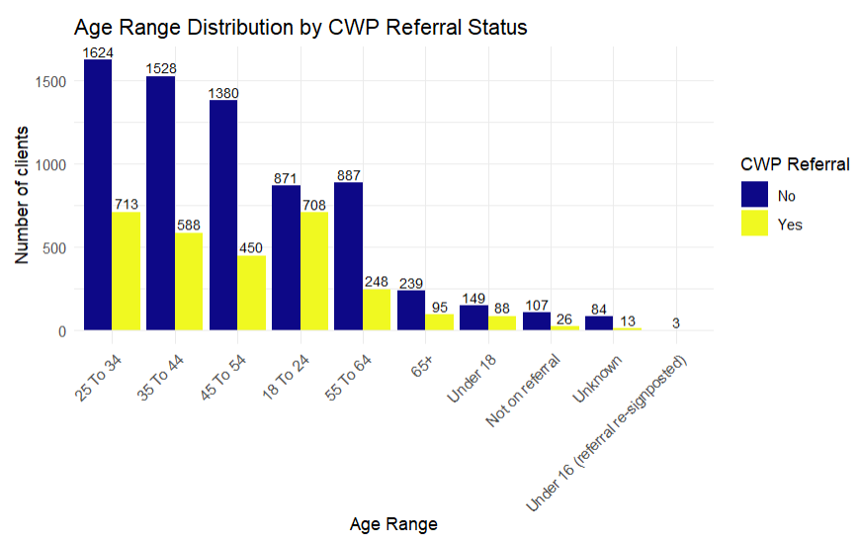

- For all age groups, a larger number and higher proportion of clients come from non-CWP referrals compared to CWP referrals.
- The highest non-CWP proportions are seen in older age groups:
  - 55 to 64 (78.15%)
  - 45 to 54 (75.41%)
- The 18 to 24 group shows a relatively smaller gap in proportions between non-CWP (55.16%) and CWP referrals (44.84%), indicating strong engagement with younger adults via CWP pathways.
- Missing or “Unknown” age and “Not on referral” categories are predominantly from non-CWP sources, with proportions of 80.45% and 86.60% respectively.
Non-CWP Referrals Dominate Across Most Age Groups: Across all recorded age ranges, a greater number and higher proportion of clients are referred via non-CWP pathways. This is particularly evident in older age brackets, suggesting that community-based and alternative referral routes are more effective at reaching middle-aged and older adults.
CWP Referrals Show Stronger Reach Among Younger Adults: While non-CWP referrals still make up the majority in the 18 to 24 group, the gap between CWP and non-CWP proportions is much smaller (44.84% CWP vs. 55.16% non-CWP). This indicates that CWP referral pathways are comparatively more successful at engaging younger adults than they are with older populations.
Older Age Groups More Likely to Access Services via Non-CWP Sources: Proportions of non-CWP referrals exceed 70% in all age groups above 35 years, reaching a high of 78.15% in the 55 to 64 range. This may point to differences in referral networks or to older adults’ greater reliance on non-clinical community services for suicidal crisis intervention.
Notable Presence of Under-18s in Both Pathways: Although small in absolute numbers, the under-18 category shows that both referral streams play a role in engaging younger clients. Non-CWP pathways account for the majority (62.87%), but over a third (37.13%) are CWP referrals, suggesting opportunities for joint strategies in youth crisis engagement.
A portion of earlier data lacks age information, largely because the service initially allowed anonymous walk-ins without requiring detailed personal information such as addresses or age. If a client’s age was not provided on the referral and could not be reasonably obtained, it has been recorded as "not on referral." Additionally, records with missing referral information have been marked as "unknown referrer." These practices reflect the service’s original emphasis on accessible, low-barrier support, which has since evolved to capture more comprehensive data.
Overall, the age profile of individuals engaging with MGP demonstrates broad service uptake across all age groups, with a notable focus on younger and middle-aged adults. The data suggests that the partnership with CWP is effectively reaching younger adults who may benefit most from the non-clinical, rapid-response interventions offered by the project.

3.1.2 Gender Distribution
The gender distribution of individuals accessing The Martin Gallier Project (MGP) reveals a relatively balanced profile between male and female clients.
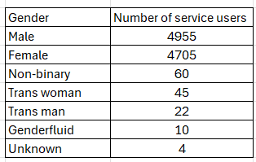

Notably, males represent the largest group across all referrals, followed closely by females. This contrasts with common perceptions that women are more likely to seek help for mental health concerns. The presence of non-binary, transgender, and genderfluid individuals, also reflects the inclusivity of the service.
As a community-based intervention, MGP appears to successfully engage a diverse population, including a higher proportion of men than typically seen in traditional clinical settings.
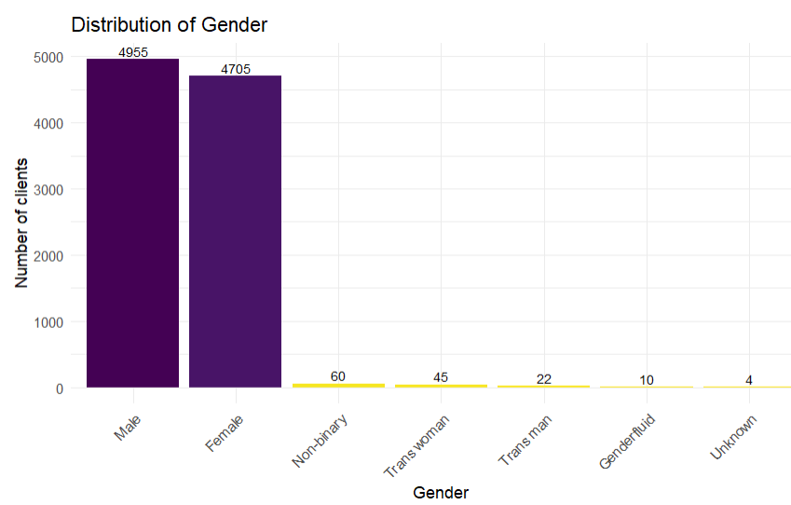
Balanced Gender Representation: The MGP supports a nearly equal number of male (50.5%) and female (48%) clients, indicating equitable access and engagement across these major gender categories.
Diverse Gender Identities Represented: Though smaller in number, the presence of non-binary (60), trans women (45), trans men (22), and genderfluid (10) clients demonstrates the service’s inclusivity toward gender-diverse individuals.
Minimal Unknown Gender Data: Only 4 records have unknown gender, reflecting high data quality and careful verification processes.

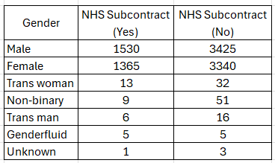

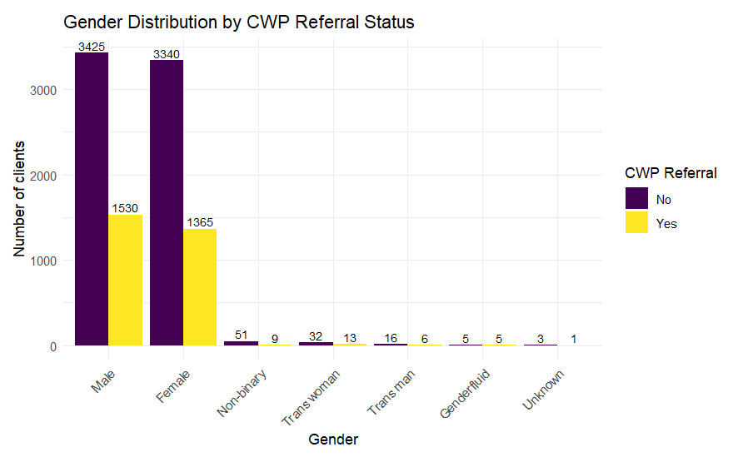
Majority Male and Female Clients in Both Referral Streams: Both CWP and non-CWP referrals show a predominance of male and female clients. Non-CWP referrals include 3,425 males and 3,340 females, while CWP referrals consist of 1,530 males and 1,365 females.
Gender-Diverse Clients Represented Across Referral Sources: Non-binary, trans women, trans men, and genderfluid clients are present in both groups, with slightly higher numbers in non-CWP referrals. For example, non-binary individuals number 51 in non-CWP referrals versus 9 in CWP, and trans women number 32 in non-CWP versus 13 in CWP.
Parity in Genderfluid Representation: The genderfluid group is equally represented with 5 individuals in each referral source category.
Low Proportion of Unknown Gender: Minimal unknown gender cases (3 non-CWP, 1 CWP) confirm effective gender data collection practices across referral pathways.
These data highlight that The Martin Gallier Project serves a diverse gender population and receives referrals through CWP across the full gender spectrum. This gender profile complements the age distribution findings, offering a clearer picture of the demographic characteristics of MGP clients and their referral sources.
This gender distribution also suggests that MGP is accessible to and utilised by a broad spectrum of gender identities, supporting the project’s goal of inclusivity and non-judgmental care. The similar proportions suggest equitable referral practices and potential to continue tailoring support to diverse gender identities across all pathways.

3.1.3 Referral Distribution
Understanding where clients are referred from provides important insight into the accessibility, visibility, and integration of the service within the wider health, social care, and community support network. The dataset summarises all referral sources recorded between February 23, 2019 (when the service began operating) and August 5, 2025, capturing both high-volume clinical pathways and a wide range of community, statutory, and informal channels.
The referral source data not only highlights the primary routes by which individuals’ access support but also reflects the service’s evolving approach to engagement from early low-barrier walk-in accessibility to the more structured, multi-agency referral environment seen in recent years. This breadth of pathways demonstrates the service’s embeddedness across diverse systems and its role as a shared community resource.
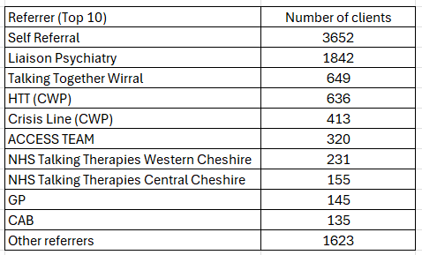

Dominance of Self-Referral: The largest proportion of clients (3,652) came through self-referral, representing the service’s strong accessibility and community awareness.
Significant NHS-Linked Pathways: Liaison Psychiatry (1,842 users), HTT – CWP (636), Crisis Line – CWP (413), and multiple NHS Talking Therapies services (Western Cheshire – 231, Central Cheshire – 155) are among the top structured clinical referral routes.
Community and Third-Sector Engagement: Talking Together Wirral (649), Wirral Ways to Recovery (120), Companeros Crisis Café (118), and Involve NW (91) are notable community-based partners providing substantial referrals.
Primary Care & GP Pathways: GPs (145) and social prescribing routes (e.g., Social Prescriber - 124) remain steady contributors, though smaller in scale compared to self-referrals and psychiatric pathways.
Wide Diversity of Low-Volume Sources: Beyond the top 20, there is an extensive network of over 130 other sources, most contributing fewer than 10 clients each. These include schools, housing providers, job centres, faith groups, police, probation services, charities, and individual advocates.
Historic Data Category: "Before data capture" (21 users) reflects cases before systematic referral source recording was implemented.
Minimal Unknowns: Only 2 cases are marked as "Unknown referrer," indicating strong current completeness in referral source recording.

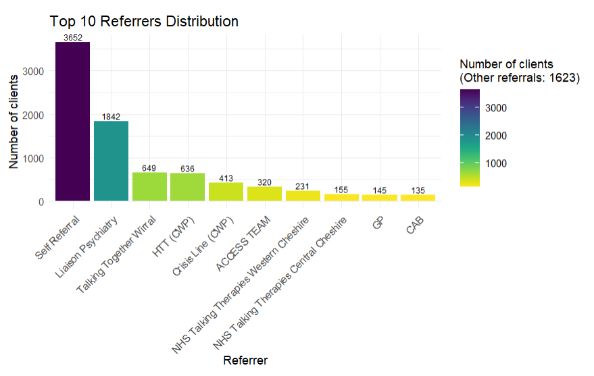

Accessibility and Public Awareness: The high proportion of self-referrals suggests that the service is well-known and approachable, enabling individuals to seek help without needing a professional intermediary. This reflects the service’s low-barrier ethos.
Strong Integration with NHS Mental Health Services: Substantial referral volumes from Liaison Psychiatry, CWP crisis and home treatment teams, and NHS Talking Therapies indicate deep integration with formal NHS mental health pathways, ensuring individuals in acute or clinical settings are signposted into the service.
Role of Community Partners: Third sector and grassroots organisations remain crucial conduits for referrals, particularly for individuals who may not be engaged with statutory services. This underlines the importance of sustained collaboration and relationship-building across the voluntary sector.
Breadth of Referral Network: The wide spread of low-volume sources demonstrates the service’s reach across multiple systems i.e. health, social care, housing, justice, education, and community networks. While individually small, collectively these represent a significant access channel and highlight the service’s adaptability to varied needs.
Data Quality Improvements: Minimal “unknown referrer” entries and the clear categorisation of legacy cases (“before data capture”) suggest that referral source recording has strengthened over time, improving monitoring and evaluation capacity.

3.2 Mental Health Diagnosis & Active Engagement

3.2.1 Mental Health Diagnosis

This section explores the distribution of known mental health diagnoses among individuals accessing The Martin Gallier Project (MGP), disaggregated by referral source. The presence or absence of a mental health diagnosis provides insight into the complexity of needs among clients and the nature of support required.

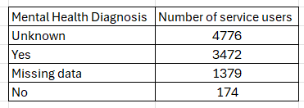

The largest single category is “Unknown,” followed by those with a confirmed diagnosis. Those recorded as having no diagnosis represent only a small proportion of the dataset.
The high number of “Unknown” and “Missing data” entries reflects the fact that the service allowed the suicide intervention workers to assist individuals in suicidal crisis through anonymous or minimal information regardless of their mental health diagnosis.
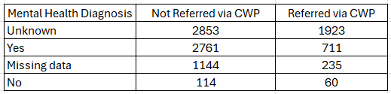

- Unknown diagnoses are most common among non-CWP referrals (2,853) but are also high among CWP referrals (1,923).
- A confirmed diagnosis (“Yes”) is more common among non-CWP referrals (2,761) than CWP referrals (711).
- Missing data affects both groups, with higher numbers in non-CWP referrals (1,144) compared to CWP referrals (235).
- Individuals recorded as having no diagnosis are relatively rare in both groups i.e.114 (non-CWP) and 60 (CWP).

Mental health diagnosis is not a mandatory field for suicide intervention workers, reflecting the service’s priority of providing rapid, person-centred support over collecting diagnostic information. Where a diagnosis is known, it is recorded.
The high levels of “Unknown” and “Missing” entries reflect the service’s open-door policy, historically allowing individuals to access support without disclosing medical history and the reality that many in crisis may not have a formal diagnosis.
With over 70% of referrals coming via non-CWP pathways, this reinforces that the MGP is open to all, not just those already in contact with NHS secondary mental health services.
The data challenges the persistent myth that a diagnosed mental illness is a prerequisite for suicidal crisis. Many people who accessed support including those without any recorded diagnosis — were experiencing acute distress, underlining the importance of broad, accessible suicide prevention services.

3.3 Progress and Outcomes Analysis

3.3.1 Initial Analysis – Recovery Star Outcome Scores by Stage
The dataset includes Recovery Star outcome scores captured at different stages of engagement with The Martin Gallier Project (MGP). The “Stage” variable categorises each record into one of four phases of support: Crisis, Interim, Post-crisis, and Final.
The Recovery Star Outcome data reveal that all clients begin with an assessment at the crisis stage; however, not all clients progress through to the interim, post-crisis, or final stages. Some clients remain in active engagement within earlier stages, while others disengage prior to completing the full support journey, as they no longer need support following the initial crisis. This accounts for the decreasing number of assessments observed across these stages and represents an important consideration for interpretation.
The distribution of records across these stages in the dataset is as follows:
Stage | n
Crisis | 1360
Post-crisis | 768
Interim | 119
Final | 114

The majority of assessments (57.6%) were conducted during the crisis stage, with 1360 of the total 2361 stage entries recorded at this point. The post-crisis stage accounts for approximately 32.5% of assessments, while interim and final stages constitute smaller proportions of the dataset.
It is important to note that some individuals completed multiple Recovery Star assessments within the same stage. To address this, average scores were calculated across repeated assessments for each individual at a given stage. This method ensures that the analysis accurately reflects individual-level progress without disproportionately weighting clients with multiple entries.
This preliminary overview establishes a basis for more detailed analyses of Recovery Star outcome scores across different stages. Such analysis will provide insight into client progress and the impact of The Martin Gallier Project ’s intervention model over time. Future work will focus on examining mean scores within each domain by stage and identifying patterns of improvement or stabilisation as clients move through the crisis pathway.

3.3.2 Recovery Star Outcome Scores: Detailed Domain Analysis by Stage

The Recovery Star is a structured, collaborative outcomes tool used to assess and track progress across ten domains of wellbeing: Managing Mental Health, Self-Care, Living Skills, Social Networks, Work, Relationships, Addictive Behaviour, Responsibilities, Identity & Self-Esteem, and Trust & Hope.
In the context of suicide intervention, individuals entering services during the Crisis stage typically present with lower scores across most domains. These low scores reflect acute distress, diminished coping capacity, and significant disruption in daily functioning.
As individuals progress to the Post-Crisis stage, scores increase across the majority of domains. This upward trend reflects the stabilisation of immediate suicidal risk, enhanced engagement with support systems, the adoption of practical coping strategies, and the gradual restoration of life skills, relationships, and social connections.
The rise in Recovery Star scores from Crisis to Post-Crisis stages provides a clear, evidence-based indicator of recovery. It not only captures the reduction in immediate suicide risk but also the strengthening of protective factors essential for long-term wellbeing. This approach highlights that recovery is multi-dimensional, encompassing practical, social, and psychological growth alongside safety from suicidal behaviour.
The Recovery Star chart below shows the scores of Crisis and Post-Crisis of a client( name and details anonymised ) at The Martin Gallier Project.
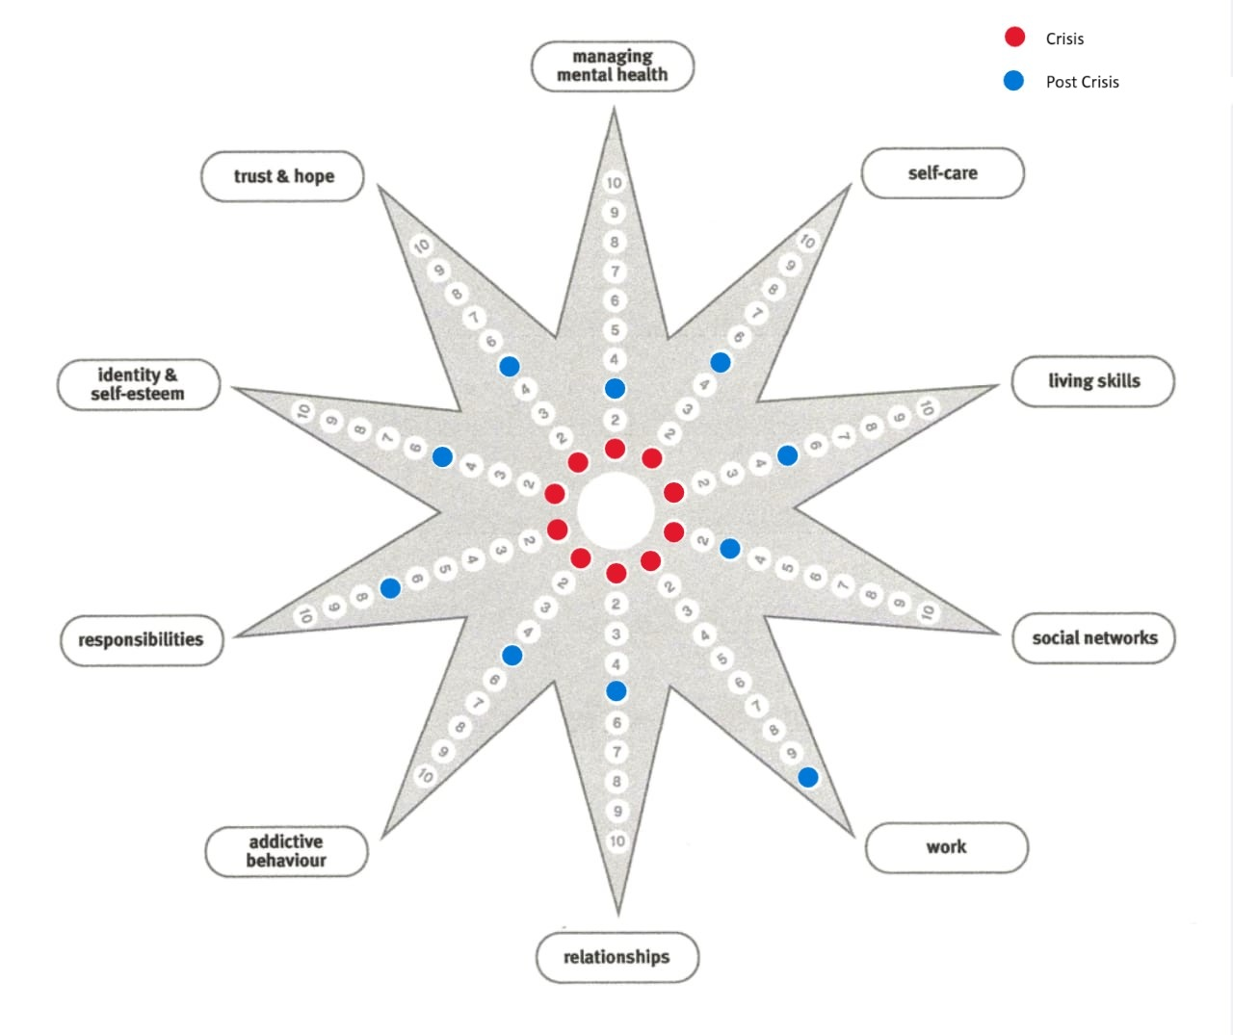

The following analysis reviews mean scores and variability (standard deviations) across the 10 Recovery Star domains and overall average score, segmented by client stage of engagement: Crisis, Interim, Post-crisis, and Final. To ensure fair analysis, average scores were calculated for individuals who completed multiple Recovery Star assessments at the same stage.

Domain | Crisis  (Mean ± SD) | Post-crisis (Mean ± SD) | Interim  (Mean ± SD) | Final (Mean ± SD)
Managing mental health | 2.14 ± 1.91 | 5.18 ± 1.92 | 5.34 ± 2.29 | 5.96 ± 2.05
Self-Care | 3.58 ± 2.86 | 5.59 ± 2.38 | 6.00 ± 2.47 | 6.26 ± 2.56
Living skills | 3.91 ± 3.04 | 6.14 ± 2.41 | 5.88 ± 2.50 | 6.27 ± 2.77
Social networks | 3.24 ± 2.72 | 5.27 ± 2.60 | 5.98 ± 2.57 | 6.87 ± 2.16
Work | 3.62 ± 3.24 | 5.34 ± 3.00 | 4.58 ± 2.77 | 6.17 ± 2.81
Relationships | 3.16 ± 2.66 | 5.66 ± 2.51 | 5.95 ± 2.60 | 6.22 ± 2.60
Addictive behaviour | 3.57 ± 2.97 | 6.96 ± 2.78 | 6.36 ± 2.50 | 7.32 ± 2.59
Responsibilities | 3.83 ± 2.97 | 6.76 ± 2.35 | 6.29 ± 2.27 | 7.04 ± 2.40
Identity & Self esteem | 2.67 ± 2.34 | 3.87 ± 2.22 | 4.49 ± 2.44 | 4.73 ± 2.59
Trust and hope | 2.68 ± 2.30 | 4.92 ± 2.20 | 5.29 ± 2.38 | 5.71 ± 2.51

Overall Progression Across Stages: There is a clear upward trend in scores from Crisis through Post-crisis, Interim, and Final stages across all domains. This demonstrates overall improvement in client wellbeing and functioning over time, reflecting the positive impact of MGP’s interventions as clients move from acute suicidal crisis toward recovery. Importantly, these increases in overall wellbeing suggest that clients are better able to step away from suicidal crisis, supporting the effectiveness of timely intervention.
Low Initial Scores During Crisis: Clients start with very low scores in the Crisis stage, particularly in “Managing Mental Health” (2.14 ± 1.91), “Identity & Self-esteem” (2.67 ± 2.34), and “Trust and Hope” (2.68 ± 2.30). These low scores underscore the severe challenges faced by clients at the point of suicidal crisis, emphasising that support begins when distress is highest.
Steady Gains Through Intermediate Stages: The Post-crisis and Interim stages show moderate improvements across most domains, signalling gradual recovery. Notably, “Managing Mental Health,” “Self-Care,” and “Living Skills” show consistent gains from Crisis to Interim, highlighting incremental progress as clients engage with services.
Substantial Improvements by Final Stage: By the Final stage, domain scores reach much higher levels, mostly in the 6–7 range. For example, “Addictive Behaviour” increases from 3.57 ± 2.97 in Crisis to 7.32 ± 2.59, and “Responsibilities” from 3.83 ± 2.97 to 7.04 ± 2.40. Even “Trust and Hope,” a key psychological marker of recovery, rises indicating meaningful gains in resilience and wellbeing.
Variability Across Domains: Higher standard deviations in some domains, particularly “Work”, Living skills, “Social Networks,” suggest wide variability in client experiences and engagement levels. This highlights the need for tailored support in areas that are more challenging for individuals.
Domains Requiring Focus: “Identity & Self-esteem” and “Trust and Hope” remain comparatively lower than other domains, indicating that these areas may require ongoing attention even as other aspects of functioning improve.
Implications for Suicide Support: The data reinforces that clients do not need a diagnosed mental illness to experience suicidal crisis or benefit from interventions. MGP supports clients at their point of need, and improvements in scores show that recovery is possible across multiple life domains, regardless of diagnosis.

The Recovery Star data illustrate meaningful improvements across key wellbeing domains as clients move through the MGP stages from Crisis to Final. Preliminary stages show clients facing suicidal crisis has considerable difficulties, but steady progression through the service correlates with enhanced mental health management, self-care, social functioning, and personal identity. The variability observed highlights the need for individualised approaches, particularly in social and occupational areas. These findings support the effectiveness of MGP’s community-based, non-clinical intervention model in facilitating recovery from suicidal crisis across multiple facets of wellbeing.

3.3.3 Longitudinal Insights: Recovery Star Scores for Individuals with Final Stage Data

This section explores the subset that includes 112 individuals who have Recovery Star scores recorded at multiple stages, with both Crisis and Final were available. 264 datapoints indicating RS outcome scores are available across the 4 stages and this data provides a valuable opportunity to examine individual progress over time.
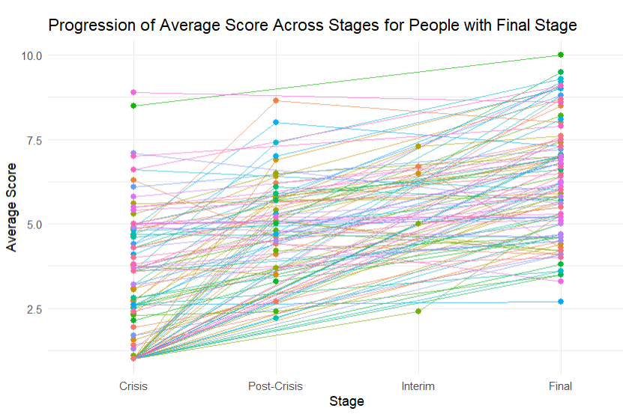

- Marked Improvement from Crisis to Final Stage: Most individuals show a clear increase in their Recovery Star scores from the Crisis stage to the Final stage, indicating substantial overall improvement.
- Range of Starting Points: Initial scores at the Crisis stage vary widely, from as low as 1.0 to as high as 10.0, illustrating that clients enter the service at different levels of need and distress.
- Variability in Post-crisis and Interim Data: Not all individuals have Post-crisis or Interim stage data available, which limits the continuity analysis for some.
- Consistent Positive Trajectory: 106 out of 112 individual (94.64%) showed an improvement from Crisis to Final stage scores, demonstrating the effectiveness of MGP’s intervention in supporting recovery and wellbeing.
- Individual Differences in Rate of Recovery: While almost all progressed positively, some individuals had more dramatic improvements compared to others with more moderate gains.
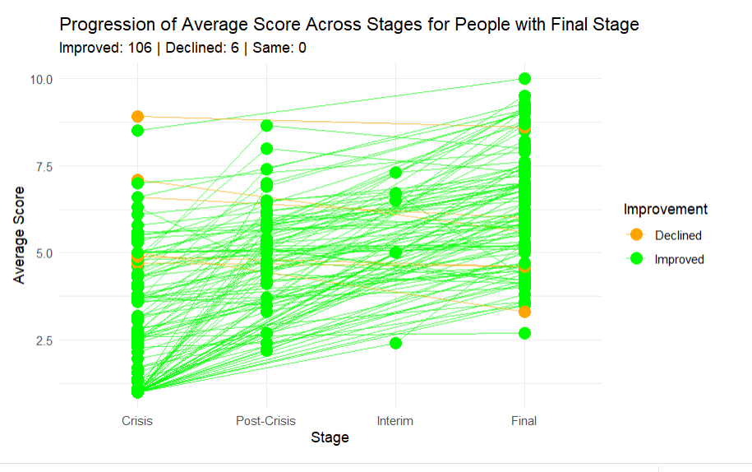

The longitudinal data from individuals with Final stage scores reinforces the quantitative finding that MGP’s community-based interventions support meaningful recovery from suicidal crisis. Despite variation in initial severity and progression pace, 94.64% individuals show clear improvements by the Final stage. The availability of Post-crisis and Interim data for some participants further highlights the value of continuous engagement in recovery pathways.
Future analysis can be done from more complete and consistent data across all factors, with fewer missing values, to enable deeper exploration of the drivers behind individual recovery trajectories and to better tailor support interventions.

3.3.4 Longitudinal Insights: Recovery Star Scores by the NHS or Non-NHS Referral
The longitudinal analysis of Recovery Star scores across different service stages reveals differences between individuals referred via NHS pathways and those referred through non-NHS sources. Notably, the dataset has retained entries, including instances where individuals appear in the same stage multiple times but through different pathways and/or has different crisis stage category. This approach preserves the full complexity of service engagement and individual progress, enabling a more detailed view of how average scores and client counts differ by referral pathway and service stage.

The table below summarises client counts and average total scores by stage and referral source:
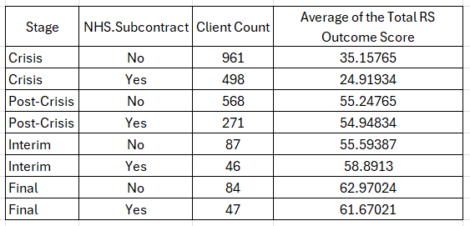

Crisis Stage: At the initial Crisis stage, average total scores are lowest for both groups, reflecting the early phase of recovery. Non-NHS referrals have a notably higher average score (35.16) compared to NHS referrals (24.92) and are also more numerous (961 vs. 498). This suggests that those entering via non-NHS pathways may begin with a stronger starting position or different support needs.
Post-crisis Stage: Scores increase substantially for both groups during the Post-crisis stage, indicating meaningful progress in recovery. The difference in averages between the two groups is minimal, with non-NHS referrals averaging 55.25 and NHS referrals averaging 54.95. Non-NHS referrals remain the larger group at this stage (568 vs. 271).
Interim Stage: During the Interim stage, NHS referrals have a slightly higher average score (58.89) than non-NHS referrals (55.59), reversing the earlier trend. However, the numbers are much smaller here, with only 87 non-NHS and 46 NHS referrals recorded.
Final Stage: At the Final stage, both groups record their highest scores, reflecting substantial recovery. Non-NHS referrals average 62.97, slightly above NHS referrals at 61.67. The number of clients at this stage remains small in both groups (84 non-NHS vs. 47 NHS), so interpretations should be cautious.
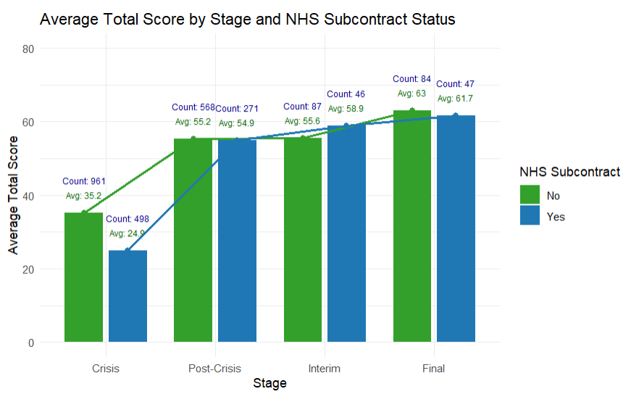
The data shows that while non-NHS referrals tend to begin with a higher starting score, differences narrow as clients progress through the stages. NHS referrals slightly outperform at the Interim stage, but by the Final stage, scores are nearly identical. This pattern suggests both referral sources support meaningful recovery, though initial differences in baseline scores may reflect variations in client profiles or pre-service support. Further analysis could examine these differences in more depth to guide equitable service delivery strategies.
Future investigations should explore underlying factors contributing to these differences and consider how service delivery can be optimised for all referral sources to support recovery trajectories.

3.4 Recovery Star Outcomes: Paired t-Test Analysis of Client Progress

Client progress throughout The Martin Gallier Project (MGP) support journey was analysed using quantitative outcome data gathered through the Recovery Star tool. Paired t-tests were conducted to assess changes across four key stages of support: Crisis, Post-Crisis, Interim, and Final.
Recovery Star measures ten interconnected areas of mental health and wellbeing, including managing mental health, self-care, relationships, social networks, identity and self-esteem, addictive behaviours, and trust and hope, among others. These 10 domains reflect the broader psychosocial and functional needs of individuals experiencing suicidal crisis.
To assess the significance and consistency of client progress over time, paired t-tests were conducted comparing scores across the different stages. These statistical tests evaluate whether average differences in outcomes between stages are meaningful and unlikely to have occurred by chance.

Findings of the paired t-tests:

Crisis to Final Stage
Comparing the Crisis and Final stages, individuals demonstrated clear and consistent improvements across all Recovery Star outcome domains. Progress was evident in areas such as Managing mental health, Self-Care, Living skills, Social networks, and Trust and hope, reflecting enhanced capacity for self-management, social engagement, and overall wellbeing.
Notable gains were observed in Addictive behaviour and Responsibilities, indicating substantial improvement in personal accountability and behavioural stability. Across all domains, the Average and Total Recovery Star scores increased significantly, highlighting the broad-based impact of the service interventions.
These findings suggest that the support provided over the course of the programme effectively facilitates recovery, helping individuals move from the initial Crisis stage toward a more stable and independent state. The consistent improvements across multiple domains underscore the value of sustained engagement and tailored interventions throughout the recovery process.

Crisis to Post-Crisis Stage
Transitioning from the Crisis to the Post-Crisis stage, participants demonstrated substantial and widespread improvements across all domains of recovery. Progress was observed in mental health management, self-care routines, and living skills, suggesting enhanced daily functioning.
Social and relational dimensions, including social networks, relationships, and trust and hope, also improved, reflecting strengthened interpersonal connections and confidence in recovery. Areas such as Addictive behaviour and Responsibilities showed marked gains, indicating better behavioural regulation and accountability.
Overall, these changes are reflected in increased average and total Recovery Star scores, illustrating that even in the early stages of intervention, meaningful recovery trajectories are evident. This highlights the effectiveness of the support provided in helping individuals move from acute crisis toward a more stable and structured stage of recovery.

Crisis to Interim Stage
From the Crisis to the Interim stage, participants showed clear and consistent improvements across all dimensions of the Recovery Star. Gains were particularly notable in mental health management, self-care, and living skills, indicating enhanced day-to-day functioning and personal autonomy.
Social and relational domains, including social networks, relationships, and trust and hope, also improved, reflecting strengthened interpersonal support and confidence in recovery. Participants made notable progress in Addictive behaviour and Responsibilities, suggesting better control over behaviours and increased accountability.
Overall, the improvements in average and total Recovery Star scores highlight that by the Interim stage, participants had achieved substantial recovery gains, demonstrating the effectiveness of ongoing support and intervention in facilitating continued progress from the acute crisis phase.

The paired t-tests conducted across all stages of the support journey show consistent, statistically significant improvements in client wellbeing and functioning. Progress is evident across all ten Recovery Star domains, from the earliest stages of support through to final outcomes. These results provide robust evidence that The Martin Gallier Project’s approach combining rapid access, personalised support, and a non-clinical model leads to measurable and meaningful change for individuals experiencing suicidal crisis.
The analysis highlights that the service not only facilitates immediate crisis stabilisation but also supports sustained recovery, promoting resilience, self-management, and enhanced life skills. This strengthens the case for continued investment, replication, and integration of The Martin Gallier Project model into broader suicide prevention strategies.

3.5 Missing-Data Analysis
There is a clear overall improvement in data completeness over time, with recent years reflecting strengthened data collection processes and more consistent quality assurance.
This improvement coincides with the evolution of service protocols, where certain personal details such as mental health diagnosis, demographic specifics, or referral information, are collected on an optional basis rather than as a mandatory prerequisite for support.
This approach is intentional and reflects MGP’s commitment to creating a welcoming, non-intrusive environment for individuals in suicidal crisis. By reducing administrative barriers and avoiding unnecessary data demands at the point of contact, the service actively works to destigmatise help-seeking, reassure clients that they will not be judged or excluded based on their background or circumstances, and avoid any perception of discrimination. The priority remains firmly on responding to suicidal crisis and providing immediate, compassionate support, with supplementary information gathered only where appropriate and possible.
This balance between robust data systems and client-centred flexibility helps ensure both inclusivity and service quality, while respecting the dignity and autonomy of those seeking help.

4. Qualitative Semi-Structured Interviews
In parallel with the quantitative dataset, 50 semi-structured interviews were conducted with key stakeholders: Clients (n=20), Carers (n=10), Staff members (n=10) and Practitioners/Referrers (n=10). These interviews provide valuable context and narrative insights into the lived experience of those accessing or delivering MGP’s services. They help to triangulate findings from the quantitative data and surface important themes that may not be captured through metrics alone.
The following section presents the key themes that emerged from the analysis of these interviews, reflecting common priorities, challenges, and opportunities across all stakeholder groups.

4.1 Rapid Access, Continuity & Immediate Support
Participants consistently emphasised the necessity of rapid and seamless access to suicide-specific support services, highlighting that minimising delays can be lifesaving during moments of crisis. The experience of consistent, uninterrupted care was described as integral to fostering trust and reducing anxiety, ensuring individuals did not feel abandoned or lost within complex systems. Immediate support not only alleviated distress but also reinforced a sense of being heard and valued across all levels of service provision.
Crucially, communication and collaboration between MGP and external referrers are reciprocal, allowing for flexible suicide safety that respond dynamically to an individual’s changing needs. By enabling referrals and contact within 24 hours and allowing walk-ins during opening hours, MGP eliminates traditional barriers such as long waiting lists that often exacerbate suicidal distress.
“If someone’s in crisis, then they need help now. Especially when it comes to suicidal crisis, this person is considering ending their life... we’re like, ‘Right, come and see us now.’”
— Chief Operating Officer
One participant expressed confidence in the environment:
“It doesn’t matter what role you’re in; you are listened to and supported. If you have an idea and it’s going to work or people think it’s good, they will promote that idea.”
Another key element was empowering clients to develop their own coping mechanisms:
“Supporting clients to be independent and support themselves.”
This approach was seen as vital for long-term recovery, enabling people to regain control and confidence, which is fundamental in promoting resilience beyond immediate crisis moments.
Timely access to support can be a decisive factor in crisis situations, particularly for carers managing acute distress in their loved ones. One participant described the referral process as exceptionally prompt: “They were quick on the referral. I think I had a phone call the same day to get me booked in, and when I went to see them, they were just fantastic. They were very, very quick.”
This immediate availability contrasts sharply with common reports of long waiting times within statutory services and underscores the critical value of responsive community-based support. For individuals in crisis and their carers, knowing that help is accessible without delay can offer not only practical relief but also a powerful sense of safety and validation.
Another participant, who supports as the clinical lead of liaison psychiatry highlighted the vital role The Martin Gallier Project plays in supporting patients following acute mental health crises. Their team conducts rapid, thorough assessments of individuals at risk, developing safety plans that often include referrals to community services. As the practitioner explained:
“The Martin Gallier Project is very much part of our safety plans if we can signpost anyone to there.”
The Martin Gallier Project is valued for its ability to provide swift and continuous support to individuals in crisis.
One of MGP staff highlighted the service’s quick response time:
“the fact that we don’t have a waiting list, people can walk in through the front door, they can phone us within our opening hours, they can make a referral and they’re contacted within a 24-hour timeframe.”
This rapid access is reassuring for both patients experiencing crisis and practitioners, offering timely intervention when it matters most.

4.2 Person-Centred & Tailored Support
The Martin Gallier Project was consistently described as offering highly individualised, flexible support that adapts to each person’s needs and pace of recovery. Rather than imposing rigid structures or expectations, the service allows clients to step in and out of activities and support groups as they feel ready, without judgement or pressure. This autonomy fosters a sense of control that is particularly valuable for those who have experienced suicidal distress.
Clients valued the non-clinical, human approach that prioritised empathy and mutual understanding. The presence of staff with lived experience enhanced this connection, helping individuals feel genuinely heard and understood. One participant reflected,
“I think it’s important, sometimes, to have people who actually understand where you’re coming from.”
The service was also praised for supporting clients to reframe difficult experiences and regain a sense of self-worth. Through group work, self-care activities, and one-to-one conversations, clients were gently encouraged to reflect on their needs and boundaries. As one participant shared,
“Sitting down and saying, ‘You’re important too,’ has been really… it sounds like it’s selfish but it’s not. You know, it’s trying to look after yourself.”
The ability to access support when needed, without fear of being judged or let down, was seen as central to The Martin Gallier Project ’s impact. This person-centred approach not only respects each individual’s journey but also empowers them to move forward with greater self-awareness and resilience.
Flexibility and individualised care planning were identified as critical components in delivering effective suicide prevention services. Participants valued the ability of services to tailor interventions according to their current therapeutic readiness, emphasising that rigid, one-size-fits-all approaches risked alienating or overwhelming vulnerable individuals. Personalisation allowed for recognition of the complex, fluctuating nature of suicidality, thereby improving engagement and outcomes.
Participants described the service as an essential safety net:
“Catching people falling through the net.”
It was particularly important for those who might otherwise miss out on support during vulnerable moments:
“Filling the gap – for those struggling with thoughts about wanting to take their own life or families that are bereaved by suicide, it’s a good service for that gap there between primary care and secondary care mental health services.”
This bridging role was recognised as crucial in preventing people from being lost between different levels of care, ensuring no individual or family felt unsupported during critical transitions.
For carers navigating the emotional turbulence of supporting a loved one in crisis, having reliable, ongoing support can be life changing. One parent described the practical and emotional guidance they received while caring for their daughter: “They’d just give me some tips on how to handle her and myself as well.”
This dual focus supporting both the individual in crisis and the carer’s own wellbeing is often absent in mainstream services.
The respondent emphasised how The Martin Gallier Project became a consistent source of comfort and stability: “Martin Gallier is my safe place.”
Beyond crisis support, the service helped them manage their own mental health struggles, providing calm, non-judgemental spaces to talk, and pathways into additional wellbeing initiatives. Unlike time-limited counselling, this flexible and ongoing support structure accommodated the respondent’s personal processing pace:
“I process things slowly, so it’s been a Godsend for me.”
The experience not only improved their coping mechanisms but also deepened their emotional literacy, helping them make sense of their own feelings and experiences. This highlights the unique value of community-based, relationship-driven services that respond not just to acute crises, but to the complex, evolving needs of carers themselves.

4.3 Lived Experience & Relatable Staff
The involvement of staff with lived experience of suicide bereavement or suicide-related distress was profoundly valued by participants. This humanised the support, allowing individuals to connect on a deeper level beyond clinical roles and formal interventions, thereby fostering trust and empathy. The presence of relatable staff was seen as a key factor in normalising experiences of distress and reducing stigma associated with seeking help.
One carer shared the significance of this connection when asked about strengths of The Martin Gallier Project:
“Their lived experience, the fact that they understand from personal experience, whether that is they have lived experience of severe mental health difficulties, or suicide, or as a carer themselves. You know, friend or family member or just being immersed in the community of experience. It's very different to clinical training and it allows that human contact, it's the human nature of them.”
This authentic relatability was seen as comforting and deeply validating, providing reassurance that individuals were understood and not alone in their struggles.
In moments of acute distress, the compassion and empathy shown by frontline crisis support workers can be a lifeline for carers. One parent recalled being overwhelmed and emotional, describing themselves as “a bit all over the place” during a particularly difficult time. Yet, the response from staff was deeply reassuring:
“They just reassured me, calmed me down, said, ‘We’ll get her some help, don’t worry.’”
In these moments, being met with calmness, understanding, and confidence in the support process helped alleviate panic and restore a sense of control.
Crucially, the workers also shared elements of their own lived experiences when appropriate, which helped the parent feel less alone:
“It wasn’t just me.”
This shared understanding, combined with practical reassurance, offered not only emotional relief but also a renewed sense of hope an essential ingredient for carers facing the frightening uncertainty of supporting a child in crisis.
One of the defining features of The Martin Gallier Project (MGP) is its deeply human and relatable approach to crisis care, delivered by staff with lived experience of suicide and mental health challenges. As one participant noted,
“It’s people who have all been affected by suicide, even partners, family. It’s all passionate people… they’re all doing it because they are passionate about it.”
This passion translates into care that feels authentic, not clinical or detached.
Unlike more bureaucratic or impersonal services, MGP staff draw from diverse personal and professional backgrounds, helping clients feel genuinely understood.
“They all come from different backgrounds, all have different stories. It’s all more relatable,” said another participant. This relatability builds trust and connection
The charity’s ability to provide rapid, face-to-face, and compassionate support makes them stand out as one-of-a-kind service.
MGP's strength lies in its person-centred culture:
“They make it personal, not in a bad way. They want to help. They want to get to know you. They want you to get better.”
“I felt very supported. They[MGP] were very emphatic, caring and I’ve never felt stigmatised by these people.”
This ethos, rooted in lived experience, breaks down stigma and fosters meaningful engagement with suicide crisis support.

4.4 Bridging the Gap
Participants highlighted the critical role of services that provide transitional support between immediate crisis interventions and longer-term mental health care. These services were seen as essential in preventing individuals from falling through systemic cracks, especially during periods where traditional support structures may not be responsive or accessible. The ability to offer continuity during these in-between stages helped reduce the fragmentation commonly experienced within mental health pathways, where clients can otherwise feel abandoned or unsure of where to turn next.
One participant poignantly reflected on the absence of alternatives, stating:
“I’ve no idea to be fair. I probably wouldn’t be here to be fair.”
This powerful expression underscores the life-saving significance of having a dedicated service that can hold and support individuals through their most vulnerable moments. The sentiment was consistently echoed across interviews, reinforcing the idea that without such bridging supports, many individuals may not have found a path forward. Ensuring that no one is left to navigate the aftermath of crisis alone was viewed as central to sustaining hope, promoting engagement, and supporting longer-term recovery trajectories.
Many carers report disappointment with the limited and sometimes delayed support available through formal mental health services, particularly during times of crisis.
One client remarked,
“They never judge anyone. They're always there for you. No matter what you say or what you do, they try and help. They, in fact, pursued the NHS and they got me an appointment with a consultant psychiatrist.”
This sentiment underscores the growing reliance on community interest groups and charitable organisations, which are often accessible and responsive during urgent situations. These services not only fill critical gaps but also restore a sense of dignity and immediacy to those seeking help and work alongside the NHS to ensure people receive timely, appropriate care.
“It is important, like where you can just go and have someone to talk to instantly.”
When reflecting on potential improvements, one carer expressed strong satisfaction with the support received, stating, “No, there’s nothing they [MGP] can change” about the service itself.
However, they acknowledged broader systemic challenges, noting the need for increased mental health resources, particularly more counsellors and better access to mental health teams. The Martin Gallier Project was praised for “filling that gap” between overstretched statutory services and community needs. This highlights the essential role MGP plays as the voluntary sector in supporting families when statutory systems become oversubscribed, overwhelmed, or are not specifically equipped to respond effectively to suicidal crisis.
While the service itself was viewed as highly effective, one carer emphasised that improvements lie in expanding mental health provision overall, to better meet demand and reduce pressure on both carers and crisis support organisations.
The service also plays a crucial role in filling gaps between different levels of mental health care. The practitioner explained how The Martin Gallier Project addresses delays in accessing psychological therapies:
“We’re in a difficult period where sometimes psychological therapy has got a bit of a waiting list.”
By providing accessible suicide interventions and support during these waiting periods, the project bridges the service gap:
Additionally, the project supports individuals who may not meet the criteria for secondary mental health services but still require more immediate help than primary care alone can offer.
Through this bridging function, The Martin Gallier Project ensures that people receive appropriate support without unnecessary delay

4.5 Follow-Up & Communication

Ongoing follow-up and communication were consistently emphasised as essential elements of effective suicide prevention, particularly in maintaining continuity of care after the immediate crisis subsides. The Martin Gallier Project ’s approach ensures that individuals are not simply stabilised and discharged but are continuously supported in the weeks and months following their crisis intervention.
This rapid access was a key factor in fostering trust and preventing relapse. Respondents shared that follow-up was timely and responsive.
When asked how quickly they were able to access support, the respondent replied simply, “Straight away.”
"They’ve done amazing for me... I was 13 years in bed with depression before I came here, and now I’ve got a life. It’s just changed my life."
The clinical lead of liaison psychiatry highlighted that the project also ensures ongoing care through its suicide intervention follow-up work:
“They follow-up anyone who has been referred to our team in A&E or in the wards. It’s then following them up and start doing suicide prevention work with that person, so it’s really reassuring when someone’s in crisis.”
This continuity of care helps maintain connection and support beyond the initial hospital contact, contributing to better outcomes and instilling hope.
A key strength of The Martin Gallier Project is its consistent and attentive follow-up, which builds trust and ensures individuals do not feel forgotten after initial contact.
Regularity in support, even if informal, fosters a sense of stability and emotional safety. The atmosphere created by the team encourages open communication in a non-clinical setting.
“I think I’ll be here for an hour maybe, I’ll have a coffee and talk over things. Really good. Really supportive, very good.”
Such interactions, though simple, play a vital role in helping individuals feel heard and connected.
The importance of timely follow-up was also noted by a carer
“I think I filled in an online form on their website. And they made contact with me, like, immediately, the first thing the next morning.”
This responsiveness reflects an understanding of how suicidal crisis needs can be, especially for those at risk of rapid decline. For people with lived experience of suicidal crisis, the reassurance that someone will check in matters. As one person explained,
“They’ll try and find something for you. And if it’s beyond what their scope is, they’ll try and find another service that can provide you with the help you need.”
This commitment to continued care, whether directly or through referral, ensures that no one is left unsupported.

4.6 Bespoke & Group-Based Interventions
MGP’s interventions are not formulaic or scripted; they are personalised, rooted in genuine human connection, and guided by the Pathway for Assisting Life framework (LivingWorks). This approach prioritises human connection, deep listening, and safety planning based on each person’s unique experience of suicidality.
Once individuals have moved out of immediate crisis, they are given opportunities to engage in tailored group-based support, which serve to extend recovery and promote long-term wellbeing. These groups are especially valuable for fostering peer support and reducing isolation, key protective factors against suicide.
MGP staff explained “We've also got groups so we could do a bereaved by suicide. We’ve got a man cave group and we've got a lady’s self-care group. It’s kind of like each person is different on their journey.”
Group-based programs offer a space where individuals can connect with others who share similar experiences, enabling mutual understanding and openness in a way that traditional services often cannot. Participants are encouraged to progress at their own pace, with post-crisis engagement structured around what each person needs most at that time.
One practitioner highlighted that The Martin Gallier Project effectively complements their assessments by offering immediate suicide interventions and a range of tailored community supports. These include social groups to reduce isolation, counselling, and self-care sessions aimed at boosting confidence. They also praised specialised groups like Man Cave, which provides a comfortable space for men to engage and talk. The variety of services aligns well with the diverse needs of patients, making the project a valuable extension of their care. The practitioner expressed a wish for more such services to be available widely. This integrated approach starting from immediate crisis response and evolving into peer-supported recovery, embodies the MGP’s commitment to holistic, continuous care. It allows individuals not just to survive, but to rebuild their lives with agency and support.
A recurring theme among carers is the increased approachability and trust they feel with smaller, community-based organisations. In contrast to the often impersonal and overwhelmed nature of formal health services, local groups offer a sense of familiarity and warmth that can make a significant difference during a crisis.
As one parent explained, “When it’s a local, more personal, group like this[MGP] I feel it’s more approachable.”
This accessibility is not just about physical proximity, but also about emotional openness and cultural resonance. Community services are often seen as less intimidating and more empathetic, creating safer spaces for families to seek support without fear of judgement or bureaucratic delay.
For carers supporting neurodivergent individuals particularly those with autism the process of understanding and managing mental health crises can be especially complex.
One parent reflected on this challenge, noting that “she doesn’t understand why she’s doing these things,” highlighting the blurred lines between autism-related behaviours, emotional distress, and mental health needs. The support service played a key role in helping the parent differentiate between these experiences:
“They [MGP] taught me in a way that… if there are any changes, is that autism or is she having a meltdown or is it about being out or is it mental health?”
This layered guidance empowered the carer to better interpret their daughter’s behaviours, enhancing their ability to respond appropriately and supportively. Importantly, the relationship between parent and child also began to shift.
The daughter, previously more withdrawn, “is actually coming to me now a lot more… when she feels rubbish and stuff like that.”
This suggests not only improved emotional communication but a growing sense of trust and safety within the relationship, an outcome made possible through targeted, informed, and compassionate support.

4.7 Carer Support & Empowerment
Supporting carers through practical assistance, targeted training, and face-to-face accessibility was identified as crucial to reducing caregiver burden and enhancing their ability to provide effective support. Validation of carers’ experiences helped them feel acknowledged and less isolated in their role, which in turn improved outcomes for both carers and those they supported.
One carer expressed deep appreciation:
“They [MGP] fully equip you to manage the situation and there's nothing else that I have encountered that actually provides a solution to a long-term problem in that sort of way.”
Such empowerment contributes to more sustainable care environments, benefiting not only individuals at risk but also the wider network of carers, families, and professionals supporting them. For many carers, particularly those navigating complex needs within their families, validation and active listening are rare experiences. As one carer, whose son has a child with additional needs, explained:
"You’re quite often dismissed and sometimes when I’ve reached out for help, they [experience with previous services] go, 'Oh, it’s quite common for children with autism to feel this way.'”
This kind of minimisation can intensify feelings of isolation and helplessness, undermining the confidence and mental health of caregivers. In contrast, services that foster genuine listening and non-judgemental support can create transformative moments of relief and recognition. The same carer participant continued:
“I came in here[MGP] and they actually listened. And I think it was the first time you could just say it all and there was no, like, 'Oh well, that’s, you know…' It wasn’t dismissed. It was acknowledged. And, in a way, it made it less frightening, if that makes sense. Because it was just accepted, there was no judgement involved.”
This highlights the crucial role of emotionally attuned, compassionate services in reducing fear and shame. When individuals and their families are met with empathy rather than dismissal, it fosters a safer environment where healing and effective support can take place. Ultimately, this approach enhances resilience not only in individuals but across the systems of care surrounding them.
For parents and carers of children experiencing suicidal thoughts, the emotional impact can be sudden, profound, and destabilising. Many describe a deep sense of disbelief, as their lives shift rapidly from normality to crisis. The act of walking into a suicide prevention service can trigger a painful realisation “How did I get here?” marking a rupture in their perceived reality.
These carers often find themselves shouldering the entire emotional burden, particularly when their child refuses to engage with professional support. In such cases, the parent becomes the sole confidant, emotional anchor, and source of stability, which can be both physically and mentally exhausting. As one parent described,
“She wants me there all the time... it’s quite hard going,” revealing the relentless nature of the support required. The isolation this creates is compounded by the lack of understanding from others, making small moments of empathy from a support worker or service provider deeply meaningful.
Simply being heard and understood can offer immense relief in a role that is otherwise marked by exhaustion, fear, and emotional solitude. These experiences highlight the urgent need for systems that not only support individuals at risk but also recognise and care for the carers who hold them through crisis.

4.8 Emotional Validation & Trauma-Informed Care
Acknowledging the deep-rooted trauma and emotional distress often present in individuals seeking crisis support was seen as foundational to effective suicide prevention. Participants consistently emphasised the need for services that do not just recognise pain, but validate it without judgment by creating a safe, compassionate space where people can express difficult emotions openly.
Trauma-informed care was described as essential, not only in preventing re-traumatisation, but in building trust and genuine human connection. Participants contrasted this with more clinical or bureaucratic services that often felt impersonal or disempowering.
One participant, an ex-military client, powerfully articulated the difference:
“I’ve seen therapists through the army and sometimes it just felt like it was an exercise – you gotta do this, gotta do that... and then they’re like ‘we cannot help you now’. Whereas [at The Martin Gallier Project ], if they don’t know the answer, they’ll get you the answer... it was a lot more attentive, a lot more personal. Felt like they actually care about you.”
This sentiment of being “seen” and understood rather than being processed through a system was echoed throughout interviews. The emotional literacy and empathy of staff, many of whom had personal experience of suicide or loss, was noted as key to fostering openness and healing.
“They help me to understand why you’re feeling that way... and to process how you’re feeling in a healthier way.”
Moreover, the service was praised for challenging the stigma around suicide and emotional suffering. Participants described it as a space where suicide was no longer a taboo subject, but a shared human experience treated with care and dignity.
“They want it to be a topic where people feel safe to talk about it—and there’s actual meaningful help.”
This validation and trauma-informed ethos not only supported emotional regulation and growth, but also restored a sense of hope, connection, and trust, which are critical ingredients in navigating suicidal crisis, fostering recovery, and promoting long-term wellbeing.

How Clients First Heard About The Martin Gallier Project
From the interviews with 20 clients, four primary routes of initial awareness were identified:
- Professional Referral: 16 out of 20 clients (80%) reported being referred by a healthcare or mental health professional, such as a GP, crisis team, or community mental health practitioner.
- Word of Mouth (Friends/Family/Acquaintance): 2 clients (10%) were introduced to the service by someone in their personal network.
- Accidental Discovery Due to Location: 1 client (5%) discovered the service spontaneously after seeing the building while in emotional distress.
- Previous Awareness (Lacked Clear Understanding): 1 client (5%) had heard of the project before but only understood its function after formal referral.
These findings are specific to the client group.

Likelihood of Recommending the Service
All 20 clients stated they would recommend The Martin Gallier Project to others in crisis. Many spoke positively about the service’s emotional understanding, reliability, and the staff’s unique ability to address suicide openly and without judgement, qualities they felt were often lacking elsewhere.
While 13 clients expressed strong confidence in the service, highlighting how it differs from other support options in its comfort and competence in directly addressing suicidal thoughts, 7 clients had already taken this a step further and recommended the service to people they knew, driven by the positive impact it had on their own lives and a desire to support others in similar situations.

Discussion
The Martin Gallier Project offers a vital, community-based response to suicide prevention by prioritising rapid access, personalised care, and continuity of support. This model effectively addresses common system failures such as delays, fragmentation, and impersonal service delivery. Clients and carers consistently report increased trust, reduced distress, and a stronger sense of agency due to MGP’s person-centred, trauma-informed approach.
A key strength lies in MGP’s ability to act as a bridge between crisis response and longer-term mental health services. By ensuring no one is left unsupported during transitional phases, the project prevents individuals from falling through care gaps. Tailored interventions and group-based recovery support further promote resilience, social connection, and sustained wellbeing. The inclusion of staff with lived experience enhances empathy, normalises distress, and challenges stigma around suicidality.
The findings reveal that non-NHS referrals generally start with higher baseline scores, though this advantage diminishes as clients progress, with NHS referrals showing a slight edge at the Interim stage. By the Final stage, outcomes are almost identical, indicating that both referral sources respond effectively to recovery from suicidal crisis. These trends suggest underlying differences in client profiles or prior support, highlighting an area for further research to ensure equity in service delivery.
The referral data highlights MGP’s accessibility, strong public awareness, and low-barrier ethos, with a high proportion of self-referrals. The service is well-integrated with NHS mental health pathways and benefits from ongoing collaboration with community and third-sector partners, extending reach to those outside statutory services. Its wide-ranging referral network across health, social care, housing, justice, education, and community systems demonstrates adaptability, while improved data recording enhances monitoring and evaluation of referral sources. While professional referral links are strong, awareness of The Martin Gallier Project in the broader community is still growing.
Demographic analysis shows that MGP predominantly serves adults aged 18 to 54, with younger and older age groups representing smaller proportions, reflecting patterns of suicidal crisis risk concentrated in early to mid-adulthood. Males make up the largest referral group, closely followed by females, with engagement also observed across a range of gender identities indicating broad accessibility and inclusivity. The high proportion of referrals without a recorded diagnosis, coupled with the majority coming via non-CWP pathways, underscores MGP’s open-door, person-centred approach and challenges the misconception that suicidal crisis is limited to those with a formal mental health diagnosis.

Future Recommendations

- Use Evidence to Support Advocacy and Sustainability
The Martin Gallier Project represents a pioneering model in community-based suicide prevention, offering rapid, person-centred, and trauma-informed care that addresses critical service gaps. As the first service of its kind in the region, it not only delivers demonstrable outcomes but also advocates meaningfully for individuals experiencing suicidality and their families. Its unique approach has the potential to inform broader systemic improvements across the mental health sector. To ensure the continued delivery and expansion of this high-impact model, MGP should leverage its robust outcome data to secure greater visibility, recognition, and long-term funding. The evidence strongly supports the case for sustained investment in a service that is both innovative and essential.

- Strengthen Referral Pathways and Community Visibility
Formalise referral processes with health professionals through training and data sharing. Improve community awareness through outreach campaigns, storytelling, visible signage, and targeted engagement with underrepresented groups including older adults and gender-diverse individuals.

- Improve Data Quality and Monitoring of Outcomes
Enhance data collection through staff training, robust intake processes, and regular audits. Standardise use of follow-up assessments and explore digital or peer-led check-ins to maintain engagement. Use qualitative follow-up to complement quantitative data and inform service development.

Conclusion
The evaluation of The Martin Gallier Project in partnership with the Cheshire and Wirral Partnership NHS Foundation Trust demonstrates that suicide prevention crisis services like MGP play a vital and complementary role within the broader mental health support pathway. The findings indicate that MGP is well positioned to support NHS services by providing rapid, accessible, and sustained interventions for individuals experiencing suicidal crises.
Quantitative data shows significant and statistically reliable improvements across mental health and social functioning measures from the initial suicidal crisis stage to subsequent stages of support, highlighting the positive impact of MGP’s suicide interventions over time. This improvement reflects the value of both the intervention itself, and the critical period of support provided between stages.
Qualitative insights from clients, carers, staff, and practitioners reinforce these outcomes by emphasising MGP’s strengths in delivering person-centred, tailored support in a non-clinical setting. Key themes such as rapid access, continuity of care, lived experience among staff, bridging service gaps, ongoing follow-up, and bespoke group-based interventions underscore MGP’s holistic and flexible approach to suicide crisis support. Importantly, MGP’s engagement with carers provides essential practical and emotional validation, empowering them to better manage their roles and reducing overall burden.
The project’s capacity to provide ongoing, varied support activities throughout the recovery journey further highlights its unique contribution in filling gaps between primary and secondary care services. This is particularly valuable for clients who may not meet strict eligibility criteria or who require sustained support beyond immediate crisis intervention.
Overall, the referral data demonstrates that MGP operates as an accessible, well-integrated, and adaptable service, drawing on a diverse network of pathways to reach individuals in suicidal crisis. High levels of self-referral reflect strong public awareness and a low-barrier ethos, while substantial input from NHS mental health services ensures that those in acute or clinical settings are connected to timely support. The continued involvement of community and grassroots organisations extends this reach to people who may be outside statutory care, and the breadth of lower-volume referral sources highlights the service’s flexibility in responding to varied needs. Improvements in data recording further enhance the ability to monitor, evaluate, and strengthen these referral pathways over time, supporting sustained collaboration across health, social care, and community systems.
Looking forward, future research should explore the cost-effectiveness of MGP in supporting NHS mental health services, given the promising evidence of improved client outcomes and potential health system cost savings. Such evaluations could strengthen the case for wider adoption and integration of innovative, community-based suicide prevention models like The Martin Gallier Project.

References
Birkenhead News (2025) New study aims to influence mental health policy with evidence from the frontlines of suicide prevention. [online] Birkenhead News, 17 June. Available at: https://www.birkenhead.news/new-study-aims-to-influence-mental-health-policy-with-evidence-from-the-frontlines-of-suicide-prevention/
Department of Health and Social Care (2023) Suicide prevention strategy for England: 2023 to 2028. Available at: https://www.gov.uk/government/publications/suicide-prevention-strategy-for-england-2023-to-2028.
Department of Health and Social Care (2022) Mental health and wellbeing plan: discussion paper and call for evidence. [online] GOV.UK. Available at: https://www.gov.uk/government/calls-for-evidence/mental-health-and-wellbeing-plan-discussion-paper-and-call-for-evidence/mental-health-and-wellbeing-plan-discussion-paper
LivingWorks. (n.d.). Our accreditation. LivingWorks. https://livingworks.net/evidence-impacts/our-accreditation/
NHS England (2025) Staying safe from suicide: Guidance for mental health services. Available at: https://www.england.nhs.uk/long-read/staying-safe-from-suicide/ .
Office for National Statistics (ONS) (2024) Suicides in England and Wales: 2023 registrations. Available at: https://www.ons.gov.uk/peoplepopulationandcommunity/birthsdeathsandmarriages/deaths/bulletins/suicidesintheunitedkingdom/2023 .
Sambrook, L., Balmer, A., Tait, J., Ashley-Mudie, P., McIntyre, J.C., Shetty, A., Nathan, R. and Saini, P. (2025) ‘I would have killed myself had it not been for this service’: qualitative experiences of NHS and third sector crisis care in the UK. BJPsych Open, 11(3), e107. https://doi.org/10.1192/bjo.2025.30
World Health Organization (2025) Suicide fact sheet. Available at: https://www.who.int/news-room/fact-sheets/detail/suicide

